Risk Management
The objectives of Project Risk Management are to increase the probability and impact of positive events and decrease the probability and impact of events adverse to the project.
—PMBOK® Guide
The business of believing only what you have a right to believe is called risk management.
—Tom DeMarco and Tim Lister, Waltzing with Bears
People who don’t take risks generally make about two big mistakes a year. People who do take risks generally make about two big mistakes a year.
—Peter Drucker
Risk management is a critical component of traditional projects. Those new to agile worry about the lack of defined risk management activities in agile processes. The framework of the agile software development process fosters organic, or naturally emerging risk management by making it an intrinsic part of the project lifecycle. The agile framework both increases positive events and decreases negative events by constantly reviewing the product functionality, the project plans, and the process itself. It is the team that takes on this responsibility—risks are addressed by everybody all the time. Daily stand-ups, iteration planning meetings, release planning meetings, demos, reviews, and retrospective meetings are all venues for risk management activities on an agile project. The agile project manager facilitates the process and makes sure that the results are visible to all.
Let’s first look at how the agile framework organically supports risk management, and then discuss specifically how each of the PMBOK®Guide Project Risk Management processes maps to agile practices. Along the way we will provide examples of specific overt practices you can ask your team to consider when managing risk in your software development teams.

Organic Risk Management in Agile
Tom DeMarco and Tim Lister identified five core risk areas common to all projects in their book, Waltzing with Bears:^{[1]}
- Intrinsic Schedule Flaw (estimates that are wrong and undoable from day one, often based on wishful thinking)
- Specification Breakdown (failure to achieve stakeholder consensus on what to build)
- Scope Creep (additional requirements that inflate the initially accepted set)
- Personnel Loss
- Productivity Variation (difference between assumed and actual performance)
We’ve all experienced these issues on projects, and in some unlucky cases it’s a perfect storm of all five risks hitting at once! Being able to address all of these core risks is what makes an agile framework so appealing. The constant planning, the stopping points built in to handle change, the involvement of all team members in solving the problem—these all successfully mitigate the core risks. The following sections discuss specifically how an agile framework addresses these risks.

Mitigating Intrinsic Schedule Flaw
This is the biggest risk of the five in terms of its impact on planned versus actual performance, and it speaks to a common tendency to underestimate the size of the product being built.^{[2]} Moving to an agile approach won’t immediately change that tendency, but it does bring the invalid estimates to light very quickly, enabling the team to resize the release.
This is accomplished by the reevaluation of the release plan at the end of each iteration, to see if the team is still on target. If it isn’t, this is the time to re-scope the remainder of the release to more accurately reflect the speed of the team as it deals with the complexities of software development. Preventing much of the wishful thinking that often gets built in to these estimates is accomplished by involving the entire team in the planning process and allowing the team to own its estimates.

When No I in Team Isn’t So Good: Conformity Pressure
Sometimes the involvement of the team does not prevent wishful thinking. In one iteration planning meeting, when the team was asked if it could commit to the iteration plan, the team members responded by holding up three or four fingers, meaning “I can live with and support this” and “this is a good idea,” respectively. The facilitator then asked the team members to put their heads down and close their eyes, and vote again. This time the room was full of hands holding up just two fingers, meaning “I have reservations and would have trouble supporting this.” In this company, the team members did not feel safe enough to openly voice their doubts.^{[3]}

As pointed out in this core risk, the estimates may be wrong on day one—but in agile they are not undoable! Instead the plan is corrected and refined as the project moves along, meaning lower-priority features are dropped from the release plan in order for the team to still make its dates. After the team has completed one or two iterations, the plan is much more accurate, because it now reflects reality and uses historic averages in predicting the future (see Chapter 6, “Time Management,” for more detail). This is in line with the PMBOK® Guide project management process that shows the results of execution feeding back into planning.^{[4]}

Mitigating Specification Breakdown
It can be difficult to agree on what to build when each stakeholder may have a different vision of the end product. Disagreements can occur between these stakeholders, leaving the software development team in limbo until the situation is resolved. Disagreements can also occur between the development team and the stakeholder, often leaving one or the other grumbling about the design of the product. Finally, in the absence of business direction the development team may be having its own internal struggle about what to build.
In agile this is resolved by having one customer, or product owner, who makes the decision about what the product should do, what the product should look like, and how it should perform. This product owner defines the features needed in priority order, and owns this backlog of work. Here’s how Mike Cohn stated it in his book, User Stories Applied:
“Collectively, the developers have a sequence in which they would like to implement the (features), as will the customer. When there is a disagreement to the sequence, the customer wins. Every time. However, customers cannot prioritize without some information from the development team...”^{[5]} It is up to the development team to “provide information (estimates, assumptions, constraints, alternatives) to the customer in order to help her prioritize the stories.”^{[6]}
There can also be a specification breakdown in terms of how to build the product—where there are several different approaches available, but no clear answer without extensive analysis, design, and experimentation. In these cases, some agile teams will use a design method called “set-based design,”^{[7]} where a set of possible design solutions are identified and remain in play until learning from each iteration leads the team to begin eliminating choices, leaving the one best choice to move forward with. This is different from the traditional point-based design approach, where one choice is made at each step of the design process to improve the design until it is deemed ready to employ.

Getting to One Product Owner
Just because this is an agile practice it doesn’t mean that it is always properly observed. One team I know of is still grappling with the problem of having too many product owners even though they’ve embraced Scrum. These product owners cannot agree on what features are most important and therefore it’s the one who screams loudest or has the most political clout who gets her features put in front of the team. Answering to so many different bosses is unfair to the team and limits their ability to effectively collaborate. They had this problem with waterfall, they have it still with Scrum, yet with Scrum’s ability to make roadblocks like these highly visible to all stakeholders, they hope that management will now be forced to eventually take action.

Imagine trying to set up a meeting with your colleagues. If you used point-based design, you would start with a specific time: “I’m free at 2 p.m. How about you guys?” “No, 2 p.m. doesn’t work for me. How about 3 p.m.?” “I can’t do 3:00. Can we meet at 9 a.m. tomorrow instead?” and so on, until a time is finally agreed upon. If you used set-based design, the conversation might go more like this: “I’m free from 10 a.m. to 2 p.m. today, or from 9 a.m. to 11 a.m. tomorrow. Are there times in there that would work for you?” “Yes, let’s meet at 9 a.m. tomorrow.” Where point-based design has us making linear choices, set-based design has us examining a set of options and constraints and making a decision as late as we responsibly can. You’ve seen this in the retail world already: paint that doesn’t have its color mixed in until you pick the palette number at the store, t-shirts customized while you wait, or Dell personal computers loaded with the software of your choice and then shipped to you. It’s simply a way of delaying commitment until the number of uncertainties is reduced.

Mitigating Scope Creep
Scope creep is also referred to as “requirements inflation,” and the longer the delivery cycle the more likely additional requirements or changes to existing requirements will occur.
In agile, change is an accepted part of software development, and there are stopping points built in to the project to enable the team to address these change requests. At the end of each iteration, the team reviews the work done on the product, the process it followed to get there, and the changes that it may have to make to better accommodate the needs of the customer or changes in the domain. This is the opportunity for the customer to make changes in the backlog, and based on priority, the team will work the next set of features in the next iteration.

Keep That Release Plan Visible
In one instance the customer, delighted with his new-found power, made “Cool! Now try this!” changes three iterations in a row before realizing that playing with the product was not getting the team any closer to a fully functional release. This is why it’s important to always have the release plan highly visible and revisit it at the end of each iteration—to remind everyone of the ultimate goal.

Mitigating Personnel Loss
Death march projects tend to experience high turnover, but all projects have to deal with the loss of key personnel at some point. Using an agile framework at least gives the team the ability to self-organize and focus on solving the problem at hand, which in turn leads to higher morale. Additionally, agile teams continuously share knowledge, via face-to-face communication; therefore, all the team members become experts about the system. This transfer of knowledge to all members of the team helps mitigate personnel loss.
A search for studies done on turnover in agile teams resulted in no findings, but we discovered that there are no studies done on non-agile technical environments either: “A significant amount of research exists in the area of turnover intent but little that deals with turnover intent of technology professionals and none that specifically addresses turnover intent in an IT organization that has implemented the Capability Maturity Model (CMM).”^{[8]} Direct correlations between job satisfaction and turnover have been proven, however, and it is our firm opinion that an agile framework gives team members the best opportunity for job satisfaction as a result of their being full participants in the process.

Mitigating Productivity Variation
Productivity variation is the difference between the assumed and actual performance of the team, but we like to extend it to mean the difference between the assumed and actual performance of the product as well. Again, both are nicely addressed at the end of the iteration in the demo and review meeting. The team reviews how well it did in meeting its commitments, and the demo of the product to the stakeholders illustrates the actual functionality that has been completed. If the team is failing to meet its commitments, it knows that in the next iteration it needs to commit to less work. If the product fails to meet the customer’s expectations, those issues are identified immediately and changes are made to correct the issues in the next iteration.
One way to mitigate productivity variation is through the use of a velocity measurement for the team. When a team begins agile development, it takes an educated guess about how much work it can take on in an iteration. After two or three iterations, this guess becomes more solid, and the team begins to confidently pick off the amount of work that it can do. This amount of work is called the team’s “velocity.” Agile also assumes that a team is dedicated to the work throughout the project. This assumption, coupled with the established team’s velocity measurement, helps mitigate the risk of productivity variation.
Now let’s look at how each of the PMBOK® Guide project risk management processes map to agile practices.

Risk Management Planning
This is the process of “deciding how to approach and conduct the risk management activities for a project.”^{[9]} Typically, several planning meetings are held with stakeholders, managers, and/or corporate representatives in order to create a formal document outlining the risk management process. This document generally contains information regarding the methodology, roles and responsibilities, budget, review schedule, risk categories, definitions and measurements, probability/impact matrix, reporting formats, and tracking activities. As outlined in the PMBOK® Guide, this risk management plan is a formal document resulting from formal discussions.
However, each company (or each team within a company) may not have a need for such formality. Although the PMBOK® Guide recommends the creation of the formal plan as a best practice, it is simply the output of the main goal, which is to agree on how to address risk in the project. Carl Pritchard addressed how to determine the appropriate level of formality in his The Cutter Edge article, “Where Do You Start in Building a Risk Standard?” Specifically, he stated that “In more independent, entrepreneurial organizations, fewer steps will likely be seen as appropriate, as individuals grant themselves license to determine how the steps will ultimately be implemented in their areas within the organization. The true heart of establishing the process, however, should be to ensure that the appropriate risks are addressed. While mirroring the organization’s culture and needs, the process should integrate with the day-to-day operations of the organization and within the amount of time allocated to accomplish the goals of the process.”^{[10]}
It’s clear that common sense should dictate that the formality around risk management planning should be context-driven and time-sensitive. Therefore, if your team doesn’t need a formal Risk Management Plan document, agile doesn’t require you to prepare one. Agile approaches support the idea of managing risk informally without a documented plan because of the way addressing risk is built organically into the agile process, as discussed in the previous section. And yet agile does not prevent teams from inserting more formal plans if their culture or needs require it. This is really the essence of doing risk management planning in agile: determining if we need to do it formally or if we should instead allow risk to be addressed organically as part of the overall process of constant inspection and adaptation. Or perhaps we need to do a blended approach where risk is managed overtly but informally. The organic and the overt practices are covered in the following process sections.
Table 11-1 presents a summary comparison of the traditional and agile approaches to risk management planning. There is no specific agile terminology for risk management planning, but we still plan to manage risk.

Table 11-1. Risk Management Planning
Traditional | Agile
Meetings with managers to decide on the risk management approach. | The team is asked to determine the appropriate risk management approach.
Results in a formal document outlining the risk management process. | Results in less formal or no documentation regarding the process.

Risk Identification
Risk identification is precisely what it sounds like—the process of identifying risks that might affect the project and determining their characteristics.^{[11]} In traditional project environments, risk identification is conducted in meetings with often only a subset of the team, who use checklists, document reviews, assumption analysis, and various other information-gathering techniques to identify project risks and record them in a Risk Register (what we commonly called a “spreadsheet”). Although the PMBOK® Guide states that this is an iterative process, oftentimes traditional teams will not perform this exercise more than a few times over the course of the project. And given some of the time constraints we find ourselves in, it’s not uncommon to see this exercise done once at the beginning of the project and then never again.
In an agile environment, the whole team does this exercise on an iterative basis during planning meetings, recording results on whiteboards or flipcharts. If the agile team is managing risk overtly, then an agenda item for the team to identify and prioritize risks is included as part of the planning meeting, with the results influencing the work that is being planned for that release or iteration.^{[12]} See Figure 11-1 for an example of an agenda that includes an item regarding the need to identify risks. The results of the risk identification activity may drive changes with regard to which items from the backlog are selected for the iteration or in how they are implemented. Risk-driven teams may wish to use this approach, whereas value-driven teams may be more interested in the next option.

Figure 11-1. Iteration planning meeting agenda with overt risk agenda item
[View full size image]
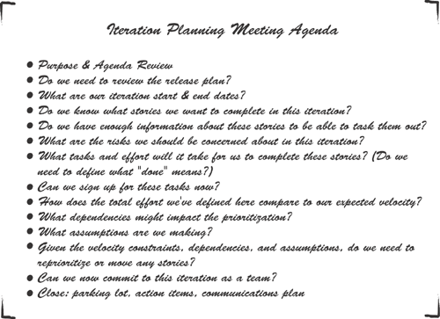

Open Space Meetings
One team uses Open Space meetings to resolve risks and cross-team dependencies. An Open Space meeting is a self-organized meeting where the participants set the topic and agenda. Usually several groups form to address the different issues.^{[13]}The team realized that putting the problem—and the right people—together in a room was the best way to solve issues and mitigate the risks in the project. After solving issues such as “agilizing” waterfall testing phases and coming up with creative solutions to an internationalization challenge, the team learned that the value of an Open Space lies within the binding decisions that are made; the people attending are truly interested in solving the problem.^{[14]}

If the agile team is managing risk organically, then potential risks are identified as part of the agenda items “What assumptions are we making?” and “What concerns do we have?” Both occur at the very end of the meeting, just prior to asking for team commitment to the iteration or release. See Figure 11-2 for an example. An example of concerns identified by one team is illustrated in Figure 11-3. Some of the items are risks, whereas others are risks already materialized (that is, problems). All of these items remain visible to the team throughout the release, as a constant reminder of what to watch and prepare for.

Figure 11-2. Iteration planning agenda using organic risk management agenda items
[View full size image]
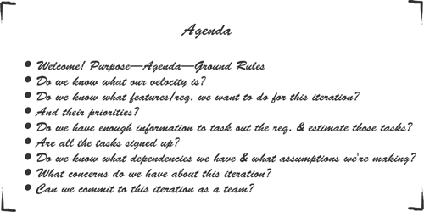

Figure 11-3. Concerns gathered during an iteration planning meeting as part of organic risk management
[View full size image]
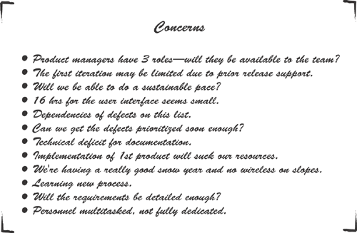

Risks and problems continue to be identified daily as part of daily stand-up meetings, as do risk triggers, which indicate that a risk has occurred or is about to occur. If the team is conducting risk management organically, then the answer to the stand-up meeting question “What obstacles are preventing me from completing my work?” may reveal new risks or risk triggers. In this organic process, agile project managers will often use sticky notes, whiteboards, or flip charts to keep track of these items.

Ferreting Out the Risks
Sometimes risks are identified as part of the responses to the other two stand-up questions, “What did I do yesterday?” and “What am I going to do today?” Agile project managers must listen carefully in stand-up meetings, because risks may be embedded in otherwise uneventful statements. For example, hearing “Yesterday I finished module XYZ; today I’m going to work with Pat on finalizing component ABC, assuming she doesn’t break our appointment again, and nothing is getting in my way” may translate into a risk identified as “Pat is often unavailable to the team, which could lead to a potential bottleneck.”

If the team is conducting risk management overtly, then new problems, risks, and risk triggers are identified during the stand-up meeting and placed in a highly visible location, usually the Risk Board (see Figure 11-4 and the “Obstacles” section of the whiteboard later on in Figure 11-5). Items placed here are discussed after the stand-up because the short 15-minute timeframe of the meeting prevents analysis and response planning. Those interested in or affected by the risk are welcome to stay, while other team members are free to get to work.

Figure 11-4. Team doing their daily stand-up at the Risk Board.^{[15]}
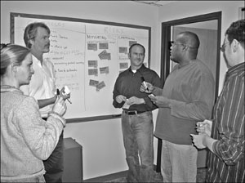

Figure 11-5. Risk response planning using DeMarco/Lister categories.
[View full size image]
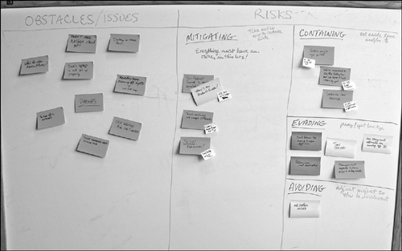

Table 11-2 presents a summary comparison of traditional and agile approaches to risk identification. There is no specific agile terminology for risk identification, but we identify risks in all our planning meetings.

Table 11-2. Risk Identification
Traditional | Agile
Identify risks using checklists, document reviews, information gathering, assumption analysis, and diagramming... | Identify risks using information gathering and assumption analysis...
In limited meetings... | In every planning meeting with the whole team...
And formally documented in the Risk Register. | And informally documented.

Risk Analysis
Risk analysis deals with the analysis of identified risks, their prioritization, and determination of which risks warrant response. Traditional projects use both quantitative analysis (assigning real numbers to the costs of safeguards and the amount of damage that can occur) and qualitative analysis (using judgment, intuition, and experience in determining risks and potential losses). Agile projects generally perform only qualitative analysis, agile’s short development cycles and constant reviews making this feasible and effective. Again, the PMBOK®Guide supports this approach: “Qualitative risk analysis is usually a rapid and cost-effective means of establishing priorities for Risk Response Planning, and lays the foundation for Quantitative Risk Analysis if this is required [emphasis mine].”^{[16]}
And if this is required, the agile framework does not prevent teams from conducting quantitative risk analysis. If deemed appropriate by the team, time should be set aside for this activity as part of the release and/or iteration planning meetings.
Qualitative analysis in agile projects can be organic, with discussions about the probability and impact of risks emerging during planning meetings. Judgment, intuition, and experience are what agile teams rely on in their analysis. This can also be an overt activity, with daily post-stand-up meetings held at the Risk Board to conduct informal analysis discussion. The end result in both cases is a short list of risks to respond to and risks to watch (Concerns and/or Risk Board). Table 11-3 provides a summary comparison of the traditional and agile approaches to risk analysis. There is no specific term for risk analysis as part of agile terminology. Risk analysis is conducted in planning meetings as appropriate.

Table 11-3. Risk Analysis
Traditional | Agile
Uses qualitative and quantitative analysis... | Uses qualitative analysis...
Prioritizes risks using probability and impact analysis... | Prioritizes or groups risks using probability and impact analysis...
Resulting in risks to respond to and risks to watch... | Resulting in risks to respond to and risks to watch...
And formally documented in the Risk Register. | And informally documented.

Risk Response Planning
Developing options and actions to reduce threats and increase opportunities is performed in both traditional and agile environments, with the key differences being that in an agile environment the entire team participates and it is conducted with more frequency than is common in traditional plan-driven projects. Performed organically in planning meetings, team discussions lead to action items that are often designed to mitigate an identified risk. Response planning is also part of the retrospective, where teams make recommendations regarding how to improve the process and reduce bottlenecks.
Many agile teams doing overt risk management using a Risk Board follow Tom DeMarco and Tim Lister’s recommended category breakout as explained in their book, Waltzing with Bears. According to DeMarco and Lister, risks can fall into one of four response categories:
- Avoid— Don’t do the project or part of the project that entails the risk. For example, avoiding an upgrade to a new platform.
- Mitigate— Take steps before the risk materializes to reduce the eventual containment costs. For example, moving a feature to an earlier iteration to ensure that it’s completed in time for the release.
- Contain— Set aside time and money to pay for the risk should it materialize (equivalent to the PMBOK® Guide “Plan Contingency”). For example, preparing training on new automated testing software.
- Evade— When you do none of the above and yet manage to get lucky (equivalent to the PMBOK® Guide “Accept”).^{[17]} For example, ignoring the problem of not having a dedicated team for the duration of the project qualifies as evading.
Figure 11-5 shows an example of risks being managed using these categories, which are displayed on a whiteboard. The larger sticky notes indicate an identified risk, and the smaller sticky notes indicate some action being taken to mitigate or contain that risk. Items on the left side of the board are obstacles identified during daily stand-ups. Obstacles tend to be either problems (risks that have already occurred) or risk triggers.
Table 11-4 presents the traditional and agile approaches to risk response planning. Again, this is not a concept for which agile includes specific terms, but it is part of how agile teams self-organize and solve problems.

Table 11-4. Risk Response Planning
Traditional | Agile
One or more people assigned to develop strategies to... | The team brainstorms strategies to...
Avoid | Avoid
Mitigate | Mitigate
Plan contingency | Contain
Accept | Evade

Risk Monitoring and Controlling
Risk monitoring and controlling involves watching for new risks, tracking and validation of identified risks, and tracking and reviewing risk responses. The PMBOK® Guide identifies several tools to use when doing risk monitoring and controlling activities: risk reassessment, risk audits, variance and trend analysis, technical performance measurement, and status meetings. All of this is accomplished as part of an agile approach, and is considered to be simply part of the organic process.
The reassessment of risks is conducted constantly in all planning meetings, as well as during the retrospective meetings, where previous risks/concerns are revisited as part of determining changes that need to be made going forward. Risk audits, which examine the effectiveness of risk responses, are also conducted as part of the retrospective meeting.
Burndown charts and other metrics are part of the variance and trend analysis done during iteration review meetings, and a review of the team’s velocity is done in keeping with the technical performance measurement.
Risks are monitored on a daily basis by the use of highly visible information radiators such as task boards and burndown charts, which show the current status (see Figure 11-6 for an example of this organic risk monitoring tool). Daily stand-up meetings contribute to the constant monitoring process by exposing potential risk triggers and new risks.

Figure 11-6. Task board with burndown chart^{[18]}
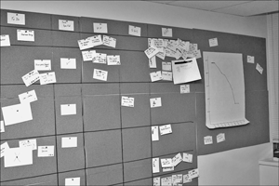

Table 11-5 provides a summary comparison of the traditional and agile approaches to risk monitoring and controlling. In the agile framework, this is simply referred to as “iteration tracking and review.”

Table 11-5. Risk Monitoring and Controlling
Traditional | Agile
Risk reassessment in formal risk management review meetings | Risk reassessment in planning and retrospective meetings
Risk audit as a formal audit or as part of risk management review meetings | Risk audit in retrospective meetings
Variance and trend analysis | Burndown chart and metrics analysis in review meetings
Technical performance measurement | Velocity analysis in review meetings
Status meetings | Task boards, burndown charts, and daily stand-up meetings

