Monitoring the Release Plan

Velocity

A boat measures its rate of progress in knots; an agile team measures its rate of
progress with velocity. Velocity is expressed as the number of story points (or
ideal days) completed per iteration. For a team that finished twelve stories worth
a total of thirty story points in their last iteration, we say that their velocity is
“thirty” or “thirty points per iteration.” Assuming that the scope of the project
hasn’t changed, the team has that much less work to complete.

Because velocity is the primary measure of a team’s progress, it is important
to establish some ground rules for how it is calculated. The most important rule
is that a team counts points toward velocity only for stories or features that are
complete at the end of the iteration.

There are three main problems with counting unfinished work. First, it is
extremely hard to measure unfinished or incomplete work. Which is further
along: A user story that has been programmed but has had no tests run against it
or a story that has been partially programmed and partially tested? How far
along is a programmer who has designed a solution for a story but hasn’t started
coding it? We’re good at knowing when something hasn’t been started, and we’re
fairly good at knowing when it’s done. We should assess work to be in one of
those two states and leave it at that.
Second, incomplete stories break down the trust between the developer
team and the customer team on the project. If a story cannot be completed as
planned during an iteration, the developers and the customer team need to collaboratively resolve the issue as soon as it’s discovered. Usually, this means the
story will be moved out of the iteration or split and parts of it moved out. The
product owner and customer team can make these decisions in real time during
the iteration and may choose to reprioritize based on the new knowledge about
the cost of the story. Alternatively, the customer team may decide to alter the acceptance criteria for the story, accepting it under lessened criteria. They
wouldn’t go so far as to accept a buggy or untested version of the story, but they
may reduce performance requirements, handling of special cases, and so on.

Third, and most important, unfinished work leads to a buildup of work in
process in the development process. The more work in process a team allows to
build up, the longer it will take new features to be transformed from raw ideas
into functioning software. Over time, this will decrease the throughput of the
whole team. Similarly, with large amounts of work in process, it takes longer for
the team to get feedback on what they’re developing. This means that learning is
also delayed.
If a team has unfinished stories at the end of an iteration, they are working
with features or stories that are too large. Small stories lead to a steady flow
through the development process. If stories are left unfinished, they need to be
split into smaller stories. Ideally, this should happen prior to the start of the iteration. However, if during an iteration a story is found to be larger than expected,
it needs to be brought to the attention of the product owner. The product owner,
in collaboration with the team, finds a way to split the story or reduce its scope
such that a portion can ideally still be completed within the iteration, with the
remainder moved to a future iteration.
So how should a team count a partially finished story when determining velocity?
How they count such a story is less important than that they determine
why it happened and how they can prevent it from happening again. It may have
happened because it was underestimated. If so, the team should think about
what type of work was underestimated or forgotten and try to remember to take
care when estimating that type of work in the future. Or the story may have been
unfinished because too many stories were pulled into the current iteration. If
that was the cause, care should be taken to plan iterations more carefully.

Release Burndown Charts

The vertical axis shows the number of story points remaining in the project. (It could
just as easily show the number of ideal days remaining.) Iterations are shown
across the horizontal axis. A release burndown chart shows the amount of work
remaining at the start of each iteration. This becomes a powerful visual indicator
of how quickly a team is moving toward its goal.

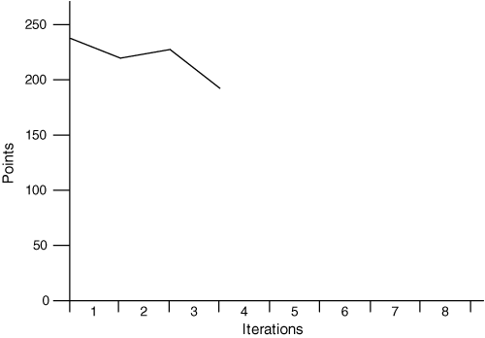
Alternatively, the burndown chart may show a burnupbecause work has
been added to the release.
To see how this works, suppose that in the second iteration the team again
completed the planned thirty points of work but that the product owner identified
another forty points of work that is needed in the release. In this case, the
net result is that there is more work to do at the end of the iteration than there
was when it began. Because a burndown chart reflects the team’s net progress,
the chart is drawn to reflect this increase.

You may wonder why we’d draw the chart this way. We draw it this way because
it allows a single burndown chart to show clearly and simply the two most
important numbers we can use to see if a project is on track: how much work is
remaining and the team’s rate of progress net of all changes to the scope of the
project.

A Release BurndownBar Chart

At one level, the release burndown chart is great. It’s easy to understand
and can be explained quickly to anyone in the organization. A release
burndown chart like this is very informative and tells us when the project is
likely to finish if all factors affecting the project remain unchanged. However,
sometimes it’s useful to draw the release burndown chart so that you can easily
see the team’s velocity and the scope changes separately. To do this, draw a release
burndown bar chart.

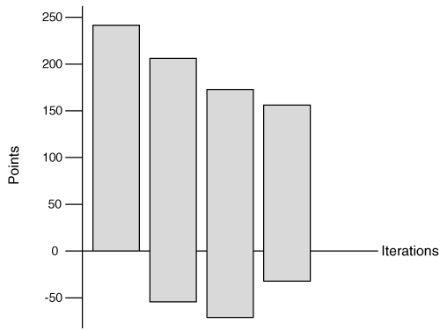

Each bar shows the amount of work in a release as of the start
of an iteration. This type of burndown chart uses bars rather than lines to help
distinguish the regions above and below the horizontal axis at 0. The bottom of
the bar is lowered whenever work is added to the project. The bottom is moved
up whenever work is removed from an iteration. If the bottom is below the horizontal axis at 0, it means that overall work has been added to the release.

An example is the best way to see how this works. In Figure , a release is
planned to include 240 points of work. At the start of the first iteration the burndownchart is drawn with a single bar extending from 0 to 240. As before, the
team expects an average velocity of thirty and expects to be done after eight iterations.

During the first iteration, the team achieves the expected velocity, and
the top of the second bar is drawn at 210. However, the product owner has realized
that the release needs more features than originally thought. An additional
fifty story points of work is identified that will be needed in this release. This
causes the bar for the second iteration to extend below the 0 line. The second bar
is drawn ranging from –50 to 210. In other words, the release now needs 260
points of work, which is more than when it was begun. By the end of the second
iteration Figure reveals three interesting facts.
1. The velocity of the team is as expected. This can be seen from the burndown
across the top of the first two bars.
2. A great deal of work has been added. You can see this from the drop at the
bottom of the second bar. Presumably, work has been added because it will
lead to a more valuable release. However, it may be worth paying attention
to the rate of scope change on this project—so far, more has been added
than has been completed. This may not be something to worry about; it will
depend on whether the trend is likely to continue and how important the
initial target release date is.
3. The total amount of work remaining in the release is greater than when the
project started. This is evident because the overall height of the second bar is
greater than the first.
Clearly, there is a great deal more expressive power in drawing a burndown
chart in this way. The drawback to it is that the meaning of the chart is not as
immediately clear.
Let’s look at the second and third iterations of the project in Figure.
During the second iteration the team again achieves their target velocity. The
product owner has again added work, but at least less was added than during the
previous iteration.
But what happened during the third iteration? During this iteration, velocity
has slowed to only twenty. This may be the result of underestimating some
stories done in that iteration, a team member’s being sick or on vacation, or the
re-estimation of some of the remaining work. The team may have completed
their planned thirty points of work but may have increased estimates on some
remaining stories such that net progress is twenty rather than thirty.

What is most interesting, however, about the third iteration is shown at the
bottom of the the fourth bar. During this iteration, the product owner removed
features from the release. When it’s released, this project will still involve more
story points than initially planned. We can tell this because the bar still extends
below the x-axis at 0. However, at this point the project contains fewer planned
points than it did at the start of the previous iteration. It’s not important
whether the features removed were ones in the original release plan or ones the
product owner added in previous iterations. Prioritzation of work is still up to
the product owner, who can add or remove functionality as desired. The net effect
is shown at the bottom of the burndown bar.
There are four simple rules to keep in mind when drawing this type of burndown
chart.
◆Any time work is completed, the top is lowered.
◆When work is re-estimated, the top moves up or down.
◆When new work is added, the bottom is lowered.
◆When work is removed, the bottom is raised.

A Parking-Lot Chart

Jeff DeLuca (2002) has suggested another useful way of visualizing how a team is
doing at completing the planned functionality of a release. Figure 19.6 shows a
variation of what DeLuca calls a parking-lot chart. A parking-lot chart contains
a large rectangular box for each theme (or grouping of user stories) in a release.
Each box is annotated with the name of the them, the number of stories in that
theme, the number of story points or ideal days for those stories, and the percentage
of the story points that are complete.

A parking-lot chart is a powerful method for compressing a great deal of information into a small space. In many cases, all of a release’s themes can be summarizedon one page using a parking-lot diagram.

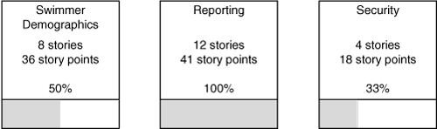

Monitoring the Iteration Plan

The Task Board

The task board is often a large whiteboard or, even better, a corkboard. Taped
or pinned to the task board are the story cards as well as the task cards that were
written during iteration planning. The task board includes one row for each
story or feature that will be worked on during the iteration. In Figure, the
first row contains information about the five-point story. The first column of the
task board holds the story card. Because the story card shows the point estimate
assigned to the story, anyone looking at the task board can quickly determine the
number of story points for each story included in the iteration.

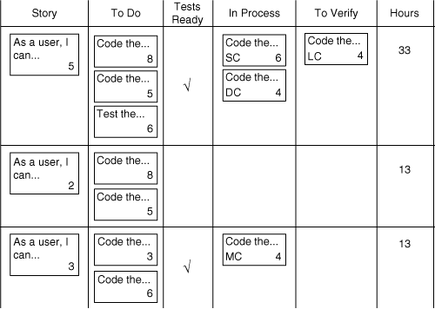

A task board in use during an iteration.

The second column holds all of the task cards that the team identified as
necessary to implement the story or feature. Each of these cards shows the estimate
of the work remaining to complete the task.

The third column indicates whether the acceptance tests are ready for the
story. I am a big fan of test-driven development (Beck 2002), both at the code
level, where I encourage developers to write a failing unit test before writing
code, and at the feature level, where I encourage teams to design high-level acceptance tests before they begin coding. If the conditions of satisfaction for each
story were identified as part of iteration planning (as advised in Chapter 14, “IterationPlanning”), this is easy, as the conditions of satisfactions are essentially a
user story’s high-level acceptance tests. This type of specification by example is
very beneficial for the programmers, as they can refer to specific examples of
how each function and business rule is expected to work.

I have teams put a big checkmark in the Tests Ready column when they have
specified the high-level tests for a story. Further, I encourage teams not to move
many cards to the fourth column, In Process, unless the tests are specified. You
may not need a Tests Specified column, but it’s a useful, visible reminder to a
team that is trying to become accustomed to specifying acceptance tests before
coding a feature.

The In Process column holds cards that developers have signed up for. Typically,
a developer takes a card from the To Do column, puts her initials on it, and
moves it to the In Process column. This happens throughout the day as developers
are finishing work and selecting what they’ll work on next. No one should
sign up for more than one or two cards at a time. This helps maintain a consistent
flow of work through the process and reduces the cost of context switching
among multiple tasks. As a constant reminder of this, when I have a team set up
their task board I have them make the In Process column the width of one card.

The To Do column is typically wider (and wider than shown in Figure 20.1) because
cards are often taped four across there.

The To Verify column is another that you may or may not need but that I
find useful, especially when working with a team that is learning how to become
agile. Ideally, each test activity is thought of and a task card written during iteration
planning. If so, when a programming task card (“Code the boojum user interface”)
is finished, it is removed from the task board (or moved to a final colum
called Done). At that time, someone can sign up for the associated test card
(“Test the boojum user interface”). However, I find there are times when a developer
considers a task card done but would like a fresh pair of eyes to take a quick,
verifying look. In those cases, and when there is no associated test task, the task
card is placed in the To Verify column.

The developers are encouraged to change the estimate on any task card on
the board at any time. For example, if I start working on a card and realize that
the estimate of two hours on it is wrong, I will go over to the task board, cross
out the two, and replace it with perhaps a six. If I believe the estimate is even further
off, I may rip up that task card and replace it with two or three task cards,
each with its own estimate. The final colum on the task board is simply a sum of
the hours of work remaining on the feature or story. I usually sum the hours for
each row every morning. I use these totals to draw an iteration burndown chart,
which is the second tool for tracking the progress of an iteration.

Iteration Burndown Charts

Drawing a release burndown chart is a great way to see whether a project is going
astray or not. Depending on the length of your iterations, it can be useful to
create an iteration burndown chart. If you’re using one-week iterations, it probably
isn’t necessary. By the time a trend is visible on an iteration burndown
chart, a one-week iteration will be over. However, I’ve found iteration burndown
charts to be extremely useful with iteration lengths of two weeks or longer. An
iterationburndown chart plots hours remaining by day, as shown in Figure 20.2.
To create an iteration burndown chart, simply sum all of the hours on your
task board once per day and plot that on the chart. If the team’s task board is
drawn on a whiteboard, I usually draw the iteration burndown by hand on one
side of the task board. If the task board is on a corkboard, I tack a large piece of
paper to the corkboard and draw the burndown chart on it.

