服务器IP 10.10.30.25 CDC-3\administrator Adtec!@#$%^
teamview 1402652976 bfe164
设备账号：admin/ adtec@123

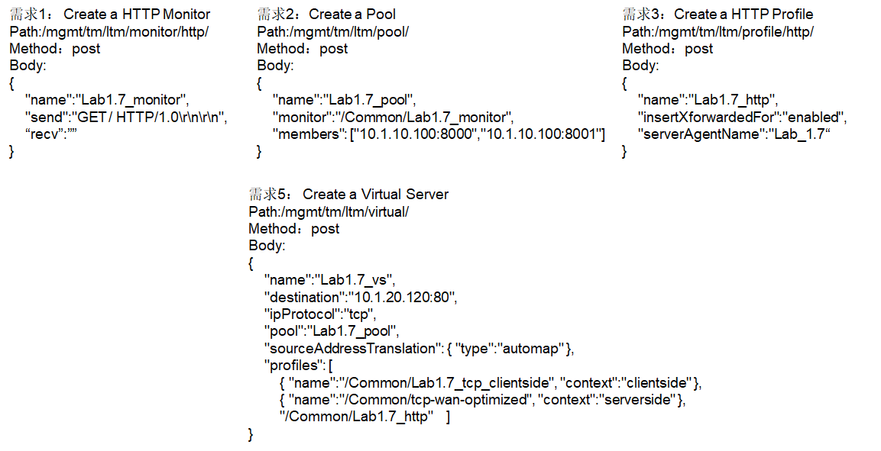

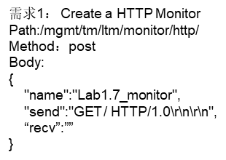

需求1： Create a HTTP Monitor
Path:/mgmt/tm/ltm/monitor/http/
Method：post
Body:
{
"name":"Lab1.7_monitor",
"send":"GET / HTTP/1.0\r\n\r\n",
“recv”:””
}

步驟

地址：218.249.66.158:6870
用户名 vts_lab
密码 Adtec@123

桌面“”运行“”然后CMD 输入mstsc

https://docs.bk.tencent.com/gcloud/term3.html#atomic 标准运维原子开发文档

https://cloud.tencent.com/edu/learning/major-100008 视频教程

