Final Project Report

Cash &Carry



Project Supervisor
Faizan Tahir

Submitted By

Project Group ID : S2002EAD71

Name : Uroosa Ajaz
VU ID: BC160403977

Software Projects & Research Section,
Department of Computer Sciences,
Virtual University of Pakistan


CERTIFICATE

This is to certify that Uroosa Ajaz (BC160403977)have worked on and completed their Software Project at Software & Research Projects Section, Department of Computer Sciences, Virtual University of Pakistan in partial fulfillment of the requirement for the degree of BS in Computer Sciences under my guidance and supervision.

In our opinion, it is satisfactory and up to the mark and therefore fulfills the requirements of BS in Computer Sciences.

Supervisor / Internal Examiner

Faizan Tahir
Supervisor,
Software Projects & Research Section,
Department of Computer Sciences
Virtual University of Pakistan

___________________
(Signature)

External Examiner/Subject Specialist
<<External Supervisor Name>>

___________________
(Signature)

Accepted By:

_____________
(For office use)

EXORDIUM

In the name of Allah, the Compassionate, the Merciful.

Praise be to Allah, Lord of Creation,
The Compassionate, the Merciful,
King of Judgment-day!

You alone we worship, and to You alone we pray for help,
Guide us to the straight path

The path of those who You have favored,

Not of those who have incurred Your wrath,
Nor of those who have gone astray.

DEDICATION

ACKNOWLEDGEMENT

I would like to appreciate Virtual University of Pakistan to provide me opportunity to complete my study under such a good environment. A special thanks to our final year project supervisor, “Faizan Tahir”, whose contribution in stimulating suggestions and encouragement helped me to complete my project.

Last but not leat, I would like to thanks all my family, my teachers and VU team who invested their effort in guiding me.
PREFACE

This project report has been prepared in partial fulfilments of requirements for degree of
BS INFORMATION TECHNOLOGY.
TABLE OF CONTENTS

CHAPTER NO. 1
gathering & Analyzing info 9

1.1 Introduction

1.2 purpose

1.3 scope

1.4 definitions, acronyms and abbreviations

1.5 Project requirements

1.5.1 Functional Requirements

1.5.2 Non-Functional Requirements

1.6 use cases and usage scenarios

1.6.1 Use Case Diagrams

1.6.2 Usage Scenarios

1.7 Development Methodology

1.7.1 Chosen Methodology

1.7.2 Reasons for Chosen Methodology
1.7.2 Work Plan (Gantt Chart)
1.7.2 Project Schedule (Submission Calendar)

CHAPTER NO. 2
designing the project 17

2.1 Introduction

2.2 purpose

2.3 scope

2.4 definitions, acronyms and abbreviations

2.5 Architectural Representation (Architecture Diagram)

2.6 Dynamic Model: Sequence Diagrams

2.7 Object Model/Logical Model: Class Diagram

2.8 Database Model (Database Diagram)

2.9 Graphical User Interfaces

Chapter no.3
DEvelopment 23
3.1 Development plan (Architecture Diagram)

CHAPTER 1
Gathering & Analyzing Info

  - Introduction

Online shopping is a trend nowadays. Everyone is busy enough to take time from their busy routine to go physically and do shopping. So, here we are developing a website through which customer can order anything from home, from edible items to non-edible item, shoes to slipper, clothes to electronics an much more.

  - purpose

Users in this case have the ability to order products from the company’s website by category wise and choose payment method on his/her purchase.

  - scope

Online shopping is a trend nowadays. Everyone is busy enough to take time from their busy routine to go physically and do shopping. So, here we are developing a website through which customer can order anything from home, from edible items to non-edible item, shoes to slipper, clothes to electronics an much more.

  - definitions, acronyms and abbreviations

C&C (Cash & Carry)

1.5 Project requirements

1.5.1 Functional Requirements

- Login/Registration
- browse items
- Add to cart
- Checkout

    - Non-Functional Requirements

- Stable internet connection
- Internet Browser

1.6 use cases and usage scenarios

1.6.1 Use Case Diagrams

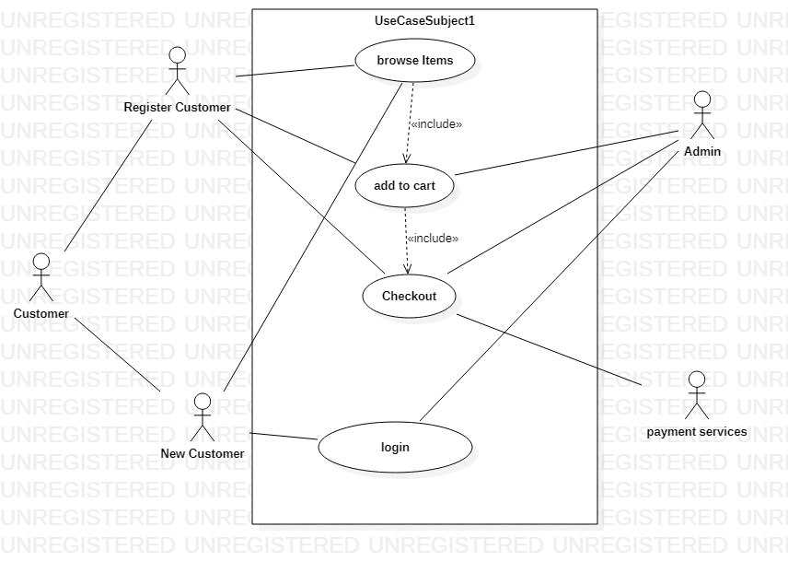

1.6.2 Usage Scenarios

Login
Use Case Name | Login
Use Case ID | UCS-001
Actors | New Customer
Use Case Description | User will register for website for checkout.
Pre-Conditions | Customer needs to be on website home page
Post Conditions | Success message for successfully registered/ login user.
Main success scenario | - User will open up webiste index page.  - User click on login/ Register button.  - user provids his details.  - user clicks submit button.
Alternative Scenarios | User may cancel the operation.
Author | S2002EAD71 (BC160403977)

Browse Items
Use Case Name | Browse items
Use Case ID | UCS-002
Actors | New Customer and Registerd Customer
Use Case Description | User will browse items on page
Pre-Conditions | Customer needs to be on website home page
Post Conditions | User successfuuly navigated the website.
Main success scenario | - User will select the category.  - User will browse the item .
Alternative Scenarios | User may close the browser/website.
Author | S2002EAD71 (BC160403977)

Add To Cart
Use Case Name | Add To Cart
Use Case ID | UCS-003
Actors | New Customer and Registerd Customer
Use Case Description | User will register for website for checkout.
Pre-Conditions | Customer needs to be on website home page.  Customer will broswe items.
Post Conditions | customer successfully added item(s) to the cart.
Main success scenario | - User will open up the webpage.  - User will browse the item.  - Customer will successfully add the items to the cart.
Alternative Scenarios | customer will leave the webpage just by browsing the items..
Author | S2002EAD71 (BC160403977)

Check Out
Use Case Name | Check Out
Use Case ID | UCS-004
Actors | Register Customer
Use Case Description | User will register for website for checkout.
Pre-Conditions | Customer needs to be registered on website.
Post Conditions | Success message for successfully registered/ login user.
Main success scenario | - User will chechout the page.  - user provids his details.  - user clicks submit button.
Alternative Scenarios | User may cancel the operation.
Author | S2002EAD71 (BC160403977)

1.7 Development Methodology

1.7.1 Chosen Methodology

Adopted methodology for our project is VU Process Model. The reason for selecting this model is its hybrid nature. It maximize the quality of system and advantages and minimize disadvantages and risk. It is the combination of waterfall and spiral model.VU Process model is a combination of the Waterfall and Spiral models and we would follow this hybrid model. As a VU study project our activities will be sequential in nature waterfall model, and we analyze each phase with regard to the end product. So it will become an un-sequential iteration. The VU Process Model is a documentation-driven model. It therefore generates complete and comprehensive documentation and hence makes the maintenance task much easier because the feedback of user must fulfill on each phase of development. This model is also known as linear sequential model. This model is depicted in the following diagram:

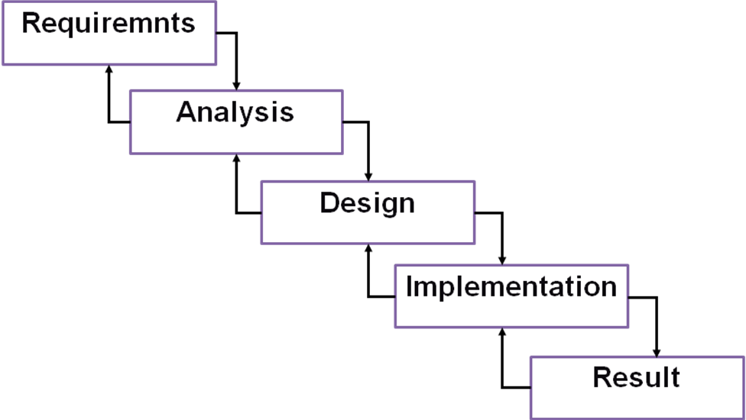

A mistake caught any stage should be referred back to the source and all the subsequent stages need to be revisited and corresponding documents should be updated accordingly. This feedback path is shown in the following diagram.

1.7.2 Reasons for Chosen Methodology

- Best for Virtual University Projects.
- Testing is inherent in every phase.
- Importance on requirement and design before writing code is saving of time and efforts.
- Clarity and clear-cut project Requirements specific.
- Use of design Documentation

1.7.2 Work Plan (Gantt Chart)

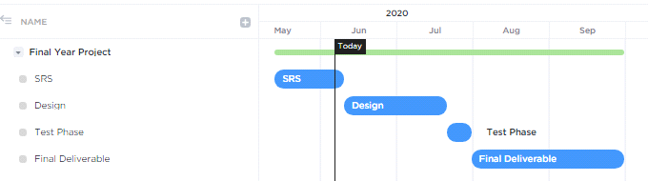

1.7.2 Project Schedule (Submission Calendar)

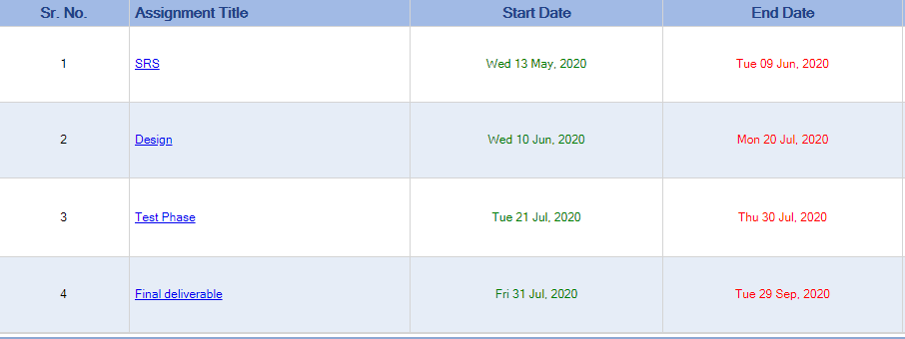

CHAPTER 2
Designing the Project

2.1 Introduction

Online shopping is a trend nowadays. Everyone is busy enough to take time from their busy routine to go physically and do shopping. So, here we are developing a website through which customer can order anything from home, from edible items to non-edible item, shoes to slipper, clothes to electronics an much more.
2.2 purpose

Users in this case have the ability to order products from the company’s website by category wise and choose payment method on his/her purchase.

2.3 scope

Online shopping is a trend nowadays. Everyone is busy enough to take time from their busy routine to go physically and do shopping. So, here we are developing a website through which customer can order anything from home, from edible items to non-edible item, shoes to slipper, clothes to electronics an much more.

2.4 definitions, acronyms and abbreviations

C&C (Cash & Carry)

2.5 Architectural Representation (Architecture Diagram)

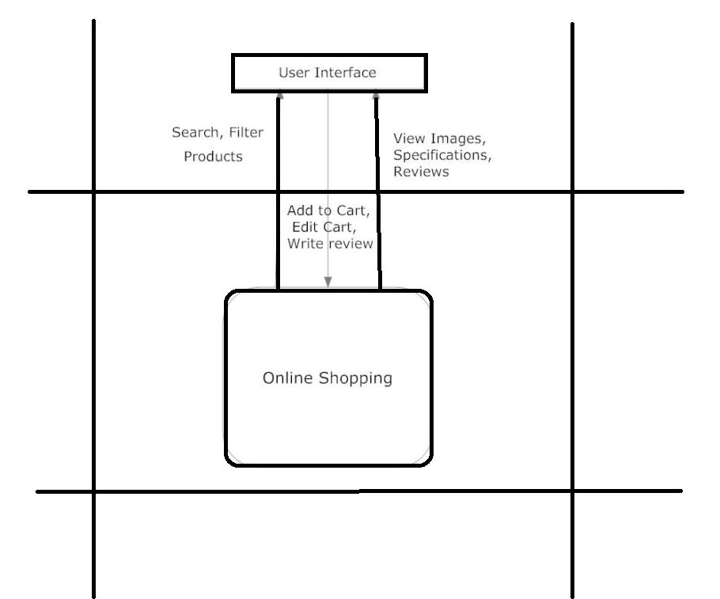

2.6 Dynamic Model: Sequence Diagrams

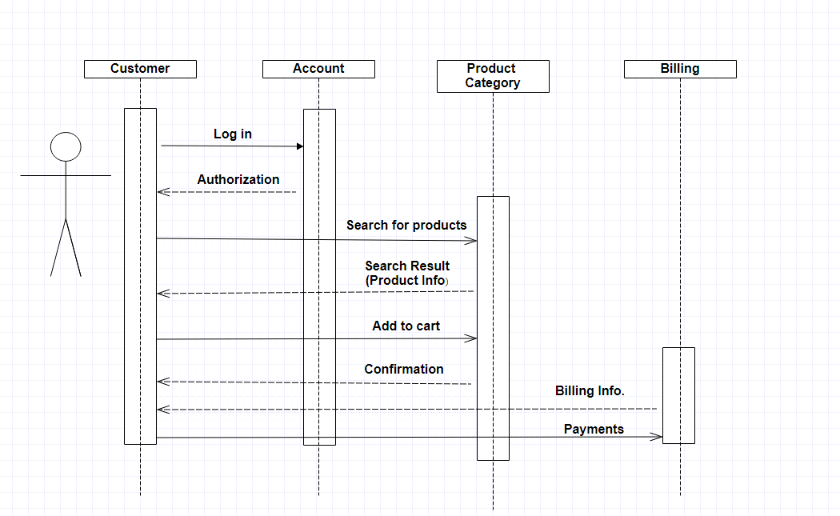

2.7 Object Model/Logical Model: Class Diagram

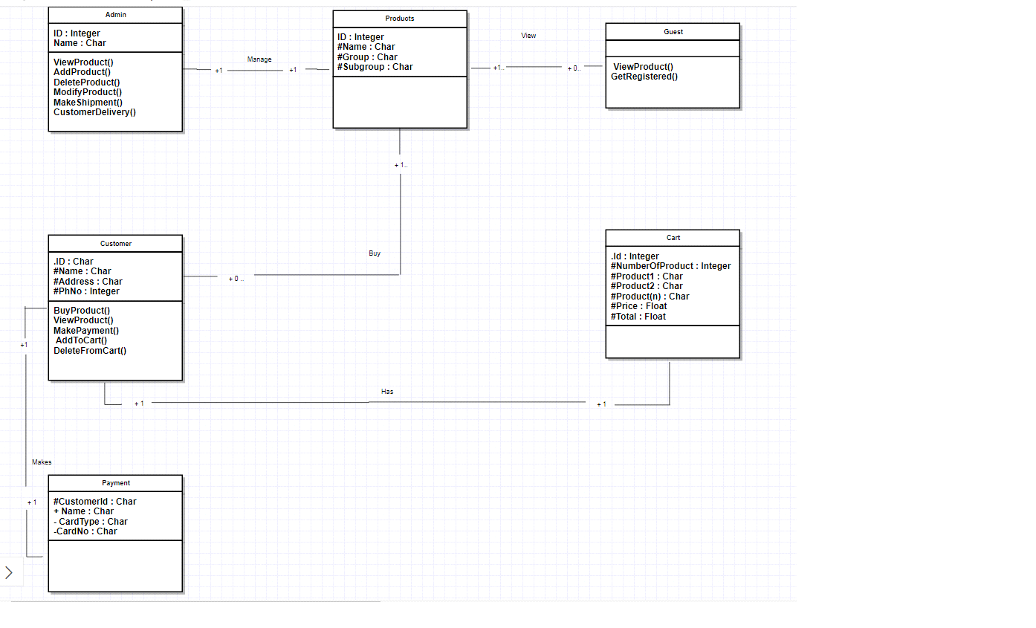
2.8 Database Model (Database Diagram)

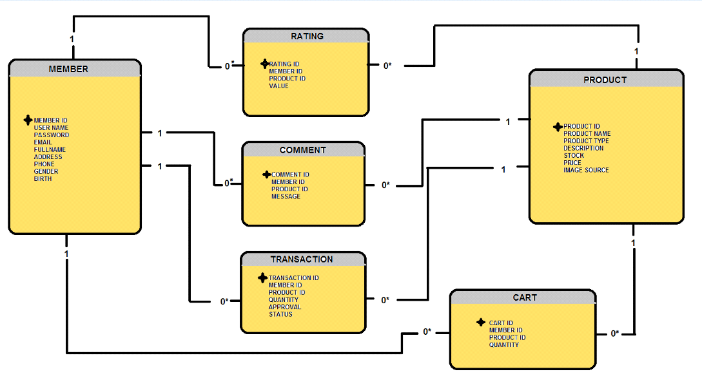

2.9 Graphical User Interfaces

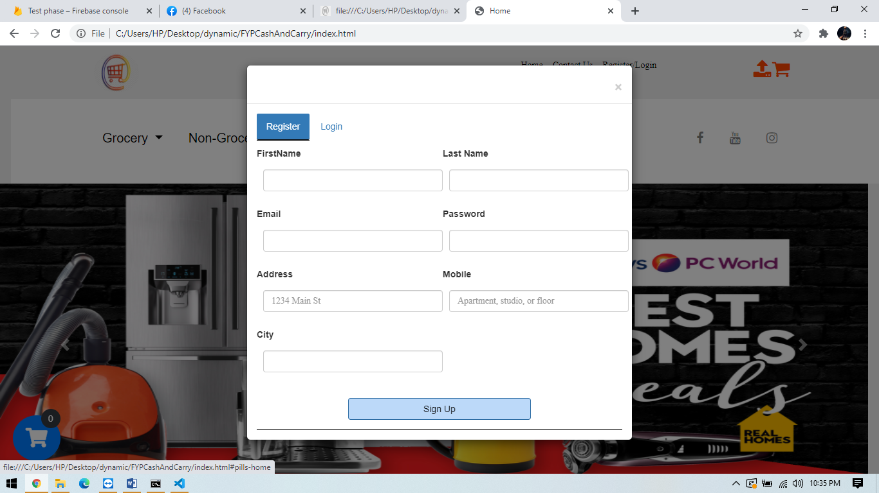

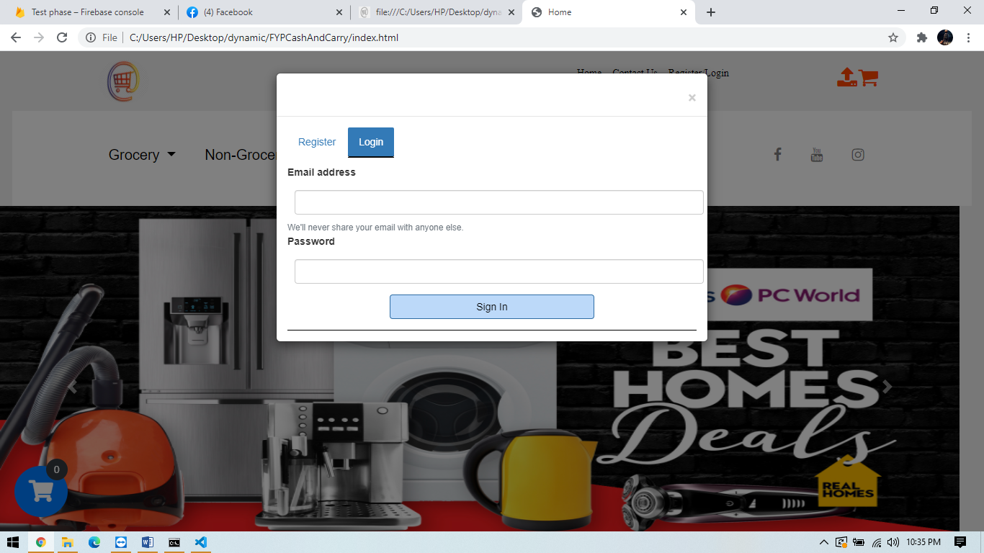

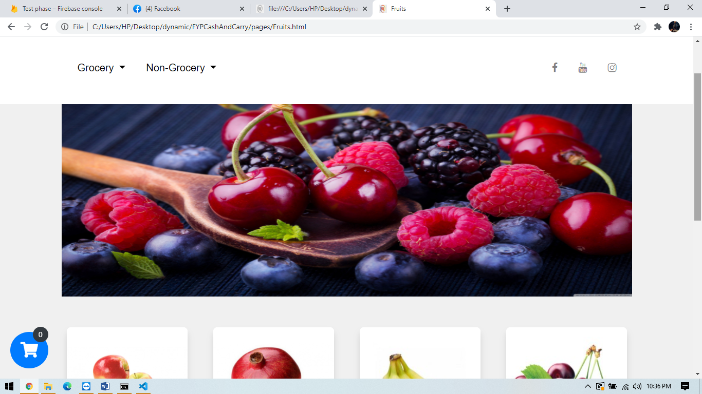

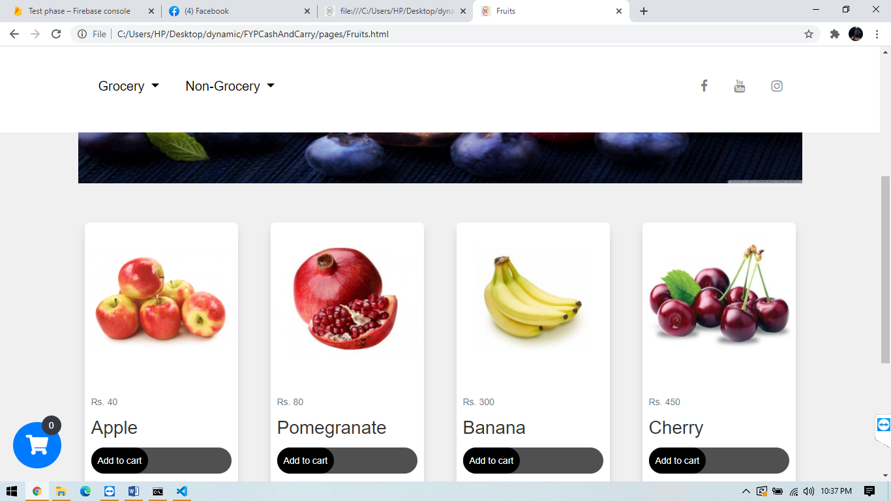

CHAPTER 3
Development

3.1 Development plan (Architecture Diagram)

REFERENCES

Virtual University of Pakistan
BS Software Engineering Cources

APPENDIX

