[Insert Physician Letterhead]

[Insert Name of Medical Director] RE: Member Name: M

[Insert Payer Name] Member Number: [Insert Member Number]

[Insert Address] Group Number: [Insert Group Number]

[Insert City, State ZIP]

**REQUEST:** Authorization for treatment with SPRAVATO® (esketamine) Nasal Spray CIII

**DIAGNOSIS:** Major depressive disorder [treatment-resistant depression F33.9 with Suicidal ideations R45.851 without psychotic features

**DOSE AND FREQUENCY:** 84 mg twice per week for 4 weeks in conjunction with an oral antidepressant (AD)

**REQUEST TYPE:** ☐ Standard x EXPEDITED

I am writing to support my request for an **authorization** for the above-mentioned patient to receive treatment with SPRAVATO® for treatment-resistant depression with suicidal ideation, dosed concomitant with bupropion. My request is supported by the following:

**Summary of Patient’s Diagnosis**

[Insert patient’s diagnosis, date of diagnosis, lab results and date, current condition]

The patient exhibits treatment-resistant major depressive disorder (F33.9) with suicidal ideations (R45.851).

The patient was first diagnosed with major depressive disorder after being hospitalized for two weeks following a suicide attempt in 1999.

The patient currently experiences daily suicidal ideation along with significant anxiety and depressive symptoms without psychotic features.

During the current depressive episode, the patient has had an inadequate response (≤ 25% improvement) to 7 different oral antidepressants of adequate dose and duration (all over 6 weeks of treatment).

**Complaint Details**

* Loss of interest in daily activities
* Lack of energy
* Inability to focus
* Irregular sleeping patterns
* Loss of appetite
* Low or decreased self-worth and self-esteem
* Suicidal thoughts
* Mild autistic-like symptoms

## Summary of Patient’s History

* Age 8 – 39: Depression, anxiety, regular suicidal ideation
* Age 15 – 35: acne on face and back
* Age 15 – 35: Severe social anxiety
* Age 29 – 39: plaque psoriasis
* Age 15 – 35: back pain
* Age 39 – 39: guttate psoriasis
* Age 29 – 39: episodic arthritis

**Previous Treatments**

**Selective Serotonin Reuptake Inhibitors (SSRIs)**

* 40 mg/day Citalopram (Celexa) for 6 months - No response, no remission
* 20 mg/day Escitalopram (Lexapro) for 3 months - No response, no remission
* 60 mg/day Fluoxetine (Prozac) for 6 months - No response, no remission
* 50 mg/day Paroxetine (Paxil) for 3 months - No response, no remission
* 100 mg/day Sertraline (Zoloft) for 9 months - No response, no remission

**Serotonin and Norepinephrine Reuptake Inhibitors (SNRIs)**

* 60 mg/day Cymbalta (duloxetine) - No response, no remission
* 150 mg/day Effexor (venlafaxine) - No response, no remission

**Tricyclic Antidepressants (TCAs)**

* 100 mg/day Anafranil - No response, no remission

**Monoamine Oxidase Inhibitors (MAOIs)**

* 10 mg/day Eldepryl (Selegiline Hcl) - Moderate response, no remission

**Atypical Antidepressants**

* 30 mg/day **Remeron (mirtazapine)**: Moderate response, no remission
* 300mg/day **Wellbutrin (bupropion)**: Moderate response, no remission, increased energy

## Site of medical service

[Insert:

* Previous therapies/procedures, including dose and duration, response to those interventions
* Description of patient’s recent symptoms/condition
* Site of medical service—include appropriate site type: inpatient, hospital outpatient, outpatient clinic, private practice, or other
* Rationale for not using drugs that are on the plan's formulary
* Summary of your professional opinion of the patient’s likely prognosis or disease progression without treatment with SPRAVATO®

Note: Exercise your medical judgment and discretion when providing a diagnosis and characterization of the patient’s medical condition.]

## Rationale for Treatment with Spravato

Based on regular self-reported data collected by the patient, it is apparent that the severity of the patient’s depressive symptoms is highly correlated with the severity of his arthritic pain over time.

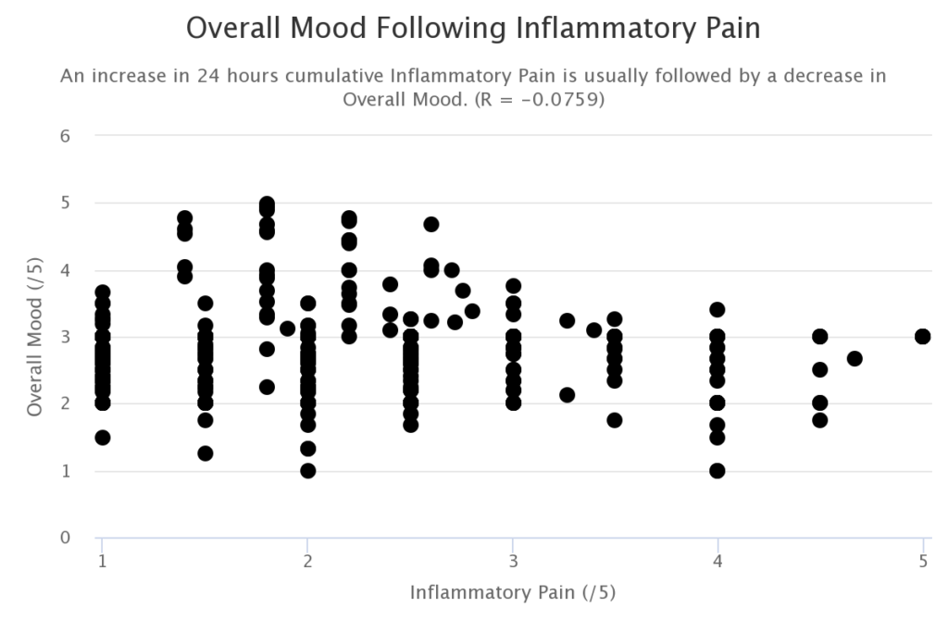

An immune activation including increased production of proinflammatory cytokines has repeatedly been described in major depression. Proinflammatory cytokines such as interleukin-2, interferon-γ, or tumor necrosis factor-α activate the tryptophan- and serotonin-degrading enzyme indoleamine 2,3-dioxygenase (IDO). Depressive states during inflammatory somatic disorders are also associated with increased proinflammatory cytokines and increased consumption of tryptophan via activation of IDO. Enhanced consumption of serotonin and its precursor tryptophan through IDO activation could well explain the reduced availability of serotonergic neurotransmission in MD. Increased activation of IDO and its subsequent enzyme kynurenine monooxygenase by proinflammatory cytokines, moreover, leads to enhanced production of quinolinic acid, a strong agonist of the glutamatergic N-methyl-D-aspartate (NMDA) receptor.

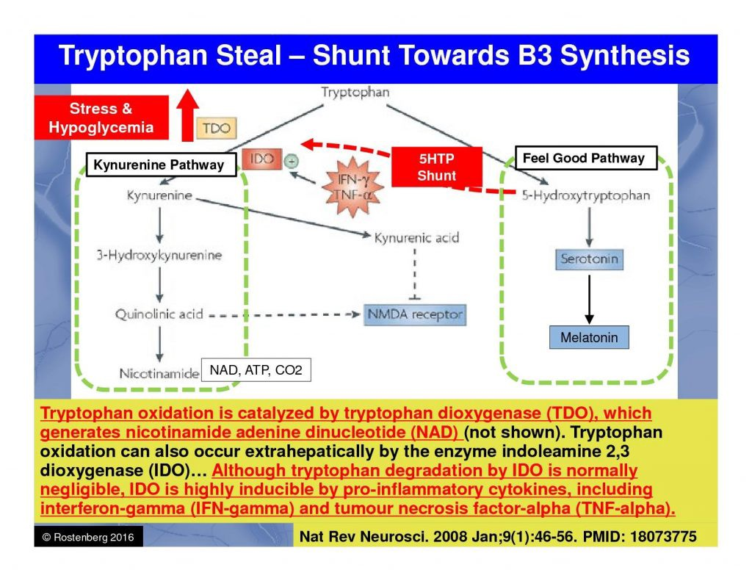

Consistent with the view that an increased activity of the glutamatergic system and NMDA receptor agonism is associated with depressed mood, a reduction of the glutamatergic activity, that is NMDA receptor antagonism might exert antidepressant effects.

[Insert summary statement for rationale for treatment such as: Considering the patient’s history, condition, and the full Prescribing Information supporting uses of SPRAVATO®, I believe treatment with SPRAVATO® at this time is medically necessary, and should be a covered and reimbursed service.]

[You may consider including documents that provide additional clinical information to support the recommendation   
for SPRAVATO® for this patient, such as the full Prescribing Information, peer-reviewed journal articles, or   
clinical guidelines.]

Given the urgent nature of this request, please provide a timely authorization. Contact my office at [Insert Phone Number] if I can provide you with any additional information.

Sincerely,

[Insert Physician Name and Participating Provider Number]

Enclosures [Include full Prescribing Information and the additional support noted above]