**PRAKTIKUM ALGORITMA DAN STRUKTUR DATA**

**QUIZ 2**



**NAMA : DIMAS ADI BAYU SAMUDRA**

**KELAS : 1A**

**NO. ABSEN : 08**

**NIM : 2341720169**

**PROGRAM STUDI TEKNIK INFORMATIKA**

**JURUSAN TEKNOLOGI INFORMASI**

**POLITEKNIK NEGERI MALANG**

**2024**

Class Antrian08

|  |
| --- |
| public class Antrian08 {  Pelanggan08 pelanggan;  Layanan08 layanan;  Antrian08 next;  Antrian08(Pelanggan08 pelanggan, Layanan08 layanan , Antrian08 next){  this.pelanggan = pelanggan;  this.layanan = layanan;  this.next = next;  }  } |

Class Pelanggan08

|  |
| --- |
| public class Pelanggan08 {  String namaPelanggan;  String NoHp;  public Pelanggan08(String b, String c){  namaPelanggan = b;  NoHp = c;  }    } |

Class layanan08

|  |
| --- |
| public class Layanan08 {  int KodeLayanan;  String namaLayanan;  int harga;    Layanan08(int x, String y, int z){  KodeLayanan = x;  namaLayanan = y;  harga = z;  }  } |

Class LLBengkel08

|  |
| --- |
| public class SLLBengkel08 {  Antrian08 head;  int size;    public SLLBengkel08() {  head = null;  size = 0;  }    public boolean isEmpty() {  return head == null;  }      public void addFirst(Pelanggan08 pelanggan,Layanan08 layanan) {  if (isEmpty()) {  head = new Antrian08(pelanggan, layanan, null, null) ;  } else {  Antrian08 newNode = new Antrian08(pelanggan, layanan, head, null);  head.prev = newNode;  head = newNode;  }  size++;  }    public void addLast(Pelanggan08 pelanggan,Layanan08 layanan) {  if (isEmpty()) {  addFirst(pelanggan,layanan);  } else {  Antrian08 current = head;  while (current.next != null) {  current = current.next;  }  Antrian08 newNode = new Antrian08(pelanggan, layanan, null, current);  current.next = newNode;  size++;  }  }  void print() {  if (!isEmpty()) {  Antrian08 tmp = head;  System.out.println("Isi Linked List:");  int counter = 1;  while (tmp != null) {  System.out.println("Antrian ke : " + counter);  System.out.println("nama pelanggan : " + tmp.pelanggan.namaPelanggan);  System.out.println("NO HP : " + tmp.pelanggan.NoHp);  System.out.println("Kode Layanan : " + tmp.layanan.KodeLayanan);  System.out.println("nama Layanan : " + tmp.layanan.namaLayanan);  System.out.println("Harga : " + tmp.layanan.harga);  tmp = tmp.next;  counter++;  }  } else {  System.out.println("Linked List kosong");  }  }    public void removeLastAndAddService(Layanan08 layanan) throws Exception {  if (isEmpty()) {  throw new Exception("Linked List masih kosong, tidak dapat dihapus!");  } else {  Antrian08 current = head;  while (current.next != null) {  current = current.next;  }  current.layanan = layanan;  }  }    public int size() {  return size;  }    public void clear() {  head = null;  size = 0;  }  public void tampilSemuaLayanan() {  Antrian08 tmp = head;  System.out.println("Daftar Semua Layanan:");  while (tmp != null) {  System.out.println("Nama Layanan: " + tmp.layanan.namaLayanan + ", Harga: " + tmp.layanan.harga);  tmp = tmp.next;  }  }  public int totalPemasukan() {  Antrian08 tmp = head;  int total = 0;  while (tmp != null) {  total += tmp.layanan.harga;  tmp = tmp.next;  }  return total;  }  public void tampilLayananTermurah() {  Antrian08 tmp = head;  Layanan08 termurah = tmp.layanan;  while (tmp != null) {  if (tmp.layanan.harga < termurah.harga) {  termurah = tmp.layanan;  }  tmp = tmp.next;  }  System.out.println("Layanan Termurah:");  System.out.println("Nama Layanan: " + termurah.namaLayanan + ", Harga: " + termurah.harga);  }  } |

Class main

|  |
| --- |
| import java.util.Scanner;  public class BengkelMobilMain08 {  public static void main(String[] args) throws Exception {  Scanner sc = new Scanner(System.in);  SLLBengkel08 list = new SLLBengkel08();  String namaPelanggan;  String NoHp;  int KodeLayanan;  String namaLayanan;  int harga;  boolean run = true;  do {  System.out.println("================================");  System.out.println("BENGKEL POLINEMA");  System.out.println("================================");  System.out.println("1. Tambah Antrian");  System.out.println("2. Print Antrian");  System.out.println("3. Hapus Antrian dan tambah layanan");  System.out.println("4. Tampil Semua Layanan");  System.out.println("5. Tampil Total Pemasukan ");  System.out.println("6. Tampil Layanan berdasarkan harga termurah");  System.out.println("7. Keluar dari menu");  System.out.println("================================");  System.out.print("Masukan Pilihan Anda : ");  int pilihan = sc.nextInt();  System.out.println("================================");  switch (pilihan) {  case 1:  System.out.print("Masukan Nama :");  namaPelanggan = sc.next();  System.out.print("Masukan No HP : ");  NoHp = sc.next();  Pelanggan08 pelanggan = new Pelanggan08(namaPelanggan, NoHp);  System.out.print("Masukan Kode Layanan : ");  KodeLayanan = sc.nextInt();  System.out.print("Masukan Nama Layanan : ");  namaLayanan = sc.next();  System.out.print("Masukan harga : ");  harga = sc.nextInt();  Layanan08 layanan = new Layanan08(KodeLayanan, namaLayanan, harga);  list.addLast(pelanggan, layanan);  break;  case 2:  list.print();  break;  case 3:  System.out.print("Masukan Kode Layanan Baru : ");  KodeLayanan = sc.nextInt();  System.out.print("Masukan Nama Layanan Baru : ");  namaLayanan = sc.next();  System.out.print("Masukan harga Layanan Baru : ");  harga = sc.nextInt();  Layanan08 layananBaru = new Layanan08(KodeLayanan, namaLayanan, harga);  list.removeLastAndAddService(layananBaru);  break;    case 4:  list.tampilSemuaLayanan();  break;  case 5:  System.out.println("Total Pemasukan: " + list.totalPemasukan());  break;  case 6:  list.tampilLayananTermurah();  break;  case 7:  run = false;  break;  default:  System.out.println("Pilihan tidak valid!");  break;  }  } while (run);  }  } |

Menu tambah antrian

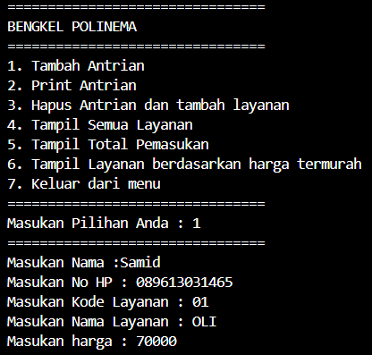

Menu 2 print antrian

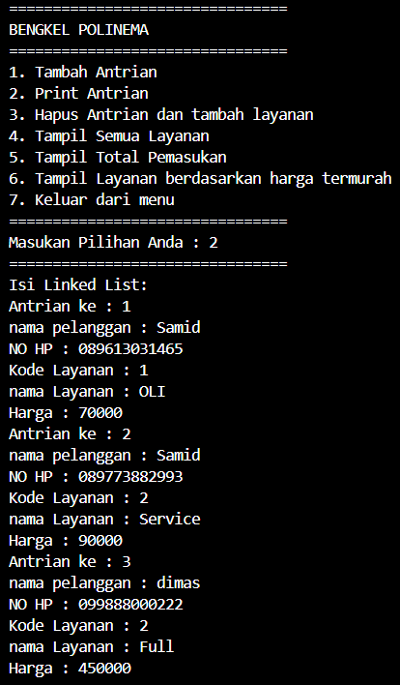

Menu 3 hapus dan tambah antrian

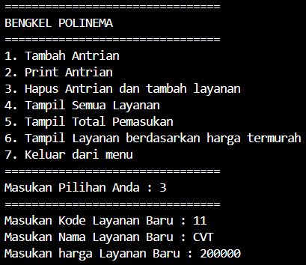

Menu 4 tampil semua layanan

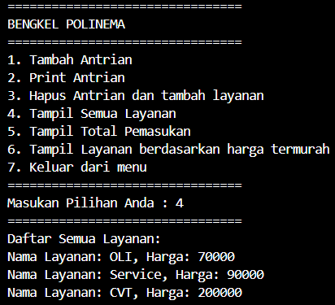

Menu 5 total pemasukan

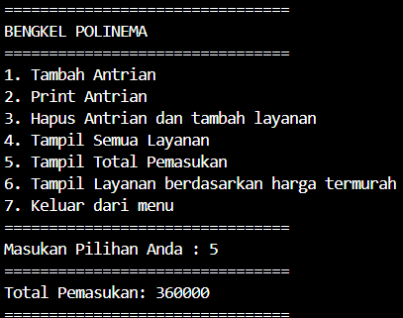

Menu 6 tampil layanan berdasarkan harga termurah

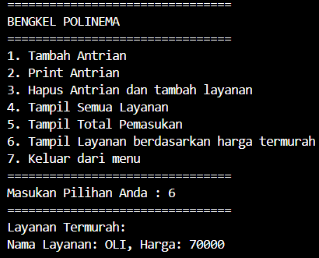

Menu 7 keluar menu

