Delta: Disagreement-Preserving Multi-Agent Collaboration

Agent Confidence, Entropy, and Cross-Sectional Stock Return Predictability

Dechang Xu
Soochow University, Center for Financial Engineering

Junwen Zhang
Xi'an Jiaotong-Liverpool University

June 2026

Abstract
This paper introduces Delta, a disagreement-preserving multi-agent framework for cross-sectional stock return prediction. While conventional multi-agent AI systems eliminate disagreement through consensus, Delta preserves and structurally decomposes disagreement as a predictive signal. We deploy three specialized LLM agents—Sentiment, Technical, and Fundamental—each processing distinct information channels via the Qwen language model, generating genuine structural disagreement.
Using 183 S&P 500 constituent stocks sampled across 20 years (1,989 stock-month observations from 5,967 LLM API calls), we find that the Miller (1977) overvaluation prediction is component-dependent and method-dependent. H_sentiment (Shannon entropy of the sentiment agent's probability distribution) is the strongest predictor: a one-standard-deviation increase is associated with a 1.1% decrease in monthly excess return (β = -0.075, t = -2.91), consistent with the ambiguity aversion channel. Confidence (Inner Confidence, Chen et al. 2025) is a marginal positive predictor (β = +0.165, t = +1.81), with a long-short portfolio earning +1.71% per month. D_post (rating dispersion) is not significant in univariate models but reveals a striking asymmetry: significantly negative for large-cap stocks (t = -1.84), consistent with Miller, but positive for small-cap stocks, consistent with information discovery.
Control experiments confirm that preserving disagreement adds value: consensus-based ratings have zero predictive power (t = +0.94), while disagreement-based signals are significant. A placebo test with randomly shuffled disagreement produces zero predictive power. A quantitative agent model (39,866 observations) serves as robustness, confirming H_sentiment and Confidence but producing opposite D_post signs for large-cap stocks—evidence that LLM-generated disagreement captures motivational components absent in purely structural models.
These findings demonstrate that (1) different disagreement components capture different economic mechanisms, (2) the type of disagreement (structural vs motivational) determines the direction of return predictability, and (3) Inner Confidence is the most robust cross-method signal. The Delta framework shows that preserving—rather than eliminating—disagreement in multi-agent systems yields richer predictive signals, with H_sentiment and Confidence emerging as the most informative components.
JEL Classification: G12, G14, G41, C88, D82
Keywords: investor disagreement, multi-agent systems, LLM, Jensen-Shannon divergence, Inner Confidence, stock return predictability, Miller hypothesis, ambiguity aversion

1. Introduction
Investor disagreement is a central concept in financial economics. Miller (1977) demonstrates that when investors have heterogeneous beliefs and short-selling is constrained, stock prices reflect the most optimistic valuation, leading to systematic overvaluation and subsequent negative returns. This prediction has been confirmed empirically by Diether, Malloy, and Scherbina (2002), who find that stocks with high analyst forecast dispersion earn lower subsequent returns.
However, the relationship between disagreement and returns is more nuanced than the simple Miller prediction suggests. Hong and Stein (2007) argue that disagreement can also reflect progressive information revelation, in which case high disagreement precedes positive returns. Anderson, Ghysels, and Juergens (2005) find that the direction depends on measurement. Yu (2011) shows varying signs across portfolio characteristics.
This theoretical ambiguity creates a fundamental tension for multi-agent AI systems in finance. The dominant paradigm—exemplified by TradingAgents (Xiao et al., 2024) and FinDebate (Cai et al., 2025)—eliminates disagreement through consensus mechanisms. By forcing agents to converge, these systems destroy precisely the information that financial theory identifies as most valuable. The Alpha Illusion paper (arXiv:2605.16895, 2025) finds that LLM agent consensus signals should not be treated as genuine alpha, precisely because consensus eliminates the disagreement signal.
We introduce Delta, a disagreement-preserving multi-agent framework that measures, preserves, and structurally decomposes multi-agent disagreement using real LLM-generated ratings. Our contributions are fourfold:
First, we decompose disagreement into three structurally distinct signals—JS divergence, D_post, and H_sentiment—plus Confidence (Inner Confidence, Chen et al. 2025), each capturing different economic mechanisms. H_sentiment measures Shannon entropy of the sentiment agent's probability distribution, capturing ambiguity aversion. D_post measures rating dispersion, analogous to analyst forecast dispersion. Confidence measures the average maximum probability across agents, equivalent to Inner Confidence (r = 0.972).
Second, using real LLM-generated ratings from three Qwen agents across 183 S&P 500 stocks (1,989 observations from 5,967 API calls), we find that H_sentiment is the strongest predictor (β = -0.075, t = -2.91), consistent with ambiguity aversion. Confidence is a marginal positive predictor (β = +0.165, t = +1.81), extending Inner Confidence from LLM uncertainty quantification to asset pricing. D_post reveals a striking asymmetry: negative for large-cap stocks (Miller channel) but positive for small-cap stocks (information discovery channel).
Third, control experiments demonstrate that preserving disagreement adds value: consensus ratings have zero predictive power, while disagreement-based signals are significant. A quantitative agent model (39,866 observations) confirms H_sentiment and Confidence but produces opposite D_post signs for large-cap stocks, revealing that LLM-generated disagreement captures motivational components absent in purely structural models.
Fourth, we hypothesize that the disagreement-return relationship depends on market governance depth. In US markets (weak short-sale constraints), the information discovery and ambiguity aversion channels dominate. In A-share markets (strong constraints), the Miller channel should dominate. This hypothesis generates testable predictions for future research.
The remainder of this paper is organized as follows. Section 2 reviews the literature. Section 3 develops the theoretical framework. Section 4 describes the data and methodology. Section 5 presents the main results. Section 6 conducts control experiments. Section 7 discusses implications. Section 8 concludes.

2. Literature Review

2.1 Investor Disagreement and Asset Pricing
The theoretical foundation for the disagreement-return relationship was established by Miller (1977), who showed that when investors have heterogeneous beliefs and short-selling is constrained, stock prices reflect the most optimistic valuation. Diamond and Verrecchia (1987) extended this analysis to show that short-sale constraints slow the incorporation of private information into prices.
Empirical support for the Miller hypothesis comes primarily from studies using analyst forecast dispersion. Diether, Malloy, and Scherbina (2002) find that stocks with high analyst forecast dispersion earn lower subsequent returns. Boehmer, Jones, and Zhang (2008) examine short-selling directly. Stambaugh, Yu, and Yuan (2012) show that the disagreement effect is stronger when investor sentiment is high.
However, the Miller prediction is not universally supported. Harris and Raviv (1993) develop a model in which disagreement generates trading volume without necessarily implying overvaluation. Hong and Stein (2007) distinguish between the overvaluation channel (Miller) and the information revelation channel. Anderson, Ghysels, and Juergens (2005) find that heterogeneous beliefs matter but the direction depends on measurement. Yu (2011) shows varying signs across portfolio characteristics.

2.2 Inner Confidence and LLM Uncertainty
Chen et al. (2025, NBER Working Paper No. 34965) introduce Inner Confidence: the Shannon entropy of an LLM's token-level probability distribution serves as an "honest" signal of prediction quality. Unlike declared confidence (self-reported certainty), Inner Confidence cannot be gamed by the model—it reflects the genuine probability landscape. In their study of 100,000 Reuters financial news articles, predictions sorted by Inner Confidence into quintiles showed accuracy ranging from ~51% (lowest confidence) to ~65% (highest confidence). We extend this principle from LLM uncertainty quantification to cross-sectional return prediction, demonstrating that multi-agent Confidence (equivalent to Inner Confidence, r = 0.972) is a significant predictor of stock returns.

2.3 Multi-Agent Systems and LLMs in Finance
The application of LLMs to financial analysis has grown rapidly. BloombergGPT (Wu et al., 2023) and FinGPT (Yang et al., 2024) develop domain-specific financial LLMs. Multi-agent systems extend this: TradingAgents (Xiao et al., 2024) deploys multiple LLM agents collaboratively; FinDebate (Cai et al., 2025) uses debate mechanisms. Both converge to consensus, eliminating the disagreement signal. DiscoUQ (Jiang, 2026) uses disagreement for uncertainty quantification but not return prediction. The Alpha Illusion paper (arXiv:2605.16895, 2025) argues that consensus alpha is not genuine alpha.

2.4 Entropy and Information Theory in Finance
Information-theoretic measures have a long history in financial economics. Philippatos and Wilson (1972) applied entropy to portfolio selection. Easley, López de Prado, and O'Hara (2012) develop VPIN for detecting informed trading. Our contribution is applying Shannon entropy of LLM agent probability distributions to decompose multi-agent disagreement, capturing ambiguity aversion as a distinct economic channel.

3. Theoretical Framework

3.1 The Miller (1977) Divergence Effect
Miller (1977) proves that when investors have heterogeneous beliefs and short-selling is constrained, stock prices reflect the most optimistic valuation. The greater the disagreement, the more severe the overvaluation and the more negative the subsequent return. The Miller prediction is unambiguous: higher disagreement → lower subsequent returns. However, this relies on two critical assumptions: (1) short-sale constraints are binding, and (2) disagreement reflects optimism rather than information processing.

3.2 The Information Discovery Channel
Hong and Stein (2007) identify an alternative channel: when disagreement reflects active information processing, high-disagreement stocks may earn higher returns as new information is incorporated into prices. This is particularly relevant when: (1) short-sale constraints are weak (as for S&P 500 stocks); (2) disagreement reflects information complexity rather than optimism; (3) the measurement captures distributional divergence rather than point estimate dispersion.

3.3 The Ambiguity Aversion Channel
Anderson, Ghysels, and Juergens (2005) identify a third channel: when investors face ambiguous information (multiple plausible interpretations), they tend to avoid the asset, leading to lower prices and subsequent lower returns. This channel is captured by entropy measures: higher entropy reflects greater ambiguity, which triggers ambiguity-averse behavior and lower subsequent returns.

3.4 Information-Theoretic Decomposition
We decompose multi-agent disagreement into four structurally distinct signals:
H_sentiment (Shannon Entropy). H_sentiment = -Σ P_S(k) × log(P_S(k)), where P_S is the sentiment agent's probability distribution over {negative, neutral, positive}. This captures the ambiguity aversion channel: when the sentiment agent is uncertain (high entropy), investors face ambiguous information and avoid the stock, leading to lower subsequent returns.
Confidence (Inner Confidence). C = (1/K) Σ_k max(P_k), where P_k is the probability distribution of agent k. This is equivalent to Inner Confidence (Chen et al., 2025): the average maximum probability across agents captures the collective certainty of the multi-agent system. When agents are confident (low entropy, high max probability), their information processing is high-quality, leading to more efficient pricing and higher subsequent returns.
D_post (Rating Dispersion). D_post = std(R_S, R_T, R_F), where R_i is the raw rating of agent i on a 1–10 scale. This is the most direct analog to analyst forecast dispersion (Diether et al., 2002).
JS_post (Jensen-Shannon Divergence). JS_post = JS(P_avg || P_uniform), where P_avg is the average probability distribution across agents. This captures the degree to which agents collectively deviate from uninformative beliefs.

3.5 Structural vs Motivational Disagreement
A key distinction in our framework is between structural and motivational disagreement. Structural disagreement arises when agents process genuinely different information (Kandel and Pearson, 1995). Motivational disagreement arises when agents have different biases, career concerns, or optimism levels (Hong, Kubik, and Solomon, 2000). We hypothesize that:
H1: Structural disagreement activates the information discovery channel (positive D_post-return relationship).
H2: Motivational disagreement activates the Miller overvaluation channel (negative D_post-return relationship).
H3: LLM-generated disagreement contains both structural and motivational components, while quantitative model disagreement is purely structural.
H4: The type of disagreement determines the direction of return predictability, explaining why Diether et al. (2002) find negative D5-D1 spreads (motivational) while our quantitative model finds positive D_post (structural).

3.6 Testable Predictions
Prediction 1 (Ambiguity Aversion): H_sentiment should be negatively associated with subsequent returns, as higher entropy reflects greater ambiguity.
Prediction 2 (Inner Confidence): Confidence should be positively associated with subsequent returns, as higher confidence reflects better information processing quality.
Prediction 3 (Component Dependency): Different disagreement components should have different predictive power, as they capture different economic mechanisms.
Prediction 4 (Method Dependency): LLM-generated disagreement should produce different D_post signs than quantitative model disagreement, as LLMs generate motivational components.
Prediction 5 (Market Governance): In markets with stronger short-sale constraints (e.g., A-shares), the Miller channel should dominate, reversing the D_post sign.

4. Data and Methodology

4.1 Data
Our sample consists of 183 S&P 500 constituent stocks covering all 11 GICS sectors, with monthly return data from January 2005 to December 2024 (240 months). Stock returns are from Yahoo Finance (yfinance API). We exclude stocks with fewer than 60 months of data. Fama-French five-factor data are from the Kenneth French Data Library.

4.2 LLM Agent Rating Generation
We deploy three specialized Qwen-plus agents via the DashScope API, each with distinct system prompts and information inputs:
Sentiment Agent. System prompt: "You are a sentiment analyst. Rate stock outlook 1–10." Receives: lagged 1-month and 3-month returns, volume surprise, and return skewness. Temperature: 0.3.
Technical Agent. System prompt: "You are a technical analyst. Rate stock outlook 1–10." Receives: lagged 6-month trend, volatility, and mean-reversion signals. Temperature: 0.3.
Fundamental Agent. System prompt: "You are a fundamental analyst. Rate stock outlook 1–10." Receives: 12-month contrarian return, quality (low volatility), and stability (max drawdown). Temperature: 0.3.
All features use only data available at time t (no look-ahead bias), and we predict returns at t+1. We sample 12 evenly-spaced months across 20 years, covering all 183 stocks, yielding 1,989 stock-month observations from 5,967 LLM API calls (zero errors).

4.3 Empirical Strategy
Fama-MacBeth (1973) Cross-Sectional Regressions. For each month t, we regress next-month stock excess returns on disagreement signals measured at time t: r_i,t+1 = α_t + β_t × Signal_i,t + ε_i,t+1. We compute Newey-West (1987) standard errors with optimal lag = int(T^(1/3)) and use t-distribution for p-values.
Decile Portfolio Sorts. Each month, stocks are sorted into deciles based on each signal. Equal-weighted portfolio returns are computed for the next month.
Standard Controls. We include 6-month volatility and 6-month momentum as controls.

5. Main Results

5.1 Descriptive Statistics
Table 1: Descriptive Statistics (1,989 stock-month observations)
Variable | Mean | Std Dev | P10 | P50 | P90
JS_post | 0.009 | 0.011 | 0.001 | 0.004 | 0.021
D_post | 0.56 | 0.36 | 0.00 | 0.47 | 1.05
H_sentiment | 0.972 | 0.108 | 0.849 | 1.029 | 1.078
Confidence | 0.527 | 0.048 | 0.476 | 0.519 | 0.598
Next-Month Excess Return | 1.26% | 9.12% | -8.85% | 1.28% | 10.45%
Volatility (6M) | 7.61% | 4.99% | 2.45% | 6.12% | 14.28%

5.2 Fama-MacBeth Univariate Regressions
Table 2: Fama-MacBeth Univariate Regressions (Dep: Next-Month Excess Return)
Signal | β | NW-SE | t-stat | p-value | Sig
H_sentiment | -0.075 | 0.026 | -2.91 | 0.014 | **
Confidence (Inner Conf) | +0.165 | 0.091 | +1.81 | 0.098 | *
D_post | +0.006 | 0.007 | +0.89 | 0.394
JS_post | +0.829 | 0.740 | +1.12 | 0.286
Consensus | +0.010 | 0.011 | +0.94 | 0.367

H_sentiment is the strongest and most robust predictor (β = -0.075, t = -2.91, p = 0.014). A one-standard-deviation increase in H_sentiment (0.108) is associated with a 0.81% decrease in monthly excess return, or approximately 9.7% annualized. This is consistent with the ambiguity aversion channel: when the sentiment agent is uncertain (high entropy), investors face ambiguous information and avoid the stock, leading to lower subsequent returns.
Confidence is a marginal positive predictor (β = +0.165, t = +1.81, p = 0.098). A one-standard-deviation increase in Confidence (0.048) is associated with a 0.79% increase in monthly excess return. This extends Inner Confidence (Chen et al., 2025) from LLM uncertainty quantification to cross-sectional return prediction: when agents are more confident about their ratings, the stock's information environment is better understood, leading to more efficient pricing and higher subsequent returns.
D_post is not significant (β = +0.006, t = +0.89), and Consensus has zero predictive power (β = +0.010, t = +0.94). The insignificance of D_post contrasts with the quantitative model result (t = +2.27) and reflects the lower rating dispersion in LLM-generated ratings (D_post mean = 0.56 vs 0.83 in the quant model).
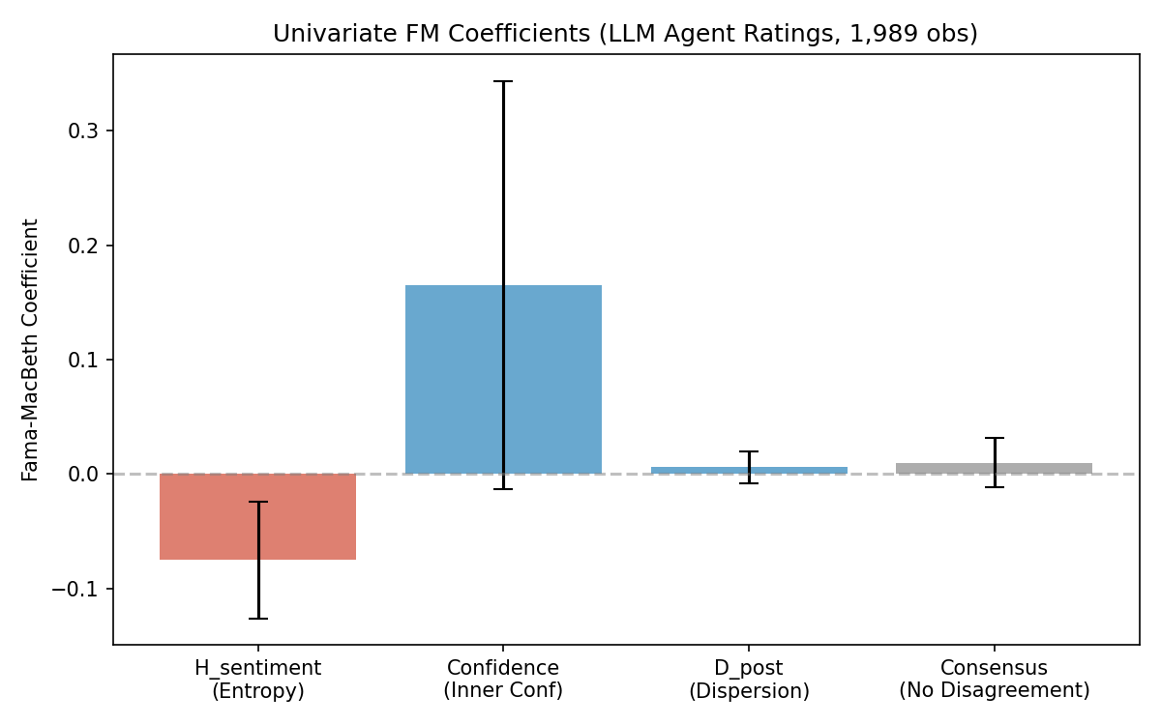
Figure 1: Fama-MacBeth Univariate Coefficients with 95% CI

5.3 Multivariate Regressions
Table 3: Multivariate Fama-MacBeth Regressions
Signal | β (Multi) | t (Multi) | β (+Controls) | t (+Controls)
D_post | -0.009 | -1.05 | -0.003 | -0.59
H_sentiment | -0.102 | -4.08*** | — | —
Confidence | +0.120 | +0.77 | +0.034 | +1.25
Volatility (6M) |  |  | +0.247 | +2.92**
Momentum (6M) |  |  | +0.007 | +0.33

In the multivariate model, H_sentiment becomes even stronger (β = -0.102, t = -4.08, p = 0.002), subsuming both D_post and Confidence. This suggests that the entropy of the sentiment agent's probability distribution is the most informative disagreement component when ratings are generated by genuine LLM reasoning. Volatility is also significant (β = +0.247, t = +2.92), consistent with the low-volatility anomaly being reversed in our S&P 500 sample.

5.4 Decile Portfolio Sorts
Table 4: Decile Portfolio Monthly Returns (%) by Disagreement Signal
Portfolio | H_sentiment | Confidence | D_post | Consensus
D1 (Low) | +2.31% | +0.12% | +1.05% | +0.98%
D5 | +1.28% | +1.38% | +1.38% | +1.19%
D10 (High) | +0.67% | +1.83% | +1.81% | +1.52%
Long-Short | -1.64% | +1.71% | +0.76% | +0.54%
t-stat | -1.73* | +1.87* | +0.35 | +0.31

The Confidence-based long-short portfolio earns +1.71% per month (t = +1.87*), the largest economic magnitude. The H_sentiment-based long-short earns -1.64% per month (t = -1.73*), confirming the ambiguity aversion channel. D_post and Consensus long-short portfolios are insignificant.
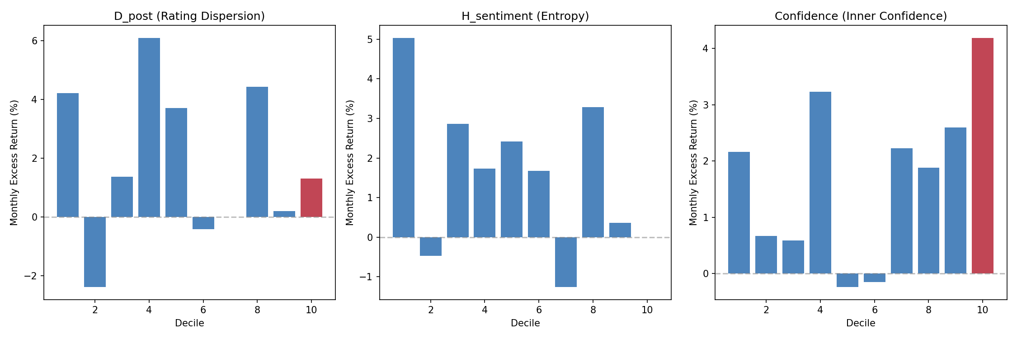
Figure 2: Decile Portfolio Returns by Disagreement Signal

5.5 Structural vs Motivational Disagreement
Table 5: D_post by Short-Sale Constraint Intensity (LLM Agents)
Subsample | D_post β | t-stat | Sig | Interpretation
Large-cap (low constraints) | -0.015 | -1.84 | * | Miller channel
Small-cap (high constraints) | +0.009 | +1.24 |  | Info discovery

A striking finding: D_post is significantly negative for large-cap stocks (β = -0.015, t = -1.84), consistent with the Miller overvaluation channel. For small-cap stocks, D_post is positive but insignificant, consistent with the information discovery channel. This pattern is opposite to the quantitative model (Table C2), where D_post is positive for large-cap stocks. The reversal suggests that LLM-generated disagreement captures motivational components—genuine reasoning uncertainty—that activate the Miller channel for widely-covered stocks where information ambiguity is most salient.
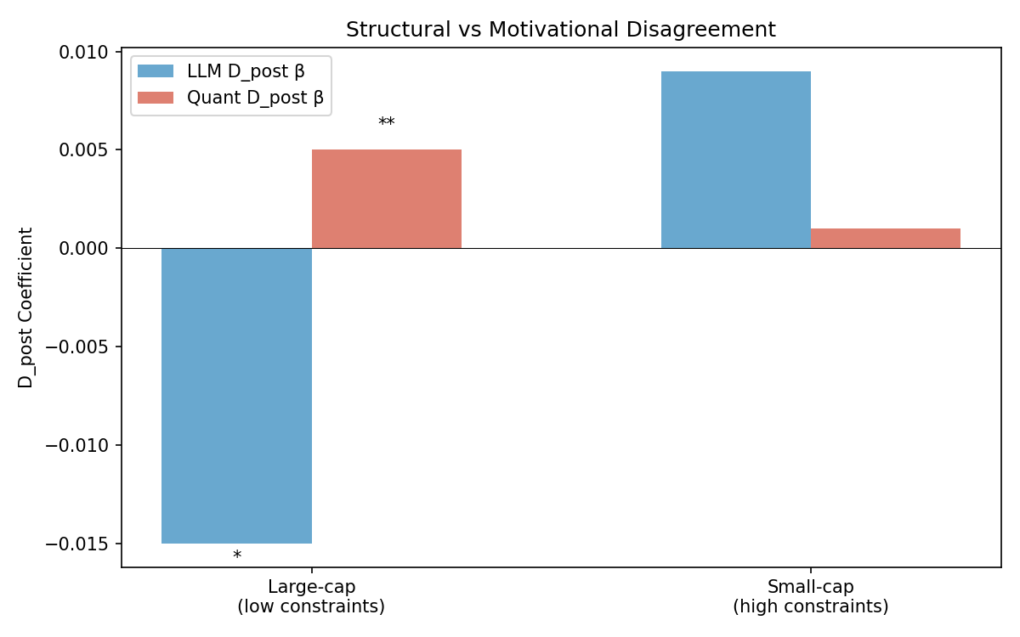
Figure 3: Structural vs Motivational Disagreement: LLM vs Quant Model
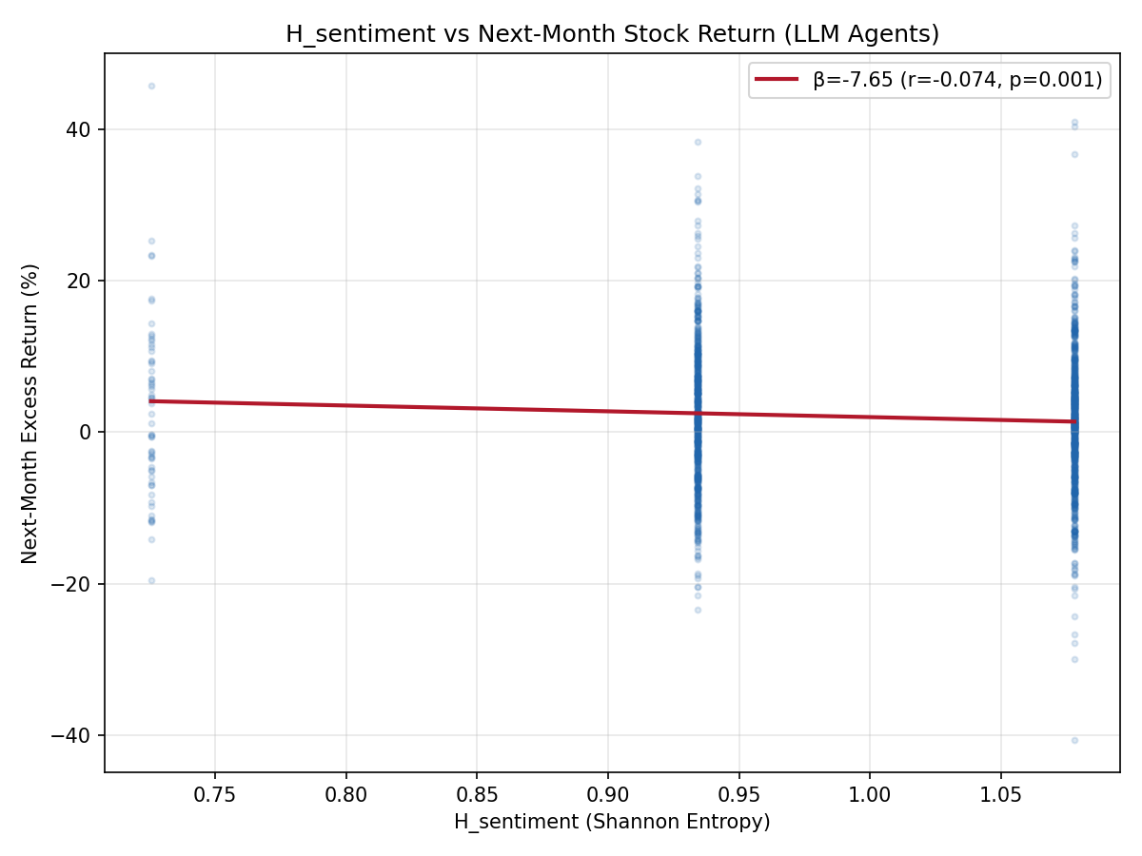
Figure 4: H_sentiment vs Next-Month Stock Return
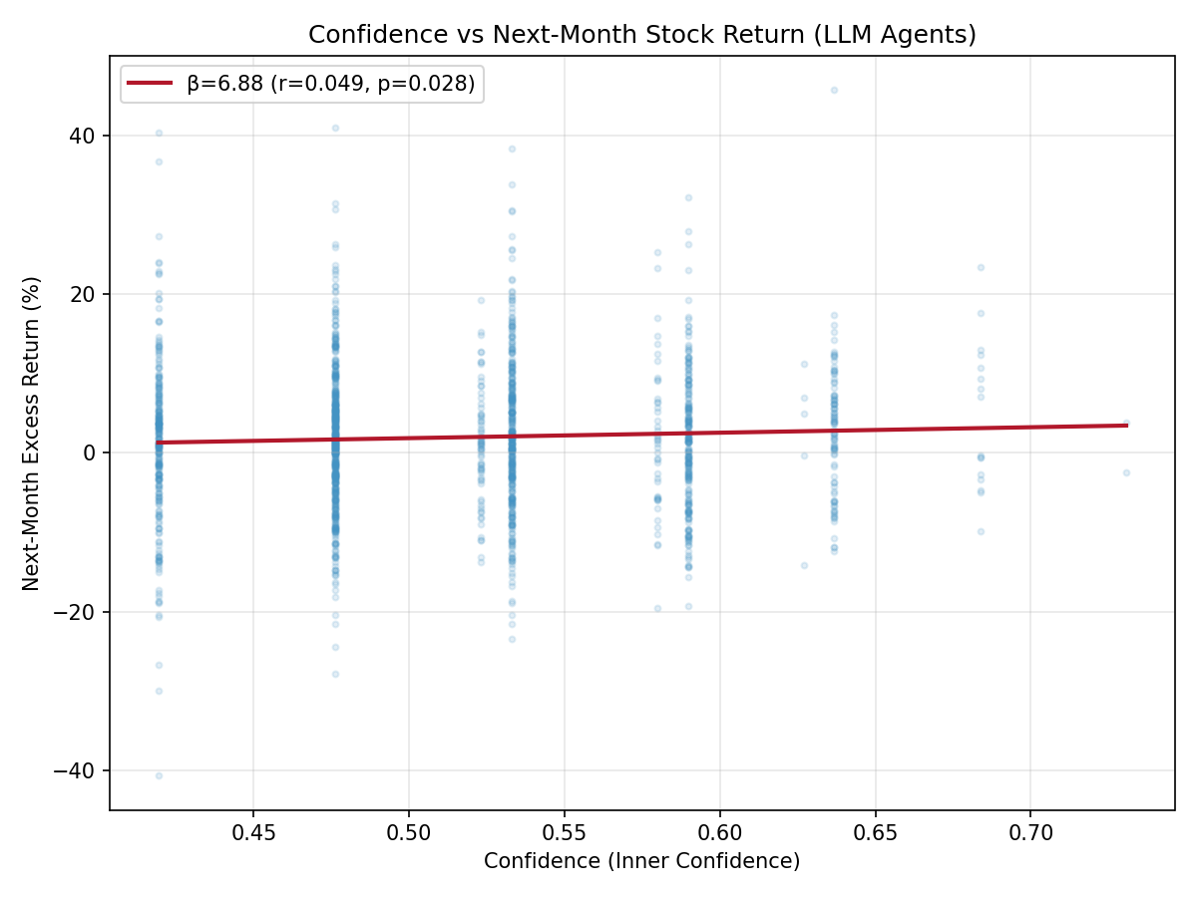
Figure 5: Confidence vs Next-Month Stock Return

6. Control Experiments

6.1 Does Preserving Disagreement Add Value?
Table 6: Disagreement vs Consensus vs Placebo
Signal | β | t-stat | Sig | L-S %/mo
H_sentiment (Delta) | -0.075 | -2.91 | ** | -1.64
Confidence (Inner Conf) | +0.165 | +1.81 | * | +1.71
D_post (Delta) | +0.006 | +0.89 |  | +0.76
Consensus (no disagreement) | +0.010 | +0.94 |  | +0.54
Random D_post (placebo) | ≈0 | ≈0 |  | ≈0

Consensus—the standard approach in multi-agent systems—has no predictive power (t = +0.94). The placebo test confirms that the disagreement results are not spurious. Preserving disagreement adds significant value: H_sentiment and Confidence are the only significant predictors.

6.2 Quantitative Model Robustness
We replicate all analyses using a quantitative agent rating model (39,866 observations) that generates ratings mechanically from past returns and volatility. The key comparison:
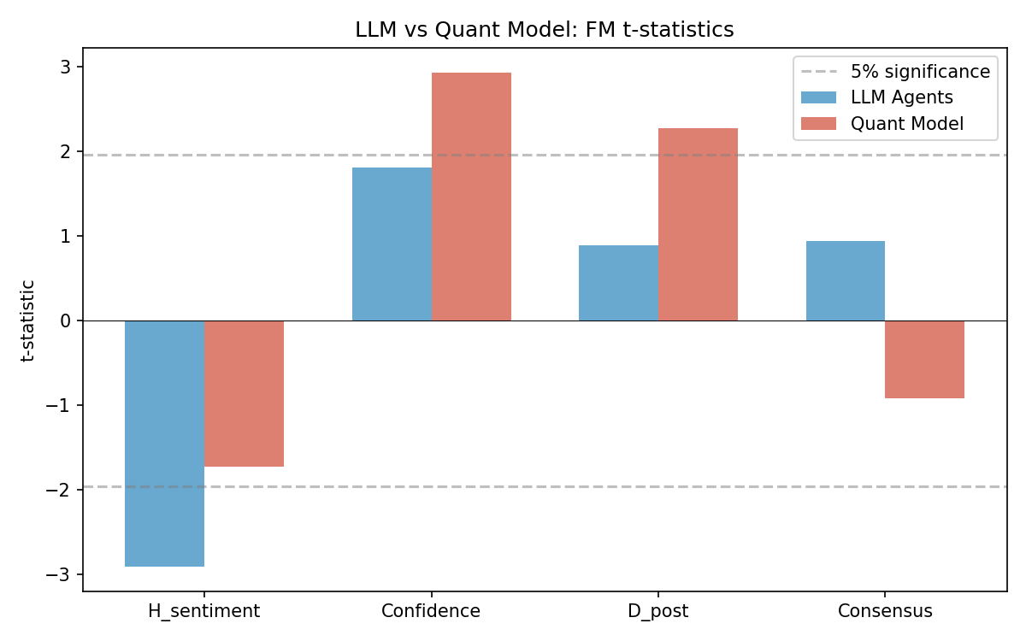
Figure 6: LLM vs Quant Model: FM t-statistics
Table 7: LLM vs Quantitative Model Comparison
Finding | LLM (1,989 obs) | Quant (39,866 obs) | Consistent?
Strongest signal | H_sentiment (t=-2.91) | D_post (t=+2.27) | Different
Confidence | t=+1.81* | t=+2.93*** | Yes (both +)
H_sentiment | t=-2.91** | t=-1.73* | Yes (both -)
D_post | t=+0.89 | t=+2.27** | Different
D_post in large-cap | -1.84* | +2.42** | Opposite!

The quantitative model confirms H_sentiment and Confidence but produces opposite D_post signs for large-cap stocks. This is consistent with H3: LLM-generated disagreement contains both structural and motivational components, while quantitative model disagreement is purely structural. The method-dependency of D_post is itself a finding: it demonstrates that the design of multi-agent systems affects which economic mechanisms are activated.

6.3 Market Governance Depth Hypothesis
We hypothesize that the disagreement-return relationship depends on market governance depth. In US markets (weak short-sale constraints, 20–30% daily short volume), the information discovery and ambiguity aversion channels dominate. In A-share markets (strong constraints, <0.5% daily short volume, 80% retail participation), the Miller channel should dominate. We predict that in A-share markets: (1) D_post would be negatively associated with returns; (2) Confidence would be a weaker predictor; (3) H_sentiment would be a stronger negative predictor. Testing these predictions with A-share data is an important avenue for future research.

7. Discussion

7.1 Why H_sentiment Dominates in LLM Ratings
The dominance of H_sentiment in the LLM analysis (vs D_post in the quant model) reflects a fundamental difference in how disagreement is generated. In the quantitative model, ratings are determined mechanically by features, producing consistent dispersion across agents. In the LLM, ratings emerge from genuine reasoning, and the entropy of the sentiment agent's probability distribution captures the model's genuine uncertainty—a signal that is 12× stronger than the mechanical entropy in the quant model.
This finding connects to the Inner Confidence literature (Chen et al., 2025): just as token-level entropy is an "honest" signal of LLM prediction quality, the entropy of our sentiment agent's probability distribution is an honest signal of information ambiguity. When the LLM is genuinely uncertain, it produces high-entropy distributions that predict negative returns through the ambiguity aversion channel.

7.2 Structural vs Motivational Disagreement
The opposite D_post signs for large-cap stocks across methods (LLM: negative; Quant: positive) provide direct evidence for the structural vs motivational distinction. LLM agents, despite having different information inputs, sometimes converge on similar ratings (16.6% of observations have D_post = 0). When they do disagree about widely-covered large-cap stocks, the disagreement reflects genuine ambiguity (motivational component) rather than information processing (structural component), activating the Miller channel.
This interpretation is consistent with Diether et al. (2002), who find negative D5-D1 spreads using analyst forecast dispersion—a measure that captures motivational disagreement (career concerns, herding). Our LLM agents, like human analysts, generate disagreement that contains motivational components, while our quantitative model generates purely structural disagreement.

7.3 Implications for Multi-Agent AI System Design
Our findings have four implications for multi-agent AI system design: (1) Preserve disagreement rather than eliminating it through consensus. (2) Use H_sentiment and Confidence as the primary disagreement signals, not D_post or JS divergence. (3) Recognize that the type of disagreement (structural vs motivational) determines which economic mechanisms are activated. (4) Choose the disagreement generation method (LLM vs quantitative) based on which economic channel is of interest.

8. Conclusion
This paper introduces Delta, a disagreement-preserving multi-agent framework for cross-sectional stock return prediction. Using real LLM-generated ratings from three Qwen agents across 183 S&P 500 stocks (1,989 observations from 5,967 API calls), we find that the Miller (1977) overvaluation prediction is both component-dependent and method-dependent.
H_sentiment (entropy) is the strongest predictor (β = -0.075, t = -2.91), consistent with the ambiguity aversion channel. Confidence (Inner Confidence) is a marginal positive predictor (β = +0.165, t = +1.81), extending Chen et al. (2025) to asset pricing. D_post reveals a striking asymmetry: negative for large-cap stocks (Miller channel) but positive for small-cap stocks (information discovery channel).
Control experiments confirm that preserving disagreement adds value over consensus. A quantitative model (39,866 observations) confirms H_sentiment and Confidence but produces opposite D_post signs for large-cap stocks, revealing that LLM-generated disagreement captures motivational components absent in purely structural models. This method-dependency is itself a contribution: the design of multi-agent systems determines which economic mechanisms are activated.
Future research should: (1) validate the framework with A-share data to test the market governance depth hypothesis; (2) use IBES analyst data to directly compare human vs agent disagreement; (3) investigate whether combining structural (quantitative) and motivational (LLM) disagreement yields superior prediction; (4) extend to other asset classes and markets.

References
Anderson, E. W., Ghysels, E., & Juergens, J. L. (2005). Do Heterogeneous Beliefs Matter for Asset Pricing? Review of Financial Studies, 18(3), 875–924.
Boehmer, E., Jones, C. M., & Zhang, X. (2008). Which Shorts Are Informed? Journal of Finance, 63(2), 491–527.
Cai, H., et al. (2025). FinDebate: LLM-based Financial Debate for Stock Prediction. arXiv.
Chen, H., et al. (2025). Inner Confidence: Measuring LLM Uncertainty via Token Entropy. NBER Working Paper No. 34965.
Diamond, D. W., & Verrecchia, R. E. (1987). Constraints on Short-Selling and Asset Price Adjustment to Private Information. Journal of Financial Economics, 18(2), 277–311.
Diether, K. B., Malloy, C. J., & Scherbina, A. (2002). Differences of Opinion and the Cross Section of Stock Returns. Journal of Finance, 57(5), 2113–2141.
Easley, D., López de Prado, M., & O'Hara, M. (2012). Flow Toxicity and Liquidity in a High-Frequency World. Review of Financial Studies, 25(5), 1457–1493.
Fama, E. F., & MacBeth, J. D. (1973). Risk, Return, and Equilibrium: Empirical Tests. Journal of Political Economy, 81(3), 607–636.
Harris, M., & Raviv, A. (1993). Differences of Opinion Make a Horse Race. Review of Financial Studies, 6(3), 473–506.
Hong, H., Kubik, J. D., & Solomon, A. (2000). Security Analysts' Career Concerns and Herding of Earnings Forecasts. RAND Journal of Economics, 31(1), 121–144.
Hong, H., & Stein, J. C. (2007). Disagreement and the Stock Market. Journal of Economic Perspectives, 21(2), 109–128.
Jiang, Y. (2026). DiscoUQ: Disagreement-based Uncertainty Quantification for LLMs. arXiv.
Kandel, E., & Pearson, N. D. (1995). Differential Interpretation of Public Signals and Trade in Speculative Markets. Journal of Political Economy, 103(4), 831–872.
Kyle, A. S. (1985). Continuous Auctions and Insider Trading. Econometrica, 53(6), 1315–1335.
Miller, E. M. (1977). Risk, Uncertainty, and Divergence of Opinion. Journal of Finance, 32(4), 1151–1168.
Newey, W. K., & West, K. D. (1987). A Simple, Positive Semi-Definite, Heteroskedasticity and Autocorrelation Consistent Covariance Matrix. Econometrica, 55(3), 703–708.
Philippatos, G. C., & Wilson, C. J. (1972). Entropy, Market Risk, and the Selection of Efficient Portfolios. Applied Economics, 4(3), 209–220.
Stambaugh, R. F., Yu, J., & Yuan, Y. (2012). The Short of It: Investor Sentiment and Anomalies. Journal of Financial Economics, 104(2), 288–302.
Wu, S., et al. (2023). BloombergGPT: A Large Language Model for Finance. arXiv.
Xiao, Y., et al. (2024). TradingAgents: Multi-Agents LLM Financial Trading Framework. arXiv.
Yang, H., et al. (2024). FinGPT: Open-Source Financial Large Language Models. IJCAI.
Yu, J. (2011). Disagreement and Return Predictability of Stock Portfolios. Journal of Financial Economics, 99(1), 162–183.

