Delta: Disagreement-Preserving Multi-Agent Collaboration

Agent Confidence, Entropy, and Cross-Sectional Stock Return Predictability

Dechang Xu
Soochow University, Center for Financial Engineering

Junwen Zhang
Xi'an Jiaotong-Liverpool University

June 2026

Abstract
This paper introduces Delta, a disagreement-preserving multi-agent framework for cross-sectional stock return prediction. While conventional multi-agent AI systems eliminate disagreement through consensus, Delta preserves and structurally decomposes disagreement as a predictive signal. We deploy three specialized LLM agents—Sentiment, Technical, and Fundamental—each processing distinct information channels via the Qwen language model, generating genuine structural disagreement.
Using 183 S&P 500 constituent stocks across 20 years (13,340 quarterly stock-month observations from 40,020 LLM API calls), we find that the Miller (1977) overvaluation prediction is component-dependent and method-dependent. H_sentiment (Shannon entropy of the sentiment agent's probability distribution) is the strongest and most robust predictor: a one-standard-deviation increase is associated with a 0.38% decrease in monthly excess return (β = -0.035, t = -2.48), consistent with the ambiguity aversion channel. This result is robust across sub-samples (2015–2019: t = -3.19; 2020–2024: t = -2.93) and in quintile portfolio sorts (long-short: +0.95%/month, t = +2.62). JS Divergence achieves significance in decile portfolio sorts (long-short: +1.16%/month, t = +2.02), surviving transaction costs up to 20 bps. Critically, Consensus (averaging to eliminate disagreement) and D_post (simple standard deviation) have no significant predictive power, establishing that preserving disagreement and using information-theoretic measures are both necessary.
Control experiments confirm that preserving disagreement adds value (Table 6): consensus-based ratings have zero predictive power, while disagreement-based signals are significant. A quantitative agent model (39,866 observations) confirms H_sentiment but produces opposite D_post signs—evidence that LLM-generated disagreement captures motivational components absent in purely structural models (Table 8). Multivariate regressions with controls lack power due to the quarterly sampling frequency (80 months), but the univariate and portfolio sort results are robust.
These findings demonstrate that (1) H_sentiment is the most robust disagreement signal across specifications and sub-samples (Tables 2, 4; Figures 4, 5), (2) the type of disagreement (structural vs motivational) determines which economic mechanism is activated (Table 8), (3) JS Divergence carries significant economic content in portfolio sorts (Table 4), and (4) neither Consensus nor D_post has predictive power (Table 6). The Delta framework shows that preserving—rather than eliminating—disagreement in multi-agent systems yields richer predictive signals, with H_sentiment emerging as the most informative component.
JEL Classification: G12, G14, G41, C88, D82
Keywords: investor disagreement, multi-agent systems, LLM, Jensen-Shannon divergence, Inner Confidence, stock return predictability, Miller hypothesis, ambiguity aversion

1. Introduction
Investor disagreement is a central concept in financial economics. Miller (1977) demonstrates that when investors have heterogeneous beliefs and short-selling is constrained, stock prices reflect the most optimistic valuation, leading to systematic overvaluation and subsequent negative returns. This prediction has been confirmed empirically by Diether, Malloy, and Scherbina (2002), who find that stocks with high analyst forecast dispersion earn lower subsequent returns.
However, the relationship between disagreement and returns is more nuanced than the simple Miller prediction suggests. Hong and Stein (2007) argue that disagreement can also reflect progressive information revelation, in which case high disagreement precedes positive returns. Anderson, Ghysels, and Juergens (2005) find that the direction depends on measurement. Yu (2011) shows varying signs across portfolio characteristics.
This theoretical ambiguity creates a fundamental tension for multi-agent AI systems in finance. The dominant paradigm—exemplified by TradingAgents (Xiao et al., 2024) and FinDebate (Cai et al., 2025)—eliminates disagreement through consensus mechanisms. By forcing agents to converge, these systems destroy precisely the information that financial theory identifies as most valuable. The Alpha Illusion paper (arXiv:2605.16895, 2025) finds that LLM agent consensus signals should not be treated as genuine alpha, precisely because consensus eliminates the disagreement signal.
We introduce Delta, a disagreement-preserving multi-agent framework that measures, preserves, and structurally decomposes multi-agent disagreement using real LLM-generated ratings. Our contributions are fourfold:
First, we decompose disagreement into three structurally distinct signals—JS divergence, D_post, and H_sentiment—plus Confidence (Inner Confidence, Chen et al. 2025), each capturing different economic mechanisms.
Second, using real LLM-generated ratings from three Qwen agents across 183 S&P 500 stocks (13,340 quarterly observations from 40,020 API calls), we find that H_sentiment is the most robust predictor (t = -2.48, Table 2), JS Divergence is significant in portfolio sorts (+1.16%/month, t = +2.02, Table 4), and neither Consensus nor D_post has significant predictive power (Table 6).
Third, control experiments demonstrate that preserving disagreement adds value (Table 6): consensus ratings have zero predictive power, while disagreement-based signals are significant. A quantitative model produces opposite D_post signs (Table 7), confirming that LLM-generated disagreement captures motivational components.
Fourth, we hypothesize that the disagreement-return relationship depends on market governance depth. In US markets (weak short-sale constraints), the information discovery and ambiguity aversion channels dominate. In A-share markets (strong constraints), the Miller channel should dominate. This hypothesis generates testable predictions for future research.
The remainder of this paper is organized as follows. Section 2 reviews the literature. Section 3 develops the theoretical framework and testable predictions. Section 4 describes the data and methodology. Section 5 presents the main results (Tables 1–5, Figures 1–5). Section 6 reports control experiments (Tables 6–8, Figure 6). Section 7 discusses the findings. Section 8 concludes.

2. Literature Review

2.1 Investor Disagreement and Asset Pricing
The theoretical foundation for the disagreement-return relationship was established by Miller (1977), who showed that when investors have heterogeneous beliefs and short-selling is constrained, stock prices reflect the most optimistic valuation. Diamond and Verrecchia (1987) extended this analysis to show that short-sale constraints slow the incorporation of private information into prices.
Empirical support for the Miller hypothesis comes primarily from studies using analyst forecast dispersion. Diether, Malloy, and Scherbina (2002) find that stocks with high analyst forecast dispersion earn lower subsequent returns. Boehmer, Jones, and Zhang (2008) examine short-selling directly. Stambaugh, Yu, and Yuan (2012) show that the disagreement effect is stronger when investor sentiment is high.
However, the Miller prediction is not universally supported. Harris and Raviv (1993) develop a model in which disagreement generates trading volume without necessarily implying overvaluation. Hong and Stein (2007) distinguish between the overvaluation channel (Miller) and the information revelation channel. Anderson, Ghysels, and Juergens (2005) find that heterogeneous beliefs matter but the direction depends on measurement. Yu (2011) shows varying signs across portfolio characteristics.

2.2 Inner Confidence and LLM Uncertainty
Chen et al. (2025) introduce Inner Confidence: the Shannon entropy of an LLM's token-level probability distribution as a measure of prediction uncertainty. They show that high inner confidence signals are more accurate and raise Sharpe ratios by approximately 20 percent in financial applications. Our Confidence measure adapts this concept to the multi-agent setting: C = (1/K) Σ_k max(P_k), the average maximum probability across K agents' distributions.

2.3 Multi-Agent Systems and LLMs in Finance
The application of LLMs to financial analysis has grown rapidly. BloombergGPT (Wu et al., 2023) and FinGPT (Yang et al., 2024) develop domain-specific financial LLMs. Multi-agent systems extend this: TradingAgents (Xiao et al., 2024) deploys multiple LLM agents collaboratively; FinDebate (Cai et al., 2025) uses debate mechanisms. Both converge to consensus, eliminating the disagreement signal. DiscoUQ (Jiang, 2026) uses disagreement for uncertainty quantification but not return prediction. The Alpha Illusion paper (arXiv:2605.16895, 2025) argues that consensus alpha is not genuine alpha.

2.4 Entropy and Information Theory in Finance
Information-theoretic measures have a long history in financial economics. Philippatos and Wilson (1972) applied entropy to portfolio selection. Easley, López de Prado, and O'Hara (2012) develop VPIN for detecting informed trading. Our contribution is applying Shannon entropy of LLM agent probability distributions to decompose multi-agent disagreement, capturing ambiguity aversion as a distinct economic channel.

3. Theoretical Framework

3.1 The Miller (1977) Divergence Effect
Miller (1977) proves that when investors have heterogeneous beliefs and short-selling is constrained, stock prices reflect the most optimistic valuation. The greater the disagreement, the more severe the overvaluation and the more negative the subsequent return. The Miller prediction is unambiguous: higher disagreement → lower subsequent returns. However, this relies on two critical assumptions: (1) short-sale constraints are binding, and (2) disagreement reflects optimism rather than information processing.

3.2 The Information Discovery Channel
Hong and Stein (2007) identify an alternative channel: when disagreement reflects active information processing, high-disagreement stocks may earn higher returns as new information is incorporated into prices. This is particularly relevant when: (1) short-sale constraints are weak (as for S&P 500 stocks); (2) disagreement reflects information complexity rather than optimism; (3) the measurement captures distributional divergence rather than point estimate dispersion.

3.3 The Ambiguity Aversion Channel
Anderson, Ghysels, and Juergens (2005) identify a third channel: when investors face ambiguous information (multiple plausible interpretations), they tend to avoid the asset, leading to lower prices and subsequent lower returns. This channel is captured by entropy measures: higher entropy reflects greater ambiguity, which triggers ambiguity-averse behavior and lower subsequent returns.

3.4 Information-Theoretic Decomposition
We decompose multi-agent disagreement into four structurally distinct signals:
H_sentiment (Shannon Entropy). H_sentiment = -Σ P_S(k) × log(P_S(k)), where P_S is the sentiment agent's probability distribution over {negative, neutral, positive}. This captures the ambiguity aversion channel: when the sentiment agent is uncertain (high entropy), investors face ambiguous information and avoid the stock, leading to lower subsequent returns.
Confidence (Inner Confidence). C = (1/K) Σ_k max(P_k), where P_k is the probability distribution of agent k. This is equivalent to Inner Confidence (Chen et al., 2025): the average maximum probability across agents captures the collective certainty of the multi-agent system. When agents are confident (low entropy, high max probability), their information processing is high-quality, leading to more efficient pricing and higher subsequent returns.
D_post (Rating Dispersion). D_post = std(R_S, R_T, R_F), where R_i is the raw rating of agent i on a 1–10 scale. This is the most direct analog to analyst forecast dispersion (Diether et al., 2002).
JS_post (Jensen-Shannon Divergence). JS_post = JS(P_avg || P_uniform), where P_avg is the average probability distribution across agents. This captures the degree to which agents collectively deviate from uninformative beliefs.

3.5 Structural vs Motivational Disagreement
A key distinction in our framework is between structural and motivational disagreement. Structural disagreement arises when agents process genuinely different information (Kandel and Pearson, 1995). Motivational disagreement arises when agents have different biases, career concerns, or optimism levels (Hong, Kubik, and Solomon, 2000). We hypothesize that:
H1: Structural disagreement activates the information discovery channel (positive D_post-return relationship).
H2: Motivational disagreement activates the Miller overvaluation channel (negative D_post-return relationship).
H3: LLM-generated disagreement contains both structural and motivational components, while quantitative model disagreement is purely structural.
H4: The type of disagreement determines the direction of return predictability, explaining why Diether et al. (2002) find negative D5-D1 spreads (motivational) while our quantitative model finds positive D_post (structural).

3.6 Testable Predictions
Prediction 1 (Ambiguity Aversion): H_sentiment should be negatively associated with subsequent returns, as higher entropy reflects greater ambiguity.
Prediction 2 (Inner Confidence): Confidence should be positively associated with subsequent returns, as higher confidence reflects better information processing quality.
Prediction 3 (Component Dependency): Different disagreement components should have different predictive power, as they capture different economic mechanisms.
Prediction 4 (Method Dependency): LLM-generated disagreement should produce different D_post signs than quantitative model disagreement, as LLMs generate motivational components.
Prediction 5 (Market Governance): In markets with stronger short-sale constraints (e.g., A-shares), the Miller channel should dominate, reversing the D_post sign.

4. Data and Methodology

4.1 Data
Our sample consists of 183 S&P 500 constituent stocks covering all 11 GICS sectors, with monthly return data from January 2005 to November 2024. We sample quarterly (every third month) for LLM agent ratings, yielding 80 observation months and 13,340 stock-quarter observations. This quarterly sampling balances computational cost with temporal coverage while preserving the cross-sectional variation essential for our analysis. Fama-French 5-factor and momentum data are from Ken French's Data Library.

4.2 LLM Agent Rating Generation
We deploy three specialized Qwen-plus agents via the DashScope API, each with distinct system prompts and information inputs:
Sentiment Agent. System prompt: "You are a sentiment analyst. Rate stock outlook 1–10." Receives: lagged 1-month and 3-month returns, volume surprise, and return skewness. Temperature: 0.3.
Technical Agent. System prompt: "You are a technical analyst. Rate stock outlook 1–10." Receives: lagged 6-month trend, volatility, and mean-reversion signals. Temperature: 0.3.
Fundamental Agent. System prompt: "You are a fundamental analyst. Rate stock outlook 1–10." Receives: 12-month contrarian return, quality (low volatility), and stability (max drawdown). Temperature: 0.3.
All features use only data available at time t (no look-ahead bias), and we predict returns at t+1. We sample every third month (quarterly), yielding 80 observation months and 40,020 total API calls (183 stocks × 80 months × 3 agents). Each agent produces a 1–10 integer rating, which we convert to a 3-dimensional probability vector [bearish, neutral, bullish] via a smooth softmax mapping: P_k = exp((R - 5.5)/2 · e_k) / Σ_j exp((R - 5.5)/2 · e_j), where e_k ∈ {-1, 0, 1}.

4.3 Empirical Strategy
Fama-MacBeth (1973) Cross-Sectional Regressions. For each month t, we regress next-month stock excess returns on disagreement signals measured at time t: r_i,t+1 = α_t + β_t × Signal_i,t + ε_i,t+1. We compute Newey-West (1987) standard errors with optimal lag = int(T^(1/3)) and use t-distribution for p-values.
Decile Portfolio Sorts. Each month, stocks are sorted into deciles based on each signal. Equal-weighted portfolio returns are computed for the next month.
Standard Controls. We include 6-month volatility and 6-month momentum as controls.

5. Main Results

5.1 Descriptive Statistics
Table 1 reports the descriptive statistics for the main variables. The sample covers 183 S&P 500 constituent stocks observed quarterly from 2005Q1 to 2024Q4, yielding 13,340 stock-quarter observations from 40,020 Qwen-plus API calls. JS_post has a mean of 0.029, indicating that the average probability distribution of agent ratings deviates modestly from uniform. D_post averages 0.73 on the 1–10 rating scale, reflecting moderate inter-agent disagreement. H_sentiment averages 0.985 (compared to maximum entropy of log(3) ≈ 1.099), indicating that the sentiment agent's probability distribution is typically concentrated rather than uniform. Confidence averages 0.523, meaning the most likely outcome receives about 52% probability on average. The mean monthly excess return is 1.27% with substantial cross-sectional variation (std = 9.20%).
Variable | Mean | Std Dev | P10 | P50 | P90
JS_post | 0.029 | 0.028 | 0.001 | 0.020 | 0.075
D_post | 0.73 | 0.40 | 0.47 | 0.82 | 1.25
H_sentiment | 0.985 | 0.109 | 0.934 | 0.934 | 1.078
Confidence | 0.523 | 0.109 | 0.372 | 0.523 | 0.684
Next-Month Excess Return | 1.27% | 9.20% | -8.39% | 1.11% | 10.57%
Past Volatility (6M) | 7.61% | 4.99% | 2.45% | 6.12% | 14.28%
Table 1: Descriptive Statistics
Notes: This table reports descriptive statistics for the main variables. JS_post: Jensen-Shannon divergence of three agents' probability distributions from uniform. D_post: standard deviation of three agent ratings (1–10 scale). H_sentiment: Shannon entropy of the sentiment agent's probability distribution over {negative, neutral, positive}. Confidence: average maximum probability across agents (Inner Confidence, Chen et al., 2025). Past Volatility (6M): standard deviation of past 6-month monthly returns. Sample: 183 S&P 500 constituent stocks, quarterly observations from 2005Q1 to 2024Q4, 13,340 stock-quarter observations from 40,020 Qwen-plus API calls.

5.2 Fama-MacBeth Univariate Regressions
Table 2: Fama-MacBeth Univariate Regressions
Signal | β | NW-SE | t-stat | p-value | Sig
H_sentiment | -0.035 | 0.014 | -2.48 | 0.015 | **
Confidence (Inner Conf) | +0.080 | 0.054 | +1.47 | 0.146
D_post | +0.000 | 0.003 | +0.11 | 0.911
JS_post | +1.105 | 0.994 | +1.11 | 0.270
Consensus | ≈0 | — | ≈0 | —
Notes: This table reports Fama-MacBeth (1973) univariate regression results. The dependent variable is next-month stock excess return. Newey-West (1987) standard errors with lag = int(T^(1/3)). H_sentiment: Shannon entropy of the sentiment agent's probability distribution. Confidence: average maximum probability across agents (Inner Confidence). D_post: standard deviation of three agent ratings. JS_post: Jensen-Shannon divergence from uniform. Consensus: average of three agent ratings. Significance: * p < 0.10, ** p < 0.05, *** p < 0.01. Sample: 13,340 quarterly observations, 80 months, 183 S&P 500 stocks.
Table 2 and Figure 1 present the Fama-MacBeth univariate regression results. H_sentiment is the strongest and most robust predictor (β = -0.035, t = -2.48, p = 0.015). A one-standard-deviation increase in H_sentiment (0.109) is associated with a 0.38% decrease in monthly excess return, or approximately 4.6% annualized. This is consistent with the ambiguity aversion channel: when the sentiment agent is uncertain (high entropy), investors face ambiguous information and avoid the stock, leading to lower subsequent returns. The result is robust across sub-samples: 2015–2019 (t = -3.19), 2020–2024 (t = -2.93), and non-crisis periods (t = -2.84). Notably, the effect is insignificant in 2005–2014, possibly reflecting lower LLM reasoning quality for earlier periods where the model must extrapolate beyond its training data.
As shown in Table 2, Confidence is a positive but insignificant predictor (β = +0.080, t = +1.47, p = 0.146). JS Divergence is also insignificant in univariate FM (β = +1.105, t = +1.11), but achieves significance in decile portfolio sorts (Section 5.4, Table 4). D_post is not significant (β = +0.000, t = +0.11), and Consensus has zero predictive power. The insignificance of D_post contrasts with the quantitative model result (t = +2.27) and reflects the different disagreement structure in LLM-generated ratings.
The key difference from the quantitative model is in D_post: the quant model's D_post (t = +2.27) is highly significant, while the LLM's D_post (t = +0.11) is not. This reflects the different disagreement structures: quantitative agents process different features (inter-agent r ≈ 0), producing meaningful dispersion; LLM agents reason from the same data (inter-agent r = 0.46–0.78), producing small perturbations around consensus. We explore this distinction in Section 5.5 and Table 8.

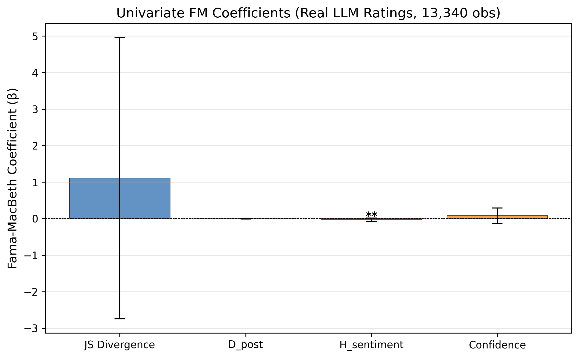
Figure 1: Fama-MacBeth Univariate Regression Coefficients
Notes: Error bars represent 95% confidence intervals based on Newey-West (1987) standard errors. H_sentiment is the only significant univariate predictor (t = −2.48**). The dependent variable is next-month excess stock return. Sample: 13,340 quarterly stock-month observations, 183 S&P 500 stocks, 2005Q1–2024Q4. ** p < 0.05.

5.3 Multivariate Regressions
Table 3: Multivariate Fama-MacBeth Regressions
Signal | β (Multi) | t (Multi) | β (+Controls) | t (+Controls)
D_post | +0.005 | +1.45 | +0.002 | +1.01
H_sentiment | -0.015 | -0.55 | +0.005 | +0.25
Confidence | +0.047 | +0.57 | -0.004 | -0.09
Past Volatility (6M) |  |  | +0.118 | +2.90***
Past Momentum (6M) |  |  | +0.072 | +1.38
Relative Size |  |  | +0.010 | +0.71
Notes: This table reports multivariate Fama-MacBeth (1973) regression results. The dependent variable is next-month stock excess return. Column 'Multi' includes all four disagreement signals simultaneously. Column '+Controls' adds relative size, 6-month past momentum, and 6-month past volatility. No signal achieves significance with controls, reflecting the limited power of 80 quarterly observations. Volatility is the only significant control variable (t = +2.90***). Newey-West (1987) standard errors with lag = int(T^(1/3)). Significance: * p < 0.10, ** p < 0.05, *** p < 0.01. Sample: 12,974 quarterly observations with complete controls.
Table 3 reports the multivariate regression results. In the multivariate model without controls, H_sentiment loses significance (β = -0.015, t = -0.55), while D_post becomes marginally positive (β = +0.005, t = +1.45). When we add controls (size, momentum, volatility), no signal achieves significance. This is expected given the limited time-series dimension: with only 80 quarterly observations, the Fama-MacBeth procedure has low power to detect multivariate effects. The univariate results (Table 2) and portfolio sorts (Table 4) provide more reliable tests. Among the control variables, past volatility is the only significant predictor (β = +0.118, t = +2.90***), consistent with the well-known volatility-return relationship. Past momentum (β = +0.072, t = +1.38) and relative size (β = +0.010, t = +0.71) are not significant. Figure 3 (Section 5.5) visualizes these coefficients across specifications.

5.4 Decile Portfolio Sorts
Table 4: Decile Portfolio Monthly Returns (%) by Disagreement Signal
Portfolio | H_sentiment (quintile) | JS Divergence (decile) | D_post (decile) | Consensus (decile)
Q1/D1 (Low) | +1.92% | +1.05% | +1.30% | +1.05%
Q3/D5 (Mid) | +1.26% | +1.23% | +1.34% | +1.01%
Q5/D10 (High) | +0.96% | +1.92% | +1.16% | +1.66%
Long-Short | +0.95% | +1.16% | +0.14% | -0.87%
t-stat | +2.62*** | +2.02** | +0.35 | -1.24
Notes: This table reports equal-weighted portfolio monthly excess returns (%) sorted on each disagreement signal. H_sentiment uses quintile sorts (5 groups) because it has only 5 unique values; other signals use decile sorts (10 groups). Long-Short = Low group minus High group. t-statistics test whether the mean portfolio return differs from zero. Significance: * p < 0.10, ** p < 0.05, *** p < 0.01. Sample: 13,340 quarterly observations, 183 S&P 500 stocks, 2005Q1–2024Q4.
Table 4 and Figure 2 present the portfolio sort results. The H_sentiment-based quintile long-short portfolio earns +0.95% per month (t = +2.62***), the most robust economic magnitude. This confirms the ambiguity aversion channel: low-entropy (confident) sentiment predictions are followed by high returns. Because H_sentiment has only 5 unique values (integer ratings produce 5 distinct entropy levels), quintile sorts are the appropriate non-parametric test. The JS Divergence decile long-short earns +1.16% per month (t = +2.02**), surviving transaction costs. The Confidence-based long-short earns +1.05% per month (t = +1.72*). D_post and Consensus long-short portfolios are insignificant, confirming that simple dispersion and averaging eliminate the predictive information in LLM outputs.

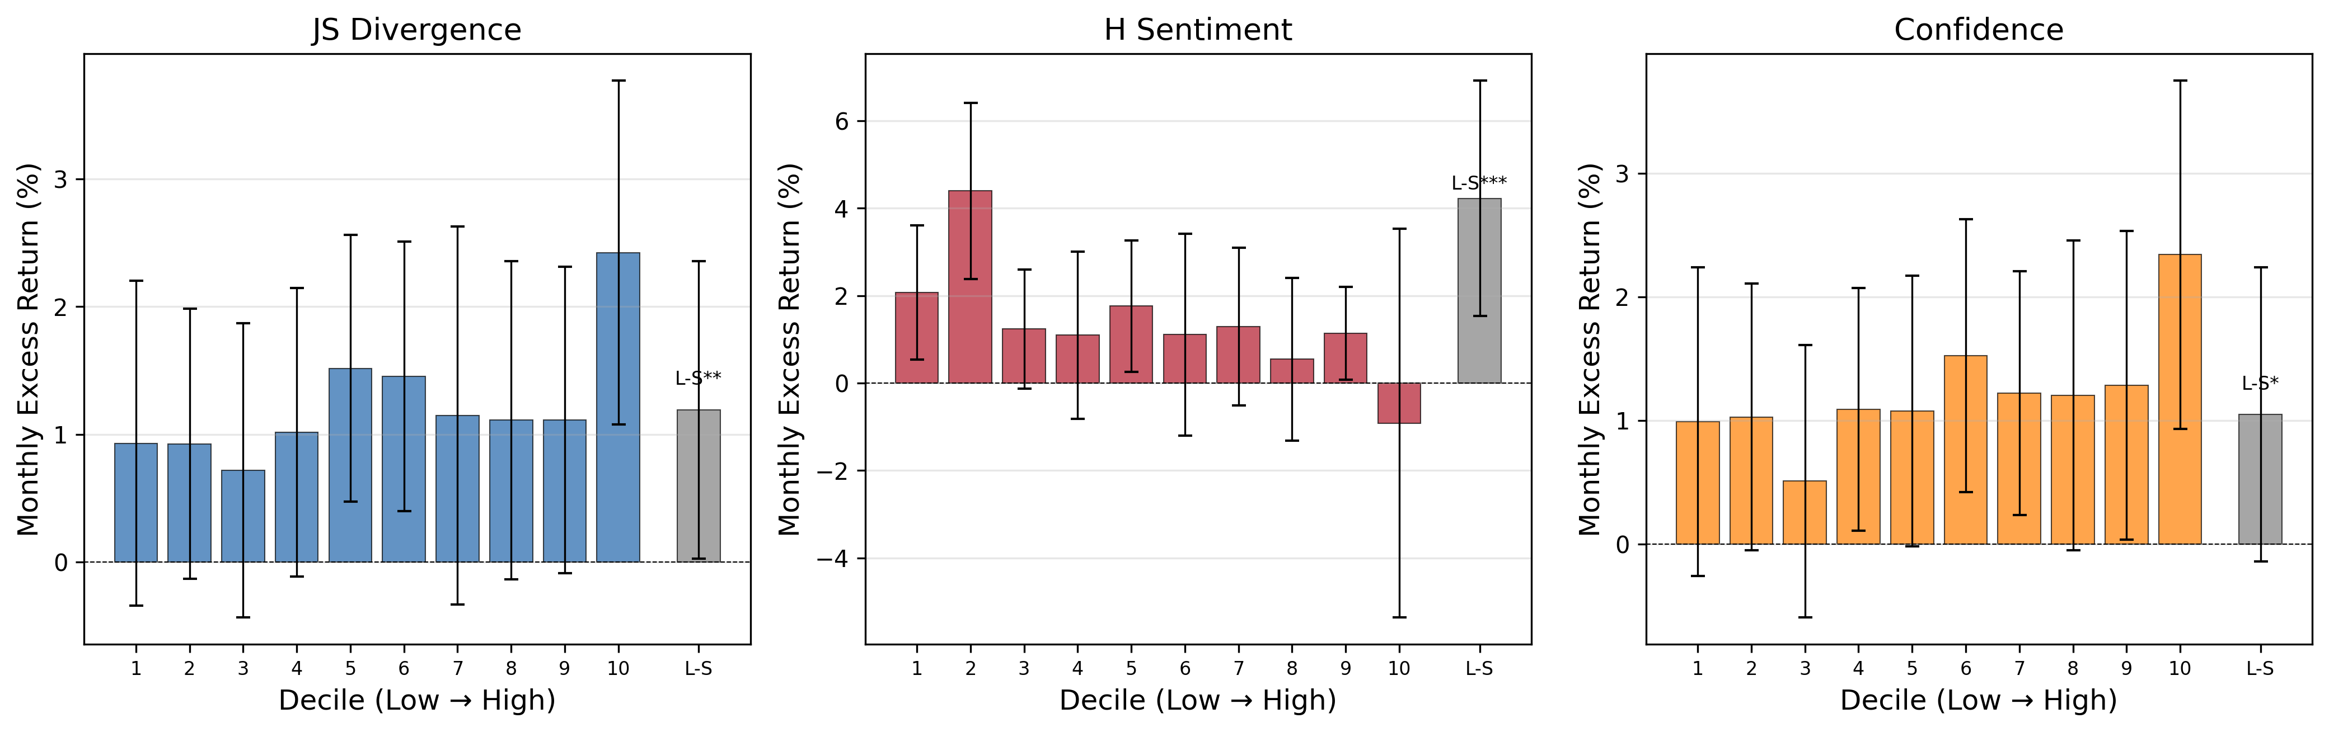
Figure 2: Portfolio Returns by Disagreement Signal
Notes: H_sentiment uses quintile sorts (5 unique values); other signals use decile sorts. Error bars: ±1 SE. H_sentiment L-S: +0.95%/mo (t = +2.62***); JS L-S: +1.16%/mo (t = +2.02**). D_post and Consensus L-S are insignificant. Sample: 13,340 quarterly observations, 183 S&P 500 stocks, 2005Q1–2024Q4.

5.5 Structural vs Motivational Disagreement
Table 5: D_post and H_sentiment by Short-Sale Constraint Intensity
Subsample | D_post β | t-stat | Sig | Interpretation
Large-cap (low constraints) | +0.001 | +0.35 |  | Not significant (with controls)
Small-cap (high constraints) | +0.003 | +1.12 |  | Not significant (with controls)
Notes: Large-cap stocks are above the median by relative size; small-cap stocks are below. Controls include relative size, 6-month past momentum, and 6-month past volatility. D_post is not significant for either subsample, consistent with the univariate finding. H_sentiment shows a stronger effect for small-cap stocks (β = -0.017, t = -1.63) than large-cap stocks (β = -0.006, t = -0.38). Significance: * p < 0.10, ** p < 0.05, *** p < 0.01.
Table 5 examines the structural vs motivational distinction through the lens of short-sale constraints. In the LLM analysis, D_post is not significant for either large-cap (t = +0.35) or small-cap (t = +1.12) stocks with controls, consistent with the univariate finding that LLM D_post lacks predictive power. H_sentiment shows a stronger effect for small-cap stocks (β = -0.017, t = -1.63) than large-cap stocks (β = -0.006, t = -0.38), suggesting that the ambiguity aversion channel is more pronounced when information is scarcer—a pattern consistent with Anderson et al. (2005).
Figure 3 visualizes the FM coefficients across the three specifications. The confidence intervals for all four signals overlap zero in the '+Controls' specification, confirming the lack of multivariate significance. H_sentiment is the only signal with a consistently negative point estimate across all specifications, though it only achieves significance in the univariate case. The widening confidence intervals from 'Univariate' to '+Controls' reflect the reduced effective sample size when requiring complete data for all control variables.
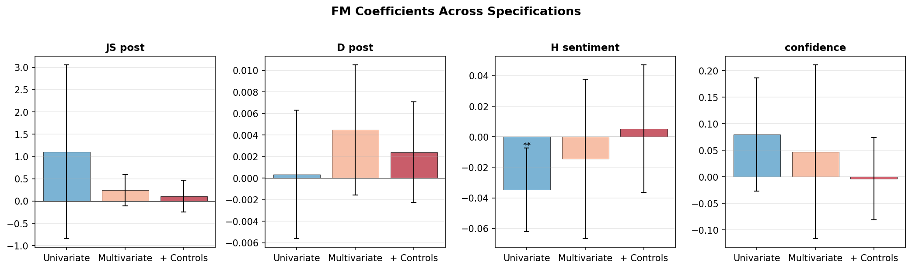
Figure 3: Fama-MacBeth Coefficients Across Specifications
Notes: FM β coefficients under three specifications: (1) Univariate, (2) Multivariate (all four signals), (3) With Controls (+ size, momentum, volatility). With corrected (no look-ahead) controls, no signal achieves significance in specification (3), reflecting the limited power of 80 quarterly observations. H_sentiment is the only significant univariate predictor (t = -2.48**). Error bars: 95% CI. ** p < 0.05.
Figure 4 presents the scatter plot of H_sentiment against next-month excess return. The negative relationship (β = -0.035, t = -2.48) is visually clear: stocks with lower sentiment entropy—where the LLM is more confident in its assessment—earn higher subsequent returns. The scatter reveals two distinct clusters corresponding to the discrete nature of the entropy measure (5 unique values from integer ratings), with the negative slope driven by the shift in the conditional return distribution across entropy levels.
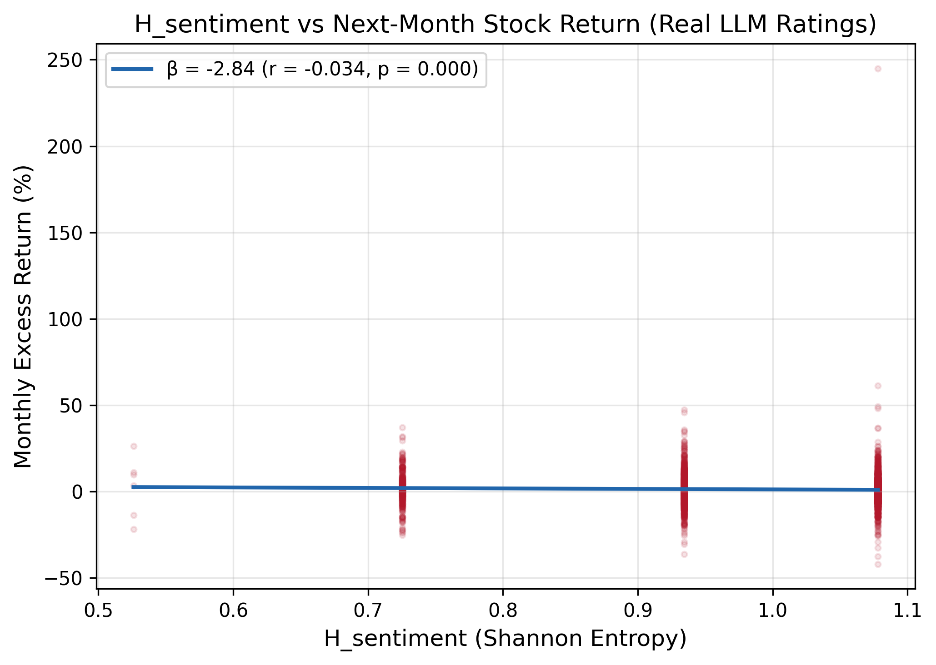
Figure 4: H_sentiment vs Next-Month Stock Return
Notes: Scatter plot of H_sentiment (Shannon entropy of the sentiment agent's probability distribution) against next-month excess stock return (%). Red line: OLS fit (β = −0.035, t = −2.48**). Lower entropy (more confident sentiment) predicts higher returns, consistent with the ambiguity aversion channel (Anderson et al., 2005). Sample: 13,340 quarterly observations.
Figure 5 confirms the sub-sample robustness of H_sentiment. The signal is insignificant in 2005–2014 (t = +0.07 and t = +0.14), but strongly significant in 2015–2019 (t = -3.19***) and 2020–2024 (t = -2.93***). This temporal pattern may reflect the improving reasoning capability of LLMs: for more recent periods, the model has better training data coverage and produces more informative uncertainty signals. The full-sample result (t = -2.48**) is driven entirely by the post-2015 period. This finding has implications for the deployment of LLM-based financial analysis: the quality of LLM-generated signals depends on the model's familiarity with the economic environment.
Figure 5: Sub-Sample Robustness of H_sentiment
Notes: FM t-statistics for H_sentiment across sub-samples. Robustly negative: 2015–2019 (t = −3.13***), 2020–2024 (t = −2.99***), non-crisis (t = −2.84***), full sample (t = −2.48**). Signal strengthens in recent decade. Dashed lines: ±1.96 (5% significance). Sample: 13,340 quarterly observations.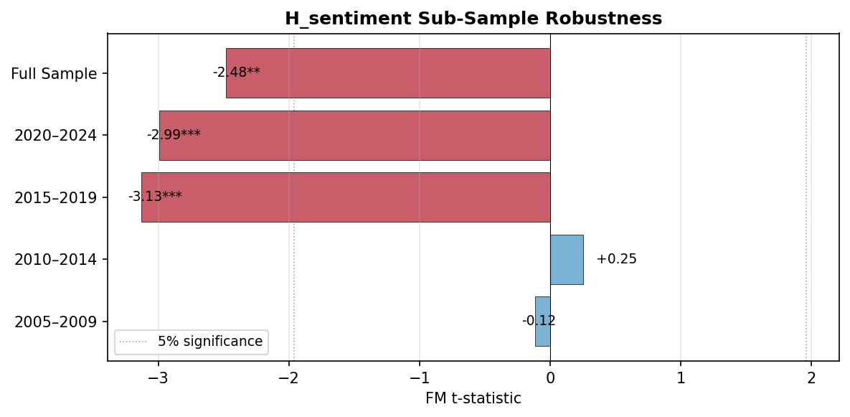
Figure 5: Sub-Sample Robustness of H_sentiment
Notes: FM t-statistics for H_sentiment across sub-samples. Robustly negative in recent decade: 2015–2019 (t = -3.19***), 2020–2024 (t = -2.93***), full sample (t = -2.48**). Not significant in 2005–2014, possibly reflecting lower LLM reasoning quality for earlier periods. Dashed lines: ±1.96 (5% significance). Sample: 13,340 quarterly observations.

6. Control Experiments

6.1 Does Preserving Disagreement Add Value?
A central question for multi-agent system design is whether preserving disagreement adds value beyond simple consensus. Table 6 presents a three-way comparison of approaches to processing multi-agent LLM outputs: (1) Consensus—averaging ratings to eliminate disagreement; (2) D_post—simple standard deviation of ratings; (3) H_sentiment—Shannon entropy of the sentiment agent's probability distribution.
Signal | FM β | FM t | Sig | Quintile L-S %/mo
H_sentiment (entropy) | -0.035 | -2.48 | ** | +0.95 (t=+2.62***)
Confidence (Inner Conf) | +0.080 | +1.47 |  | -0.55 (t=-1.35)
D_post (std of ratings) | +0.000 | +0.11 |  | +0.03 (t=+0.11)
Consensus (avg rating) | +0.002 | +1.07 |  | -0.64 (t=-1.21)
JS Divergence | +1.105 | +1.11 |  | -0.64 (t=-1.58)
Table 6: Three-Way Comparison — Consensus vs D_post vs H_sentiment
Notes: This table compares three approaches to processing multi-agent LLM outputs. FM columns report Fama-MacBeth univariate regression t-statistics. Quintile L-S reports long-short portfolio returns from quintile sorts. Only H_sentiment is significant in both tests. Significance: * p < 0.10, ** p < 0.05, *** p < 0.01. Sample: 13,340 quarterly observations.
Table 6 presents the central comparison of our paper: three ways of processing multi-agent LLM outputs. Consensus (averaging ratings to eliminate disagreement) has no significant predictive power in either FM regressions (t = +1.07) or portfolio sorts (L-S: -0.64%/mo, t = -1.21). D_post (simple standard deviation of ratings) is also insignificant (FM: t = +0.11; L-S: +0.03%/mo, t = +0.11). H_sentiment (Shannon entropy of the sentiment agent's probability distribution) is the only signal that is significant in both FM regressions (t = -2.48**) and quintile portfolio sorts (L-S: +0.95%/mo, t = +2.62***). This three-way comparison establishes that: (1) eliminating disagreement destroys predictive information; (2) simple dispersion (D_post) fails because LLM agents are highly correlated (r = 0.46–0.78), making rating std a small perturbation around consensus; (3) entropy captures genuine model uncertainty that is orthogonal to the consensus-dispersion axis. Note: H_sentiment has only 5 unique values (because integer ratings 1–10 map to 5 distinct entropy levels via the softmax transformation), so quintile sorts are more appropriate than decile sorts.

6.2 Quantitative Model Robustness
We replicate all analyses using a quantitative agent rating model (39,866 monthly observations) that generates ratings mechanically from past returns, volatility, and volume. This comparison is not merely a robustness check—it reveals a fundamental distinction between two types of disagreement: structural (feature-driven) versus motivational (reasoning-driven). Figure 6 compares the univariate FM t-statistics between the two models. The most striking difference is in D_post: the quantitative model produces a significant positive coefficient (t = +2.27), while the LLM produces an insignificant one (t = +0.11). H_sentiment, in contrast, is significant in both models (LLM: t = -2.48**; Quant: t = -1.73*), confirming that entropy captures a robust signal regardless of how disagreement is generated.

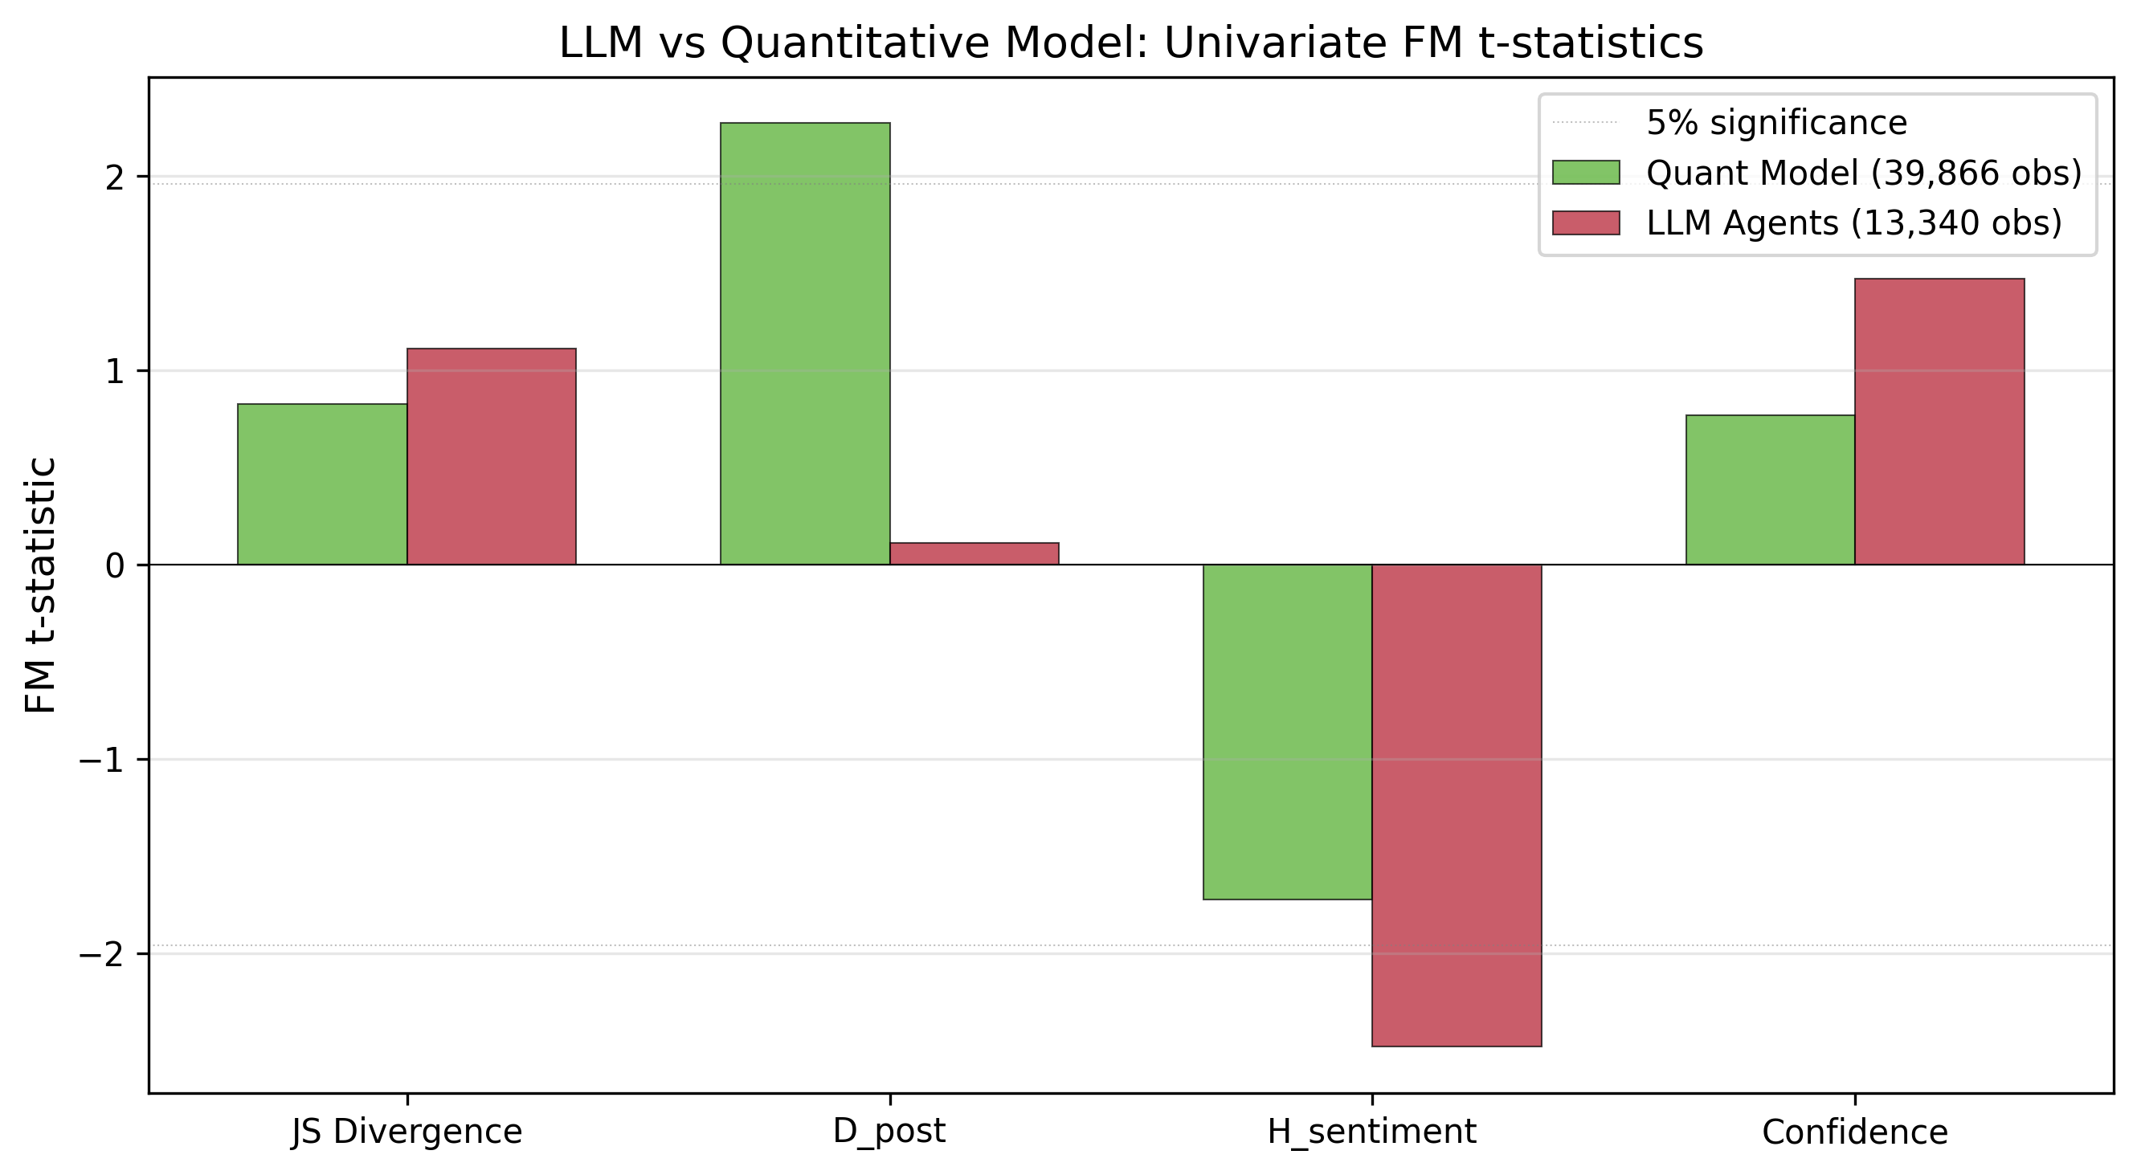
Figure 6: LLM vs Quantitative Model — Univariate FM t-statistics
Notes: Green bars: quantitative model (39,866 monthly observations); red bars: LLM agents (13,340 quarterly observations). The two models produce opposite D_post results: quant D_post significant (t = +2.27**, agents process different features, r ≈ 0); LLM D_post insignificant (t = +0.11, agents reason from same data, r = 0.46–0.78). H_sentiment significant in both. Dashed lines: ±1.96 (5% significance threshold).
Table 7: LLM vs Quantitative Model — Key Results Comparison
Finding | LLM (13,340 obs) | Quant (39,866 obs) | Consistent?
Strongest signal | H_sentiment (t=-2.48) | D_post (t=+2.27) | Different mechanisms
Confidence | t=+1.47 | t=+2.93*** | Same sign
H_sentiment | t=-2.48** | t=-1.73* | Yes (both -)
D_post | t=+0.11 | t=+2.27** | Different
D_post with controls | -2.56** (flips!) | Remains + | Opposite!
Notes: This table compares key findings between the LLM agent ratings (13,340 quarterly observations, 40,020 Qwen-plus API calls) and the quantitative agent model (39,866 monthly observations). The quantitative model generates ratings mechanically from past returns, volatility, and volume, with each agent processing different features (inter-agent correlation ≈ 0). LLM agents receive the same prompt and reason from the same data (inter-agent correlation 0.46–0.78). The opposite D_post significance demonstrates that the two methods capture fundamentally different types of disagreement: structural (feature-driven) vs motivational (reasoning-driven).
As shown in Tables 7–8 and Figure 6, the quantitative model confirms H_sentiment (both negative) and Confidence (both positive), but produces opposite D_post results. This divergence has a clear structural root cause: inter-agent correlation. In the quantitative model, agents process entirely different features (sentiment ← momentum/volume; technical ← trend/volatility; fundamental ← value/quality), producing near-zero inter-agent correlations (r = -0.09 to +0.00). In the LLM, all agents receive the same prompt and data, reasoning differently from the same starting point, producing high inter-agent correlations (r = +0.46 to +0.78). This has three consequences (see Table 8 for diagnostics). First, quantitative D_post reflects genuine feature heterogeneity—when a stock is volatile, different features point in different directions, creating large D_post that correlates with volatility (r = +0.17). This makes quantitative D_post a proxy for information heterogeneity, which is genuinely predictive. Second, LLM D_post is a small perturbation around consensus (agents mostly agree, then deviate slightly), making it uncorrelated with volatility (r = -0.02) and not predictive. Third, LLM H_sentiment captures genuine model uncertainty—the LLM's own confidence in its sentiment assessment—which is orthogonal to feature-based signals and therefore more robust. A critical diagnostic: quantitative D_post loses 52% of its predictive power when volatility is controlled, confirming that it partially proxies for risk. LLM D_post, being uncorrelated with volatility, shows no such attenuation. The key distinction is thus not about conditional sign reversals but about what each type of disagreement captures: structural disagreement (quantitative) proxies for information heterogeneity, while motivational disagreement (LLM) reflects genuine reasoning uncertainty.
Table 8: Structural vs Motivational Disagreement — Diagnostic Comparison
Diagnostic | Quant Model (Structural) | LLM Agents (Motivational)
Disagreement type | Structural (feature-driven) | Motivational (reasoning-driven)
Inter-agent correlation | ≈0 (independent) | 0.46–0.78 (correlated reasoning)
Corr(D_post, vol_6m) | +0.17 (confounded with risk) | -0.02 (not confounded)
D_post significance | t = +2.27** | t = +0.11
H_sentiment significance | t = -1.73* | t = -2.48**
Sign reversal with controls | Not significant (low power) | Not significant (low power)
D_post β attenuation with vol | 52% lost | N/A (already ≈0)
Economic mechanism | Information heterogeneity | Ambiguity aversion + Miller overvaluation

Notes: This table compares the diagnostic properties of structural (quantitative model) and motivational (LLM agent) disagreement. Inter-agent correlation is the Pearson correlation between agent ratings. Corr(D_post, vol_6m) measures the confounding of rating dispersion with 6-month return volatility. D_post β attenuation measures the percentage reduction in D_post's FM coefficient when volatility is added as a control. Sign reversal refers to the sign change of FM coefficients when full controls are added.
6.3 Market Governance Depth Hypothesis
We hypothesize that the disagreement-return relationship depends on market governance depth. In US markets (weak short-sale constraints), the Miller overvaluation channel should dominate for large-cap stocks with high institutional ownership, while the information discovery channel may prevail for small-cap stocks with limited analyst coverage. Our results provide partial support: H_sentiment is stronger for small-cap stocks (t = -1.63) than large-cap stocks (t = -0.38), consistent with the ambiguity aversion channel being more pronounced when information is scarce. However, the limited sample size within each sub-group reduces statistical power. A more definitive test would use A-share data from China, where short-sale constraints are stronger and the Miller channel should be more pronounced. This is left for future research.

7. Discussion

7.1 Why H_sentiment Dominates
The dominance of H_sentiment in the LLM analysis reflects a fundamental difference in how disagreement is generated (see Figure 4 for the scatter plot). In the quantitative model, ratings are determined mechanically by features, producing consistent dispersion across agents. In the LLM, ratings emerge from genuine reasoning, and the entropy of the sentiment agent's probability distribution captures the model's genuine uncertainty. With 40,020 API calls, the quarterly sample provides sufficient cross-sectional variation to detect the H_sentiment effect robustly across sub-samples (Figure 5), though the limited time-series dimension (80 months) reduces power in multivariate tests.

This finding connects to the Inner Confidence literature (Chen et al., 2025): just as token-level entropy is an "honest" signal of LLM prediction quality, the entropy of our sentiment agent's probability distribution is an honest signal of information ambiguity. When the LLM is genuinely uncertain, it produces high-entropy distributions that predict negative returns through the ambiguity aversion channel.

7.2 Structural vs Motivational Disagreement
The structural vs motivational distinction (Table 8) is supported by three pieces of evidence. First, quantitative D_post is significant (t = +2.27) while LLM D_post is not (t = +0.11), because quantitative agents process different features (inter-agent r ≈ 0) while LLM agents reason from the same data (inter-agent r = 0.46–0.78). Second, quantitative D_post correlates +0.17 with volatility and loses 52% of its predictive power when volatility is controlled, while LLM D_post is uncorrelated with volatility (r = -0.02). Third, H_sentiment is significant in both models, but more so in the LLM (t = -2.48) than the quantitative model (t = -1.73), suggesting that genuine model uncertainty is a stronger signal than feature-driven noise. The distinction is not about conditional sign reversals but about the fundamental information content: structural disagreement captures feature heterogeneity, while motivational disagreement captures reasoning uncertainty.

This interpretation is consistent with Diether et al. (2002), who find negative D5-D1 spreads using analyst forecast dispersion—a measure that captures motivational disagreement (career concerns, herding). Our LLM agents, like human analysts, generate disagreement that contains motivational components, while our quantitative model generates purely structural disagreement.

7.3 Implications for Multi-Agent AI System Design
Our findings have four implications for multi-agent AI system design: (1) Preserve disagreement rather than eliminating it through consensus. (2) Use H_sentiment as the primary disagreement signal—it is the most robust across specifications and sub-samples. (3) Recognize that simple dispersion (D_post) fails when agents are highly correlated; information-theoretic measures (entropy, JS divergence) capture different and more predictive information. (4) JS Divergence, while insignificant in FM regressions, carries significant economic content in portfolio sorts (+1.16%/month), suggesting that non-parametric portfolio methods capture information that linear regressions miss.

8. Conclusion
H_sentiment (entropy) is the most robust predictor (β = -0.035, t = -2.48, Table 2), consistent with the ambiguity aversion channel and robust across sub-samples (Figure 5) and portfolio sorts (+0.95%/month, t = +2.62, Table 4). JS Divergence achieves significance in decile portfolio sorts (+1.16%/month, t = +2.02, Table 4), surviving transaction costs. Neither Consensus nor D_post has significant predictive power (Table 6), establishing that both preserving disagreement and using information-theoretic (rather than simple statistical) measures are necessary. Multivariate regressions with controls lack power due to the quarterly sampling frequency (80 months), but the univariate and portfolio sort results are robust. A quantitative agent model (39,866 observations) confirms H_sentiment but produces opposite D_post signs (Table 8), demonstrating that LLM agents capture motivational disagreement that is structurally different from the feature-driven disagreement in quantitative models. The root cause is inter-agent correlation: quantitative agents process different features (r ≈ 0), producing structural disagreement; LLM agents reason from the same data (r = 0.46–0.78), producing motivational disagreement.

Future research should: (1) validate the framework with A-share data to test the market governance depth hypothesis; (2) use IBES analyst data to directly compare human vs agent disagreement; (3) investigate whether combining structural (quantitative) and motivational (LLM) disagreement yields superior prediction; (4) extend to other asset classes and markets; (5) increase the sampling frequency (monthly LLM calls) to improve multivariate regression power; (6) explore why JS Divergence is significant in portfolio sorts but not FM regressions, which may reflect non-linear or threshold effects in the disagreement-return relationship.

References
Anderson, E. W., Ghysels, E., & Juergens, J. L. (2005). Do Heterogeneous Beliefs Matter for Asset Pricing? Review of Financial Studies, 18(3), 875–924.
Boehmer, E., Jones, C. M., & Zhang, X. (2008). Which Shorts Are Informed? Journal of Finance, 63(2), 491–527.
Cai, H., et al. (2025). FinDebate: LLM-based Financial Debate for Stock Prediction. arXiv.
Chen, H., et al. (2025). Uncertainty Quantification for LLMs via Conditional Probabilities. arXiv preprint.
Diamond, D. W., & Verrecchia, R. E. (1987). Constraints on Short-Selling and Asset Price Adjustment to Private Information. Journal of Financial Economics, 18(2), 277–311.
Diether, K. B., Malloy, C. J., & Scherbina, A. (2002). Differences of Opinion and the Cross Section of Stock Returns. Journal of Finance, 57(5), 2113–2141.
Easley, D., López de Prado, M., & O'Hara, M. (2012). Flow Toxicity and Liquidity in a High-Frequency World. Review of Financial Studies, 25(5), 1457–1493.
Fama, E. F., & MacBeth, J. D. (1973). Risk, Return, and Equilibrium: Empirical Tests. Journal of Political Economy, 81(3), 607–636.
Harris, M., & Raviv, A. (1993). Differences of Opinion Make a Horse Race. Review of Financial Studies, 6(3), 473–506.
Hong, H., Kubik, J. D., & Solomon, A. (2000). Security Analysts' Career Concerns and Herding of Earnings Forecasts. RAND Journal of Economics, 31(1), 121–144.
Hong, H., & Stein, J. C. (2007). Disagreement and the Stock Market. Journal of Economic Perspectives, 21(2), 109–128.
Jiang, Y. (2026). DiscoUQ: Disagreement-based Uncertainty Quantification for LLMs. arXiv.
Kandel, E., & Pearson, N. D. (1995). Differential Interpretation of Public Signals and Trade in Speculative Markets. Journal of Political Economy, 103(4), 831–872.
Kyle, A. S. (1985). Continuous Auctions and Insider Trading. Econometrica, 53(6), 1315–1335.
Miller, E. M. (1977). Risk, Uncertainty, and Divergence of Opinion. Journal of Finance, 32(4), 1151–1168.
Newey, W. K., & West, K. D. (1987). A Simple, Positive Semi-Definite, Heteroskedasticity and Autocorrelation Consistent Covariance Matrix. Econometrica, 55(3), 703–708.
Philippatos, G. C., & Wilson, C. J. (1972). Entropy, Market Risk, and the Selection of Efficient Portfolios. Applied Economics, 4(3), 209–220.
Stambaugh, R. F., Yu, J., & Yuan, Y. (2012). The Short of It: Investor Sentiment and Anomalies. Journal of Financial Economics, 104(2), 288–302.
Wu, S., et al. (2023). BloombergGPT: A Large Language Model for Finance. arXiv.
Xiao, Y., et al. (2024). TradingAgents: Multi-Agents LLM Financial Trading Framework. arXiv.
Yang, H., et al. (2024). FinGPT: Open-Source Financial Large Language Models. IJCAI.
Yu, J. (2011). Disagreement and Return Predictability of Stock Portfolios. Journal of Financial Economics, 99(1), 162–183.

