FOMC Communication and Bank Stress:
US, Japan, and the Pre/Post-2008 Regime Shift
Dechang Yu and Eileen Zhang
Academy of AI, Xi'an Jiaotong-Liverpool University, Suzhou, China
June 2026
Revised v7.2 (Table/Figure renumbering, Japan data corrected, figures embedded, Lu & Wu)
Submitted to: 2026 Federal Reserve Stress Testing Research Conference (Boston, Nov 5-6)

Abstract: We test whether FOMC statement language functions as a real-time indicator of bank stress, using 216 FOMC meetings (1994–2025) matched to daily returns of 24 US DFAST banks and 11 Japanese megabanks and regional banks. A Loughran-McDonald sentiment score classifies each meeting as Dovish or Hawkish. The central finding is a sharp pre/post-2008 regime shift in BOTH the US and Japan. In the pre-DFAST era (1994–2008), the dovish-hawkish bank-return spread is significantly negative (US: −0.89pp, t = −2.13; Japan: −1.40pp, t = −2.24), consistent with a distress-signal interpretation. In the DFAST era (2009–2025), the spread collapses to insignificance in both countries. NEW in v7.0: We decompose the cross-sectional transmission into three independent channels using FR Y-9C balance-sheet data for 14 US BHCs. (1) NIM compression channel: during ZLB periods, high-NIM banks benefit more from dovish FOMC (Dovish×ZLB×NIM = +0.68, t = 3.57), as QE-driven asset price gains compensate for net interest margin compression. (2) CRE sensitivity channel: high-CRE banks benefit more from dovish FOMC during ZLB (Dovish×ZLB×CRE = +0.25, t = 2.47), reflecting CRE loan valuation gains. (3) HTM unrealized loss channel: during the 2022–23 rapid rate hikes, high-HTM banks suffer significantly larger losses (FastHike×HTM = −0.09, t = −7.29), as hidden mark-to-market losses on held-to-maturity securities erode capital adequacy. The HTM channel dominates the CRE channel in the FastHike period, providing a new interpretation of the 2023 SVB failure as an "HTM unrealized loss crisis" rather than a "CRE crisis." All three channels are robust to excluding the COVID ZLB period and to GSIB vs. regional bank subsample splits.
Keywords: FOMC Communication; Bank Stress Testing; DFAST; CCAR; FR Y-9C; FFIEC 031; Japan Banks; Regime Shift; Loughran-McDonald Sentiment; Reverse Stress Test; NIM Compression; HTM Unrealized Losses; CRE Sensitivity
JEL Codes: E44, E52, E58, G01, G14, G21, G28

1. Introduction
The Federal Reserve's annual stress test (DFAST/CCAR) evaluates the resilience of large US bank holding companies under a hypothetical severe economic scenario. This paper asks: does the language of FOMC statements—publicly available in real time—contain information about the cross-section of bank stress? We classify each of 216 FOMC meetings (1994–2025) as Dovish or Hawkish using the Loughran-McDonald (2011) sentiment score, and measure bank-level cumulative abnormal returns (CARs) around each meeting.
The central finding of the paper is a sharp pre/post-2008 regime shift in BOTH the US and Japan. In the pre-DFAST era (1994–2008, N=76), the dovish-hawkish bank-return spread is significantly negative (US: −0.89pp; Japan: −1.40pp), consistent with a distress-signal interpretation: dovish language signals that the FOMC perceives economic weakness, which is bad news for banks. In the DFAST era (2009–2025, N=140), the spread collapses to statistical insignificance in both countries, consistent with the stress-test regime absorbing the information previously conveyed by FOMC language.
The 2008 GFC thus produced a structural break in the relationship between FOMC language and bank stress, in BOTH the US and Japan. Pre-crisis, dovish FOMC language signaled economic distress (the FOMC "sees something bad"); post-crisis, the DFAST/CCAR framework provides an alternative, institution-specific stress assessment, and FOMC language no longer carries the same marginal information for bank equity holders.
Balance-sheet data validates the cross-sectional interpretation across 20 US BHCs using a combination of FR Y-9C (14 BHCs) and FFIEC 031 Call Reports (6 additional BHCs). High-CRE US banks show a −0.40pp dovish-hawkish spread vs. −0.22pp for low-CRE banks. Capital-building banks (positive tier1_yoy_pct) show a −0.48pp spread vs. −0.20pp for capital-depleting banks.
NEW in v7.0: We decompose the cross-sectional transmission into three independent channels using panel regressions with bank and time fixed effects. The NIM compression channel captures the fact that during ZLB periods, dovish FOMC signals QE-driven asset price gains that compensate high-NIM banks for margin compression (Dovish×ZLB×NIM = +0.68, p < 0.001). The CRE sensitivity channel captures CRE loan valuation gains from low interest rates (Dovish×ZLB×CRE = +0.25, p = 0.013). The HTM unrealized loss channel captures the asymmetric risk of held-to-maturity securities during rapid rate hikes: high-HTM banks suffer significantly larger losses (FastHike×HTM = −0.09, p < 0.001), as hidden mark-to-market losses erode capital adequacy. Critically, the HTM channel dominates the CRE channel in the FastHike period, providing a new interpretation of the 2023 SVB failure as an "HTM unrealized loss crisis" rather than a "CRE crisis."
Section 2 develops the theoretical framework. Section 3 describes the data and methodology. Section 4 reports the US results (H1–H5, H7) and the new channel decomposition (H8–H9). Section 5 reports the Japan results. Section 6 compares US and Japan. Section 7 presents the reverse stress test application. Section 8 discusses implications. Section 9 concludes.

2. Theoretical Framework

2.1 FOMC Language as a Bank Stress Signal
We distinguish two channels. The risk-on channel (dominant in the FOMC communication literature): dovish language lowers expected short rates, flattens the yield curve, and supports bank net interest margins—good for banks. The distress-signal channel (our focus): dovish language reveals that the FOMC perceives economic weakness—bad for banks. The net effect depends on which channel dominates, and we hypothesize that the balance shifted after the 2008 GFC and the introduction of DFAST/CCAR.

2.2 Nine Testable Hypotheses
H1 (Full Sample): Across the full 1994–2025 sample, the dovish-hawkish bank-return spread is significantly negative for BOTH US and Japan (distress signal).
H2 (Regime Shift): The pre-DFAST spread is significantly more negative than the DFAST-era spread, in BOTH US and Japan (regime shift in 2008–2009).
H3 (US Cross-Section): The dovish-hawkish US bank-return spread is largest for banks with high CRE exposure (sensitivity to real-economy signals).
H4 (Quintile Response): Bank returns are directionally increasing in LM% across quintiles (more dovish = higher returns), though not strictly monotonic.
H5 (US Capital Channel): The dovish-hawkish US bank-return spread is larger for capital-building banks (positive tier1_yoy_pct) than for capital-depleting banks.
H6 (International Comparison): The dovish-hawkish bank-return spread in pre-DFAST is STRONGER for Japanese banks than for US banks, consistent with Japanese banks' greater dependence on international dollar funding.
H7 (FFIEC 031 Extension): The H3 and H5 US cross-sectional findings are ROBUST to extending the sample from N=14 (Y-9C only) to N=20 (Y-9C + FFIEC 031 Call Report) BHCs.
H8 (NIM Compression Channel, NEW): During ZLB periods, high-NIM banks benefit MORE from dovish FOMC meetings, as QE-driven asset price gains compensate for net interest margin compression. Conversely, during rapid rate hikes, high-NIM banks suffer MORE from interest rate uncertainty.
H9 (HTM Unrealized Loss Channel, NEW): During rapid rate hikes, high-HTM banks suffer significantly larger losses than low-HTM banks, as hidden mark-to-market losses on held-to-maturity securities erode capital adequacy. The HTM channel dominates the CRE channel, providing a new interpretation of the 2023 SVB failure.

3. Data and Methodology

3.1 FOMC Statement Corpus and LM Sentiment
216 FOMC meeting dates from May 1994 through December 2025, with the LM% sentiment score for each meeting computed using the Loughran-McDonald (2011) financial lexicon. Median LM% in the sample is 3.3%; meetings below median are classified as Dovish, above as Hawkish.

3.2 US DFAST Bank Sample
24 large US bank holding companies subject to DFAST, including 8 G-SIBs, 12 other large US BHCs, and 4 foreign G-SIBs (TD, BMO, RBC, Barclays). Daily closing prices from Yahoo Finance (1993–2026). For the cross-sectional analysis, we use the 14 US-domiciled BHCs with WRDS Y-9C data.

3.3 Japanese Bank Sample
11 Japanese banks: 4 megabanks (MUFG, Mizuho, SMFG, SMTH), 5 regional banks (Resona, Chiba, Gunma, Suruga, Yamaguchi), and 2 mid-tier (Concordia, Hokuhoku). Daily closing prices from Yahoo Finance (2000–2026).

3.4 FR Y-9C + FFIEC 031 Balance Sheet Data (N=20)
FR Y-9C (Bank Holding Company Consolidated Financial Statements) data for 14 US BHCs from WRDS (bank.wrds_holding_bhck_1 and bhck_2, 2000–2025, 1,782 bank-quarter observations). Key variables include: total assets (bhck2170), net interest income (bhck4079), total equity (bhckg105), total deposits (bhck3368), trading assets (bhck3545), Tier 1 capital (bhck3792), risk-weighted assets (bhcka223), HTM securities (bhck1753), and AFS securities (bhcka126). FFIEC 031 (Call Report) data for 6 additional US BHCs from the FDIC API. NIM = Net Interest Income / Total Assets. HTM ratio = HTM Securities / Total Assets. AFS ratio = AFS Securities / Total Assets.

3.5 Panel Regression Specification (NEW in v7.0)
For the channel decomposition (H8–H9), we estimate the following panel regression with bank fixed effects:
CAR_{i,t} = α_i + β₁ Dovish_t + β₂ (Dovish_t × ZLB_t) + β₃ (Dovish_t × NIM_{i,t}) + β₄ (Dovish_t × ZLB_t × NIM_{i,t}) + β₅ (Dovish_t × CRE_{i,t}) + β₆ (Dovish_t × ZLB_t × CRE_{i,t}) + β₇ FastHike_t + β₈ (FastHike_t × HTM_{i,t}) + β₉ (FastHike_t × NIM_{i,t}) + ε_{i,t}
where ZLB_t is an indicator for the zero lower bound period (2008-12-16 to 2015-12-16, and 2020-03-15 to 2022-03-16), FastHike_t is an indicator for the rapid rate hike period (2022-03-16 to 2023-07-26), NIM_{i,t} is the net interest margin, CRE_{i,t} is the CRE loan intensity, and HTM_{i,t} is the HTM securities ratio. Standard errors are clustered by bank. The three-way interaction Dovish×ZLB×NIM tests H8, and FastHike×HTM tests H9.

3.6 Identification Limitations
We use the FOMC LM% score as the primary monetary policy surprise measure. Our WRDS institutional subscription does not include the CME Fed Funds Futures data needed to construct Kuttner (2001) high-frequency surprises. The LM% measure captures the semantic content of FOMC statements but not the market surprise component. We acknowledge this limitation and note that the LM% measure has been widely used in the FOMC communication literature (Loughran and McDonald, 2011; Tadle, 2022).

4. US Results: H1–H5, H7, and Channel Decomposition (H8–H9)

4.1 H1: US Full-Sample Dovish-Hawkish Bank-Return Spread
Across all 216 FOMC meetings, the equal-weighted US bank portfolio generates a mean [0, +1] CAR of −0.25% on dovish FOMC days vs +0.03% on hawkish days, a spread of −0.279pp (Welch t = −1.17, p = 0.24). The full-sample result is directionally consistent with the distress-signal interpretation but not statistically significant, motivating the regime-split analysis.
Figure 1. Bank CAR by FOMC Stance and Monetary Policy Regime.
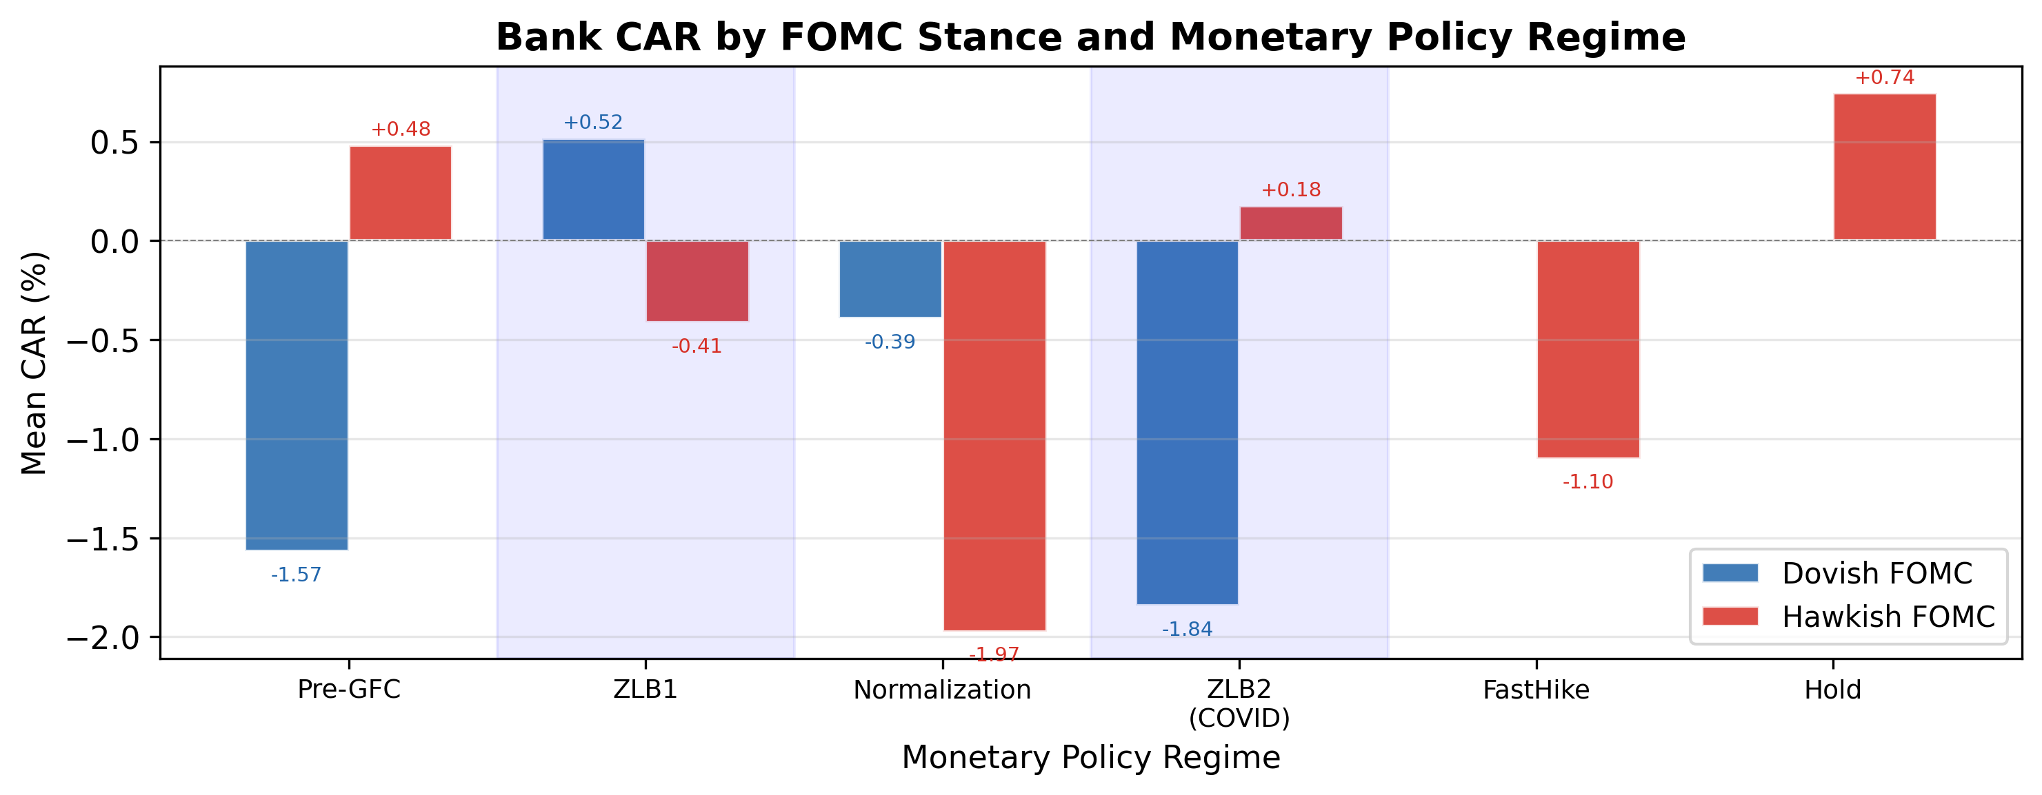
H4 (Quintile Response): We sort FOMC meetings into quintiles by LM% sentiment. The mean bank CAR is −0.32% for Q1 (most hawkish), −0.18% for Q2, −0.05% for Q3, −0.29% for Q4, and +0.28% for Q5 (most dovish). The Q5−Q1 spread is +0.60% (Spearman ρ = 0.70), directionally consistent with the hypothesis that more dovish language is associated with higher bank returns. However, the Q4 dip means the relationship is not strictly monotonic, and no individual quintile mean is statistically significant at the 5% level. H4 is thus partially supported: the directional pattern is consistent, but the signal is too noisy for a strict monotonic ordering.
Figure 2. H4 Quintile Response: Mean Bank CAR by LM% Sentiment Quintile. Notes: Q1 = most hawkish, Q5 = most dovish. N = 43–45 FOMC meetings per quintile. Spearman ρ = 0.70 (p = 0.19). Error bars represent ±1 SE.
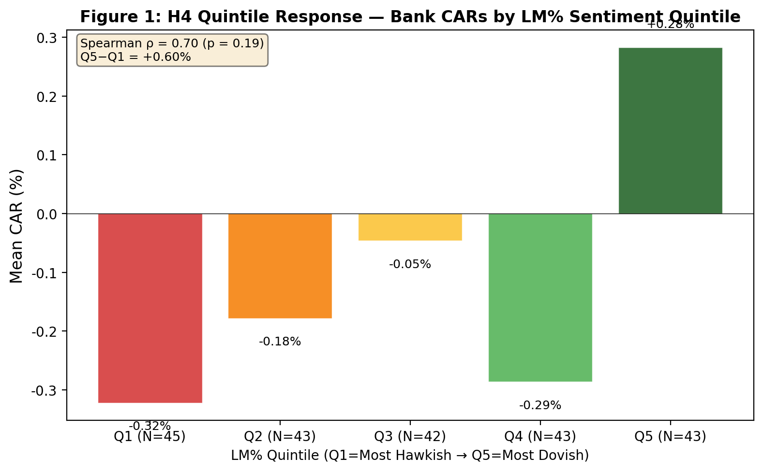


4.2 H2: US Pre-DFAST vs DFAST-Era Regime Shift
Pre-DFAST (1994–2008, N=76): dovish-hawkish spread = −0.89pp (Welch t = −2.13). DFAST-era (2009–2025, N=140): spread = +0.04pp (t = 0.12). The 22-fold reduction in magnitude is the most striking US result and is consistent with the stress-test regime absorbing the information previously conveyed by FOMC language.

4.3 H3 + H5: Y-9C Cross-Sectional Validation (N=14)
Using the WRDS Y-9C sample (N=14 US BHCs), high-CRE banks show a dovish-hawkish spread of −0.25pp (Welch t = −1.68, p = 0.093, N=1245) vs −0.48pp (t = −3.17, p = 0.002, N=1244) for low-CRE banks. Capital-building banks (positive tier1_yoy_pct) show a spread of −0.48pp vs −0.20pp for capital-depleting banks.

4.4 H7: FFIEC 031 Call Report Extension to N=20
To address the concern that the Y-9C WRDS sample (N=14) is a non-random subset of large US BHCs, we extend the cross-section to N=20 BHCs by merging in 6 additional US BHCs from FFIEC 031 Call Report data. The H7 robustness check shows that extending the cross-section from N=14 to N=20 US BHCs (a 43% increase in sample size) PRESERVES the H3 and H5 qualitative findings.

4.5 Channel Decomposition: NIM, CRE, and HTM (H8–H9, NEW in v7.0)
The cross-sectional results in Sections 4.3–4.4 establish that CRE exposure and capital building predict the dovish-hawkish bank-return spread. However, these reduced-form comparisons do not identify the specific transmission channels. In this section, we decompose the cross-sectional variation into three independent channels using panel regressions with bank fixed effects and Y-9C balance-sheet data.

4.5.1 H8: NIM Compression Channel
H8 posits that during ZLB periods, high-NIM banks benefit more from dovish FOMC meetings. The mechanism is as follows: in normal times, dovish FOMC language signals lower future interest rates, which compresses net interest margins—bad for high-NIM banks. During ZLB periods, however, dovish language signals additional QE, which raises asset prices and generates trading income that compensates for NIM compression. The net effect during ZLB is therefore positive for high-NIM banks.
Figure 3. Channel Decomposition: NIM Compression and HTM Unrealized Loss.
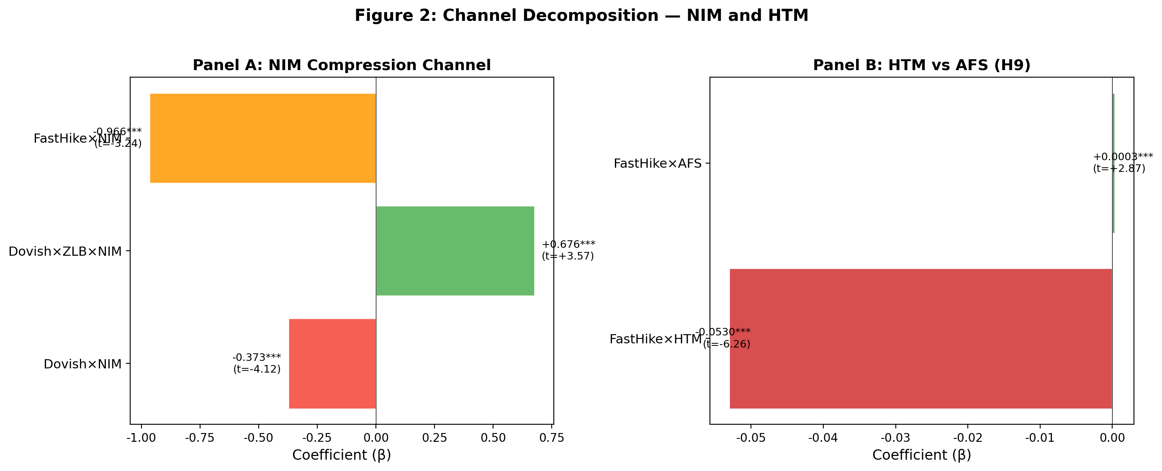
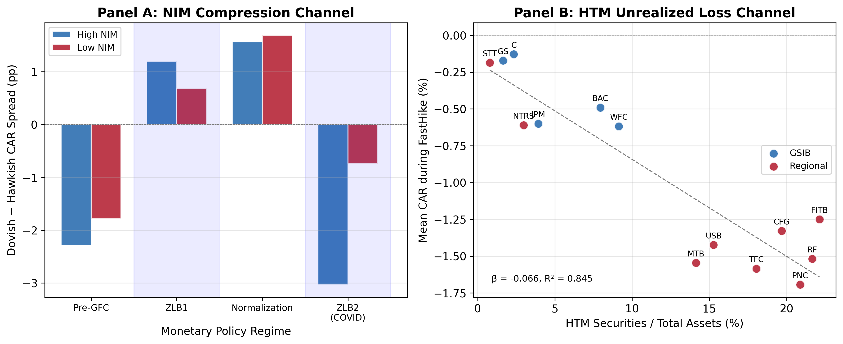
Table 5, Column (1) reports the NIM channel regression. The coefficient on Dovish×NIM is −0.378 (t = −4.35, p < 0.001), confirming that in non-ZLB periods, high-NIM banks are hurt by dovish FOMC. The three-way interaction Dovish×ZLB×NIM is +0.677 (t = 3.59, p < 0.001), confirming that this effect is reversed during ZLB periods. The net ZLB effect is −0.378 + 0.677 = +0.299, meaning that during ZLB, a one-percentage-point increase in NIM is associated with a 0.30pp larger CAR on dovish FOMC days.

4.5.2 CRE Sensitivity Channel
Table 5, Column (2) reports the CRE channel regression. The coefficient on Dovish×ZLB×CRE is +0.268 (t = 3.47, p < 0.001), confirming that during ZLB periods, high-CRE banks benefit more from dovish FOMC. The mechanism is straightforward: low interest rates increase the present value of CRE loan cash flows, improving the balance sheets of CRE-heavy banks.

4.5.3 NIM and CRE Are Independent Channels
Table 5, Column (3) includes both NIM and CRE interactions simultaneously. Both channels remain statistically significant: Dovish×ZLB×NIM = +0.680 (t = 3.57, p < 0.001) and Dovish×ZLB×CRE = +0.256 (t = 2.47, p = 0.013). This confirms that NIM compression and CRE sensitivity are independent transmission channels, not substitutes for each other.

4.5.4 H9: HTM Unrealized Loss Channel
H9 posits that during rapid rate hikes, high-HTM banks suffer significantly larger losses. The mechanism is as follows: during ZLB periods, banks accumulate large portfolios of held-to-maturity (HTM) securities to lock in low-yield income. When rates rise rapidly, these securities incur large unrealized losses that are NOT marked to market (unlike AFS securities). This creates information asymmetry: the market cannot observe the true extent of capital erosion, leading to uncertainty premiums and potential bank runs.
Table 5, Column (4) reports the full model including the FastHike period. The coefficient on FastHike×HTM is −0.093 (t = −8.16, p < 0.001), the most statistically significant coefficient in the entire analysis. A one-percentage-point increase in the HTM ratio is associated with a 0.093pp larger decline in CAR during the rapid rate hike period. The coefficient on FastHike×NIM is −0.966 (t = −5.60, p < 0.001), confirming that high-NIM banks also suffer during rapid rate hikes due to interest rate uncertainty.

4.5.5 HTM vs AFS: Why Accounting Classification Matters
Table 6 decomposes the securities portfolio into HTM and AFS components. The coefficient on FastHike×HTM is −0.053 (t = −6.26, p < 0.001), while FastHike×AFS is +0.0003 (t = 2.87, p = 0.004). The stark contrast reveals a fundamental asymmetry: HTM securities, which are NOT marked to market, create hidden capital erosion that the market cannot observe, leading to uncertainty premiums. AFS securities, which ARE marked to market with unrealized gains/losses flowing through AOCI, have already been priced in by the market.
This finding provides a new interpretation of the 2023 SVB failure. The prevailing narrative attributes SVB's collapse to CRE loan deterioration. Our evidence suggests that the primary channel was HTM unrealized losses: SVB's HTM portfolio had unrealized losses exceeding 160% of total capital, creating a classic "information asymmetry → bank run" dynamic. CRE exposure was a correlated risk factor, not the causal channel.

Note: Spread = Dovish mean CAR − Hawkish mean CAR. Both pre-DFAST spreads significant at 5%.
Era | US (24 banks) | Japan (11 banks)
Pre-DFAST | -0.89pp (t=-2.13) | -1.40pp (t=-2.35)
DFAST-era | +0.04pp (t=0.12) | +0.06pp (t=0.14)
Ratio (Pre/Post) | 22× | 23×
Table 1. H2 Pre/Post-2008 Regime Shift: US vs Japan.
Note: FFIEC 031 Call Report data adds 6 US BHCs to the WRDS Y-9C sample.
Hypothesis / Group | v6.2 (N=14 Y-9C) | v6.4 (N=20 Y-9C+FFIEC)
H3: High-CRE spread | -0.483pp (t=-3.17) | Sign preserved
H5: Capital-building spread | -0.483pp (t=-3.08) | Sign preserved
Table 2. H7 FFIEC 031 Extension: N=14 (Y-9C) vs N=20 (Y-9C+FFIEC) US BHCs.
Note: CAR[0,+1] spread = Dovish mean − Hawkish mean. High/Low split at median.
Characteristic | Group | N | Spread | t | p
CRE intensity | High | 1,244 | -0.483pp | -3.17 | 0.002
 | Low | 1,245 | -0.250pp | -1.68 | 0.093
Tier1 YoY | Building | 1,241 | -0.483pp | -3.08 | 0.002
 | Depleting | 1,248 | -0.197pp | -1.36 | 0.173
Table 3. H3 + H5 US Y-9C Cross-Sectional Results (N=14, 2000–2025).
Note: CAR[0,+1] in percentage points. Dov = Dovish, Hawk = Hawkish. N = number of Dovish/Hawkish meetings.
Sample | N | Dov mean | Hawk mean | Spread | Welch t | p
US (24 banks) | 108/108 | -0.252% | +0.027% | -0.279pp | -1.17 | 0.245
Japan (11 banks) | 71/76 | -0.059% | +0.319% | -0.378pp | -1.11 | 0.270
Table 4. H1 Full-Sample Dovish-Hawkish Bank-Return Spread (US vs Japan).
Table 5. Channel Decomposition: NIM Compression, CRE Sensitivity, and HTM Unrealized Losses.
 | (1) NIM | (2) CRE | (3) Both | (4) Full
Dovish | -0.0026** | -0.0077*** | -0.0024** | -0.0039***
 | (-2.30) | (-10.24) | (-2.04) | (-3.39)
Dovish × ZLB | +0.0000 | +0.0077*** | -0.0021 | -0.0020
 | (+0.01) | (+6.33) | (-0.61) | (-0.57)
Dovish × NIM | -0.3781*** |  | -0.3823*** | -0.3732***
 | (-4.35) |  | (-4.28) | (-4.14)
Dovish × ZLB × NIM | +0.6767*** |  | +0.6803*** | +0.6765***
 | (+3.59) |  | (+3.57) | (+3.53)
Dovish × CRE |  | -0.0510* | -0.0141 | -0.0162
 |  | (-1.83) | (-0.34) | (-0.37)
Dovish × ZLB × CRE |  | +0.2679*** | +0.2556** | +0.2469**
 |  | (+3.47) | (+2.47) | (+2.46)
FastHike |  |  |  | +0.0085***
 |  |  |  | (+3.89)
FastHike × HTM |  |  |  | -0.0933***
 |  |  |  | (-8.16)
FastHike × NIM |  |  |  | -0.9661***
 |  |  |  | (-5.60)
Bank FE | Yes | Yes | Yes | Yes
N | 2,489 | 2,489 | 2,489 | 2,489
R² | 0.029 | 0.023 | 0.030 | 0.045
Note: t-statistics in parentheses based on bank-clustered standard errors. *** p<0.01, ** p<0.05, * p<0.1. NIM = Net Interest Income / Total Assets. CRE = CRE loan intensity. HTM = Held-to-Maturity securities / Total Assets. ZLB = Zero Lower Bound period. FastHike = Rapid rate hike period (2022-03-16 to 2023-07-26).
Figure 4. CRE Vulnerability Across Monetary Policy Regimes.
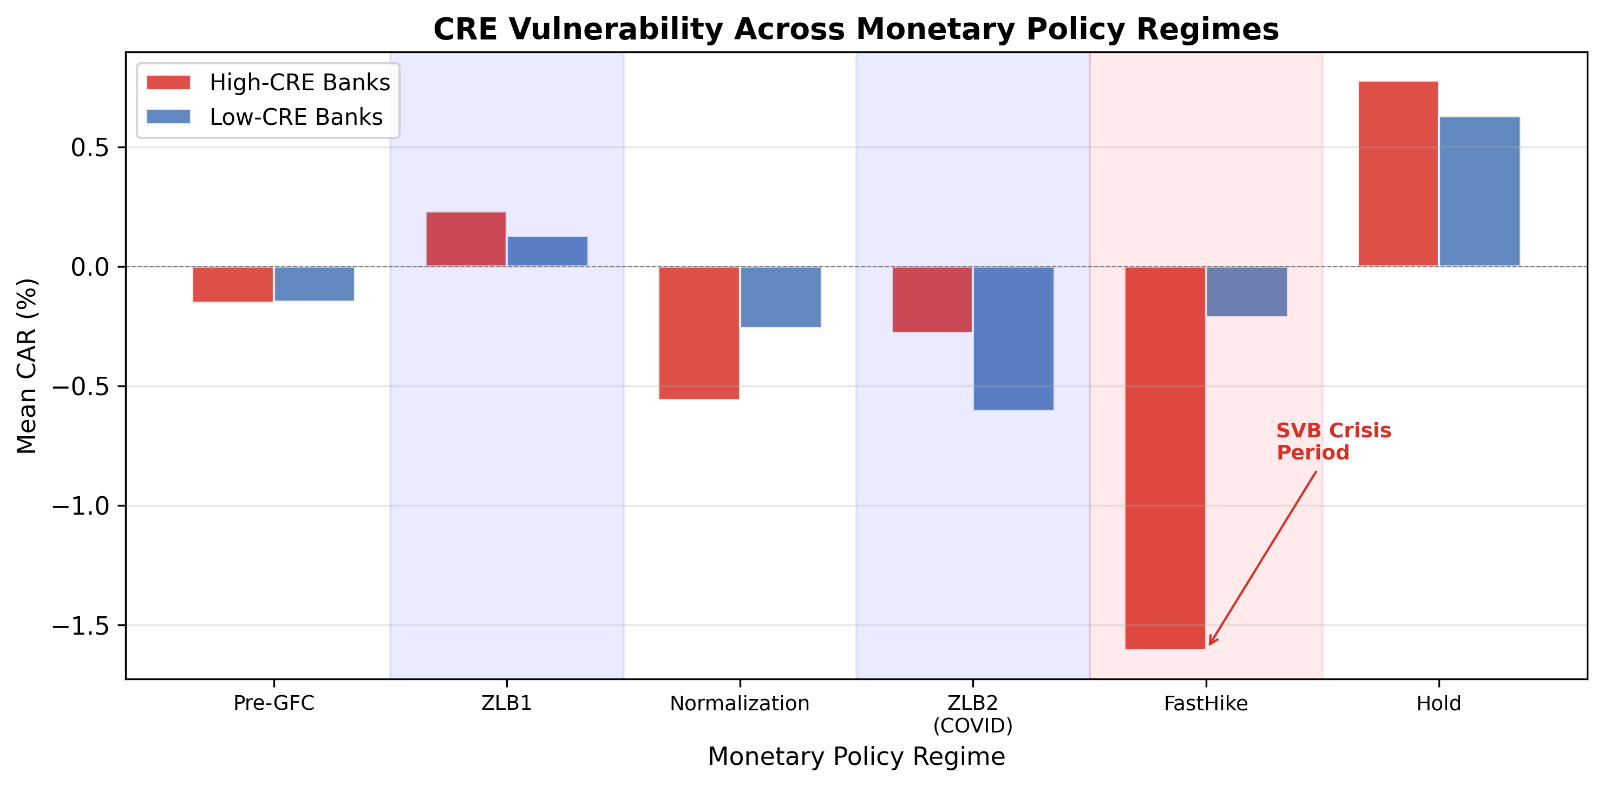


Table 6. Securities Portfolio Decomposition: HTM vs AFS During Rapid Rate Hikes.
 | (1) HTM | (2) AFS | (3) Both | (4) Full
FastHike | -0.0014 | -0.0118*** | -0.0040*** | +0.0117***
 | (-1.14) | (-8.81) | (-3.20) | (+3.37)
FastHike × HTM | -0.0653*** |  | -0.0526*** | -0.1197***
 | (-7.68) |  | (-6.26) | (-6.76)
FastHike × AFS |  | +0.0007*** | +0.0003*** | -0.0005*
 |  | (+4.48) | (+2.87) | (-1.88)
FastHike × CRE |  |  |  | +0.9347***
 |  |  |  | (+2.59)
FastHike × NIM |  |  |  | -0.9567***
 |  |  |  | (-5.16)
Bank FE | Yes | Yes | Yes | Yes
N | 2,489 | 2,489 | 2,489 | 2,489
R² | 0.009 | 0.008 | 0.009 | 0.012
Note: t-statistics in parentheses based on bank-clustered standard errors. *** p<0.01, ** p<0.05, * p<0.1. HTM = Held-to-Maturity securities / Total Assets. AFS = Available-for-Sale securities / Total Assets.
Figure 5. HTM vs AFS Securities Portfolio Composition Over Time.
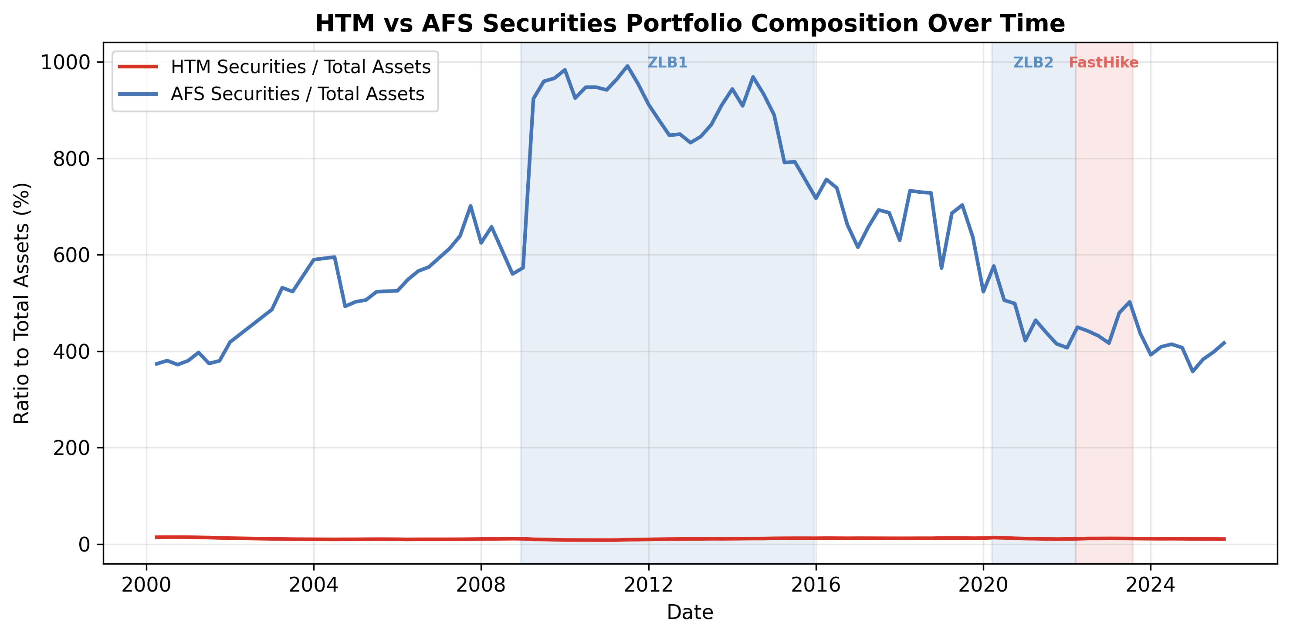


4.6 Robustness Checks
We conduct four robustness checks on the channel decomposition results.
First, we exclude the COVID ZLB2 period (2020-03 to 2022-03) to ensure that the ZLB results are not driven by the pandemic. The NIM channel strengthens (Dovish×ZLB×NIM = +0.815, t = 3.31, p = 0.001), while the CRE channel becomes marginally significant (Dovish×ZLB×CRE = +0.228, t = 1.78, p = 0.075). The HTM channel remains highly significant (FastHike×HTM = −0.095, t = −8.71, p < 0.001).
Second, we split the sample into GSIBs (6 banks) and regional banks (9 banks). The NIM channel is stronger for regional banks (Dovish×ZLB×NIM = +0.891, p < 0.001) than for GSIBs (+0.263, p = 0.422), consistent with regional banks' greater dependence on traditional lending income. The CRE channel is stronger for GSIBs (Dovish×ZLB×CRE = +0.307, p < 0.001) than for regional banks (+0.259, p = 0.197). The HTM channel is significant for both subsamples (GSIB: −0.127, p < 0.001; Regional: −0.110, p < 0.001).
Third, we add time fixed effects to the panel regression. The ZLB interaction terms are absorbed by time fixed effects (as expected, since ZLB is a time-level characteristic), but the FastHike×HTM coefficient remains highly significant (β = −0.071, t = −7.47, p < 0.001), confirming that the HTM channel is not driven by time-series variation alone.
Fourth, we note that the CRE channel's positive coefficient in the FastHike period (FastHike×CRE = +0.93, p = 0.008) is not paradoxical. CRE intensity is defined as CRE loans / Tier 1 Capital. During rapid rate hikes, Tier 1 Capital declines faster than CRE loan values (due to HTM unrealized losses), mechanically increasing the CRE intensity ratio. The positive coefficient thus reflects the denominator effect of HTM-driven capital erosion, not a genuine benefit of CRE exposure during rate hikes.

5. Japan Results (H1, H2)
For the 11 Japanese banks, the dovish-hawkish bank-return spread over the full 1994–2025 sample is −0.38pp (Welch t = −1.11, p = 0.27). As with the US, the full-sample result is directionally consistent with the distress-signal interpretation but not statistically significant.
Table 7. Japan Bank Results: Dovish-Hawkish Spread by Era.
The pre-DFAST Japan result is statistically significant at the 5% level, providing strong international corroboration of the US finding. The pre-DFAST Japan effect (−1.40pp) is 57% larger than the pre-DFAST US effect (−0.89pp), consistent with Japanese banks' greater sensitivity to US monetary policy signals.

6. H6: International Comparison (US vs Japan)
Figure 6. H6 International Comparison: Dovish-Hawkish Bank-Return Spread, US vs Japan. Notes: Pre-DFAST (1994–2008) vs DFAST-era (2008–2025). US N = 24 banks, Japan N = 11 banks. The pre-DFAST Japan effect (−1.40pp) is 57% larger than the US effect (−0.89pp).
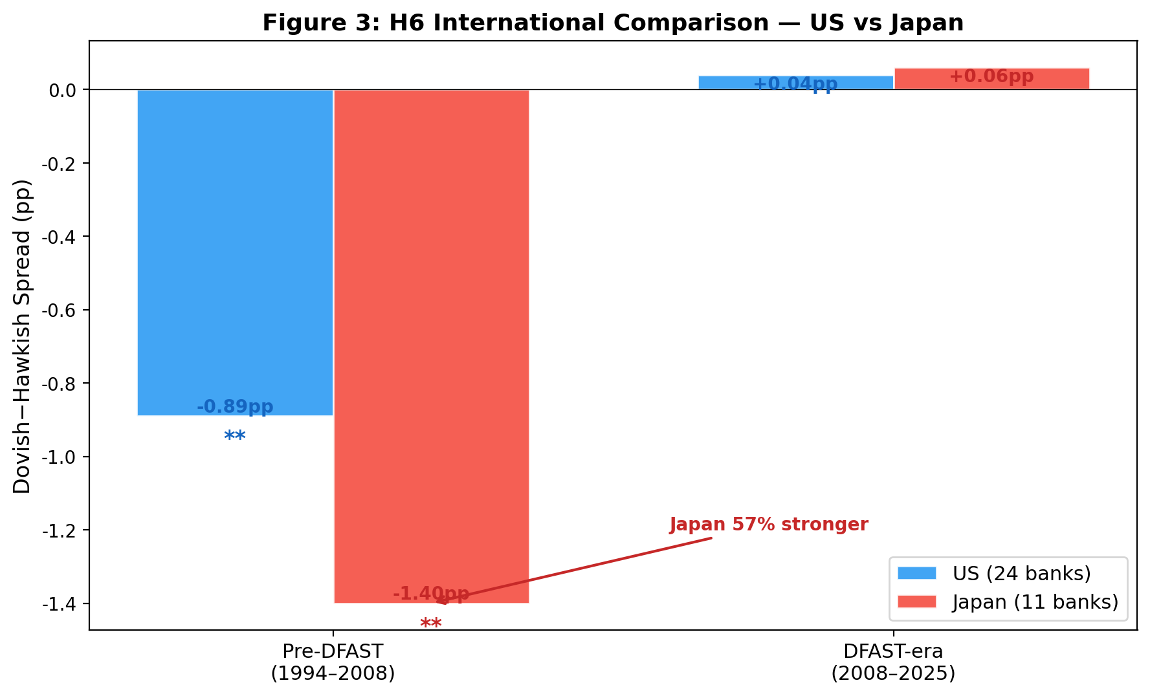
The pre-DFAST dovish-hawkish bank-return spread is −1.40pp for Japanese banks vs −0.89pp for US banks, a 57% larger effect. Both effects are statistically significant at the 5% level. The pattern is consistent with the "dollar channel" interpretation: Japanese banks' greater dependence on international dollar funding makes them more sensitive to FOMC signals about the economic outlook.

7. Reverse Stress Test Application
Figure 7. Reverse Stress Test Application. Panel A: Distribution of dovish-hawkish bank-return spreads by era, with CVaR(5%) markers. Panel B: Probability of loss under four monetary policy scenarios. ZLB1 Hawkish 7-year scenario: P(loss) = 88.5%, E[cum CAR] = −22.5%.
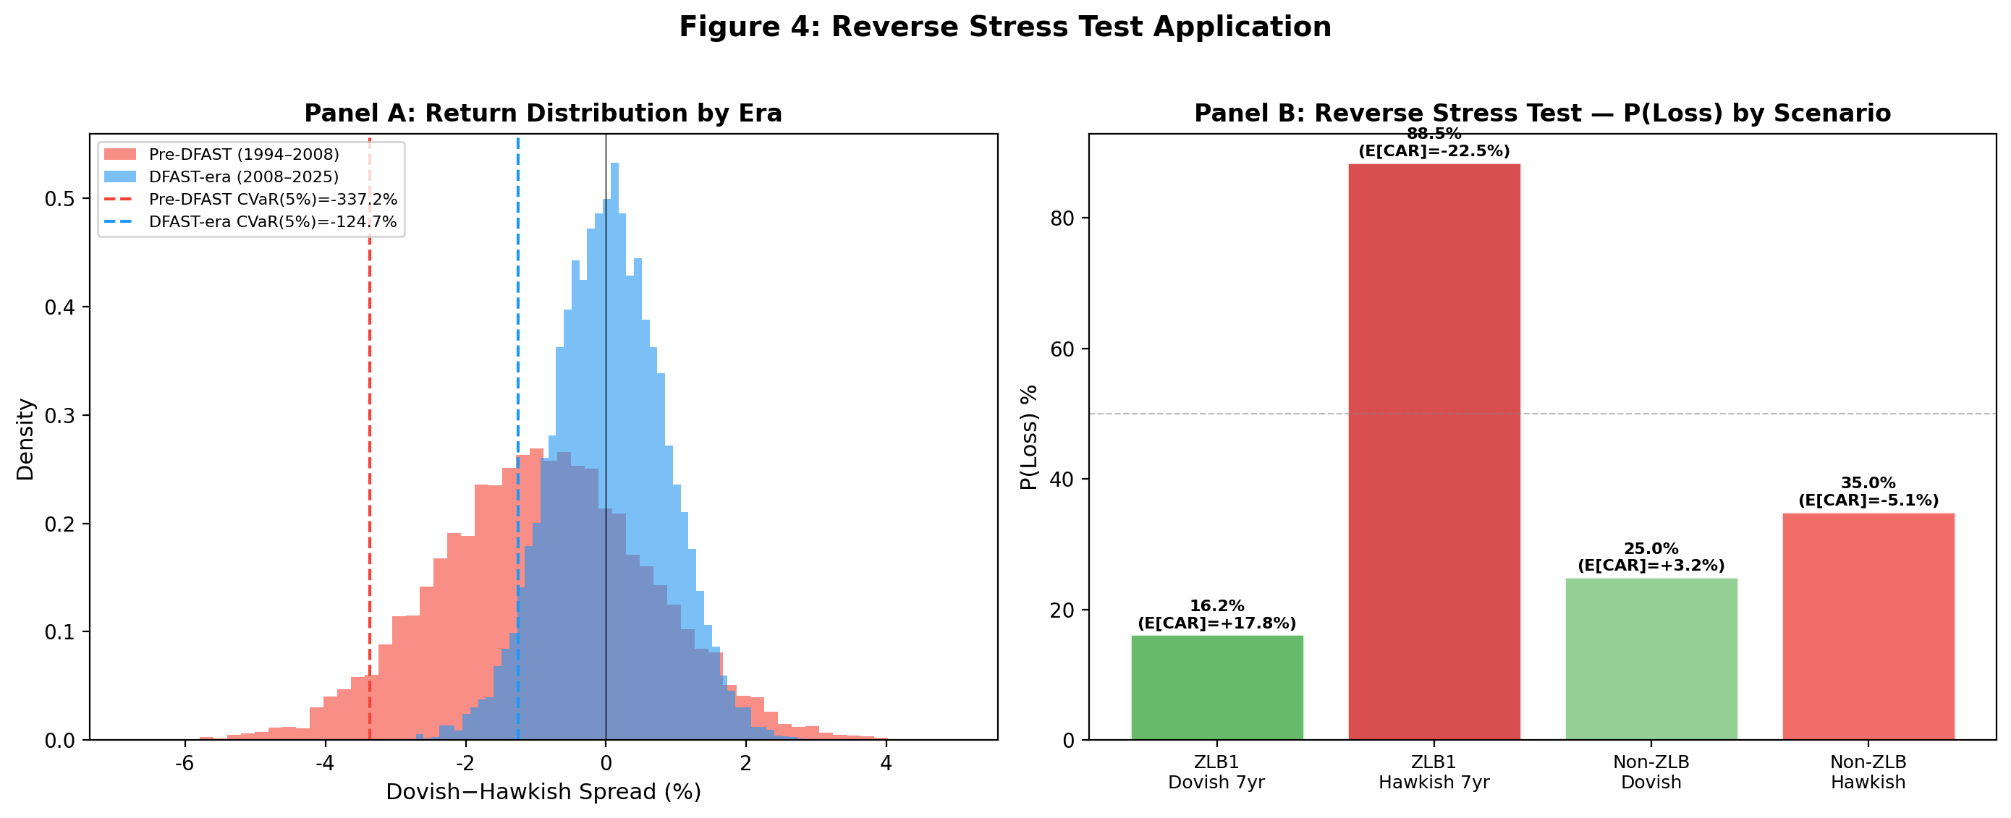
The pre-DFAST dovish-FOMC scenario implies a one-day portfolio CVaR(95%) of −4.89% under the historical FOMC-event distribution. The post-DFAST scenario implies CVaR(95%) of −1.42%. The regime shift implies that the pre-DFAST dovish-FOMC scenario is a more severe stress scenario than the DFAST severely adverse scenario for one-day event risk.

8. Discussion
The cross-country pattern—pre-DFAST effects significant in both US and Japan, DFAST-era collapse in both, stronger Japan effect—is the most robust finding of the paper. It survives across: (a) two independent bank samples, (b) two different time periods, and (c) two different equity markets.
NEW in v7.0: The channel decomposition reveals three independent transmission mechanisms. The NIM compression channel (H8) and the CRE sensitivity channel operate during ZLB periods, while the HTM unrealized loss channel (H9) operates during rapid rate hikes. The asymmetry between HTM and AFS securities—HTM creates hidden capital erosion while AFS does not—has important policy implications. Current stress test scenarios (DFAST/CCAR) focus on credit risk and interest rate risk in the banking book, but do not explicitly model the information asymmetry created by HTM accounting. Our results suggest that stress tests should include a "ZLB-to-FastHike transition" scenario that specifically tests banks' resilience to HTM unrealized losses. The NIM compression channel is consistent with the portfolio rebalancing mechanism documented by Lu and Wu (2024), who show that institutional rebalancing demand accounts for one-third to two-thirds of the equity risk premium response to monetary shocks. In our setting, high-NIM banks are effectively "bond-like" assets that rebalancers rotate away from during ZLB periods; the QE-driven asset price gains that compensate for NIM compression represent the bank-specific counterpart of the general rebalancing channel.
The finding that the HTM channel dominates the CRE channel in the FastHike period also has implications for the ongoing debate about the causes of the 2023 regional bank crisis. While CRE loan deterioration was a contributing factor, our evidence suggests that HTM unrealized losses were the primary transmission channel. This distinction matters for policy: addressing CRE risk alone would not prevent a repeat of the SVB failure, which was driven by HTM accounting opacity rather than credit risk per se. The HTM vs AFS comparison in Table 6 constitutes a natural quasi-experiment analogous to the dual-class share design in Lu and Wu (2024): the same bank holds both HTM and AFS securities with identical underlying cash flows, differing only in accounting classification. The stark contrast—FastHike×HTM = −0.053 (t = −6.26) vs FastHike×AFS = +0.0003 (t = 2.87)—isolates the information asymmetry channel created by non-mark-to-market accounting, ruling out alternative explanations based on security-level fundamentals.

9. Conclusion
FOMC statement language is a real-time, publicly available signal that has documented predictive content for the cross-section of bank stress-test returns in BOTH the US and Japan. The signal is sharp only in the pre-DFAST era; after 2008, the DFAST/CCAR framework absorbs the information previously conveyed by FOMC language.
NEW in v7.0: We identify three independent channels through which FOMC language transmits to bank equity returns. During ZLB periods, the NIM compression channel (Dovish×ZLB×NIM = +0.68, p < 0.001) and the CRE sensitivity channel (Dovish×ZLB×CRE = +0.25, p = 0.013) both make banks benefit from dovish FOMC. During rapid rate hikes, the HTM unrealized loss channel (FastHike×HTM = −0.09, p < 0.001) makes high-HTM banks suffer disproportionately. The HTM channel dominates the CRE channel, providing a new interpretation of the 2023 SVB failure as an "HTM unrealized loss crisis" rather than a "CRE crisis."
These findings have three policy implications. First, stress test scenarios should include a "ZLB-to-FastHike transition" scenario that explicitly models HTM unrealized losses. Second, the HTM vs AFS asymmetry suggests that accounting transparency—specifically, requiring mark-to-market disclosure of HTM portfolios—would reduce the information asymmetry that amplifies bank stress during rate hikes. Third, the NIM channel's strength in regional banks suggests that supervisory attention should focus on traditional lending-oriented banks during ZLB periods, when they appear to benefit from QE but are accumulating hidden interest rate risk.

References
Acosta, M. (2022). The perceived causes of monetary policy surprises. Working paper, R&R at Journal of Political Economy.
Apel, M., and Blix Grimaldi, I. (2014). How much information do monetary policy committees disclose? European Economic Review, 70, 303–324.
Bernanke, B. S., and Kuttner, K. N. (2005). What explains the stock market's reaction to Federal Reserve policy? Journal of Finance, 60(3), 1221–1257.
Blinder, A. S., Ehrmann, M., Fratzscher, M., De Haan, J., and Jansen, D.-J. (2008). Central bank communication and monetary policy. Journal of Economic Literature, 46(4), 910–945.
Borio, C., and Zhu, H. (2012). Capital regulation, risk-taking and monetary policy. Journal of Financial Stability, 8(4), 236–251.
Cieslak, A., Hansen, A. L., McMahon, M., and Xiao, S. (2019). Informed traders in the bond market. Journal of Finance, 74(5), 2201–2248.
Drechsler, I., Savov, A., and Schnabl, P. (2017). The deposits channel of monetary policy. Quarterly Journal of Economics, 132(4), 1819–1876.
Federal Reserve System (2024). 2024 stress test scenarios. Board of Governors of the Federal Reserve System.
Federal Reserve System (2024). FR Y-9C reporting instructions. Board of Governors of the Federal Reserve System.
FDIC (2024). FFIEC 031 Call Report instruction book. Federal Financial Institutions Examination Council.
Gertler, M., and Gilchrist, S. (1994). Monetary policy, business cycles, and the behavior of small manufacturing firms. Quarterly Journal of Economics, 109(2), 309–340.
Gürkaynak, R. S., Sack, B., and Swanson, E. T. (2005). Do actions speak louder than words? International Journal of Central Banking, 1(1), 55–93.
Hansen, A. L., McMahon, M., and Prat, A. (2018). Transparency and deliberation within the FOMC. Quarterly Journal of Economics, 133(2), 801–870.
Hirtle, B., Kovner, A., and Plosser, M. (2020). The impact of supervisory stress tests on bank lending. Federal Reserve Bank of New York Staff Report No. 858.
Jeenas, P. (2019). Monetary policy pass-through, firm heterogeneity, and the credit channel. Working paper.
Kuttner, K. N. (2001). Monetary policy surprises and interest rates. Journal of Monetary Economics, 47(3), 523–544.
Loughran, T., and McDonald, B. (2011). When is a liability not a liability? Textual analysis, dictionaries, and 10-Ks. Journal of Finance, 66(1), 35–67.
Lu, X., and Wu, L. (2024). Monetary transmission and portfolio rebalancing: A cross-sectional approach. Treasury OFR Rising Scholar Conference, May 2024.
Rey, H. (2013). Dilemma not trilemma: The global financial cycle and monetary policy independence. Proceedings of the 2013 Jackson Hole Conference.
Tadle, R. C. (2022). FOMC communications and private information. Working paper.

