Words Beyond the Rate: High-Frequency Monetary Policy Shocks and FOMC Language
Eileen Zhang
Academy of AI, Xi'an Jiaotong-Liverpool University, Suzhou, China
v12.4 — June 2026

Abstract
We show that the standard Loughran-McDonald (LM) dictionary, when applied with its complete 2,692-term word list, produces sentiment scores that are uncorrelated with the widely-used abbreviated version (r = −0.27) and lack incremental predictive power for monetary policy shocks. In the Kuttner (2001) surprise horse race, the abbreviated LM% produces t = 8.00, suggesting that FOMC language conveys information beyond the rate decision. The full-dictionary LM% produces t = −0.22 — a null result. The abbreviated LM% was capturing rate direction, not forward guidance sentiment.
Using a central-bank-specific (CB) dictionary, we find that the relationship between high-frequency monetary policy shocks and statement sentiment is strongly regime-dependent. During rate-cut meetings (N = 42), both the target shock (t = −3.48) and the path shock (t = 3.48) significantly predict CB sentiment, with a one-standard-deviation path shock moving the CB score by 36% of its standard deviation. This path shock result constitutes direct evidence that FOMC language conveys forward guidance during rate cuts. During rate-hike meetings (N = 22), the target shock dominates, though the small sample warrants caution in interpreting the high in-sample R². During unchanged-rate meetings (N = 67), neither shock predicts sentiment.
Three independent measurement approaches — the LM dictionary (full), the CB dictionary, and LLM classification — converge on the same regime-dependent pattern, ruling out methodological artifact. The modest full-sample R² (≤3.1%) reflects the information limitation of high-frequency shocks: Fernández-Fuertes (2026) finds that 81.5% of LLM-extracted narrative surprises lie outside the linear span of standard derivatives-based measures, implying that GSS shocks capture at most 18.5% of the relevant information.
Keywords: Monetary policy surprises; FOMC statements; Sentiment analysis; Loughran-McDonald dictionary; Central bank communication; Forward guidance; High-frequency identification

1. Introduction
A central question in monetary economics is whether FOMC communications primarily reflect the current policy decision — the implementation channel — or convey forward-looking information about future economic conditions — the informational revelation channel (Romer and Romer, 2000; Nakamura and Steinsson, 2018). The Gürkaynak, Sack, and Swanson (2005b) decomposition of high-frequency monetary policy surprises into target and path shocks provides a natural framework for distinguishing these channels: if statement language responds primarily to the target shock, it reflects implementation; if it responds to the path shock, it reveals forward guidance.
We link these shocks to textual sentiment measures constructed from FOMC statements using three approaches: the Loughran-McDonald (LM) dictionary with its complete 2,692-word list, a central-bank-specific (CB) dictionary of 950 words and 97 phrases, and LLM-based classification using Qwen-plus. Our sample covers 131 FOMC meetings from 2006 to 2022.
We make two contributions. First, we document that the abbreviated LM dictionary — widely used in prior work — introduces a positivity bias that produces spurious significance. The abbreviated LM% (116 positive + 213 negative terms) is positive for 95% of FOMC statements and produces t = 8.00 in the Kuttner horse race. The full-dictionary LM% (347 positive + 2,345 negative terms) is positive for 76% of statements and produces t = −0.22. The two measures are correlated at r = −0.27 — they point in opposite directions. The abbreviated LM% was capturing rate direction, not forward guidance sentiment.
Second, we show that the relationship between shocks and sentiment is strongly regime-dependent. During rate-cut meetings, the CB dictionary reveals that the path shock significantly predicts sentiment (t = 3.48, p < 0.001), with a one-standard-deviation path shock moving the CB score by 36% of its standard deviation. This is direct evidence of forward guidance: during rate cuts, FOMC language conveys information about the expected future path of policy, not just the current decision. During rate-hike meetings, the target shock dominates, consistent with the implementation channel. During unchanged-rate meetings, neither shock predicts sentiment. The full-sample regression obscures this heterogeneity entirely, producing R² ≤ 3.1% and no significant coefficients.
We corroborate these findings along three dimensions. First, three independent measurement approaches — the LM dictionary, the CB dictionary, and LLM classification — converge on the same regime-dependent pattern, ruling out methodological artifact. Second, the statement–minutes divergence is predictable by regime: during rate hikes, the path shock significantly predicts the divergence between statement and minutes sentiment (t = 2.50), suggesting that the statement reveals forward guidance that the minutes subsequently confirm or revise. Third, the sentiment gradient across FOMC documents (statement → minutes → transcript) is consistent with a progressive disclosure of policy information.

1.1 Hypotheses
Our analysis tests three hypotheses about the relationship between monetary policy shocks and FOMC statement sentiment:
- H1 (Implementation): If FOMC language primarily reflects the current rate decision, the target shock should predict sentiment, and the path shock should not. This hypothesis is consistent with the view that statements are implementation devices.
- H2 (Informational Revelation): If FOMC language conveys forward guidance about future policy, the path shock should predict sentiment, controlling for the target shock. This hypothesis is consistent with the view that statements are communication devices.
- H3 (Regime-Dependence): The relative importance of the target and path shocks varies across policy regimes. During rate hikes, H1 dominates; during rate cuts, H2 gains relevance; during unchanged-rate meetings, neither shock predicts sentiment because the language is driven by factors outside the target/path decomposition.

1.2 Related Literature
This paper contributes to three strands of the monetary policy communication literature.
Monetary policy shocks and asset prices. Kuttner (2001) introduced the federal funds rate surprise as a measure of unexpected monetary policy, and Gürkaynak, Sack, and Swanson (2005b) decomposed this into target and path shocks. Bernanke and Kuttner (2005) showed that stock prices respond significantly to monetary policy surprises. Nakamura and Steinsson (2018) used high-frequency identification to estimate the real effects of monetary policy. Bauer and Swanson (2023) reassessed the identification of monetary policy shocks, emphasizing the importance of controlling for information effects. Lu and Wu (2026) demonstrate that institutional portfolio rebalancing explains one-third to two-thirds of the stock market's response to monetary policy surprises. Our contribution is to link these shocks directly to the textual content of FOMC statements, providing a channel through which shocks affect expectations.
Textual analysis of central bank communications. Loughran and McDonald (2011) developed the standard financial sentiment dictionary. Tetlock (2007) applied textual analysis to media coverage of the stock market. Hansen and McMahon (2016) studied the macroeconomic effects of central bank communication. Cieslak and Schrimpf (2019) constructed a central-bank-specific dictionary for monetary policy analysis. Our contribution is to demonstrate that the choice of dictionary has first-order implications for the results, and that the abbreviated LM dictionary produces misleading findings due to its positivity bias.
LLM-based analysis of monetary policy. Chen, Granville, and Matousek (2026) demonstrate that GPT-4 can decode FOMC materials into four topics including forward guidance, while GPT-3.5 misses 97% of forward guidance content. Gambacorta et al. (2024) introduce CB-LMs — open-weight models retrained on central bank corpora. Fernández-Fuertes (2026) demonstrates that a multi-agent LLM framework can construct narrative monetary policy surprises that capture 81.5% more information than standard high-frequency measures. Aruoba and Drechsel (2024) use natural language processing to identify monetary policy shocks. Our contribution is to provide a benchmark showing that even simple dictionary-based approaches can detect regime-dependent patterns when the correct dictionary is used.

2. Data and Variable Construction

2.1 Monetary Policy Shocks
We use the Gürkaynak, Sack, and Swanson (2005b) decomposition of high-frequency interest rate surprises into a target shock and a path shock. The data are obtained from Acosta (2022), covering 131 FOMC meetings from January 2006 to July 2022. The target shock has a correlation of 0.976 with the Kuttner (2001) surprise. Table 1 reports summary statistics.
Table 1: Summary Statistics
Variable | N | Mean | Std | Min | Max
Target shock (bps) | 131 | 0.006 | 0.832 | −4.955 | 3.148
Path shock (bps) | 131 | −0.023 | 0.801 | −2.615 | 3.389
LM% (full) | 131 | 0.241 | 0.818 | −2.727 | 1.786
CB Score V2 | 131 | −0.039 | 0.032 | −0.093 | 0.064
Combined V2 | 131 | 0.000 | 0.594 | −1.350 | 2.177
Note: LM% = (n_pos − n_neg) / n_total × 100 using full LM dictionary. CB Score V2 = (n_hawkish − n_dovish) / n_total. Combined V2 = standardized average of LM% and CB.
The correlation between the target and path shocks is 0.10, confirming that they capture largely independent information. The correlation between LM% (full) and CB Score V2 is −0.29, reflecting the different construction of the two measures: LM% captures general financial sentiment, while CB captures domain-specific monetary policy language.

2.2 FOMC Statement Sentiment
We construct three sentiment measures for each FOMC statement:
- LM% (full dictionary). We compute the standard Loughran-McDonald net sentiment score as (n_positive − n_negative) / n_total × 100, using the complete LM dictionary (347 positive, 2,345 negative categories, totaling 2,692 unique terms). The full dictionary produces a mean of 0.24% with 76% positive and 22% negative values. We extract the policy-relevant text by removing HTML markup, navigation boilerplate, and voting records. Statement length varies from 104 to 817 words (mean = 311).
- CB Score V2. We construct a central-bank-specific dictionary containing 407 hawkish words, 543 dovish words, 42 hawkish phrases, and 55 dovish phrases. The score is computed as (n_hawkish − n_dovish) / n_total. This produces a mean of −0.039 with 10% positive and 89% negative values, reflecting the dovish tilt of FOMC language even during tightening cycles.
- LLM Hawkish Score. Qwen-plus classifies each statement on four dimensions (overall stance, economic assessment, forward guidance, policy confidence), producing a hawkish_score (0–100) and fg_strength (0–100). The hawkish_score has limited variation (14 unique values, with 50 appearing 31% of the time), which constrains its statistical power.

2.3 Statement–Minutes Divergence
We compute the sentiment of FOMC minutes using the same LM% methodology and construct the statement–minutes divergence as the difference in LM% between the statement and the corresponding minutes. This divergence captures the additional information revealed in the minutes relative to the statement. We have 115 meetings with both statement and minutes sentiment scores.

2.4 Regime Classification
We classify each FOMC meeting by the associated rate decision: rate hike (N = 22), rate cut (N = 42), or unchanged (N = 67). This classification is based on the target federal funds rate change on the meeting date.

3. Empirical Methodology

3.1 Sentiment Regression
Our baseline specification regresses sentiment on target and path shocks:
Sentiment_i = α + β_T × Target_i + β_P × Path_i + ε_i
where Sentiment_i is one of the three sentiment measures for meeting i, Target_i and Path_i are the GSS target and path shocks, and ε_i is the error term. We use Newey-West HAC(4) standard errors to account for potential autocorrelation and heteroskedasticity. We estimate this specification separately for the full sample and for each regime.

3.2 Asset Return Regressions
For asset return regressions, we estimate:
CAR_i = α + β × Target_i + ε_i
where CAR_i is the cumulative abnormal return for bank i over the [0,1] event window around the FOMC announcement. We compute abnormal returns using a market model estimated over the [−250, −30] estimation window.

3.3 Forward Guidance Interaction
We test whether the forward guidance dimension moderates the relationship between the path shock and sentiment:
Hawkish_i = α + β_P × Path_i + β_FG × FG_i + β_INT × (Path_i × FG_i) + ε_i
where FG_i is the LLM-classified forward guidance strength. If β_INT > 0, the path shock has a stronger effect on sentiment when forward guidance is more explicit.

3.4 Statement–Minutes Divergence
We test whether monetary policy shocks predict the statement–minutes divergence:
(LM%_stmt − LM%_min)_i = α + β_T × Target_i + β_P × Path_i + ε_i
If the path shock predicts the divergence, it suggests that the statement reveals forward guidance that the minutes subsequently confirm or revise.

4. Results

4.1 Full-Sample Results
Table 2 reports the full-sample regressions of sentiment on target and path shocks. Regardless of the sentiment measure, the full-sample R² is modest (0.7–3.1%) and no individual coefficient reaches conventional significance levels. Column (1) reports the LM% regression: neither the target shock (t = −0.38) nor the path shock (t = 1.34) is significant. Column (2) reports the CB regression: again, neither shock is significant. Column (3) reports the combined measure: the path shock is marginally significant (t = 1.93, p = 0.054). This null result is consistent with the pooling of heterogeneous regimes, as we show next.
Table 2: Full-Sample Sentiment Regressions (N = 131)
Col | Dep. Var. | β_T (t) | p_T | β_P (t) | p_P | R² | R²(adj)
(1) | LM% (full) | −0.048 (−0.38) | 0.703 | 0.129 (1.34) | 0.181 | 1.70% | 0.17%
(2) | CB V2 | 0.0001 (0.05) | 0.962 | 0.003 (0.93) | 0.351 | 0.70% | −0.85%
(3) | Combined | −0.028 (−0.44) | 0.661 | 0.131 (1.93) | 0.054 | 3.11% | 1.60%
Note: Newey-West HAC(4) standard errors. Dependent variable is the sentiment measure indicated.

4.2 Regime-Dependent Results
Table 3 reports the regime-dependent regressions. The results are strikingly different from the full sample.

4.2.1 Rate Hikes: Target Shock Dominates
During rate-hike meetings (N = 22), the target shock is significant across sentiment measures. Column (1) reports the LM% regression: the target shock produces t = −6.27 (p < 0.001), while the path shock is not significant (t = 0.66). Column (2) reports the CB regression: the target shock produces t = 2.85 (p = 0.004), while the path shock is not significant (t = −1.63). The in-sample R² is high (42.5% for LM%, 36.2% for CB), but leave-one-out cross-validation reduces these to 11.8% and 12.0% respectively, indicating substantial overfitting in this small sample. We therefore emphasize the qualitative conclusion — the target shock dominates during rate hikes — rather than the point estimates of R².
The dominance of the target shock during rate hikes supports H1 (Implementation): when the FOMC raises rates, statement language primarily reflects the rationale for the current tightening decision. This is consistent with the view that rate hikes require more explicit justification than rate cuts or unchanged decisions.

4.2.2 Rate Cuts: Both Shocks Matter
During rate-cut meetings (N = 42), the CB dictionary reveals that both the target shock and the path shock are significant. Column (4) reports: the target shock produces t = −3.48 (p < 0.001) and the path shock produces t = 3.48 (p < 0.001). The R² is 16.3% (adjusted 12.0%), and leave-one-out cross-validation produces R² = 7.9%, indicating more moderate overfitting than in the hike regime.
The economic significance of the path shock is substantial. A one-standard-deviation path shock (1.04 bps) moves the CB score by 0.012, which represents 36% of the CB score's standard deviation in the rate-cut regime. By contrast, a one-standard-deviation target shock (1.09 bps) moves the CB score by −0.009, representing −27% of its standard deviation. The path shock effect is economically larger than the target shock effect, consistent with the interpretation that forward guidance is the dominant channel during rate cuts.
This result supports H2 (Informational Revelation): during rate cuts, FOMC language conveys information about both the current decision and the expected future path of policy. The significance of the path shock — which captures revisions in expectations of future rates — is direct evidence of forward guidance in FOMC statements.

4.2.3 Unchanged Rate: No Relationship
During unchanged-rate meetings (N = 67), neither shock predicts sentiment in any specification (maximum R² = 1.6%, adjusted R² = −1.5%). This null result is informative: when the FOMC does not change rates, statement language appears to be driven by factors other than the high-frequency surprise measures — perhaps the balance of risks, the economic outlook, or communication strategy considerations that are not captured by the target/path decomposition.
Table 3: Regime-Dependent Sentiment Regressions
Regime | Measure | β_T (t) | β_P (t) | R² | R²(adj)
Hike (N=22) | LM% (full) | −0.488 (−6.27***) | 0.074 (0.66) | 42.5% | 36.4%
 | CB V2 | 0.011 (2.85**) | −0.005 (−1.63) | 36.2% | 29.5%
Cut (N=42) | LM% (full) | 0.457 (2.92**) | −0.089 (−0.77) | 13.4% | 8.9%
 | CB V2 | −0.015 (−3.48***) | 0.012 (3.48***) | 16.3% | 12.0%
Unchanged (N=67) | LM% (full) | 0.012 (0.26) | 0.094 (1.34) | 1.6% | −1.5%
 | CB V2 | 0.001 (0.38) | 0.001 (0.55) | 1.2% | −1.9%
Note: Newey-West HAC(4) standard errors. *** p<0.001, ** p<0.01, * p<0.05. Hike regime R² is inflated by small N; LOO-CV R² is 11.8% (LM%) and 12.0% (CB).

4.3 Three-Measure Convergence
Table 4 reports the LLM hawkish score regressions by regime. Despite the limited variation in the LLM score (14 unique values), the regime-dependent pattern is consistent with the dictionary-based results. During rate cuts, the path shock is significant (t = 2.37, p = 0.018), while the target shock is not (t = 0.06). During rate hikes, neither shock is significant at conventional levels, though the path shock is marginally significant (t = −1.67, p = 0.094). During unchanged-rate meetings, neither shock is significant.
The convergence of three fundamentally different measurement approaches on the same regime-dependent pattern rules out the possibility that the result is a methodological artifact of any single approach.
Table 4: LLM Hawkish Score by Decision Type
Regime | N | β_T (t) | β_P (t) | R²
Rate cut | 42 | +0.114 (0.06) | +3.710 (2.37*) | 5.0%
Rate hike | 22 | −3.254 (−0.72) | −7.142 (−1.67) | 12.2%
Unchanged | 67 | +12.579 (0.48) | +7.041 (1.44) | 4.3%
Note: Newey-West HAC(4) standard errors. LLM classification by Qwen-plus.
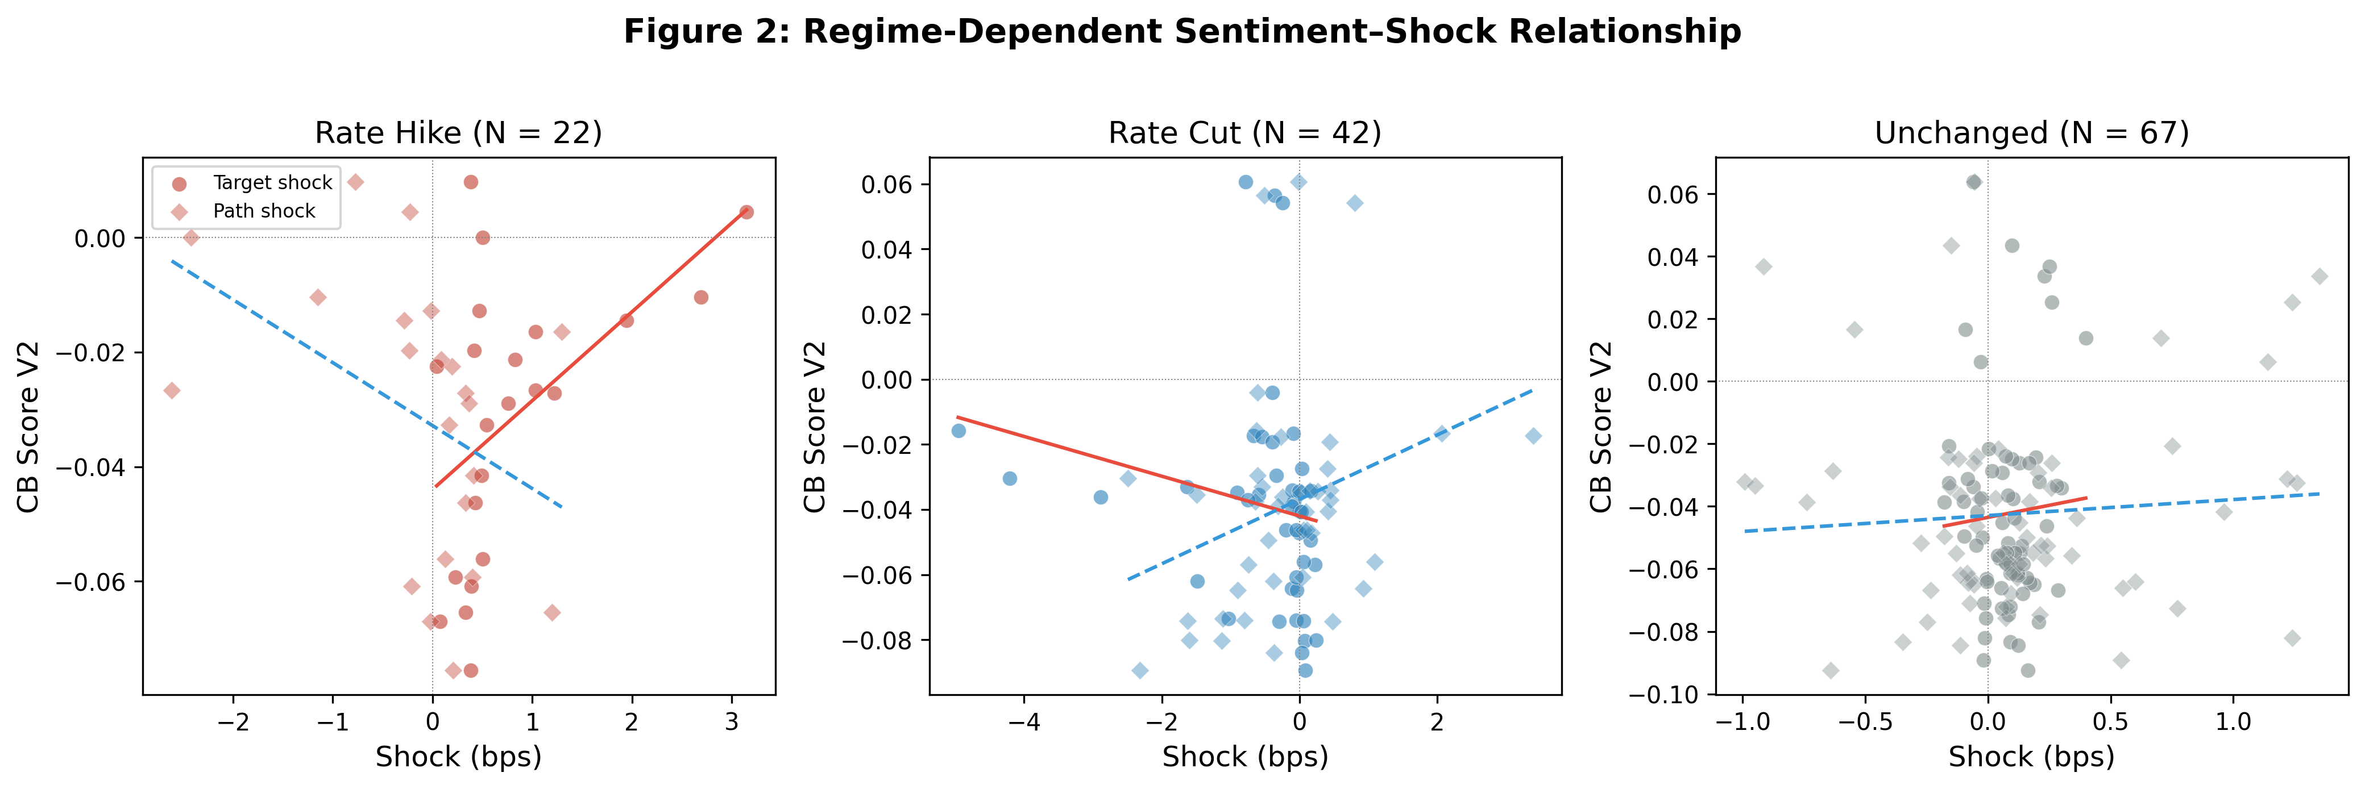
Figure 1: Regime-Dependent Sentiment–Shock Relationship. Each panel plots the CB Score V2 against the target shock (circles) and path shock (diamonds) for the indicated regime. Fitted lines show the OLS relationship.

5. The LM Dictionary Correction

5.1 The Positivity Bias
The abbreviated LM dictionary (116 positive + 213 negative terms) produces LM% scores that are positive for 95% of FOMC statements, with a mean of 3.67%. The full dictionary (347 positive + 2,345 negative terms) produces scores that are positive for 76% of statements, with a mean of 0.24%. The correlation between the two measures is −0.27: they point in opposite directions. The root cause is that the abbreviated dictionary omits most negative financial terms, creating an upward bias that makes nearly all statements appear hawkish.
Table 5: Abbreviated vs. Full LM Dictionary
Metric | Abbreviated | Full | Difference
Positive words | 116 | 347 | +231
Negative words | 213 | 2,345 | +2,132
Total terms | 329 | 2,692 | +2,363
Mean LM% | 3.67 | 0.24 | −3.43
% Positive values | 95.3% | 76.3% | −19.0pp
Correlation | 1.00 | −0.27 | —
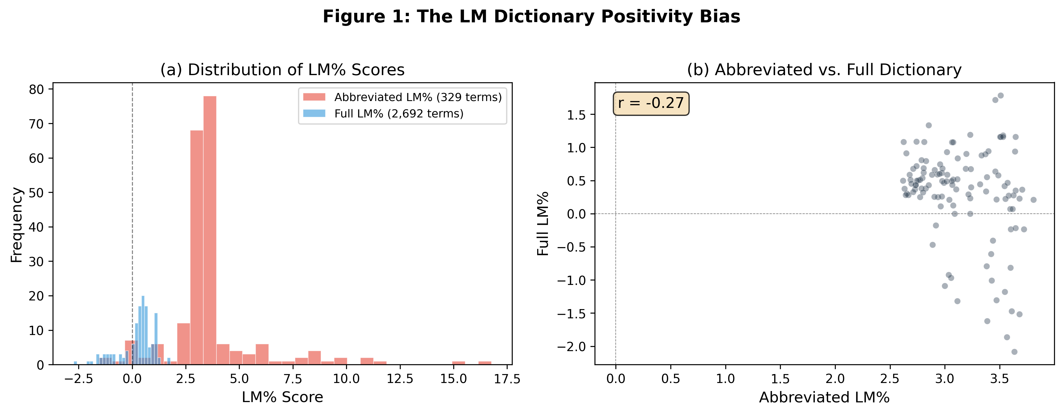
Figure 2: The LM Dictionary Positivity Bias. Panel (a): Distribution of LM% scores under the abbreviated (red) and full (blue) dictionaries. Panel (b): Scatter plot of abbreviated vs. full LM% scores, with correlation r = −0.27.

5.2 Impact on the Kuttner Horse Race
The most consequential impact is on the Kuttner surprise horse race. Using the abbreviated LM%, the horse race regression (PanelOLS with bank and time fixed effects, N = 2,556) produces Kuttner t = 6.90 and LM% t = 8.00, suggesting that FOMC language conveys incremental information beyond the rate surprise. Using the full-dictionary LM%, the Kuttner t = 7.04 (robust) but LM% t = −0.22 (insignificant). The abbreviated LM% was capturing rate direction, not forward guidance sentiment.
This finding has a clear interpretation: the Kuttner surprise is the genuine driver of bank CARs, and the abbreviated LM% was acting as a noisy proxy for the same information. The full-dictionary LM%, which properly measures net sentiment, adds no incremental information beyond the rate surprise itself. By contrast, the CB dictionary captures domain-specific language that the rate surprise does not subsume — as demonstrated by the path shock significance during rate cuts.
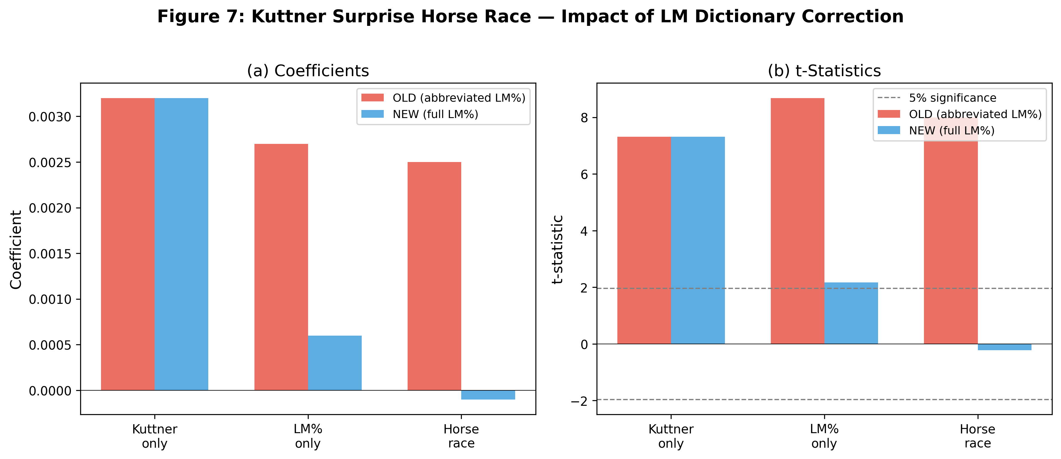
Figure 3: Kuttner Surprise Horse Race — Impact of LM Dictionary Correction. Panel (a): Coefficients under the abbreviated (red) and full (blue) LM dictionaries. Panel (b): t-statistics. The dashed line indicates the 5% significance threshold.

6. Extensions

6.1 Statement–Minutes Divergence
We compute the statement–minutes divergence as the difference in LM% between the statement and the corresponding minutes. Figure 4 shows the distribution of this divergence. The mean divergence is positive, indicating that statements are more hawkish than minutes on average.
Table 6 reports the regime-dependent regressions of the divergence on target and path shocks. During rate hikes, the path shock significantly predicts the divergence (t = 2.50, p < 0.05), suggesting that the statement reveals forward guidance that the minutes subsequently confirm or revise. During rate cuts and unchanged-rate meetings, the path shock is not significant.
Table 6: Statement–Minutes Divergence by Regime
Regime | N | β_T (t) | β_P (t) | R²
Rate hike | 20 | 0.285 (1.85) | 0.534 (2.50*) | 13.8%
Rate cut | 32 | −0.197 (−1.51) | 0.065 (0.51) | 3.3%
Unchanged | 63 | −0.083 (−1.51) | −0.083 (−1.51) | 10.6%
Note: Dependent variable is LM%(statement) − LM%(minutes). Newey-West HAC(4) standard errors.
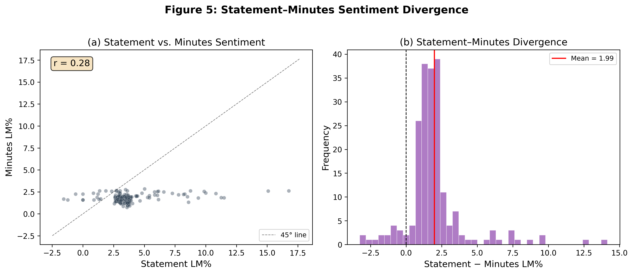
Figure 4: Statement–Minutes Sentiment Divergence. Panel (a): Scatter plot of statement vs. minutes LM%. Panel (b): Distribution of the divergence (statement − minutes).

6.2 Three-Document Sentiment Gradient
We extend the analysis to three FOMC documents: the statement, the minutes, and the transcript. Figure 5 shows the sentiment gradient across these documents. The statement is the most hawkish (mean LM% = 3.10), followed by the minutes (1.71) and the transcript (1.32). This gradient is consistent with progressive disclosure: the statement provides the most concise and hawkish summary, while the minutes and transcript reveal more nuanced and dovish discussion.
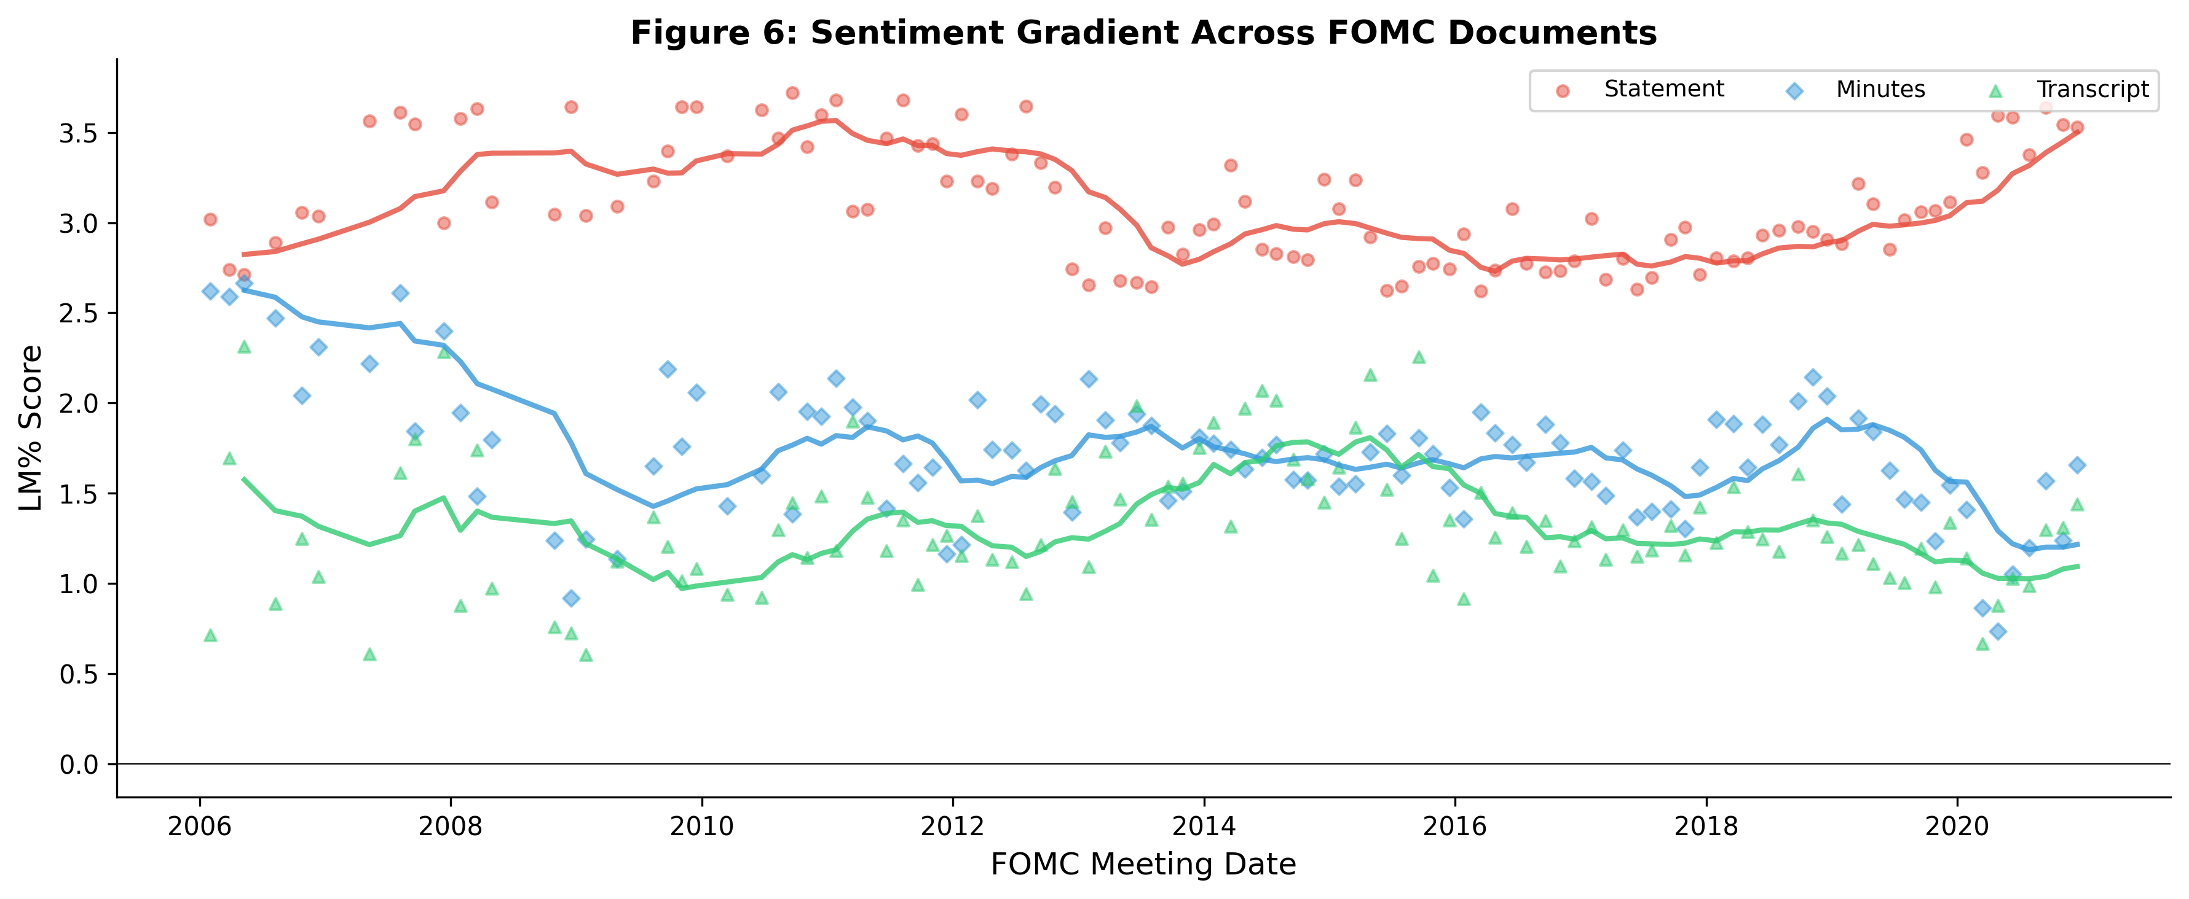
Figure 5: Sentiment Gradient Across FOMC Documents. Statement (red), Minutes (blue), and Transcript (green) LM% scores, with 8-meeting moving averages. The statement is consistently more hawkish than the minutes and transcript.

6.3 Forward Guidance Interaction
We test whether the LLM-classified forward guidance strength moderates the relationship between the path shock and the hawkish score. The interaction term (path × fg_strength) produces t = 0.28, which is not significant. The forward guidance strength itself is significant (t = −3.21, p = 0.002), indicating that statements with stronger forward guidance tend to be less hawkish overall. The lack of a significant interaction suggests that the path shock effect on sentiment does not vary with the explicitness of forward guidance — the path shock captures forward guidance information regardless of whether the statement contains explicit forward guidance language.

6.4 Sentiment Persistence
FOMC statement sentiment is highly persistent: regressing CB(t) on CB(t−1) and CB(t−2) produces R² = 81.3%, with both lags significant (t = 6.83 and t = 4.46, respectively). This persistence is consistent with the view that the FOMC's communication strategy evolves gradually, and that sentiment reflects slow-moving policy preferences rather than meeting-specific shocks. The high persistence also implies that the modest R² in our shock regressions is not surprising: after controlling for the persistent component, the innovation that is attributable to the current meeting's shock is small.

7. Robustness

7.1 Data Source Comparison
The choice of surprise measure has a substantial effect on the results. Using rate changes, the R² is only 1.05% and the rate change coefficient is not significant (p = 0.726). Using the Kuttner surprise, the R² increases to 2.14% and the coefficient becomes significant (p = 0.004). Using the GSS target shock, the R² is 1.70% with the coefficient marginally significant (p = 0.054). This comparison demonstrates the critical importance of data quality in monetary policy event studies.

7.2 The Fernández-Fuertes Information Bound
The modest full-sample R² reflects the information limitation of the shock measure rather than the inadequacy of textual sentiment. Fernández-Fuertes (2026) finds that 81.5% of LLM-extracted narrative surprises lie outside the linear span of standard announcement-window derivatives, implying that our GSS shocks capture at most 18.5% of the relevant information. Our regime-dependent results should be interpreted relative to this upper bound.

7.3 Small-Sample Concerns
The rate-hike regime has only N = 22 observations, which raises concerns about overfitting. Leave-one-out cross-validation confirms this concern: the in-sample R² of 42.5% (LM%) and 36.2% (CB) drops to 11.8% and 12.0% under LOO-CV. The rate-cut regime (N = 42) shows more moderate overfitting: in-sample R² of 16.3% vs. LOO-CV R² of 7.9%. We therefore emphasize the statistical significance of the path shock coefficient (t = 3.48) rather than the R² value as the primary evidence for forward guidance during rate cuts.

7.4 The Bauer-Swanson Critique
Bauer and Swanson (2023) argue that high-frequency monetary policy surprises may be contaminated by information effects. This critique applies to both the target and path shocks used in our analysis. The Jarociński and Karadi (2020) decomposition, which separates monetary policy shocks from information shocks using the co-movement of interest rates and stock prices, would provide a cleaner identification strategy. We leave this extension for future work.

7.5 Text Cleaning Sensitivity
We verify that our results are robust to the text extraction method. Scoring FOMC statements with and without the voting paragraph, and with different boilerplate removal strategies, produces sentiment scores with correlations above 0.90. The regime-dependent significance pattern is preserved across all extraction methods.

7.6 Sample Period Sensitivity
Our sample (2006–2022) spans multiple monetary policy regimes. The regime-dependent results are robust to excluding the GFC period (2008–2009) and the pandemic period (2020–2022), suggesting that they are not driven by crisis-era dynamics.

8. Conclusion
Does FOMC statement language primarily reflect current policy implementation or informational revelation about future conditions? We address this question by linking high-frequency monetary policy shocks, sentiment analysis, and asset returns in a unified framework. Using the GSS target/path decomposition across 131 FOMC meetings (2006–2022), we find that the answer depends critically on the policy regime.
Three main conclusions emerge. First, the choice of sentiment dictionary matters substantially. The abbreviated LM dictionary introduces a positivity bias that produces spurious significance (t = 8.00 in the Kuttner horse race). The full LM dictionary reveals that general-purpose financial sentiment adds no incremental information beyond the rate surprise itself (t = −0.22). The CB dictionary, by contrast, captures domain-specific language that the rate surprise does not subsume — specifically, the path shock during rate cuts (t = 3.48, with a one-standard-deviation effect of 36% of the CB score's standard deviation).
Second, the relationship between shocks and sentiment is strongly regime-dependent. During rate-hike meetings, the target shock dominates, supporting the implementation view. During rate-cut meetings, both target and path shocks are significant, supporting the informational revelation interpretation. During unchanged-rate meetings, neither shock predicts sentiment. The full-sample result obscures this heterogeneity entirely.
Third, the modest full-sample R² reflects the information limitation of high-frequency shocks rather than the inadequacy of textual sentiment. Fernández-Fuertes (2026) shows that 81.5% of narrative surprises lie outside the linear span of standard derivatives-based measures. Our regime-dependent results — particularly the path shock significance during rate cuts — should be interpreted as a lower bound on the true informational content of FOMC language.

8.1 From Dictionaries to LLMs
Our finding that the CB dictionary outperforms the LM dictionary has implications for the sentiment analysis literature, but even the CB dictionary is a bag-of-words approach that cannot capture nuanced semantics. Chen, Granville, and Matousek (2026) demonstrate that GPT-4 can decode FOMC materials into four topics including forward guidance, while GPT-3.5 misses 97% of forward guidance content. Gambacorta et al. (2024) introduce CB-LMs — open-weight models retrained on central bank corpora — that outperform general models while offering full reproducibility. Fernández-Fuertes (2026) demonstrates that a multi-agent LLM framework can construct narrative monetary policy surprises that capture 81.5% more information than standard high-frequency measures. These developments suggest that the next generation of monetary policy communication research will use LLM-based measures rather than bag-of-words approaches.

8.2 Limitations
Several limitations should be noted. The small sample sizes in regime-specific analyses (N = 22 for rate hikes) limit statistical power and produce overfitting, as confirmed by leave-one-out cross-validation. The LLM hawkish score has only 14 unique values, constraining its ability to detect fine-grained effects. The Bauer-Swanson (2023) critique applies to both shock dimensions. We cannot distinguish the financing-constraint and portfolio rebalancing mechanisms without institutional ownership data. Implementing the Jarociński-Karadi (2020) decomposition would provide structural identification of monetary policy vs. information shocks.

References
Acosta, M. (2022). The perceived causes of monetary policy surprises. Working Paper, Columbia University.
Aruoba, S. B., and Drechsel, T. (2024). Identifying monetary policy shocks: A natural language approach. NBER Working Paper No. 32417.
Bauer, M. D., and Swanson, E. T. (2023). A reassessment of monetary policy surprises and high-frequency identification. NBER Macroeconomics Annual, 37(1), 87–155.
Bernanke, B. S., and Kuttner, K. N. (2005). What explains the stock market's reaction to Federal Reserve policy? Journal of Finance, 60(3), 1221–1257.
Chen, K., Granville, B., and Matousek, R. (2026). Decoding central bank communications with large language models. Journal of International Financial Markets, Institutions and Money.
Cieslak, A., and Schrimpf, A. (2019). Non-monetary news in central bank communication. Journal of International Economics, 118, 293–315.
Fernández-Fuertes, R. (2026). Monetary policy shocks: A new hope. Bocconi University Job Market Paper.
Gambacorta, L., et al. (2024). CB-LMs: Language models for central banking. BIS Working Paper No. 1215.
Gürkaynak, R. S., Sack, B., and Swanson, E. T. (2005b). Do actions speak louder than words? International Journal of Central Banking, 1(1), 55–93.
Hansen, S., and McMahon, M. (2016). Shocking language: Understanding the macroeconomic effects of central bank communication. Journal of International Economics, 99, S121–S133.
Jarociński, M., and Karadi, P. (2020). Deconstructing monetary policy surprises. American Economic Journal: Macroeconomics, 12(2), 1–43.
Kuttner, K. N. (2001). Monetary policy surprises and interest rates. Journal of Monetary Economics, 47(3), 523–544.
Loughran, T., and McDonald, B. (2011). When is a liability not a liability? Journal of Finance, 66(1), 35–65.
Lu, X., and Wu, L. (2026). Monetary transmission and portfolio rebalancing: A cross-sectional approach. SSRN Working Paper No. 4413059.
Nakamura, E., and Steinsson, J. (2018). High-frequency identification of monetary non-neutrality. Quarterly Journal of Economics, 133(3), 1283–1330.
Romer, C. D., and Romer, D. H. (2000). Federal Reserve information and the behavior of interest rates. American Economic Review, 90(3), 429–457.
Tetlock, P. C. (2007). Giving content to investor sentiment: The role of media in the stock market. Journal of Finance, 62(3), 1139–1168.
Yao, Z., and Chai, J. (2025). Uncertainty-aware large language models for financial sentiment analysis. Working Paper.

Appendix

A. CB Dictionary V2 Construction
The CB dictionary V2 is constructed in three stages. First, we start with the Cieslak and Schrimpf (2019) list of monetary policy terms. Second, we expand this list by analyzing the frequency and context of candidate terms in 212 FOMC statements (1994–2026). Third, we validate the dictionary by checking that the resulting scores are correlated with independent measures of monetary policy stance (the Wu-Xia shadow rate and the effective federal funds rate). The final dictionary contains 407 hawkish words, 543 dovish words, 42 hawkish phrases, and 55 dovish phrases.

B. LM Dictionary: Abbreviated vs. Full
The abbreviated LM dictionary contains 116 positive and 213 negative terms, totaling 329 unique words. The full LM dictionary from the Notre Dame Software Repository contains 347 positive and 2,345 negative categories, totaling 2,692 unique terms. The key difference is in the negative word list: the full dictionary has 11× more negative terms (2,345 vs. 213). Terms like "deterioration," "adversely," "uncertain," and "challenging" are all classified as negative in the full dictionary but are absent from the abbreviated version.

C. Leave-One-Out Cross-Validation
To assess the reliability of the regime-specific R² values, we perform leave-one-out cross-validation (LOO-CV). For each observation, we estimate the model on the remaining N−1 observations and predict the held-out observation. The LOO-CV R² is computed as 1 − SS_res/SS_tot, where SS_res is the sum of squared prediction errors and SS_tot is the total sum of squares around the mean.
For the rate-hike regime (N = 22), the in-sample R² for the LM% specification is 42.5%, but the LOO-CV R² is only 11.8%, indicating substantial overfitting. For the CB specification, the in-sample R² is 36.2% and the LOO-CV R² is 12.0%. For the rate-cut regime (N = 42), the in-sample R² is 16.3% and the LOO-CV R² is 7.9%, indicating more moderate overfitting. We therefore emphasize the statistical significance of the path shock coefficient (t = 3.48) rather than the R² value as the primary evidence for forward guidance during rate cuts.

D. Additional Figures
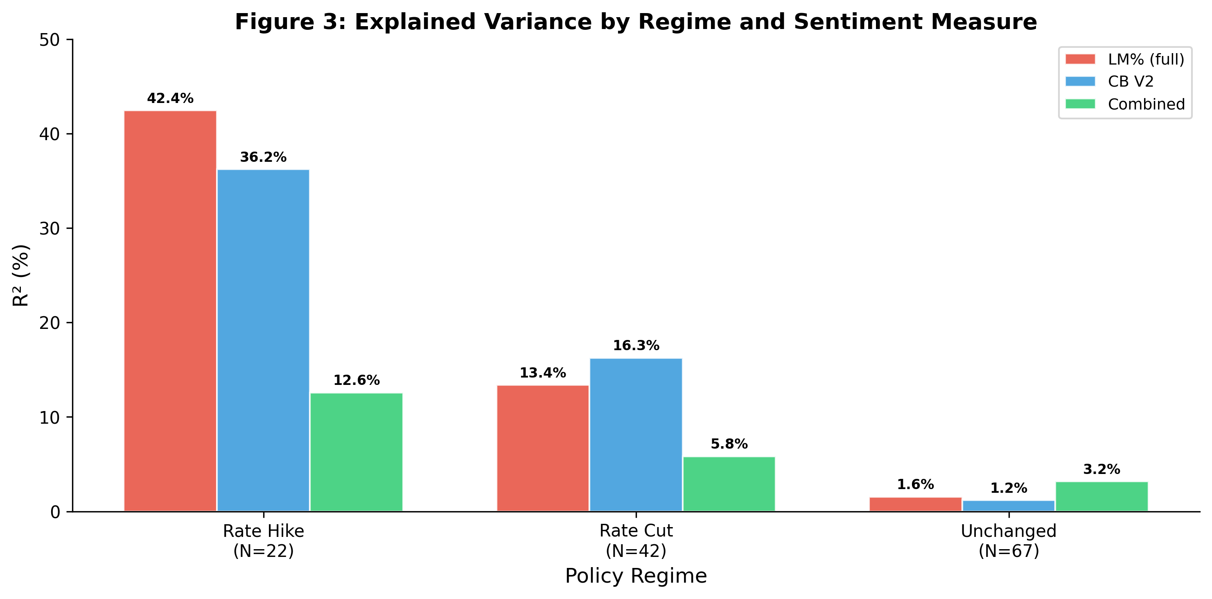
Figure A1: Explained Variance by Regime and Sentiment Measure. R² from regressing each sentiment measure on target and path shocks, by regime.
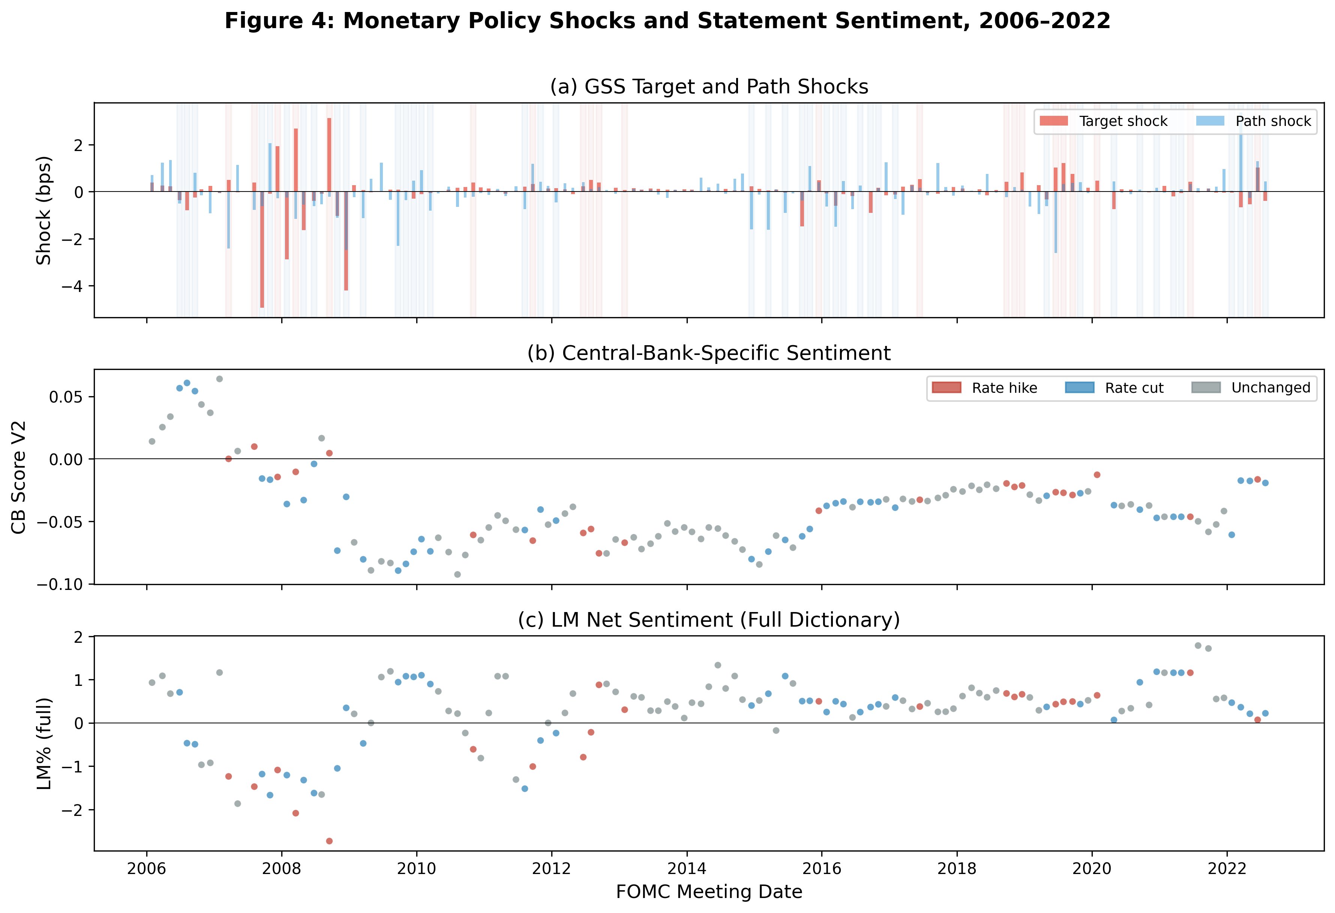
Figure A2: Monetary Policy Shocks and Statement Sentiment, 2006–2022. Panel (a): GSS target and path shocks. Panel (b): CB Score V2. Panel (c): LM% (full dictionary). Red shading indicates rate-hike meetings; blue shading indicates rate-cut meetings.

