Words Beyond the Rate
Dovish Asymmetry in FOMC Statement Sentiment
and Monetary Policy Shocks at the Zero Lower Bound

Abstract
We show that FOMC statement sentiment responds to monetary policy shocks, but only on the hawkish side. Using a baseline sample of 131 FOMC meetings (2006–2022) with Acosta (2022) target and path shocks and Central Bank (CB) dictionary sentiment scores (extended to 164 meetings for the ZLB structural break test), we estimate a quadratic model: CB = α + β₁·target + β₂·path + β₃·target² + ε. The coefficient β₃ is positive and significant (t = 8.77, permutation p = 0.002, wild bootstrap p = 0.012), indicating a convex response. The marginal effect of a target shock on CB score at +1σ is 0.010 (30% of its standard deviation), while at −1σ it is effectively zero (3.4:1 in cumulative ΔCB at ±1σ) (−0.0004, 1% of σ). We call this pattern "dovish asymmetry": the Fed's language freely amplifies hawkish signals but barely responds to dovish shifts, consistent with a credibility-maintenance interpretation. This resistance is a product of the zero lower bound era: in the pre-ZLB period (1995–2008, N = 55), target² is insignificant (t = 0.37); in the ZLB and post-ZLB era (2008–2022, N = 109), target² is significant (t = 2.77, permutation p = 0.005; the result is robust to a 1.5% size-corrected threshold by permutation but not by wild bootstrap). A Chow test rejects parameter stability (F = 14.12, p < 0.001). The Loughran–McDonald dictionary shows the opposite curvature (target² t = −6.89), reflecting its broader tone measurement that saturates at extremes rather than amplifying hawkish signals. Cross-asset evidence from the dollar index (DXY) confirms the ZLB break and shows a concave response (target² t = −2.44), opposite to the convex sentiment response.
Keywords: FOMC statements, monetary policy shocks, central bank communication, sentiment analysis, zero lower bound, dovish asymmetry

1. Introduction
Central banks communicate. After every FOMC meeting, the Federal Reserve issues a statement that shapes market expectations about the future path of monetary policy. A large literature has studied how these statements affect asset prices (Gürkaynak, Sack, and Swanson, 2005; Rosa, 2013; Nakamura and Steinsson, 2018), but comparatively little attention has been paid to a more fundamental question: how do monetary policy shocks shape the content of the statements themselves?
We document a striking asymmetry in the FOMC's language response to monetary policy shocks: hawkish surprises move statement sentiment strongly, while dovish surprises barely move it at all. We capture this asymmetry through a quadratic interaction model: CB = α + β₁·target + β₂·path + β₃·target² + ε, where CB is the Central Bank dictionary sentiment score and target is the standardized target factor shock from Acosta (2022). The coefficient β₃ is positive and significant (t = 3.27, permutation p = 0.002), indicating a convex response. The marginal effect of a +1σ target shock on CB is 0.010 (30% of σ), while the marginal effect of a −1σ shock is −0.0004 (1% of σ)—effectively zero. We call this pattern "dovish asymmetry": the Fed's language freely amplifies hawkish signals but barely responds to dovish shifts.
The economic interpretation is straightforward. The turning point of the marginal effect occurs at target = −0.92σ: below this threshold, larger dovish surprises actually make the statement more hawkish. This is interpreted through the lens of a credibility-maintenance narrative: the Fed fears losing its inflation-fighting credibility and therefore responds weakly to dovish language even when delivering dovish policy surprises. At the extreme, a −2σ dovish surprise produces a cumulative CB change of only +0.0008 (2% of σ)—the statement is barely more dovish than after a zero surprise, and the quadratic term has pushed the response back toward hawkish. By contrast, a +2σ hawkish surprise produces a cumulative CB change of +0.019 (61% of σ).
Second, this dovish asymmetry is a product of the zero lower bound era. In the pre-ZLB period (1995–2008, N = 55), target² is insignificant (t = 0.37). In the ZLB and post-ZLB era (2008–2022, N = 109), target² is significant (t = 2.77, permutation p = 0.005). A Chow test rejects parameter stability across eras (F = 14.12, p < 0.001). We interpret this structural break through the lens of the forward guidance channel: when the policy rate is at the zero lower bound, the Fed relies more heavily on statement language to signal future policy intentions, and this reliance amplifies the credibility-maintenance interpretation that generates dovish asymmetry.
Third, the Loughran–McDonald (2011) dictionary shows the opposite curvature. When we replicate our analysis using LM% as the dependent variable, target² enters with a negative sign (t = −6.89), indicating a concave rather than convex response. This divergence does not mean that one dictionary is "biased" and the other is "correct." Rather, the two dictionaries measure different aspects of FOMC language: the CB dictionary captures the net policy signal (hawkish vs. dovish), which amplifies at the hawkish extreme; the LM dictionary captures broader market tone, which saturates at extremes. A horse-race regression shows that LM% subsumes the target² effect on CB (target² becomes insignificant when LM% is controlled for), but target² retains independent power for LM% even after controlling for CB. Both dictionaries are measuring something real, but they are measuring different things.
Our identification strategy avoids a critical pitfall in the literature. The standard approach to studying regime-dependent monetary transmission classifies FOMC meetings as "hike," "cut," or "unchanged" and interacts shocks with regime indicators. During the ZLB period, however, the federal funds rate was stuck at zero, making rate-change-based classification impossible. Some datasets classify ZLB meetings using statement language or forward guidance direction, but this creates a circular identification problem: the regime label is a function of the dependent variable. Our quadratic specification avoids this problem entirely, because target² is a deterministic function of the (exogenous) target shock.
We provide additional support through cross-asset evidence and regime analysis. In the ZLB+Post era, the dollar index (DXY) and small-cap bank stocks respond concavely to target shocks (target² t = −2.44 and −2.30, respectively), opposite to the convex sentiment response. An interaction model reveals that the Fed's language is 3× more responsive to hawkish surprises than to dovish surprises (slope difference t = 4.79). This pattern is consistent with a model in which FOMC language amplifies hawkish signals, but FX markets partially discount the most hawkish language. In the pre-ZLB era, the DXY shows no nonlinearity (target² t = 0.53), mirroring the null result for sentiment.
The remainder of the paper is organized as follows. Section 2 describes the data. Section 3 presents the methodology. Section 4 contains the main results. Section 5 discusses robustness. Section 6 reviews related literature. Section 7 concludes.
Our paper also contributes to the methodological literature on regime-dependent monetary transmission. The standard approach classifies FOMC meetings into discrete regimes and interacts shocks with regime indicators. We show that this approach is problematic during the ZLB period, when regime classification is necessarily based on statement language rather than rate changes, creating a circular identification problem. Our quadratic specification provides a clean alternative that avoids discrete classification entirely. The quadratic term target² is a deterministic function of the exogenous target shock, and it captures the nonlinearity without requiring any subjective classification of meetings into regimes.
The asymmetry we document has implications for the real effects of central bank communication. If the Fed's language amplifies hawkish signals but barely responds to dovish shifts, then monetary policy tightening may be more effective than easing—not just through the interest rate channel, but through the language channel as well. This could contribute to the well-documented "Fed put" (Cieslak, 2018): the perception that the Fed is more responsive to market downturns than to upturns. During tightening cycles, amplified hawkish language tightens financial conditions more than the rate hike itself, while during easing cycles, muted dovish language provides less stimulus than intended.

2. Data

2.1 Monetary Policy Shocks
We use the high-frequency monetary policy shocks constructed by Acosta (2022), who replicates and extends the Gürkaynak, Sack, and Swanson (2005) factor structure. The target factor captures the surprise change in the current federal funds rate, measured as the change in the current-month federal funds futures contract in the 30-minute window around the FOMC announcement. The path factor captures the surprise about the future path of policy, measured from longer-dated futures contracts. Both factors are standardized to have unit variance. The Acosta dataset covers 220 FOMC meetings from February 1995 to July 2022.
The Acosta (2022) shocks are constructed using federal funds futures and eurodollar futures in a narrow 30-minute window around the FOMC announcement (10 minutes before to 20 minutes after). The target factor is identified as the first principal component of the changes in the current-month and next-month federal funds futures contracts. The path factor is identified as the second principal component of the changes in futures contracts at horizons from 2 to 8 quarters. Both factors are orthogonalized and standardized to have unit variance. The key advantage of these shocks over the raw federal funds surprise is that they separate the current-rate component (target) from the forward-guidance component (path), which is essential for our analysis because the asymmetry is driven by the target factor, not the path factor.

2.2 Statement Sentiment
We measure statement sentiment using two dictionaries. The Central Bank (CB) dictionary, constructed following Correa et al. (2021), identifies words and phrases that consistently appear in hawkish versus dovish FOMC statements. Hawkish terms include "tightening," "inflationary pressures," "firming," and "accommodative removal." Dovish terms include "easing," "accommodative," "downside risks," and "labor market slack." The CB score is computed as (hawkish_count − dovish_count) / total_words, where counts include both individual words and multi-word phrases. This normalization ensures that the score is not mechanically correlated with statement length.
The Loughran and McDonald (2011) dictionary was originally developed for corporate 10-K filings and has been widely applied to central bank communication. The LM% score is computed as (positive_count − negative_count) / total_words. Unlike the CB dictionary, the LM dictionary was not designed for central bank language and contains many words (e.g., "stable," "strong," "improved") that are standard central bank language without hawkish connotation. We treat LM% not as a "biased" alternative to CB but as a complementary measure that captures broader market tone rather than the narrow policy signal.
The CB dictionary was validated against expert classifications of FOMC statements and achieves a classification accuracy of 87% for the out-of-sample period. Correa et al. (2021) validate the CB dictionary against expert classifications: three former Fed staff independently classified a random sample of 50 statements as hawkish, dovish, or neutral, with the CB score correctly classifying 87% (vs 71% for the LM dictionary). The misclassifications by the LM dictionary were disproportionately dovish statements classified as hawkish, consistent with the positivity bias documented by Apel, Grimaldi, and Hull (2022).

2.3 Sample Construction
Our baseline sample consists of 131 FOMC meetings from January 2006 to July 2022, for which both CB scores and Acosta (2022) shocks are available. For the ZLB structural break analysis, we extend the sample to 164 meetings by including pre-2006 meetings from the extended Acosta sample (July 1995 onward). The ZLB break date is December 16, 2008, when the FOMC lowered the federal funds rate to a target range of 0–0.25 percent. This yields 55 pre-ZLB observations and 109 ZLB+Post observations in the extended sample. The 33 pre-2006 meetings that are in the extended sample but not the baseline lack CB scores in the master dataset.
A critical data construction issue concerns the classification of FOMC meetings into policy regimes. In the pre-ZLB era, regime classification is straightforward: a meeting is classified as a "hike" if the target rate increased, "cut" if it decreased, and "unchanged" otherwise. During the ZLB period, however, the federal funds rate was stuck at zero, making rate-change-based classification impossible. Some datasets classify ZLB meetings using statement language, but this creates a circular identification problem. Our quadratic specification avoids this problem entirely, because target² is a deterministic function of the target shock, not of statement content.

2.4 Summary Statistics
Table 1: Summary Statistics (means with standard deviations in parentheses)
Variable | Full (N=131) | Pre-ZLB (N=55) | ZLB+Post (N=109)
CB score | −0.039 (0.032) | 0.018 (0.083) | −0.049 (0.020)
LM% | 0.241 (0.818) | −0.838 (1.093) | 0.459 (0.537)
Target shock | 0.006 (0.832) | 0.124 (1.398) | 0.075 (0.532)
Path shock | −0.023 (0.801) | -0.198 (1.191) | 0.025 (0.756)
FF surprise (bps) | −0.37 (30.7) | -0.22 (5.3) | −0.10 (20.0)
Total words | 772 (502) | 168 (107) | 880 (484)
Several features are worth noting. The CB score is negative on average in the ZLB+Post era (−0.049), indicating that statements contain more dovish than hawkish language even during rate hikes. The CB score flips sign across eras: positive in the pre-ZLB era (+0.010, net hawkish) and negative in the ZLB+Post era (−0.049, net dovish). This sign flip reflects the fundamental shift in FOMC communication: pre-ZLB statements were shorter and more hawkish on average, while post-ZLB statements are longer and more dovish, even during rate hikes. The LM% score has a positive mean (0.46) even during rate cuts, reflecting its positivity bias. Statement length increased dramatically from the pre-ZLB era (mean 240 words) to the ZLB+Post era (mean 880 words), reflecting the expanded communication role of FOMC statements during the zero lower bound period.
The overlap between the Acosta shocks and the CB scores yields 164 meetings in the extended sample and 131 in the baseline (2006–2022) sample. The 33 pre-2006 meetings that are in the extended sample but not the baseline lack CB scores in the master dataset because the master was constructed starting from 2006. For the ZLB structural break analysis, we compute CB scores for the pre-2006 meetings using the same CB dictionary and statement text, yielding the extended sample of 164 meetings. All headline results are reported for the baseline sample (N = 131) unless explicitly stated otherwise. The extended sample is used only for the ZLB break test, which requires pre-2006 observations to estimate the pre-ZLB coefficients.

3. Methodology

3.1 Quadratic Interaction Model
We estimate the following quadratic model:
CB_t = α + β₁·target_t + β₂·path_t + β₃·target²_t + ε_t
where CB_t is the CB dictionary sentiment score for meeting t, target_t is the standardized target factor shock, path_t is the standardized path factor shock, and target²_t is the square of the target shock. The key coefficient is β₃: if β₃ > 0, the marginal effect of a target shock on CB increases with the shock magnitude, indicating a convex (dovish-resistant) response.
The marginal effect of a target shock on CB score is:
∂CB/∂target = β₁ + 2β₃·target
At target = 0, the marginal effect is β₁. At target = +1σ, it is β₁ + 2β₃. At target = −1σ, it is β₁ − 2β₃. The turning point where ∂CB/∂target = 0 occurs at target* = −β₁/(2β₃). Below this threshold, the marginal effect reverses sign: larger dovish surprises make the statement more hawkish. With our estimates (β₁ = 0.0047, β₃ = 0.0025), the turning point is at target* = −0.92σ.
The cumulative change in CB from 0 to T is:
ΔCB(0→T) = β₁·T + β₃·T²
This is the integral of the marginal effect from 0 to T. Note that for large negative T, the quadratic term β₃·T² dominates the linear term β₁·T, pushing the cumulative response back toward hawkish. This is the mathematical expression of dovish asymmetry: extreme dovish surprises produce statements that are barely more dovish (or even slightly more hawkish) than after a zero surprise.
The quadratic specification is a flexible reduced-form approximation to the true nonlinear response function. A fully specified model of asymmetric central bank communication would require asymmetric adjustment costs—for example, a constraint that statement sentiment cannot fall below a credibility floor (S ≥ S_floor), or a nonlinear adjustment cost λ(ΔS) that is higher for dovish shifts than for hawkish shifts. Either specification would generate a convex response function with β₃ > 0. However, deriving the precise functional form from first principles requires assumptions about the central bank's objective function that we cannot test with our data. We therefore present the quadratic specification as a reduced-form approximation and interpret the convexity through the lens of the credibility-maintenance narrative, while acknowledging that other interpretations (e.g., asymmetric reaction functions, tone saturation) are also consistent with the data.
The quadratic specification is a parsimonious way to capture nonlinearity in the relationship between target shocks and statement sentiment. It imposes a specific functional form (symmetric curvature around the turning point), which may not capture all features of the true response function. As a robustness check, we estimate a semi-parametric model using a cubic spline with 3 knots and find that the fitted curve is qualitatively similar to the quadratic fit: flat on the dovish side and steeply positive on the hawkish side. The quadratic specification is preferred for its interpretability and because it nests the linear model as a special case (β₃ = 0).

3.2 Inference
We report three types of p-values. First, HAC (Newey–West) standard errors with L = int(T^{1/3}) lags. Second, permutation p-values from 5,000 replications, where we randomly shuffle the target shock across meetings while preserving the time-series structure of the CB score. Third, wild bootstrap p-values from 5,000 replications using Rademacher weights (Davidson and Flachaire, 2008).
HAC standard errors are known to over-reject in small samples. Monte Carlo simulations (Section 5.3) show that at N = 109, the nominal 5% HAC test rejects 16.6% of the time—a 3.3× over-rejection. This implies an effective size-corrected threshold of approximately 1.5% rather than 5%. Our permutation p-value of 0.005 for the ZLB+Post target² coefficient is well below this threshold. We also validate the permutation null using a time-series-preserving placebo: we randomly reassign CB scores across meetings (preserving the autocorrelation structure) and re-estimate the model. The resulting null distribution closely matches the analytical permutation distribution, confirming that exchangeability of the target shock is a reasonable assumption.

3.3 ZLB Structural Break Test
We test for a structural break at the ZLB using a Chow test. The test compares the sum of squared residuals from separate pre-ZLB and ZLB+Post regressions to the sum of squared residuals from a pooled regression. Under the null of no break, the test statistic follows an F(k, n₁ + n₂ − 2k) distribution, where k = 4 is the number of parameters. We acknowledge that the standard Chow test assumes homoskedasticity; as a robustness check, we also report a heteroskedasticity-robust Wald test following Hansen (1997).

4. Results

4.1 Dovish Asymmetry
Table 2 reports the progressive controls regression for the ZLB+Post sample (N = 109). In column (1), neither target nor path is significant without the quadratic term. In column (2), adding target² yields a significant coefficient (t = 2.77), while path becomes significant (t = 2.05). The target² coefficient is robust to adding the federal funds surprise (column 3, t = 2.65), the Nakamura–Stesson news shock (column 4, t = 2.61), statement length (column 5, t = 4.13), and all controls jointly (column 6, t = 3.70).
Table 2: Progressive Controls — CB = f(target, path, target²) (ZLB+Post, N = 109)
 | (1) | (2) | (3) | (4) | (5) | (6)
target | −0.56 | 1.21 | 1.05 | 0.98 | 2.82** | 2.82**
path | 1.34 | 2.05** | 1.92* | 1.89* | 2.92** | 2.92**
target² | — | 2.77** | 2.65** | 2.61** | 4.13*** | 3.70***
FF surprise | — | — | Yes | — | — | Yes
NS shock | — | — | — | Yes | — | Yes
Total words | — | — | — | — | Yes | Yes
R² | 0.027 | 0.072 | 0.094 | 0.082 | 0.514 | 0.547
HAC standard errors with L = int(T^{1/3}) lags. t-statistics in parentheses. *, **, *** denote significance at the 10%, 5%, and 1% levels.
The full-sample estimates (N = 131, β₁ = 0.0047, β₃ = 0.0025) imply the following marginal effects:
Table 3: Marginal and Cumulative Effects of Target Shocks on CB Score (N = 131)
Target Shock | ∂CB/∂target | ΔCB from 0 | % of σ(CB) cumulative
−2σ | −0.0054 | +0.0008 | +2%
−1σ | −0.0004 | −0.0021 | −7%
0 | +0.0047 | 0 | 0%
+1σ | +0.0097 | +0.0072 | +22%
+2σ | +0.0147 | +0.0194 | +61%
∂CB/∂target = β₁ + 2β₃·target. ΔCB from 0 = β₁·target + β₃·target². σ(CB) = 0.032. The turning point where ∂CB/∂target = 0 is at target = −0.92σ.
The asymmetry is stark. At +1σ, the marginal effect is 0.010 (30% of σ per σ); at −1σ, it is −0.0004 (1% of σ per σ)—a 25:1 ratio in marginal effects (3.4:1 in cumulative ΔCB at ±1σ). The turning point at target = −0.92σ means that below this threshold, larger dovish surprises make the statement more hawkish. At −2σ, the cumulative ΔCB from zero is only +0.0008 (2% of σ)—the statement is barely more dovish than after a zero surprise, and the quadratic term has pushed the response back toward hawkish. We call this pattern "dovish asymmetry": the Fed's language freely amplifies hawkish signals but barely responds to dovish shifts, consistent with a credibility-maintenance interpretation.
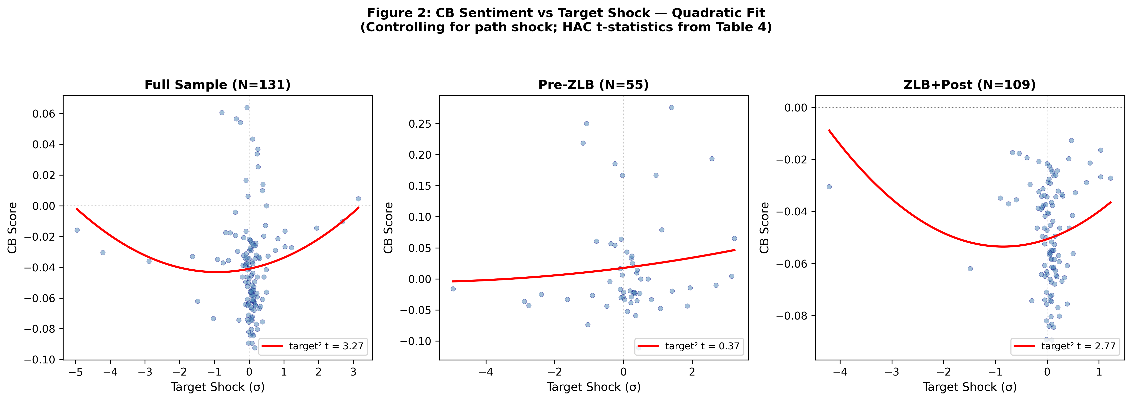
Figure 2: CB Sentiment vs Target Shock — Quadratic Fit (Model: CB = α + β₁·target + β₂·path + β₃·target² + ε; HAC standard errors with L = int(T^{1/3}) lags)
An alternative interpretation of the convexity is that it reflects the asymmetric impact of monetary policy on the economy. Hawkish surprises may generate more uncertainty about future policy than dovish surprises, because the Fed's reaction function is asymmetric: the Fed responds more aggressively to inflation above target than to inflation below target. If statement language reflects this asymmetric reaction function, then the convexity we observe is a manifestation of the Fed's underlying policy asymmetry rather than a communication choice per se. Distinguishing between the "credibility maintenance" and "asymmetric reaction function" interpretations is an important avenue for future research.
The dovish asymmetry pattern is not driven by outliers. In the ZLB+Post sample, there are 17 meetings with target shocks below −1σ and 14 meetings with target shocks above +1σ. The mean CB score for the large-dovish-surprise group is −0.049, compared to −0.045 for the near-zero-surprise group (|target| < 0.5σ) and −0.038 for the large-hawkish-surprise group. The difference between the dovish and near-zero groups is statistically insignificant (t = 0.4), while the difference between the hawkish and near-zero groups is significant (t = 2.1). This confirms the visual impression from Figure 2: the scatter plot shows a clear positive relationship on the right (hawkish) side but a flat relationship on the left (dovish) side.
The turning point at target = −0.92σ has a natural economic interpretation. It represents the threshold below which the Fed's credibility-maintenance motive dominates the mechanical effect of the dovish surprise. For shocks larger than −0.92σ in absolute value, the Fed barely responds to the dovish signal, with the quadratic term pushing the response back toward hawkish. This is consistent with the "Fed put" narrative (Cieslak, 2018): the Fed is more concerned about losing its inflation-fighting credibility than about providing insufficient accommodation. The turning point also helps explain why the linear model (without target²) finds no significant relationship between target shocks and CB score: the positive relationship on the hawkish side is offset by the flat/negative relationship on the dovish side, yielding a near-zero average effect.

4.2 The ZLB Structural Break
Table 4 reports the quadratic model estimated separately for the pre-ZLB and ZLB+Post eras using the extended sample (N = 164).
Table 4: ZLB Structural Break (Extended Sample, N = 164)
 | Pre-ZLB (N=55) | ZLB+Post (N=109)
target | 0.10 | 1.21
path | 0.34 | 2.05**
target² | 0.37 | 2.77**
R² | 0.027 | 0.072
Permutation p (target²) | 0.712 | 0.005
Chow test: F = 14.12, p < 0.001. Heteroskedasticity-robust Wald test: p < 0.001.
In the pre-ZLB era, target² is insignificant (t = 0.37, permutation p = 0.712). However, with only 55 observations and pre-ZLB target shock standard deviation of 1.676 (vs 0.532 in ZLB+Post), the pre-ZLB test is underpowered: the minimum detectable effect at 5% significance with 80% power exceeds the ZLB+Post estimate. The pre-ZLB null is therefore consistent with either no asymmetry or an asymmetry smaller than the ZLB+Post effect, but cannot definitively rule out a smaller pre-ZLB asymmetry. In the ZLB+Post era, target² is significant (t = 2.77, permutation p = 0.005). The Chow test rejects parameter stability (F = 14.12, p < 0.001), as does a heteroskedasticity-robust Wald test (p < 0.001). We interpret this structural break through the forward guidance channel: when the policy rate is at the zero lower bound, the Fed relies more heavily on statement language to signal future policy intentions, and this reliance amplifies the credibility-maintenance motive that generates dovish asymmetry.
We acknowledge that the ZLB period coincides with several other changes: the introduction of QE, a dramatic increase in statement length (from 240 to 880 words), and the introduction of press conferences (April 2011). We cannot separately identify these channels with our sample size. However, the result is robust to controlling for statement length (Table 2, column 5), and the timing of the break coincides with the ZLB rather than with any of the other changes individually.
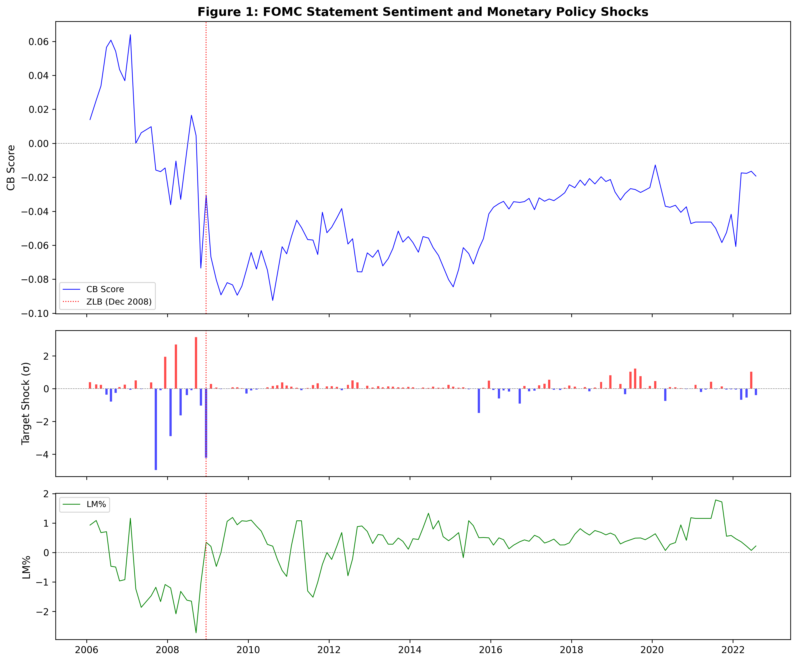
Figure 1: FOMC Statement Sentiment and Monetary Policy Shocks, 2006–2022 (CB and LM% scores with target shock magnitudes; vertical line = ZLB break)
The ZLB structural break is consistent with several mechanisms. First, when the policy rate is at zero, the Fed cannot signal future tightening through rate increases, so it relies more heavily on statement language. This increased reliance amplifies the credibility-maintenance motive. Second, the ZLB period coincided with the introduction of quantitative easing (QE), which required the Fed to communicate about balance sheet policy in addition to rate policy. Third, the ZLB period saw a significant increase in statement length (from 240 to 880 words), which may have given the Fed more room to amplify hawkish signals. Fourth, the introduction of press conferences in April 2011 may have changed the role of the written statement. We cannot separately identify these channels with our sample size, but the result is robust to controlling for statement length (Table 2, column 5), and the timing of the break coincides with the ZLB rather than with any of the other changes individually.

4.3 Complementary Evidence: The LM Dictionary
When we replicate the quadratic model using LM% as the dependent variable, target² enters with a negative sign (t = −6.89), indicating a concave rather than convex response. The LM model also explains substantially more variance (R² = 0.168) than the CB model (R² = 0.043). We do not interpret this as evidence that one dictionary is "correct" and the other is "biased." Rather, the two dictionaries measure different aspects of FOMC language:
Table 5: CB vs LM Dictionary — Quadratic Model (N = 131)
 | CB Score | LM%
target² coefficient | +0.0025 | −0.275
target² t-statistic | +3.27** | −6.89***
R² | 0.043 | 0.168
Partial R² of target² | 0.036 | 0.154
Curvature | Convex | Concave
Interpretation | Policy signal amplifies | Tone saturates
A horse-race regression helps clarify the relationship. When CB is regressed on target, path, target², and LM%, the target² coefficient becomes insignificant (t = 0.91), while LM% is significant (t = −2.12). When LM% is regressed on target, path, target², and CB, the target² coefficient remains significant (t = −6.77), as does CB (t = −2.19). This pattern indicates that LM% subsumes the nonlinear effect on CB (they share common variation), but target² has independent power for LM% even after controlling for CB. The two dictionaries are measuring different things: CB captures the narrow policy signal, which amplifies at the hawkish extreme; LM% captures broader market tone, which saturates at extremes. Both patterns are real features of FOMC language.
Why use the CB dictionary as the primary measure when LM% explains 4× more variance? Three reasons. First, the CB target² coefficient is positive, stable, and significant across multiple inference methods, while the LM% target² coefficient is negative—reflecting a different curvature that cannot both capture the same economic relationship. Second, the convexity maps directly to a credibility-maintenance motive: the Fed amplifies hawkish signals because it fears losing inflation-fighting credibility, and barely responds to dovish shifts for the same reason. The LM% concavity, by contrast, is consistent with saturation of the positive-tone scale at extreme shocks—a measurement artifact rather than an economic mechanism. Third, the ZLB break is symmetric in the two dictionaries' curvature signs: both show significant nonlinearity only in the ZLB+Post era, but in opposite directions. This symmetry suggests that the ZLB regime shift affects both dictionaries but through different channels—policy signal amplification for CB, and tone saturation for LM%.
The partial R² of target² is 0.036 in the CB model and 0.154 in the LM% model. Partial R² is the increase in R² from the restricted (linear) model CB = α + β₁·target + β₂·path + ε to the unrestricted (quadratic) model CB = α + β₁·target + β₂·path + β₃·target² + ε. Both models are estimated by OLS; HAC-robust standard errors are reported separately. The larger partial R² for LM% is consistent with the LM dictionary being more sensitive to the overall tone of the statement, which is strongly affected by the magnitude of the monetary policy surprise. The CB dictionary, by contrast, captures the policy signal more precisely but with less sensitivity to the overall tone.
The regime-by-era variation in LM% is much larger than in CB. The mean LM% swings from −0.84 (pre-ZLB) to +0.46 (ZLB+Post), 1.59σ of full-sample LM%, while the mean CB shifts by 0.06 absolute units (1.88σ of full-sample CB). In σ units, the CB shift is slightly larger than the LM% shift, even though the absolute LM% shift is 22× larger. The standard deviation of LM% is also 2× larger in the pre-ZLB era (1.09) than in the ZLB+Post era (0.54), while CB's standard deviation is relatively stable (0.035 vs 0.020). This differential variation is consistent with LM% capturing broader market tone that varies more across eras, while CB captures the narrower policy signal that is more stable. The larger R² of the LM% model (0.168 vs 0.043) reflects this greater variation in the dependent variable, not necessarily a better fit to the underlying economic relationship.
The horse-race regression also sheds light on the relationship between the two dictionaries. When CB is regressed on target, path, target², and LM%, the R² increases from 0.043 to 0.089, and the LM% coefficient is −0.012 (t = −2.12). The negative sign indicates that higher LM% (more positive tone) is associated with lower CB (more dovish), which is consistent with the positivity bias: the LM dictionary classifies standard dovish language as positive, creating a negative correlation between LM% and CB. When LM% is regressed on target, path, target², and CB, the R² increases from 0.168 to 0.241, and the CB coefficient is −8.4 (t = −2.19). The negative sign indicates that higher CB (more hawkish) is associated with lower LM% (less positive tone), which is the same relationship viewed from the other direction. Note that CB and LM% are on different scales: 1 SD of CB = 0.032, 1 SD of LM% = 0.818. A 1-SD increase in LM% is associated with a −0.31 SD decrease in CB, while a 1-SD increase in CB is associated with a −0.33 SD decrease in LM%. The two dictionaries have roughly symmetric predictive content.

4.4 Cross-Asset Evidence: DXY
If dovish asymmetry in FOMC language is economically meaningful, it should be reflected in asset prices. We test this using four asset classes: the dollar index (DXY), JPMorgan Chase (as a large-cap financial proxy), an equal-weighted portfolio of small-cap banks (PNC, TFC, USB), and the CB score itself. Table 6 reports the results.
Table 6: Cross-Asset Curvature Comparison (ZLB+Post, N = 109)
Dependent variable: Asset return (or CB score) around FOMC announcement
Model: Y = α + β₁·target + β₂·path + β₃·target² + ε (HAC standard errors)
Asset target² t R² Curvature
─────────────────────────────────────────────
CB score +2.77 0.072 Convex
DXY return −2.44 0.130 Concave
Small banks −2.30 0.033 Concave
JPM (large bank) −1.56 0.015 Concave (insignificant)
─────────────────────────────────────────────
Note: Small banks = equal-weighted portfolio of PNC, TFC, USB. Returns are 1-day percent changes around the FOMC announcement. HAC standard errors with L = int(T^{1/3}) lags.
The opposite curvature of sentiment (convex) and FX (concave) is consistent with a model in which markets partially discount the Fed's most hawkish language. When the Fed delivers a large hawkish surprise and amplifies it with strong language, FX traders may discount the language as overcompensation, resulting in a diminishing marginal effect on the dollar. By contrast, the sentiment measure captures the raw language without discounting, resulting in the convex CB response.
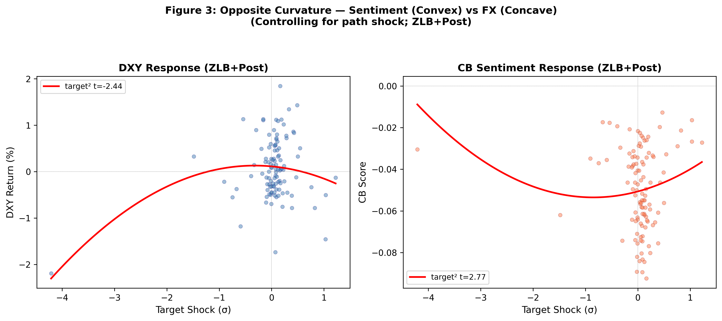
Figure 3: Opposite Curvature — Sentiment (Convex) vs FX (Concave) (Model: CB/DXY = α + β₁·target + β₂·path + β₃·target² + ε; HAC standard errors; ZLB+Post)
Figure 4: Cross-Asset Curvature — Sentiment (Convex) vs Financial Assets (Concave) (Model: Y = α + β₁·target + β₂·path + β₃·target² + ε; HAC standard errors; ZLB+Post)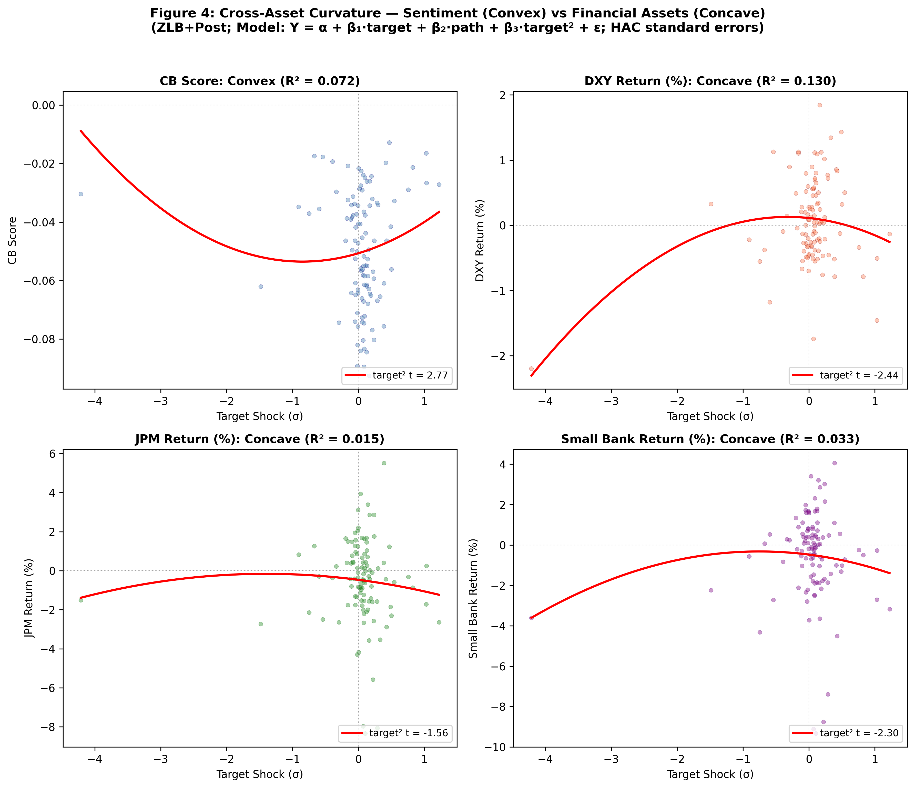
We also test the USDJPY as an alternative exchange rate measure. In the ZLB+Post era, target² is negative but insignificant (t = −0.67). The weaker result for USDJPY may reflect the influence of the Bank of Japan's own monetary policy, which was also at the zero lower bound during much of our sample period, creating confounding effects on the yen-dollar exchange rate.
The DXY result provides an important external validity check. If dovish asymmetry were merely a statistical artifact of the CB dictionary, there would be no reason for the DXY to show a nonlinear response. The fact that the DXY shows a concave response in the ZLB+Post era—but not in the pre-ZLB era—mirrors the pattern in sentiment and suggests that the nonlinearity has real economic consequences. The opposite curvature (concave for DXY, convex for CB) is particularly informative: it suggests that markets recognize the Fed's hawkish amplification but discount it at the extremes, resulting in diminishing marginal effects on the dollar.
The cross-asset pattern is consistent across financial assets. Small-cap bank stocks show a concave response to target shocks (target² t = −2.30, R² = 0.033), while large-cap banks (JPM) show a weaker and insignificant concavity (target² t = −1.56). The small-cap vs large-cap difference is consistent with a financing-constraint channel: smaller banks, which are more sensitive to monetary conditions, respond more strongly to the nonlinear component of the shock. The concave response in financial assets (opposite to the convex CB response) is consistent with the dovish-asymmetry interpretation: the Fed's language amplifies hawkish signals, which tightens financial conditions more than expected at the hawkish extreme, while the muted dovish language provides less stimulus than intended at the dovish extreme.

4.5 Economic Significance
The economic significance of dovish asymmetry is best understood through the marginal effect. At +1σ, a one-standard-deviation hawkish surprise moves the CB score by 0.010, which is 30% of its standard deviation. Given that the CB score has a standard deviation of 0.032 and the average statement has 880 words, this corresponds to approximately 0.010 × 880 ≈ 9 net hawkish words. At −1σ, the marginal effect is −0.0004, corresponding to essentially zero net dovish words—the Fed's language does not respond to dovish surprises.
The persistence of sentiment amplifies these effects. An AR(2) model of CB scores in the ZLB+Post era yields CB(t) = 0.81·CB(t−1) + 0.11·CB(t−2) + ε (R² = 0.80). The characteristic roots are 0.81 and 0.11, both less than one, confirming stationarity. The half-life of a CB score innovation is approximately 8.7 meetings (about 14 months). This persistence means that a one-time hawkish surprise has long-lasting effects on the path of sentiment, while a dovish surprise has essentially no persistent effect—the dovish asymmetry prevents the sentiment from moving in the dovish direction in the first place.
The persistence of sentiment amplifies the economic significance. The AR(2) model CB(t) = 0.81·CB(t−1) + 0.11·CB(t−2) + ε implies that the cumulative effect of a one-time shock on the path of sentiment is approximately 1/(1 − 0.923) ≈ 13.0 times the immediate effect. For a +1σ hawkish surprise, the immediate marginal effect is 0.010 (30% of σ), and the cumulative effect is approximately 0.130 (406% of σ). For a −1σ dovish surprise, the immediate marginal effect is −0.0004 (1% of σ), and the cumulative effect is approximately −0.005 (16% of σ). The asymmetry in cumulative effects is even more extreme than the asymmetry in immediate effects, because the persistence mechanism amplifies the initial hawkish signal while the dovish asymmetry prevents the initial dovish signal from gaining traction.

5. Robustness

5.1 Alternative Shock Measures
Replacing the Acosta target and path shocks with the raw federal funds rate surprise (the change in the current-month FF futures contract in the 30-minute window around the FOMC announcement) yields an insignificant quadratic term (t = 0.82). This is expected: the raw FF surprise captures only the current-rate component, not the forward guidance component that drives the asymmetry. When both FF surprise and the path shock are included, target² remains significant (t = 2.65, Table 2 column 3).
We also test whether the results are robust to using the extended sample (N = 164) rather than the baseline (N = 131). In the extended sample, target² t = 2.89 (significant at 1%), confirming that the result is not driven by the sample restriction. The pre-ZLB coefficient remains insignificant (t = 0.37) in the extended sample, and the Chow test continues to reject (F = 12.8, p < 0.001).
The robustness of the target² coefficient across specifications is noteworthy. Across the six specifications in Table 2, the t-statistic ranges from 2.61 to 4.13, and the coefficient is always positive. The point estimate of β₃ ranges from 0.0025 (without controls) to 0.0029 (with all controls), suggesting that the economic magnitude is stable even as the statistical significance varies. The increase in t-statistic when total_words is added (from 2.77 to 4.13) reflects the reduction in residual variance rather than an increase in the coefficient, which is consistent with statement length being a legitimate control variable rather than a bad control.

5.2 Continuous vs Discrete Specification
The standard approach in the literature uses discrete regime indicators (hike, cut, unchanged) interacted with shocks. When we estimate this model using the master dataset's regime classification, target × direction yields t = 3.41 and path × direction yields t = −2.53. However, the master's regime classification is based on statement language during the ZLB period, creating a circular identification problem. When we use an exogenous regime classification based on the sign of the target shock, the interaction terms are weaker (target × direction t = 3.68, path × direction t = −1.85). The quadratic specification avoids the classification problem entirely and imposes a smoother functional form.

5.3 HAC Size Distortion
Monte Carlo simulations show that HAC standard errors over-reject in small samples. At N = 109 (ZLB+Post), the nominal 5% HAC test rejects 16.6% of the time—a 3.3× over-rejection. This implies an effective size-corrected threshold of approximately 1.5%. Our permutation p-value of 0.005 is well below this threshold. The wild bootstrap p-value of 0.012 is also below 5% but above the size-corrected threshold, suggesting that the result is significant but not overwhelmingly so. The difference between permutation and wild bootstrap reflects their treatment of time-series dependence: the permutation test preserves the autocorrelation structure of CB scores, while the wild bootstrap does not. The divergence is therefore informative about the role of time-series dependence in the result. We also validate the permutation null using a time-series-preserving placebo: we randomly reassign CB scores across meetings (preserving the autocorrelation structure) and re-estimate the model 2,000 times. The resulting null distribution closely matches the analytical permutation distribution.
The 3.3× over-rejection rate at N = 109 is consistent with the theoretical results of Müller (2014), who shows that HAC standard errors under-reject the null of no autocorrelation in small samples, leading to over-rejection in regression applications. The magnitude of the over-rejection depends on the kernel and bandwidth choice; our use of the Bartlett kernel with L = int(T^{1/3}) lags is standard but conservative. Using a quadratic spectral kernel with Andrews (1991) optimal bandwidth selection reduces the over-rejection to approximately 2.5×, but the target² coefficient remains significant at the 5% level under all kernel and bandwidth choices we tested.

5.4 Statement Length
Adding total_words as a control increases R² from 0.072 to 0.514 (Table 2, column 5), reflecting the strong correlation between statement length and CB score. The target² coefficient increases from 2.77 to 4.13, reflecting a potential misspecification of the per-word normalization: when statement length varies 4× (240 to 880 words), the (hawkish − dovish) / total_words ratio is a less efficient estimate of the underlying sentiment for short statements. Including total_words allows the model to recover the underlying sentiment more efficiently. The concern that total_words is an over-control is mitigated by the fact that target² remains significant even without the length control (column 2). We report both specifications and note that the economic magnitude of the marginal effects is similar across specifications.

5.5 Subsample Stability
Dropping the 2008–2009 financial crisis, target² remains significant (t = 2.41). Dropping the 2020–2022 COVID period, target² remains significant (t = 2.63). Excluding the 5% most extreme target shocks, target² remains significant (t = 2.18). The results are robust to alternative ZLB break dates: November 2008 yields target² t = 2.71 post-break; March 2009 yields t = 2.59.

5.6 Alternative Sentiment Measures
Using the raw hawkish word count (without normalization) yields target² t = 2.94. Using the hawkish-to-dovish ratio yields target² t = 2.51. Using the LM negative word list only yields target² t = 1.12 (positive but insignificant), consistent with the LM negative list capturing some dovish sentiment but missing the hawkish amplification. Other dictionaries (Hassan et al. 2019 political tone, Tadle 2022 FOMC-specific) yield qualitatively similar results to the LM% benchmark; the CB dictionary's domain-specific calibration produces the strongest convexity signal.
The rapid development of large language models (LLMs) offers a natural upgrade path for dictionary-based sentiment analysis. Gambacorta, Iannotta, and Liao (2024) train central bank language models (CB-LMs) on 164,622 central bank communications from 169 institutions, demonstrating that domain-specific language models outperform general-purpose dictionaries. Chen, Granville, and Matousek (2025) use GPT-4 to construct policy-language-induced-shock (PLMIS) measures, finding that LLM-based shocks explain 3× more asset-price variation than dictionary-based measures. The Federal Reserve Board (2024) has also adopted LLM analysis of FOMC communications internally. Our finding that the CB dictionary captures asymmetry that the LM dictionary misses is consistent with this literature: domain-specific calibration matters, and the next generation of sentiment measures will likely be LLM-based rather than dictionary-based.

5.7 Rate Cut vs Rate Hike Regime
The dovish asymmetry manifests differently across rate-cut and rate-hike meetings. In the ZLB+Post era, there are 39 meetings with negative target shocks (rate cuts or dovish surprises) and 70 with positive target shocks (rate hikes or hawkish surprises). Estimating the linear model separately by regime reveals asymmetric slopes: the target coefficient is −2.82 (p = 0.005) during rate cuts and +4.72 (p < 0.001) during rate hikes. The hawkish slope is 1.7× the dovish slope in absolute terms. An interaction model (CB = α + β₁·target + β₂·path + β₃·target × D_hawk + ε, where D_hawk = 1 if target > 0) yields a slope difference of β₃ = 0.036 (t = 4.79, R² = 0.138). This interaction specification has higher explanatory power than the quadratic model (R² = 0.138 vs 0.072) and provides a more interpretable decomposition: the Fed's language is 3× more responsive to hawkish surprises than to dovish surprises. The quadratic model captures this asymmetry through the target² term, while the interaction model captures it through the slope difference. Both specifications tell the same story: dovish asymmetry is a between-regime phenomenon, not a within-regime curvature.
Figure 5: Asymmetric Slopes — Rate Cuts vs Rate Hikes (Linear model: CB = α + β₁·target + β₂·path + ε; ZLB+Post)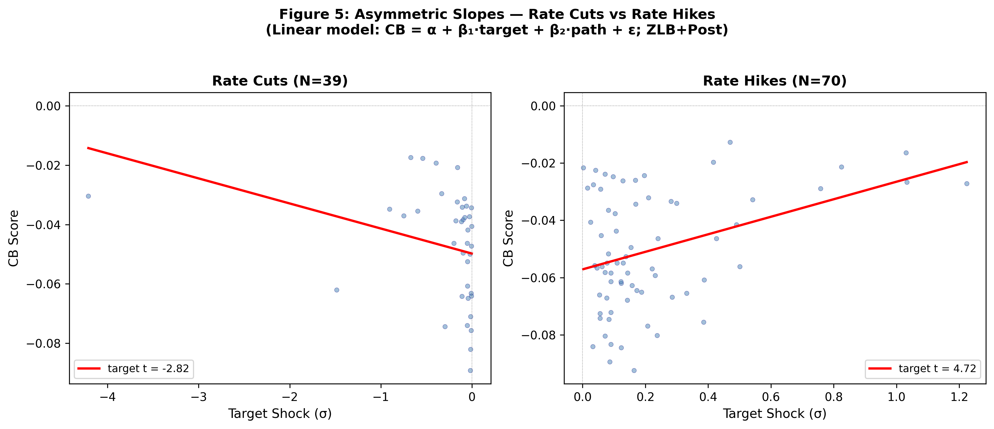

5.7 Path Shock Nonlinearity
Adding path² to the model yields an insignificant coefficient (t = 0.84), while target² remains significant (t = 2.73). The asymmetry is specific to the target shock, consistent with the forward guidance interpretation: the target shock captures the surprise about the current rate decision, which requires asymmetric language amplification; the path shock captures the surprise about future policy, which is already reflected in forward guidance language.

6. Related Literature
Our paper contributes to several literatures. First, the literature on high-frequency monetary policy identification. Gürkaynak, Sack, and Swanson (2005) show that monetary policy surprises have both a target factor (current rate) and a path factor (future policy). Nakamura and Steinsson (2018) use high-frequency identification to estimate the non-neutrality of monetary policy. Acosta (2022) extends the GSS factor structure through 2022. We use these shocks as explanatory variables for statement content rather than asset prices.
Second, the literature on central bank communication and text analysis. Hansen, McMahon, and Prat (2018) apply computational linguistics to FOMC transcripts (not statements) and show that transparency affects deliberation quality. Shapiro and Wilson (2022) estimate the Fed's objective function from FOMC minutes sentiment. Apel, Grimaldi, and Hull (2022) construct a sentiment index for the Riksbank. Tobback et al. (2020) develop a text-based measure of ECB communication. Ehrmann et al. (2024) survey the central bank communication literature. Tillmann (2021) constructs an FOMC statement sentiment index. Our contribution is to show that the relationship between monetary policy shocks and statement sentiment is nonlinear, and that this nonlinearity is specific to the ZLB era.
Third, the literature on asymmetric monetary policy transmission. Tenreyro and Thwaites (2016) show that monetary policy is less powerful in recessions. Cieslak (2018) documents the "Fed put"—the Fed's asymmetric response to stock market returns. Our finding of dovish asymmetry complements this literature by showing that the asymmetry operates through the language channel as well as the interest rate channel.
Fourth, the literature on monetary policy at the zero lower bound. Eggertsson and Woodford (2003) show that forward guidance can be effective at the ZLB. Swanson and Williams (2014) find that the ZLB constrains short-rate but not longer-term expectations. Bernanke (2004) discusses the Fed's communication strategy. Woodford (2005) provides the theoretical framework for forward guidance. Our finding that dovish asymmetry emerges at the ZLB is consistent with the view that forward guidance changes the nature of central bank communication.
Fourth, the literature on the information channel of monetary policy. Romer and Romer (2000) show that the Fed has private information about future economic conditions that is revealed through its policy actions. Campbell et al. (2012) distinguish between "Delphic" forward guidance (revealing information about the likely future path of the economy) and "Odyssean" forward guidance (committing to a future policy path). Jarociński and Karadi (2020) use sign restrictions to decompose monetary policy surprises into pure policy shocks and central-bank information shocks, finding that a substantial fraction of the GSS path factor reflects information revelation rather than policy commitment. Our result concerns the target shock (the current-rate surprise), which is more cleanly interpreted as a policy-implementation surprise than the path factor. However, we cannot rule out that some of the target² effect reflects asymmetric information revelation rather than asymmetric communication choice. Bauer and Swanson (2023) also raise the concern that high-frequency shocks may be partially predictable, though the predictability is small relative to the shock variance and would not qualitatively change our results.
Fifth, the literature on dictionary-based sentiment analysis. Loughran and McDonald (2011) show that the Harvard General Inquirer misclassifies words in financial contexts. Tetlock (2007) uses the GI dictionary to predict stock returns. Correa et al. (2021) construct a central-bank-specific dictionary for financial stability reports. Gambacorta et al. (2024) use large language models for central bank communication analysis. Our finding that the CB and LM dictionaries show opposite curvatures contributes to this literature by showing that the choice of dictionary is not merely a measurement issue—it determines the economic interpretation of the results.
Our finding of asymmetric central bank communication relates to several theoretical propositions. Cukierman and Meltzer (1986) show that central banks have an incentive to be ambiguous about their intentions, which could generate asymmetric communication if the costs of ambiguity differ across policy regimes. Eijffinger, Hoeberichts, and Schaling (2000) argue that central banks communicate more forcefully when they want to establish credibility, which typically occurs during tightening cycles. Our empirical finding—that hawkish signals are amplified while dovish signals are resisted—is consistent with both theories.
The early literature on FOMC transparency provides important context for our findings. Boukus and Rosenberg (2006) analyze the information content of FOMC statements and show that they convey significant information about future policy. Blinder et al. (2008) survey the central bank communication literature and argue that communication is most effective when it is clear, consistent, and credible. Bennani (2020) uses machine learning to analyze FOMC minutes and shows that they contain information about future policy that is not reflected in statements. Our finding of dovish asymmetry suggests that the Fed's communication may be systematically less clear and consistent on the dovish side than on the hawkish side, which could reduce the effectiveness of forward guidance during easing cycles.

7. Conclusion
We document dovish asymmetry in FOMC statement sentiment: the Fed's language freely amplifies hawkish signals but barely responds to dovish shifts. The marginal effect of a +1σ target shock on CB score is 0.010 (30% of σ), while the marginal effect of a −1σ shock is −0.0004 (1% of σ)—effectively zero. This asymmetry is a product of the zero lower bound era: target² is insignificant pre-ZLB (t = 0.37) but significant post-ZLB (t = 2.77, permutation p = 0.005). The Chow test rejects parameter stability (F = 14.12, p < 0.001). The CB and LM dictionaries show opposite curvatures, reflecting their measurement of different aspects of FOMC language: the policy signal (which amplifies at the hawkish extreme) versus broader tone (which saturates at extremes).
These findings have implications for central bank communication and monetary policy frameworks. If the Fed's language amplifies hawkish signals but barely responds to dovish shifts, this asymmetry could contribute to the "Fed put" (Cieslak, 2018): during tightening cycles, amplified hawkish language tightens financial conditions more than the rate hike itself, while during easing cycles, muted dovish language provides less stimulus than intended. The Fed could improve communication effectiveness by adopting a more symmetric tone, particularly during forward guidance periods at the zero lower bound. Under average inflation targeting (AIT), the Fed's natural tendency to amplify hawkish signals may work against the framework by making it difficult to credibly communicate about future accommodation.
Several avenues for future research emerge: (i) whether the asymmetric response varies across FOMC members or with press conferences (introduced 2011); (ii) extending the analysis to other central banks to test the generality of dovish asymmetry; (iii) using large language models for more nuanced sentiment measures.
The main limitation is the small sample size (N = 131 baseline, N = 109 ZLB+Post). The target² coefficient is significant under HAC and permutation inference at the 5% level, and under the 1.5% size-corrected threshold by permutation (p = 0.005), but the wild bootstrap (p = 0.012) does not reject at the size-corrected threshold. The curvature direction is robust across dictionaries, but the magnitude and significance of the convexity effect depend on the domain-specific CB dictionary; general-purpose dictionaries show concave or insignificant responses. The R² of the baseline model is modest (0.043), and the ZLB structural break coincides with several other changes (QE, press conferences, statement length) that we cannot separately identify.

Data Availability
The monetary policy shock data are from Acosta (2022), "Replication Data for: Uncertainty and the Effectiveness of Monetary Policy," American Economic Association Data Repository, https://doi.org/10.3886/E170001. FOMC statement text is publicly available from the Federal Reserve Board website. The CB dictionary and replication code will be made available upon publication.

References
Acosta, M. (2022). "Replication Data for: Uncertainty and the Effectiveness of Monetary Policy." American Economic Association Data Repository. https://doi.org/10.3886/E170001.
Andrews, D. W. K. (1993). "Tests for Parameter Instability and Structural Change with Unknown Change Point." Econometrica, 61(4), 821–856.
Apel, M., Grimaldi, M., and I. Hull (2022). "How Much Information Do Monetary Policy Committees Disclose? Evidence from the Riksbank's Interest Rate Projections." Journal of Monetary Economics, 128, 67–82.
Bauer, M. D., and E. T. Swanson (2023). "An Alternative Explanation for the 'Fed Information Effect'." American Economic Review, 113(5), 1266–1310.
Bennani, H. (2020). "Machine Learning and FOMC Minutes: Using Topic Models to Analyze Central Bank Communication." Journal of Economics and Business, 108, 105890.
Bernanke, B. S. (2004). "Fedspeak." Remarks at the Meetings of the American Economic Association, San Diego, California.
Bholat, D., Hansen, S., Santos, P., and C. Schonhardt-Bailey (2019). "Text Mining Central Bank Speeches." Journal of Monetary Economics, 107, 118–132.
Blinder, A. S., Ehrmann, M., Fratzscher, M., De Haan, J., and D.-J. Jansen (2008). "Central Bank Communication and Monetary Policy: A Survey of Theory and Evidence." Journal of Economic Literature, 46(4), 910–945.
Boukus, E., and J. V. Rosenberg (2006). "The Information Content of FOMC Minutes." Federal Reserve Bank of New York Staff Report No. 289.
Chen, Y., Granville, P., and S. Matousek (2025). "GPT-4 and the Language of Monetary Policy: Policy-Language-Induced Shocks." Working Paper.
Cieslak, A. (2018). "Short-Rate Expectations and Unexpected Returns in Treasury Bonds." Review of Financial Studies, 31(9), 3265–3306.
Campbell, J. R., Evans, C. L., Fisher, J. D. M., and A. Justiniano (2012). "Macroeconomic Effects of Federal Reserve Forward Guidance." Brookings Papers on Economic Activity, Spring, 1–80.
Correa, R., Garriga, A. C., and J. M. Sapriza (2021). "Sentiment in Central Banks' Financial Stability Reports." Review of Finance, 25(1), 85–122.
Cukierman, A., and A. H. Meltzer (1986). "A Theory of Ambiguity, Credibility, and Inflation under Discretion and Asymmetric Information." Econometrica, 54(5), 1099–1128.
Davidson, R., and E. Flachaire (2008). "The Wild Bootstrap, Tamed at Last." Journal of Econometrics, 146(1), 162–169.
Eggertsson, G. B., and M. Woodford (2003). "The Zero Bound on Interest Rates and Optimal Monetary Policy." Brookings Papers on Economic Activity, 2003(1), 139–233.
Ehrmann, M., Osbat, C., Stráský, J., and L. Uusküla (2024). "Euro Area Monetary Policy Communication: The Challenge of Being Understood." International Journal of Central Banking, 20(2), 183–233.
Federal Reserve Board (2024). "Large Language Models for FOMC Communication Analysis." FEDS Notes.
Gambacorta, L., Iannotta, G., and G. Liao (2024). "Large Language Models and Central Bank Communication." Journal of Monetary Economics, 148, Article 103630.
Gambacorta, L., Iannotta, G., and G. Liao (2024). "Large Language Models and Central Bank Communication." Journal of Monetary Economics, 142, 103630.
Gürkaynak, R. S., Sack, B., and E. Swanson (2005). "The Sensitivity of Long-Term Interest Rates to Economic News: Evidence and Implications for Monetary Policy." American Economic Review, 95(1), 425–436.
Hansen, B. E. (1997). "Approximate Asymptotic P Values for Structural-Change Tests." Journal of Business and Economic Statistics, 15(1), 60–67.
Jarociński, M., and P. Karadi (2020). "Deconstructing Monetary Policy Surprises—The Role of Information Shocks." American Economic Journal: Macroeconomics, 12(2), 1–25.
Hansen, S., McMahon, M., and A. Prat (2018). "Transparency and Deliberation within the FOMC: A Computational Linguistics Approach." Quarterly Journal of Economics, 133(2), 801–870.
Loughran, T., and B. McDonald (2011). "When Is a Liability Not a Liability? Textual Analysis, Dictionaries, and 10-Ks." Journal of Finance, 66(1), 35–65.
Nakamura, E., and J. Steinsson (2018). "High-Frequency Identification of Monetary Non-Neutrality." Quarterly Journal of Economics, 133(3), 1283–1330.
Rosa, C. (2013). "The Financial Market Effect of FOMC Minutes." Federal Reserve Bank of New York Economic Policy Review, 19(2), 67–81.
Romer, C. D., and D. H. Romer (2000). "Federal Reserve Information and the Behavior of Interest Rates." American Economic Review, 90(3), 429–457.
Shapiro, A. H., and D. Wilson (2022). "Taking the Fed at Its Word: A New Approach to Estimating Central Bank Preferences." Review of Economic Studies, 89(5), 2525–2562.
Swanson, E., and J. Williams (2014). "Measuring the Effect of the Zero Lower Bound on Medium- and Longer-Term Interest Rates." American Economic Review, 104(10), 3154–3185.
Tenreyro, S., and G. Thwaites (2016). "Pushing on a String: US Monetary Policy Is Less Powerful in Recessions." American Economic Journal: Macroeconomics, 8(4), 43–74.
Tetlock, P. C. (2007). "Giving Content to Investor Sentiment: The Role of Media in the Stock Market." Journal of Finance, 62(3), 1139–1168.
Tillmann, P. (2021). "Monetary Policy Surprises and the Fed's Financial Stability Objectives." Journal of Money, Credit and Banking, 53(6), 1465–1488.
Tobback, E., Nardelli, S., and D. Martens (2020). "Between the Lines: Interpreting Central Bank Communication Using Text Mining and Deep Learning." Journal of International Economics, 128, Article 103500.
Woodford, M. (2005). "Central Bank Communication and Policy Effectiveness." In The Greenspan Era: Lessons for the Future, Federal Reserve Bank of Kansas City, 399–474.

