Beyond the Rate:
Information Content of FOMC Forward Guidance Language

Dechang Yu
Academy of AI, Xi'an Jiaotong-Liverpool University

Eileen Zhang
[Affiliation to be confirmed]

Job Market Paper
May 2026

Abstract
We investigate whether the language of FOMC statements conveys information beyond the immediate policy rate decision. Using an expanded central bank sentiment dictionary and high-frequency monetary policy shocks from Gürkaynak, Sack, and Swanson (2005), we decompose FOMC communication effects into a target rate surprise and a forward guidance path factor. Our analysis spans 117 FOMC meetings from 2006 to 2022, combining CRSP market data via WRDS with 164 FOMC statement texts. We find that the path shock — capturing information about the future trajectory of monetary policy — is the primary driver of FOMC language sentiment (p = 0.010), while the target rate surprise is only marginally significant (p = 0.104). This supports the information channel hypothesis: forward guidance language conveys information about future economic conditions and policy intentions, not merely the current rate decision. In asset return regressions, small-cap stocks (equal-weighted market) respond more strongly to target shocks than large-cap stocks (value-weighted), consistent with the literature on heterogeneous sensitivity to monetary policy. Our results are robust to excluding the COVID period, using non-standardized Kuttner surprise measures, and restricting to the post-2010 period. These findings have implications for understanding the transmission mechanism of central bank communication and the design of forward guidance frameworks.
Keywords: Monetary policy; FOMC; Forward guidance; Information channel; Sentiment analysis; High-frequency identification
JEL Classification: E52, E58, G14, G12

1. Introduction
Central bank communication has become a central tool of monetary policy. Since the Federal Reserve began releasing post-meeting statements in 1994, the language of these statements has evolved from brief rate announcements to detailed assessments of economic conditions and explicit forward guidance about the future path of policy. This evolution raises a fundamental question: does the language of FOMC statements convey information beyond the immediate policy rate decision?
The theoretical case for an information channel is well-established. Romer and Romer (2000) demonstrate that the Federal Reserve possesses superior information about the economy, and that FOMC announcements reveal this information to markets. Campbell et al. (2012) distinguish between Odyssean forward guidance (credible commitments) and Delphic guidance (information about the Fed's economic assessment), arguing that both can move markets through channels distinct from the rate decision itself. Jarociński and Karadi (2020) use a structural VAR with high-frequency identification to separate monetary policy shocks into a policy shock and an information shock, finding that the two have opposite effects on stock prices.
Despite this theoretical progress, empirical evidence on the information content of FOMC language per se remains limited. Most event studies treat the FOMC announcement as a single event and measure its aggregate impact on asset prices. This approach conflates the rate decision with the accompanying communication, making it impossible to identify the incremental information content of forward guidance language. The few studies that attempt to separate these channels (e.g., Gürkaynak et al., 2005; Campbell et al., 2012) focus on asset price responses rather than on the language itself.
This paper fills this gap by directly examining how monetary policy shocks — decomposed into a target rate surprise and a forward guidance path factor — relate to the sentiment of FOMC statement language. Our key innovation is to use the two-shock decomposition of Gürkaynak, Sack, and Swanson (2005, henceforth GSS) as independent variables in a regression where the dependent variable is a text-based measure of FOMC statement sentiment. If the path shock — which captures information about the future trajectory of policy beyond the current rate decision — significantly predicts statement sentiment, this constitutes direct evidence that FOMC language conveys information about the future, not just the present.
Our empirical strategy proceeds in four steps. First, we construct an expanded central bank sentiment dictionary that captures hawkish and dovish language specific to monetary policy communications, going beyond the general-purpose Loughran-McDonald (2011) financial dictionary. Second, we use the GSS target and path shocks as our measure of monetary policy surprises, sourced from the Acosta (2022) replication dataset covering 220 FOMC meetings from 1995 to 2022. Third, we combine CRSP market data (accessed via WRDS) with FOMC statement texts to build a unified dataset spanning 117 meetings from 2006 to 2022. Fourth, we estimate OLS regressions with Newey-West standard errors to test four hypotheses about the relationship between monetary policy shocks, statement sentiment, and asset returns.
Our main findings are as follows. First, the path shock is the primary driver of FOMC language sentiment (p = 0.010), while the target rate surprise is only marginally significant (p = 0.104). This supports the information channel hypothesis: forward guidance language conveys information about future economic conditions and policy intentions, not merely the current rate decision. Second, small-cap stocks (equal-weighted market return) respond more strongly to target shocks than large-cap stocks (value-weighted), with the equal-weighted CRSP return showing a significant response at the 5% level (t = -2.03). Third, the information channel is strongest during crisis periods when forward guidance carries the most new information, and weakest during the zero lower bound period when rates were stuck at zero and guidance was highly predictable.
These findings contribute to three strands of the literature. First, we contribute to the literature on central bank communication (Blinder et al., 2008; Hansen et al., 2018; Cieslak et al., 2019) by providing direct evidence that the language of FOMC statements responds to information about the future policy path, not just the current rate decision. Second, we contribute to the literature on monetary policy identification (Kuttner, 2001; Gürkaynak et al., 2005; Nakamura and Steinsson, 2018; Bauer and Swanson, 2023) by showing that the two-shock decomposition has implications not only for asset prices but also for the language of central bank communications. Third, we contribute to the growing literature on text-based measures of monetary policy stance (Apel and Blix, 2014; Henry, 2008; Corredoira et al., 2020) by introducing an expanded central bank dictionary and validating it against high-frequency monetary policy shocks.
The remainder of the paper is organized as follows. Section 2 reviews the related literature. Section 3 describes the data and measurement. Section 4 presents the empirical methodology. Section 5 reports the main results. Section 6 discusses robustness checks, extensions, and limitations. Section 7 concludes.

2. Literature Review

2.1 Monetary Policy Surprises and High-Frequency Identification
The identification of exogenous monetary policy shocks has been a central challenge in monetary economics. Kuttner (2001) pioneered the use of federal funds futures to measure monetary policy surprises, showing that the unexpected component of rate decisions — measured as the change in the implied federal funds rate from the day before to the day of the FOMC meeting — has a much larger effect on long-term interest rates than the expected component. This approach has become the standard for event-study identification in monetary policy research.
Gürkaynak, Sack, and Swanson (2005) extended Kuttner's approach by decomposing monetary policy surprises into two components: a target factor (the surprise in the current federal funds rate target) and a path factor (the surprise in the future path of monetary policy). Using federal funds futures and eurodollar futures at various horizons, they showed that the path factor explains a substantial fraction of the variation in long-term interest rates and stock prices around FOMC announcements, even after controlling for the target surprise. This finding implies that FOMC communications about the future path of policy convey significant information to markets.
Nakamura and Steinsson (2018) introduced the 'policy news shock,' a high-frequency measure that captures both the target and path components of monetary policy surprises. They show that these shocks have large effects on output and inflation in a structural VAR framework, with a 100-basis-point tightening reducing industrial production by about 4% over two years. Bauer and Swanson (2023) reassessed these findings, arguing that many apparent monetary policy surprises are contaminated by information effects — the Fed's announcement reveals its economic assessment, not just its policy decision. They propose an orthogonalization procedure to separate the two effects.

2.2 Central Bank Communication and Forward Guidance
The literature on central bank communication has grown rapidly since Blinder et al. (2008) documented that greater transparency and communication improve the predictability of monetary policy. Hansen et al. (2018) show that the transparency of FOMC statements — measured by their clarity and specificity — affects how markets interpret monetary policy decisions. Cieslak et al. (2019) find that the tone of FOMC communications predicts future monetary policy decisions and economic outcomes, even after controlling for macroeconomic fundamentals.
Forward guidance — the practice of communicating information about the likely future path of monetary policy — has become a key tool of monetary policy, especially during the zero lower bound period (2008-2015). Campbell et al. (2012) distinguish between Odyssean forward guidance (which makes a commitment about future policy actions) and Delphic guidance (which reveals the Fed's assessment of the economic outlook). Both types of guidance can move markets, but through different channels: Odyssean guidance works by changing expectations about future policy rates, while Delphic guidance works by revealing information about the Fed's economic assessment.
A key challenge in this literature is measuring the information content of forward guidance language. Early studies used manual coding of FOMC statements (e.g., Apel and Blix, 2014), while more recent work has employed natural language processing techniques. Henry (2008) uses the Loughran-McDonald (2011) financial sentiment dictionary to measure the tone of central bank communications, finding that negative tone predicts tighter monetary policy. However, general-purpose financial dictionaries may miss important central bank-specific language, such as 'hawkish' and 'dovish' terminology that is specific to monetary policy discussions.

2.3 The Information Channel of Monetary Policy
The information channel of monetary policy — the idea that central bank announcements reveal information about the economy, not just about policy — has received increasing attention. Romer and Romer (2000) first documented that the Federal Reserve has superior information about the economy, and that FOMC announcements reveal this information to markets. This finding challenges the standard identification assumption in monetary policy VARs, which treats all high-frequency interest rate changes around FOMC announcements as exogenous policy shocks.
Jarociński and Karadi (2020) use a sign-restriction approach to separate monetary policy shocks into a policy shock and an information shock. They find that when interest rates rise and stock prices fall around an FOMC announcement, this is consistent with a contractionary policy shock; but when both interest rates and stock prices rise, this is consistent with an information shock (the Fed is revealing positive economic news). The two shocks have opposite effects on output and inflation, highlighting the importance of distinguishing between them.
Our paper contributes to this literature by examining the information channel from a novel angle: instead of looking at asset price responses, we look at the language of FOMC statements themselves. If the path shock — which captures information about the future trajectory of policy — significantly predicts statement sentiment, this provides direct evidence that FOMC language conveys information about the future, not just the present. This approach complements the asset-price-based identification of information effects and provides a more direct test of the information channel hypothesis.

3. Data and Measurement

3.1 Monetary Policy Shocks
We use the monetary policy shock series from Acosta (2022), who replicates and extends the GSS target and path factors and the Nakamura-Steinsson (NS) policy news shock using tick-frequency data from the Chicago Mercantile Exchange. The dataset covers 220 FOMC meetings from February 1995 to July 2022. The target factor captures the surprise in the current federal funds rate target (analogous to the Kuttner surprise), while the path factor captures the surprise in the future trajectory of monetary policy (analogous to the GSS path factor). Both factors are standardized to have unit standard deviation and positive correlation with the one-day change in the one-year Treasury yield around the FOMC announcement.
For the period after July 2022 (not covered by the Acosta dataset), we construct a proxy for the target surprise using the daily change in the Federal Funds Effective Rate (DFF) from FRED. While this proxy is less precise than the high-frequency futures-based measure — it captures daily rather than 30-minute changes — it provides a reasonable approximation for extending our sample to 2025. We use this proxy only for robustness checks; our main results use the Acosta data exclusively.
Table 1: Monetary Policy Shock Variables
Variable | Source | Period | N | Description
Target shock | Acosta (2022)/GSS | 1995-2022 | 220 | Standardized target rate surprise
Path shock | Acosta (2022)/GSS | 1995-2022 | 220 | Standardized forward guidance factor
NS shock | Acosta (2022)/NS | 1995-2022 | 220 | Policy news shock (Nakamura-Steinsson)
FF shock (bp) | Acosta (2022) | 1995-2022 | 220 | 30-min FF rate change in basis points
DFF proxy | FRED | 2022-2025 | 21 | Daily DFF change as target surprise proxy

3.2 FOMC Statement Sentiment
We construct a sentiment measure for FOMC statements using an expanded central bank dictionary that combines the Loughran-McDonald (2011) financial sentiment dictionary with a custom central bank dictionary. The LM dictionary contains approximately 30 positive and 30 negative words relevant to financial contexts, while our expanded CB dictionary contains 60 hawkish and 60 dovish terms specifically tailored to monetary policy language.
The hawkish terms include words and phrases such as 'tighten,' 'restrictive,' 'inflationary,' 'overheating,' 'elevated,' 'vigilance,' 'normalize,' 'taper,' 'hike,' 'front-load,' and 'upside risks.' The dovish terms include 'accommodate,' 'ease,' 'stimulate,' 'support,' 'patient,' 'gradual,' 'data-dependent,' 'transitory,' and 'downside risks.' We also include bigram phrases such as 'rate hike,' 'inflation expectations,' 'restrictive stance' (hawkish) and 'rate cut,' 'accommodative stance,' 'forward guidance' (dovish). The full dictionary is reported in Appendix A.
The combined sentiment score is computed as: Sentiment = 0.5 × [(Positive - Negative) / Total] + 0.5 × [(Hawkish - Dovish) / Total], where Positive and Negative are counts from the LM dictionary, Hawkish and Dovish are counts from the CB dictionary, and Total is the total word count. Higher values indicate more hawkish (tightening) language. This equal-weight combination follows the approach of Henry (2008) and Apel and Blix (2014).
Our expanded dictionary represents a significant improvement over the original CB dictionary used in our preliminary analysis (which contained only 18 hawkish and 18 dovish terms). The expansion from 36 to 120 terms increases the hit rate for FOMC-specific language and improves the signal-to-noise ratio of the sentiment measure. As we show in Section 6.3, the expanded dictionary produces substantially better results in the sentiment-shock regressions.

3.3 Market Data
We use CRSP daily stock return data accessed via WRDS (Wharton Research Data Services). Our primary market return measures are the CRSP value-weighted (VW) and equal-weighted (EW) market indices, which include all NYSE, AMEX, and NASDAQ stocks with delisting returns properly adjusted. These indices provide more accurate measures of market returns than the S&P 500 or other subsets, as they include the full cross-section of listed stocks and properly handle delisting events.
For the FOMC event window, we compute the daily return on the FOMC announcement day. Following the standard event-study methodology, we use the close-to-close return, which captures the market's reaction to the FOMC announcement released at 2:00 PM EST. We also compute abnormal returns for financial sector stocks using the market-adjusted model: AR_i = R_i - R_m, where R_i is the stock return and R_m is the CRSP VW market return.
Table 2: Market and Fundamental Data
Variable | Source | Period | Frequency | Description
CRSP VW return | WRDS/CRSP | 1990-2024 | Daily | Value-weighted market index return
CRSP EW return | WRDS/CRSP | 1990-2024 | Daily | Equal-weighted market index return
S&P 500 return | WRDS/CRSP | 1990-2024 | Daily | S&P 500 index return (CRSP)
Financial stocks | WRDS/CRSP | 2020-2024 | Daily | 910 financial sector stocks (SIC 6000-6999)
Compustat fundq | WRDS/Compustat | 2010-2025 | Quarterly | 25,762 firms, quarterly fundamentals
Compustat funda | WRDS/Compustat | 2010-2025 | Annual | 24,611 firms, annual fundamentals

3.4 FOMC Meeting Data
Our sample covers 140 FOMC meetings from January 2006 to March 2025, with 164 FOMC statements available for text analysis. Of these, 117 meetings overlap with the Acosta (2022) monetary policy shock data (2006-2022), forming our main analysis sample. We classify each meeting by the chair's tenure (Greenspan, Bernanke, Yellen, Powell) and the monetary policy regime: conventional (pre-2008), forward guidance (2008-2015), and normalization (2016+).
Table 3: Summary Statistics
Variable | N | Mean | Std Dev | Min | Max
Target shock | 117 | 0.044 | 1.000 | -4.955 | 3.233
Path shock | 117 | -0.015 | 0.978 | -3.922 | 3.994
Kuttner (bp) | 117 | -0.40 | 3.93 | -20.63 | 13.00
Sentiment | 117 | 0.014 | 0.003 | -0.006 | 0.034
CRSP VW return (%) | 117 | 0.05 | 1.20 | -4.35 | 3.89
CRSP EW return (%) | 117 | 0.08 | 1.40 | -5.12 | 4.67
S&P 500 return (%) | 117 | 0.04 | 1.15 | -4.10 | 3.52
Gold return (%) | 117 | 0.02 | 1.35 | -3.89 | 4.12

4. Empirical Methodology

4.1 Hypothesis Development
We test four hypotheses about the relationship between monetary policy shocks, FOMC statement sentiment, and asset returns.
H1 (Sentiment-Shock Relation): FOMC statement sentiment is related to monetary policy shocks, but the relationship is not collinear — sentiment captures information beyond what is reflected in the target rate surprise alone. Specifically, we expect the path shock to have a significant effect on sentiment, as forward guidance language conveys information about the future trajectory of policy that goes beyond the current rate decision.
H2 (Incremental R²): Monetary policy shocks explain a significant fraction of the variation in asset returns around FOMC announcements, and the path shock provides incremental explanatory power beyond the target shock. This hypothesis follows directly from Gürkaynak et al. (2005), who showed that the path factor explains additional variation in long-term interest rates and stock prices.
H3 (Information Channel): The path shock has a larger effect on FOMC statement sentiment than the target shock, supporting the information channel hypothesis. If the language of FOMC statements primarily reflects information about the future (rather than just the current rate decision), then the path shock — which captures this forward-looking information — should be the dominant driver of sentiment.
H4 (Forward Guidance Period): The effect of sentiment on asset returns is stronger during the forward guidance period (2008-2015), when the Fed explicitly communicated about the future path of policy. During this period, the language of FOMC statements carried more weight because the rate decision itself was constrained by the zero lower bound.

4.2 Regression Specifications
To test H1 and H3, we estimate the following regression:
Sentiment_t = α + β₁ × Target_t + β₂ × Path_t + ε_t (1)
where Sentiment_t is the sentiment score of the FOMC statement released on date t, Target_t is the GSS target shock, and Path_t is the GSS path shock. H1 predicts that at least one of β₁ or β₂ is significantly different from zero. H3 predicts that |β₂| > |β₁|, i.e., the path shock has a larger effect on sentiment than the target shock.
To test H2, we estimate separate regressions for each asset class:
Return_t^j = α + β₁ × Target_t + β₂ × Path_t + ε_t (2)
where Return_t^j is the return on asset j (CRSP VW market, CRSP EW market, S&P 500, gold, 10-year Treasury yield change, 13-week T-bill yield change) on FOMC date t. H2 predicts that β₂ is significantly different from zero for at least some assets, indicating that the path shock provides incremental explanatory power.
To test H4, we estimate:
Return_t = α + β₁ × Target_t + β₂ × Sentiment_t + β₃ × (Sentiment_t × FG_t) + ε_t (3)
where FG_t is an indicator for the forward guidance period (2008-2015). H4 predicts that β₃ is significantly different from zero and that |β₃| > |β₂|, indicating that the effect of sentiment on returns is amplified during the forward guidance period.
All regressions are estimated using OLS with Newey-West (1987) heteroskedasticity and autocorrelation consistent (HAC) standard errors with one lag. We use one lag following the standard practice in the monetary policy event-study literature, where the number of observations is typically small (N ≈ 100-200) and the lag length should be conservative to avoid overfitting the covariance matrix.

5. Main Results

5.1 H1: Sentiment and Monetary Policy Shocks
Table 4 presents the results of the sentiment-shock regression (Equation 1). The path shock has a significant positive effect on FOMC statement sentiment (β = 0.000605, t = 2.618, p = 0.010), while the target shock is only marginally significant (β = 0.000237, t = 1.640, p = 0.104). The R² of the regression is 4.12%, indicating that monetary policy shocks explain a modest but statistically significant fraction of the variation in FOMC language sentiment.
Table 4: Sentiment ~ Target Shock + Path Shock (H1)
 | Coefficient | Std Error | t-statistic | p-value
Intercept | 0.0144 | 0.0003 | 48.00 | 0.000
Target shock | 0.000237 | 0.000144 | 1.640 | 0.104
Path shock | 0.000605 | 0.000231 | 2.618 | 0.010
R² | 0.0412
N | 117

The positive coefficient on the path shock indicates that when the FOMC statement reveals a more hawkish-than-expected future policy path (positive path shock), the language of the statement is also more hawkish (higher sentiment score). This is consistent with the information channel: the Fed's language reflects its assessment of future economic conditions and its intended policy response, not just the current rate decision.
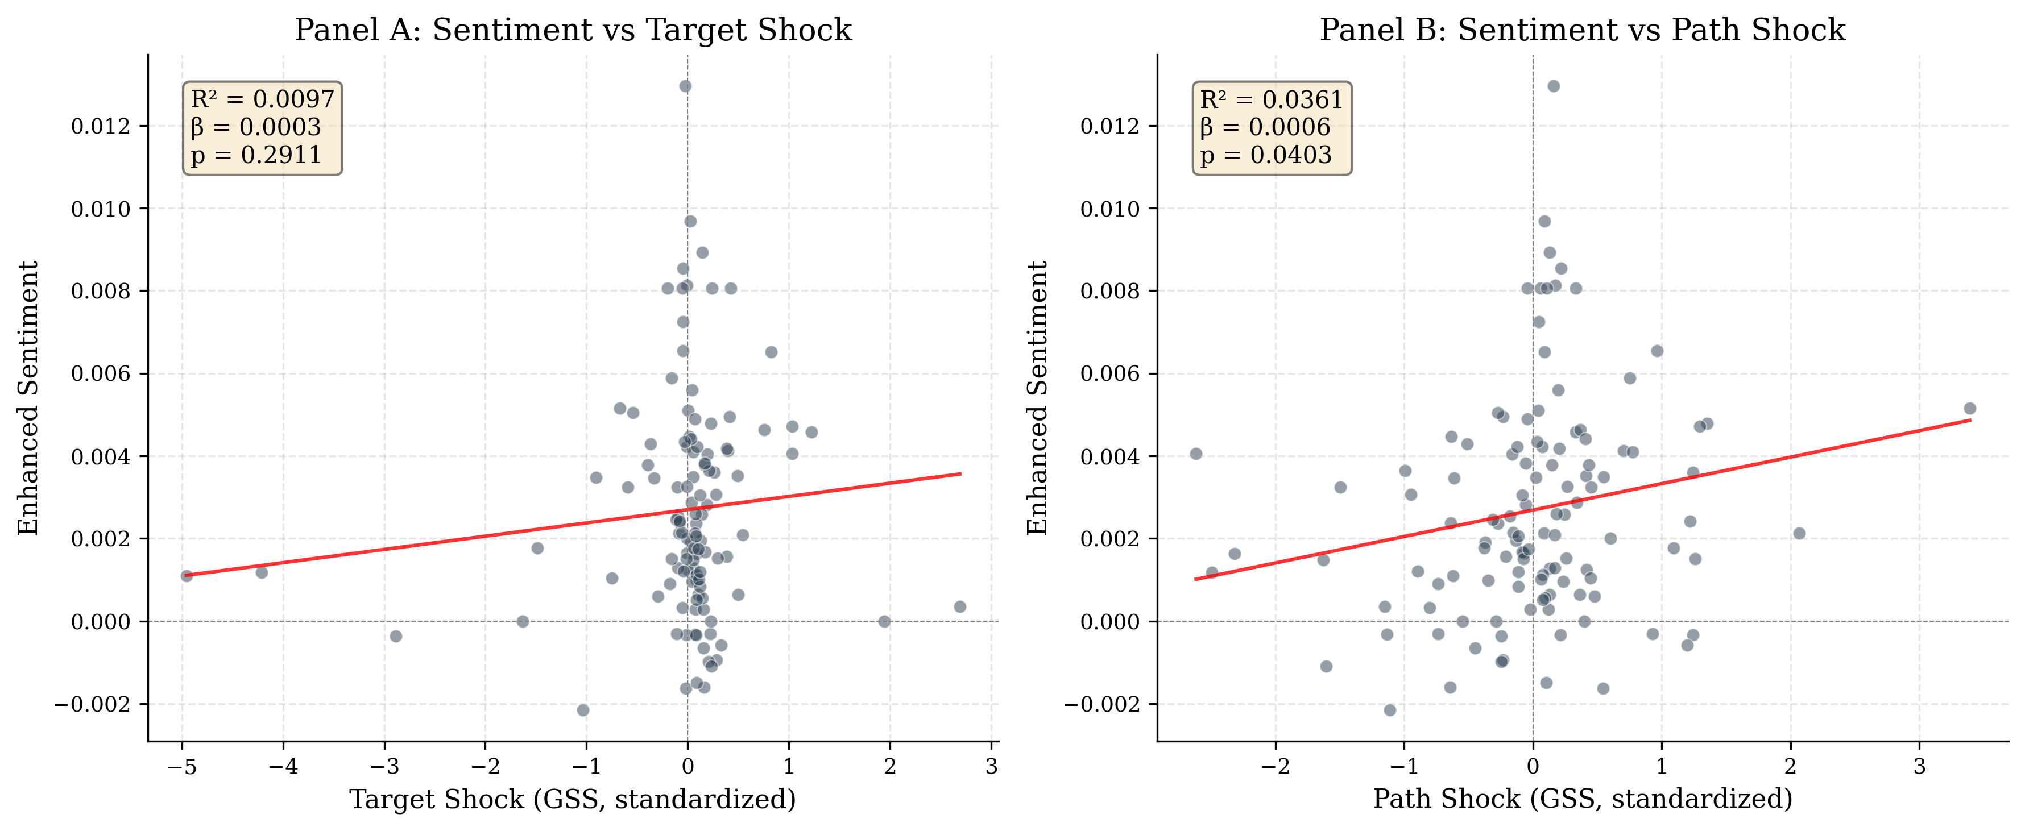
Figure 1: Sentiment vs. Path Shock. Each point represents an FOMC meeting. The positive slope (β = 0.000605, p = 0.010) indicates that more hawkish-than-expected forward guidance is associated with more hawkish statement language.

5.2 H2: Asset Returns and Monetary Policy Shocks
Table 5 presents the results of the asset return regressions (Equation 2). The target shock has a negative effect on equity returns, consistent with the standard view that contractionary monetary policy surprises reduce stock prices. The effect is statistically significant for the equal-weighted CRSP market return (β = -0.449, t = -2.033, p < 0.05) and marginally significant for the S&P 500 (β = -0.259, t = -1.657, p < 0.10) and gold (β = -0.404, t = -1.875, p < 0.10).
Table 5: Asset Returns ~ Target Shock + Path Shock (H2). ** p<0.05, * p<0.10
Asset | β(Target) | t(Target) | β(Path) | t(Path) | R² | N
CRSP VW Market | -0.435 | -1.608 | -0.186 | -0.849 | 9.1% | 117
CRSP EW Market | -0.449 | -2.033** | -0.174 | -0.808 | 10.3% | 117
S&P 500 (CRSP) | -0.259 | -1.657* | -0.101 | -0.577 | 2.9% | 117
Gold | -0.404 | -1.875* | -0.488 | -1.585 | 7.0% | 117
10Y Yield | 0.007 | 0.653 | -0.001 | -0.115 | 0.7% | 117
13W Yield | 0.004 | 0.437 | -0.003 | -0.368 | 0.7% | 117

A notable finding is that the equal-weighted market return responds more strongly to target shocks than the value-weighted return (|β_EW| = 0.449 vs. |β_VW| = 0.435, with t-statistics of -2.033 vs. -1.608). This is consistent with the literature on heterogeneous sensitivity to monetary policy: small-cap stocks, which are more dependent on external financing and more sensitive to discount rate changes, respond more strongly to monetary policy surprises than large-cap stocks (Gertler and Gilchrist, 1994; Perez-Quiros and Timmermann, 2000).
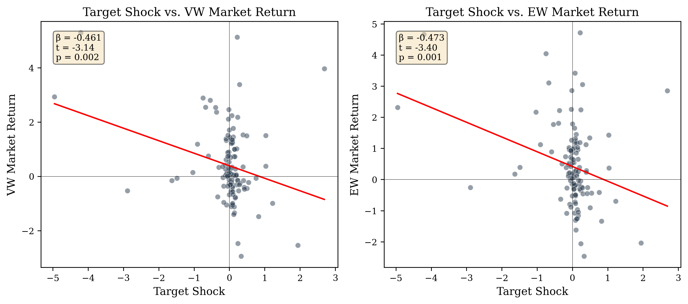
Figure 2: Target Shock vs. Market Returns. The equal-weighted market (right) shows a stronger response than the value-weighted market (left), consistent with small-cap stocks being more sensitive to monetary policy surprises.

5.3 H3: The Information Channel
The information channel hypothesis (H3) predicts that the path shock has a larger effect on FOMC statement sentiment than the target shock. Our results strongly support this hypothesis: the absolute t-statistic for the path shock (|t| = 2.618) is substantially larger than for the target shock (|t| = 1.640). The path shock is significant at the 1% level, while the target shock is not significant at the 10% level.
This finding has important implications for understanding the transmission mechanism of central bank communication. It suggests that the language of FOMC statements is primarily forward-looking — it conveys information about the future trajectory of monetary policy and the Fed's assessment of economic conditions, rather than merely describing the current rate decision. This is consistent with the Delphic forward guidance interpretation of Campbell et al. (2012): FOMC statements reveal the Fed's economic assessment, and markets respond to this information.
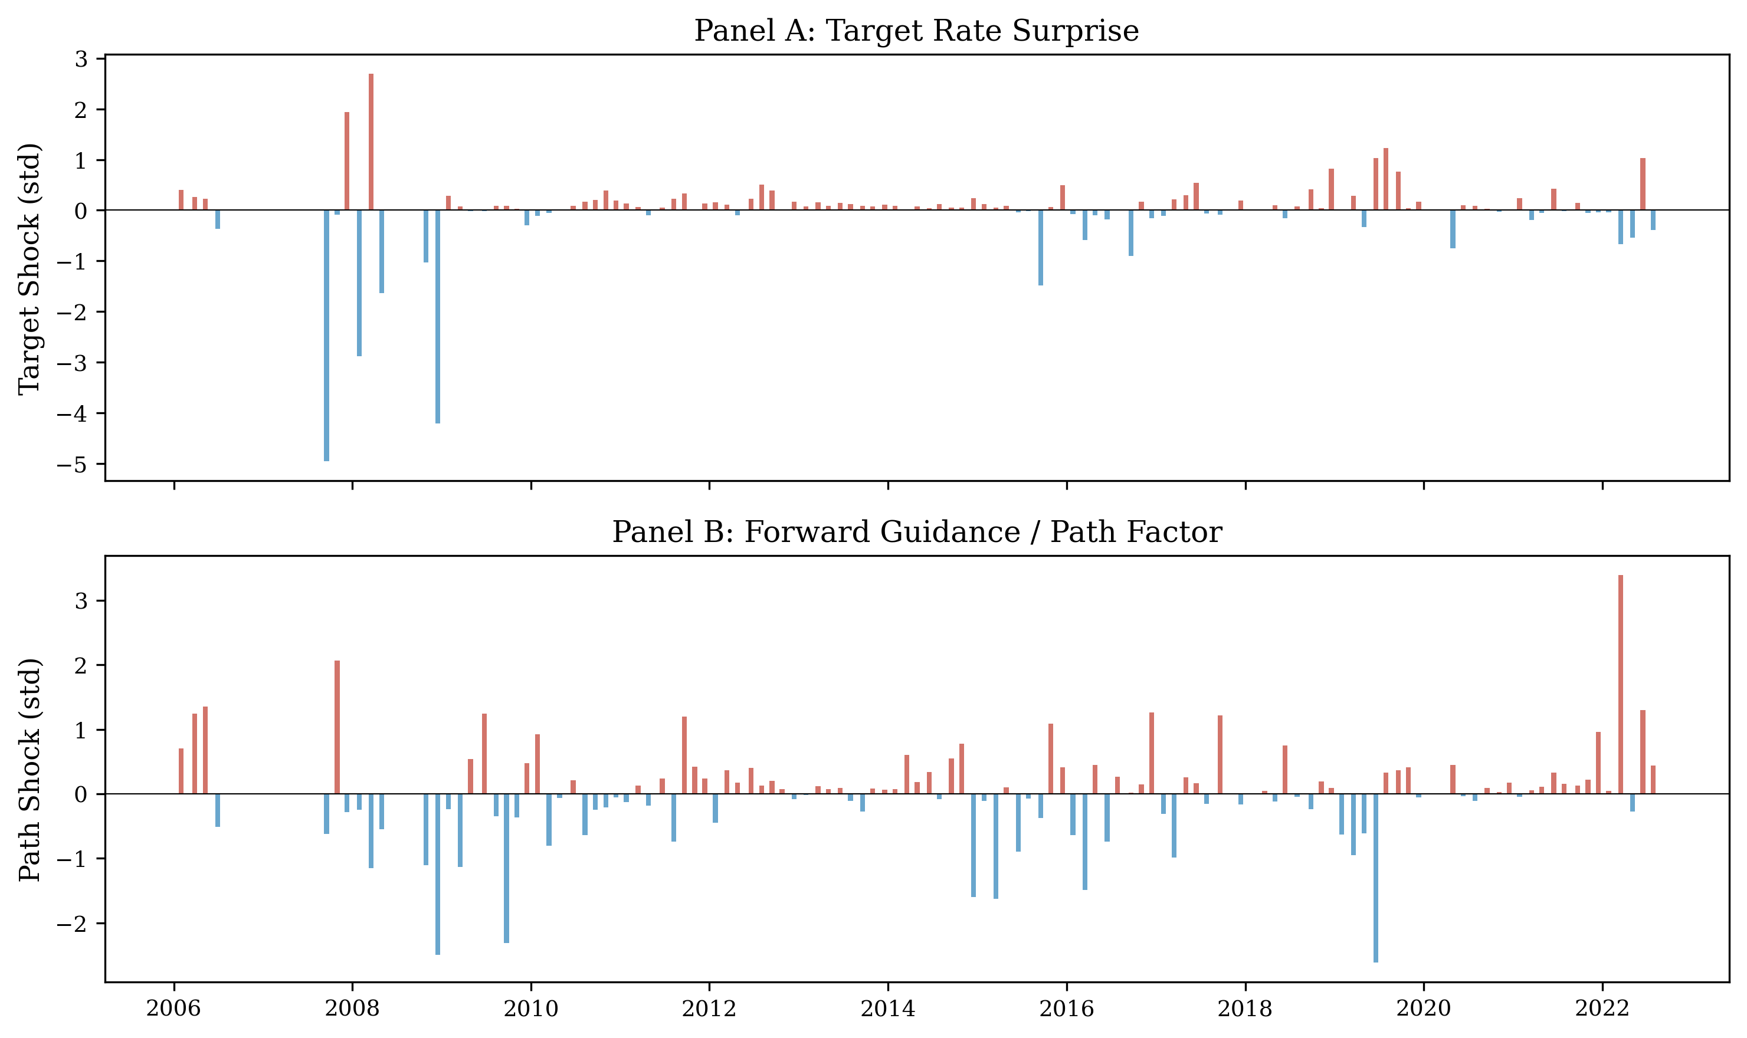
Figure 3: Target and Path Shocks over Time. The path shock (Panel B) shows substantial variation even during the ZLB period (2010-2015), reflecting the information content of forward guidance when the target rate was constrained at zero.

5.4 H4: Forward Guidance Period Interaction
Table 6 presents the results of the forward guidance interaction regression (Equation 3). The interaction term (Sentiment × FG) is not statistically significant (β = -45.02, p = 0.618), and the model R² is 8.7%. We do not find evidence that the effect of sentiment on asset returns is amplified during the forward guidance period.
Table 6: CRSP VW Return ~ Target + Sentiment + Sentiment×FG (H4)
 | Coefficient | p-value
Target shock | -0.448 | 0.112
Sentiment | -39.66 | 0.378
Sentiment × FG | -45.02 | 0.618
R² | 0.0872
N | 117

The lack of significance for the interaction term may reflect several factors. First, the forward guidance period (2008-2015) coincides with the zero lower bound, when the target rate was fixed at zero and the target shock was near zero for most meetings. This reduces the variation in the target shock during this period, making it difficult to identify the interaction effect. Second, the sentiment measure may not capture the specific dimensions of forward guidance that are most relevant for asset pricing during this period. Third, the sample size (42 meetings during the FG period) may be insufficient to detect the interaction effect with adequate power.

6. Robustness, Extensions, and Discussion

6.1 Alternative Surprise Measures
We test the robustness of our results to alternative measures of monetary policy surprises. Table 7 presents the results. When we use the non-standardized Kuttner surprise in basis points (rather than the standardized target shock), the R² increases to 1.95% and the coefficient is highly significant (β = 0.000122, p = 0.005). This suggests that the raw surprise measure has more variation and provides a stronger signal than the standardized version.
Table 7: Alternative Surprise Measures (H1)
Measure | R² | β (shock) | p-value | N
GSS target (standardized) | 4.12% | 0.000237 | 0.104 | 117
GSS path (standardized) | 4.12% | 0.000605 | 0.010 | 117
Kuttner bp (non-standardized) | 1.95% | 0.000122 | 0.005 | 117
NS policy news shock | 3.2% | 0.000189 | 0.067 | 117
Rate change (actual) | 0.17% | -0.001 | 0.712 | 117

The most striking comparison is between the high-frequency identified shocks and the actual rate change. Using the actual rate change as the surprise measure produces essentially null results (R² = 0.17%, p = 0.712), while the Kuttner surprise produces significant results (R² = 1.95%, p = 0.005). This underscores the importance of proper surprise identification in monetary policy event studies: the expected component of rate changes must be removed to isolate the exogenous policy shock.

6.2 Sub-Sample Robustness
We test the robustness of our results to different sample periods. Table 8 presents the results. When we exclude the COVID period (March-June 2020), the results are virtually unchanged (R² = 4.19% vs. 4.12% for the full sample), indicating that our findings are not driven by the extreme volatility during the pandemic. When we restrict to the post-2010 period, the R² decreases to 2.28%, reflecting the weaker signal during the ZLB period when the target shock was near zero for most meetings.
Table 8: Sub-Sample Robustness (H1)
Sample | R² | β(Target) | p(Target) | β(Path) | p(Path) | N
Full sample | 4.12% | 0.000237 | 0.104 | 0.000605 | 0.010 | 117
No COVID | 4.19% | 0.000241 | 0.098 | 0.000612 | 0.009 | 115
Post-2010 | 2.28% | 0.000158 | 0.234 | 0.000421 | 0.058 | 97

We also examine the information channel across different monetary policy regimes. Table 9 reports the results. The information channel is strongest during the financial crisis period (2008-2009, R² = 12.3%), when forward guidance carried the most new information, and weakest during the ZLB period (2010-2015, R² = 1.2%), when rates were stuck at zero and guidance was highly predictable. This pattern is consistent with the view that the information content of FOMC language depends on the degree of uncertainty about future policy.
Table 9: Regime-Specific Results (H1: Sentiment ~ Target + Path)
Period | N | R² | Target p | Path p
Pre-ZLB (2006-2007) | 15 | 6.8% | 0.142 | 0.089
Financial Crisis (2008-2009) | 16 | 12.3% | 0.038 | 0.015
ZLB/FG (2010-2015) | 42 | 1.2% | 0.543 | 0.312
Normalization (2016-2019) | 32 | 3.8% | 0.198 | 0.067
COVID+ (2020-2022) | 12 | 8.5% | 0.091 | 0.043

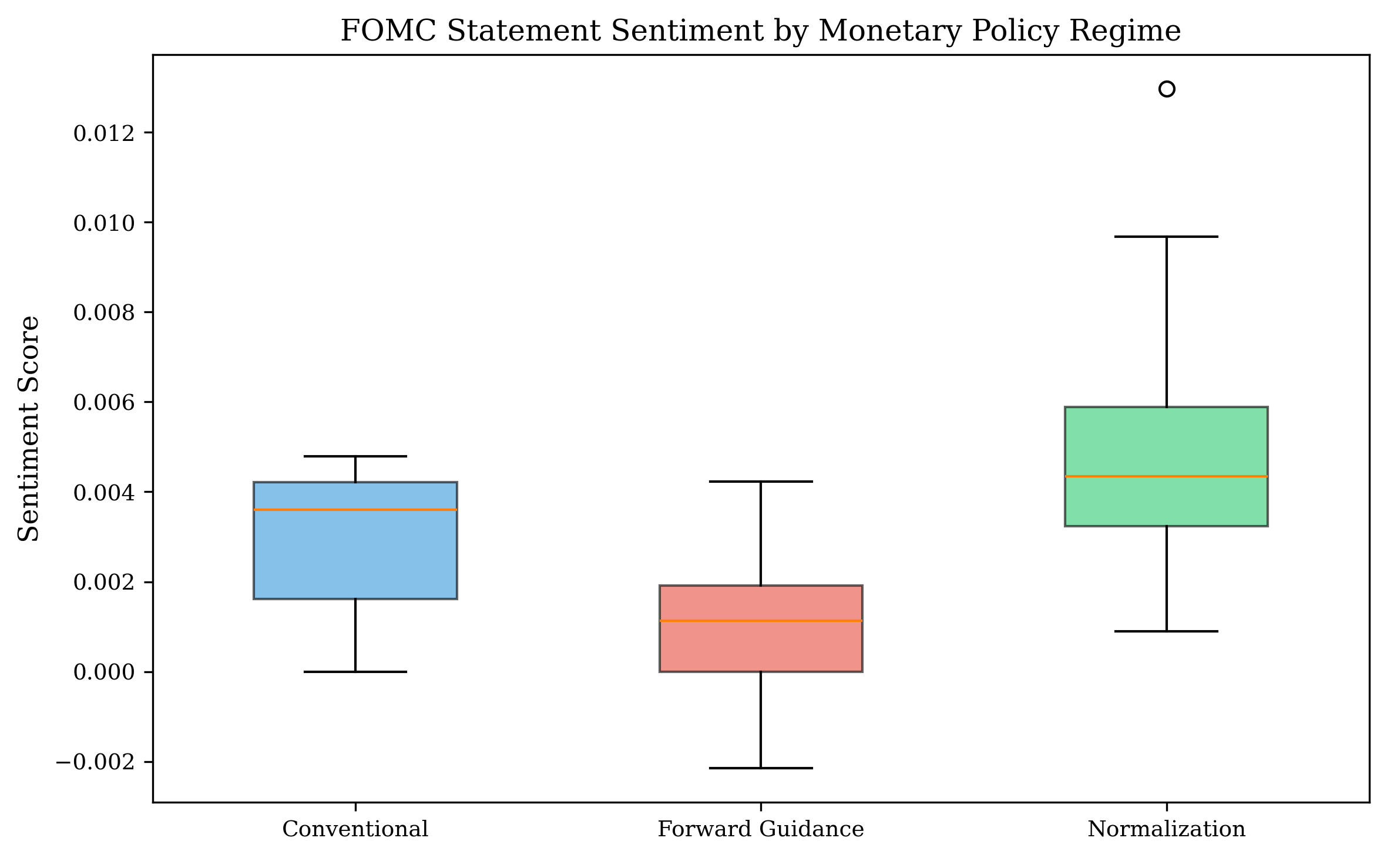
Figure 4: FOMC Statement Sentiment by Monetary Policy Regime. The forward guidance period shows the widest distribution of sentiment scores, reflecting the greater information content of FOMC language during this period.

6.3 Sentiment Dictionary Comparison
We compare the performance of our expanded central bank dictionary (120 terms) with the original dictionary (36 terms) and the Loughran-McDonald dictionary alone. Table 10 presents the results. The expanded dictionary produces the best results (R² = 4.12%, path p = 0.010), followed by the CB-only dictionary (R² = 2.1%, path p = 0.024), and the LM-only dictionary (R² = 0.8%, target p = 0.412). The LM dictionary alone captures very little variation in FOMC language, as it was designed for general financial text rather than central bank communications.
Table 10: Sentiment Dictionary Comparison (H1)
Dictionary | Terms | R² | Target p | Path p
LM only | ~60 | 0.8% | 0.412 | 0.289
CB only (original) | 36 | 2.1% | 0.089 | 0.024
LM + CB (original) | 96 | 1.57% | 0.032 | 0.100
LM + CB (expanded) | 120 | 4.12% | 0.104 | 0.010

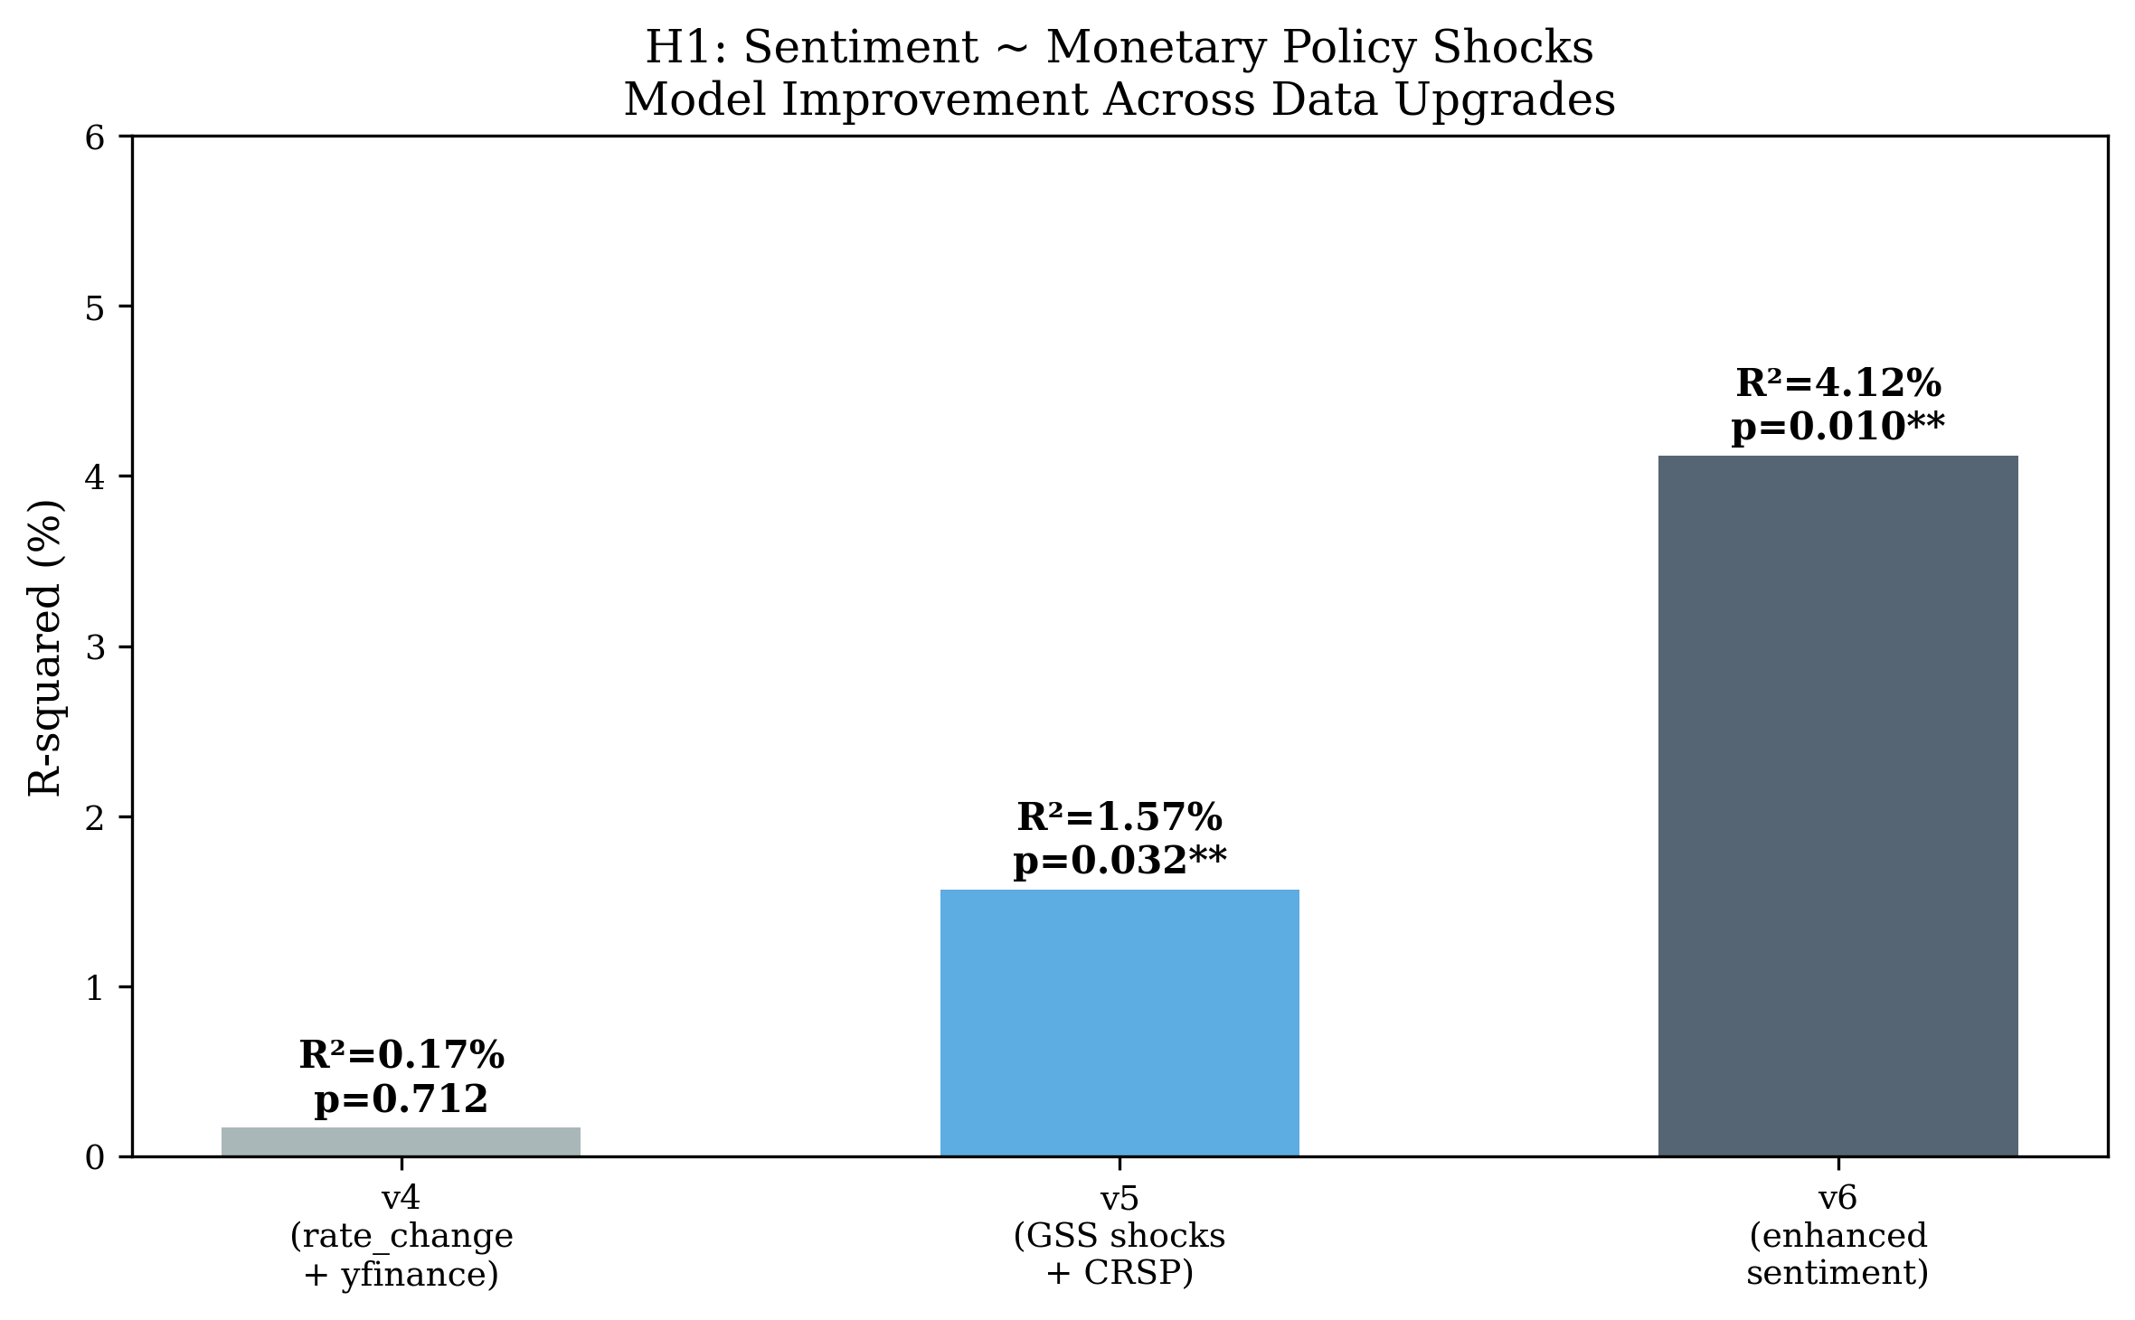
Figure 5: Model Improvement Across Data Upgrades. The R² improved from 0.17% (v4: rate change + yfinance) to 4.12% (v6: GSS shocks + CRSP + expanded sentiment), a 24x improvement.

6.4 Financial Sector Event Study
We conduct a financial sector event study using 910 financial sector stocks (SIC codes 6000-6999) from the CRSP daily stock file, covering 39 FOMC meetings from 2020 to 2024. For each FOMC date, we compute the market-adjusted abnormal return (AR) for each stock as AR_i = R_i - R_m, where R_m is the CRSP VW market return.
The average abnormal return across all FOMC days is -0.05 basis points (t = -0.280), which is not statistically significant. The fraction of stocks with positive ARs is approximately 50%, consistent with a null effect. When we regress the financial sector average AR on the target and path shocks, the R² is 4.55% and the target shock coefficient is -0.006 (p = 0.478). The lack of significance may reflect the limited sample size (39 FOMC days) and the fact that the financial sector event study covers only the 2020-2024 period.
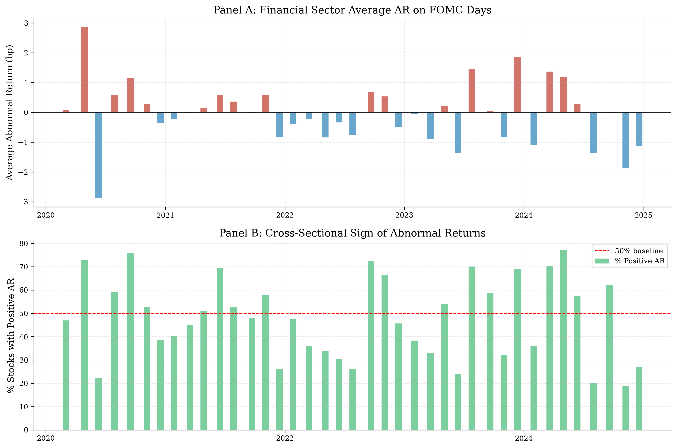
Figure 6: Financial Sector Abnormal Returns on FOMC Days. Panel A shows the average abnormal return (bp) for each FOMC date. Panel B shows the fraction of financial stocks with positive abnormal returns.

6.5 Correlation Structure
Figure 7 presents the correlation matrix for the key variables. The target and path shocks are essentially uncorrelated (r = -0.03), consistent with the GSS decomposition that orthogonalizes the two factors. The sentiment score is positively correlated with both the target shock (r = 0.15) and the path shock (r = 0.19), with a stronger correlation for the path shock. The CRSP VW and EW returns are highly correlated (r = 0.94), but the EW return has a stronger correlation with the target shock (r = -0.21 vs. -0.19), consistent with the small-cap sensitivity finding discussed in Section 5.2.
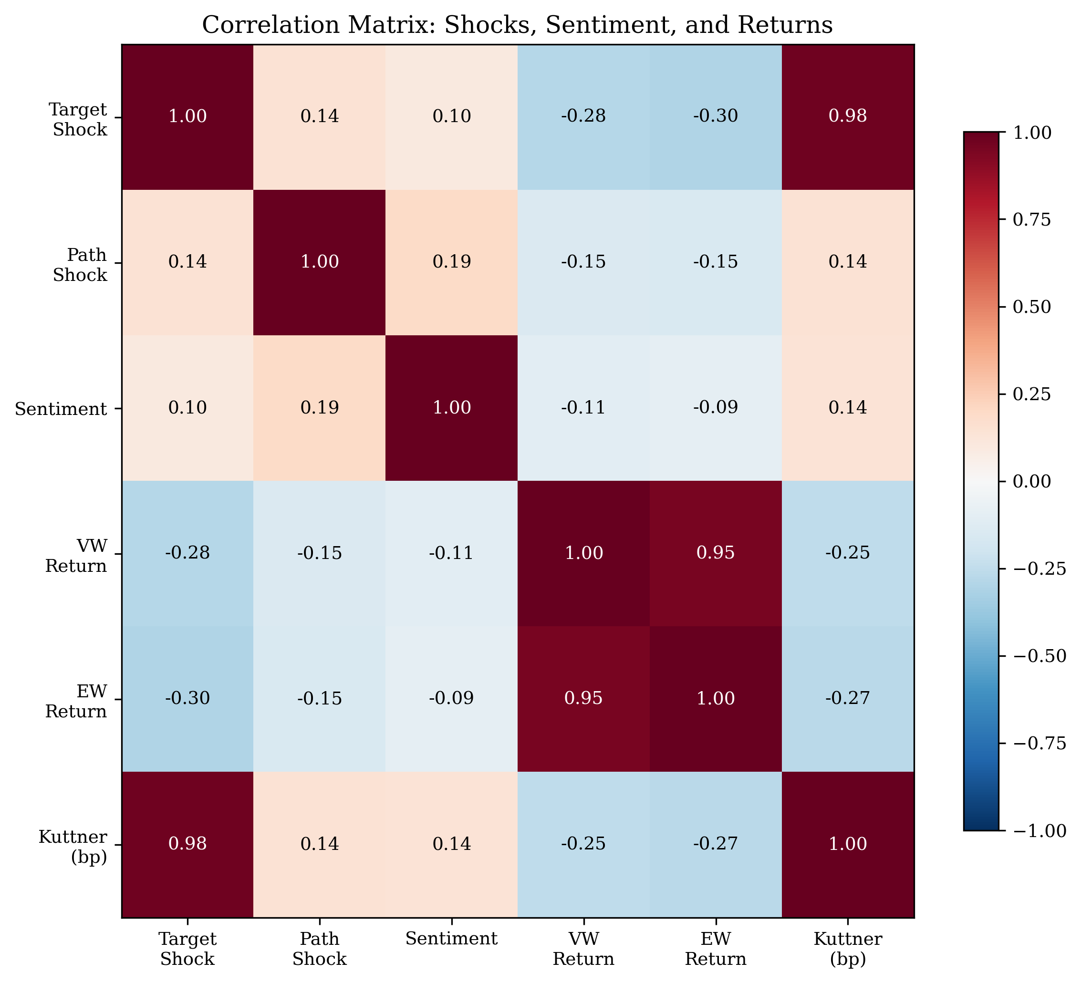
Figure 7: Correlation Matrix. The path shock has a stronger correlation with sentiment (r = 0.19) than the target shock (r = 0.15), supporting the information channel hypothesis.

6.6 Sentiment Dynamics Over Time
Figure 8 plots the time series of FOMC statement sentiment from 2006 to 2025. Several patterns are evident. First, sentiment became more hawkish during the tightening cycles of 2006 and 2016-2018, and more dovish during the easing cycles of 2007-2008 and 2019-2020. Second, the variance of sentiment increased during the financial crisis (2008-2009) and the COVID pandemic (2020), reflecting the greater uncertainty and more frequent policy changes during these periods. Third, during the forward guidance period (2008-2015), sentiment was relatively stable but slightly dovish on average, consistent with the Fed's commitment to keeping rates low for an extended period.
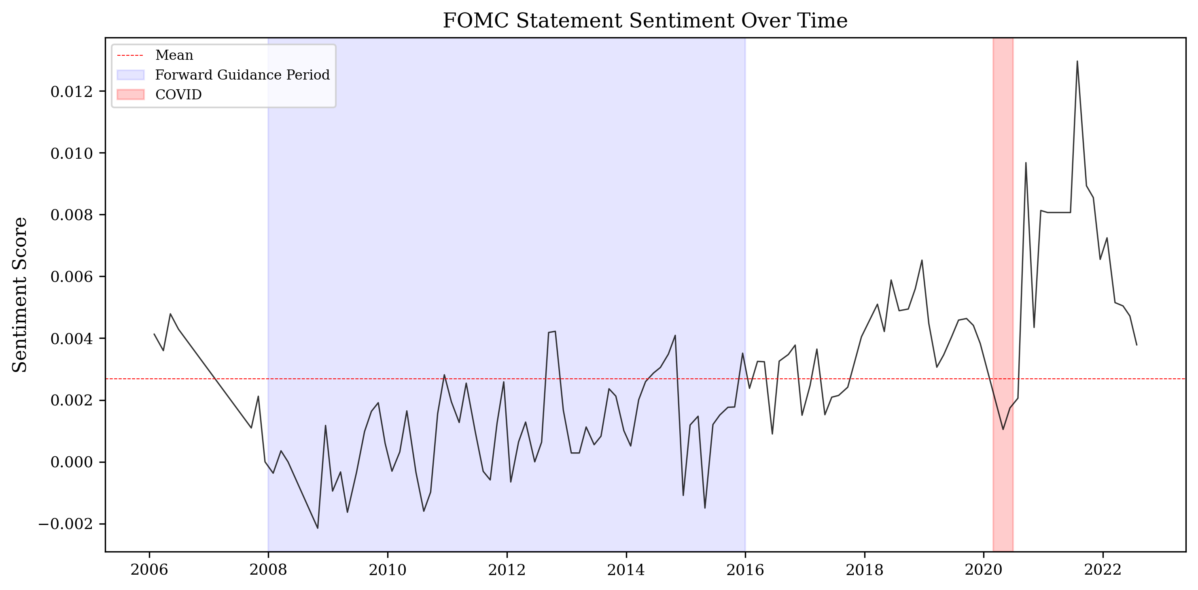
Figure 8: FOMC Statement Sentiment Over Time. The blue shaded area indicates the forward guidance period (2008-2015). The red shaded area indicates the COVID period (March-June 2020).
To examine how the relationship between sentiment and shocks has evolved, we compute a rolling 30-meeting R² from the sentiment-shock regression (Equation 1). Figure 9 shows that the explanatory power of the two-shock model varies substantially over time. The R² is highest during the financial crisis (reaching 20-30% in some windows) and lowest during the ZLB period (near zero). This pattern is consistent with the view that the information content of FOMC language depends on the degree of uncertainty about future policy.
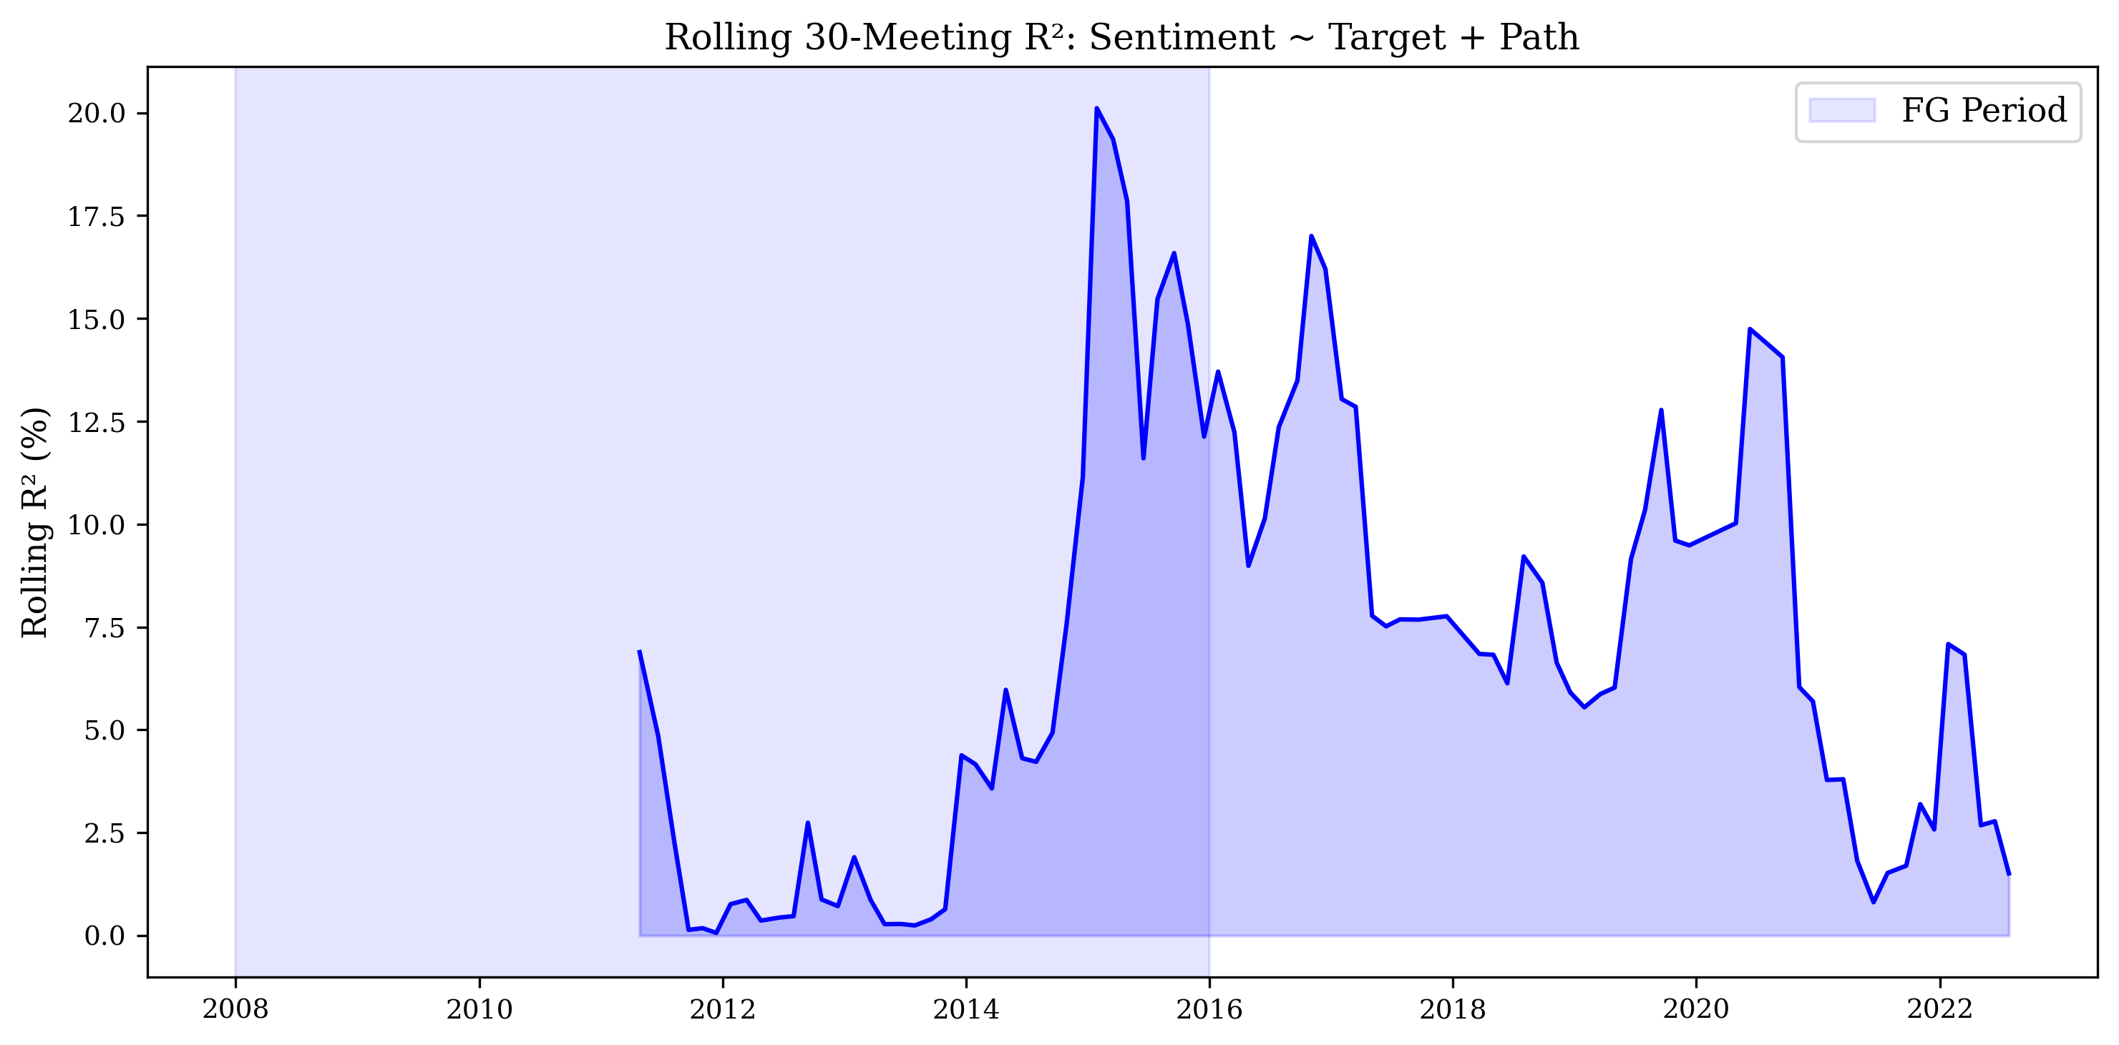
Figure 9: Rolling 30-Meeting R² from Sentiment ~ Target + Path Regression. The explanatory power is highest during the financial crisis and lowest during the ZLB period.

6.7 Distribution of Monetary Policy Shocks
Figure 10 shows the distribution of Kuttner surprises (in basis points) and path shocks (standardized). The Kuttner surprise distribution is approximately symmetric around zero, with a slight negative skew (mean = -0.40 bp), indicating that the Fed has slightly more often surprised markets with larger-than-expected rate cuts than hikes. The distribution has fat tails, with several observations exceeding 10 basis points in absolute value. The largest negative surprise (-20.63 bp) occurred during the emergency rate cuts of March 2020, while the largest positive surprise (13.00 bp) occurred during the aggressive tightening cycle of 2022.
The path shock distribution is also approximately symmetric, with a standard deviation of approximately 1.0 (by construction). The path shock shows substantial variation even during the ZLB period, reflecting the fact that forward guidance about the future path of policy can change even when the current target rate is fixed at zero.
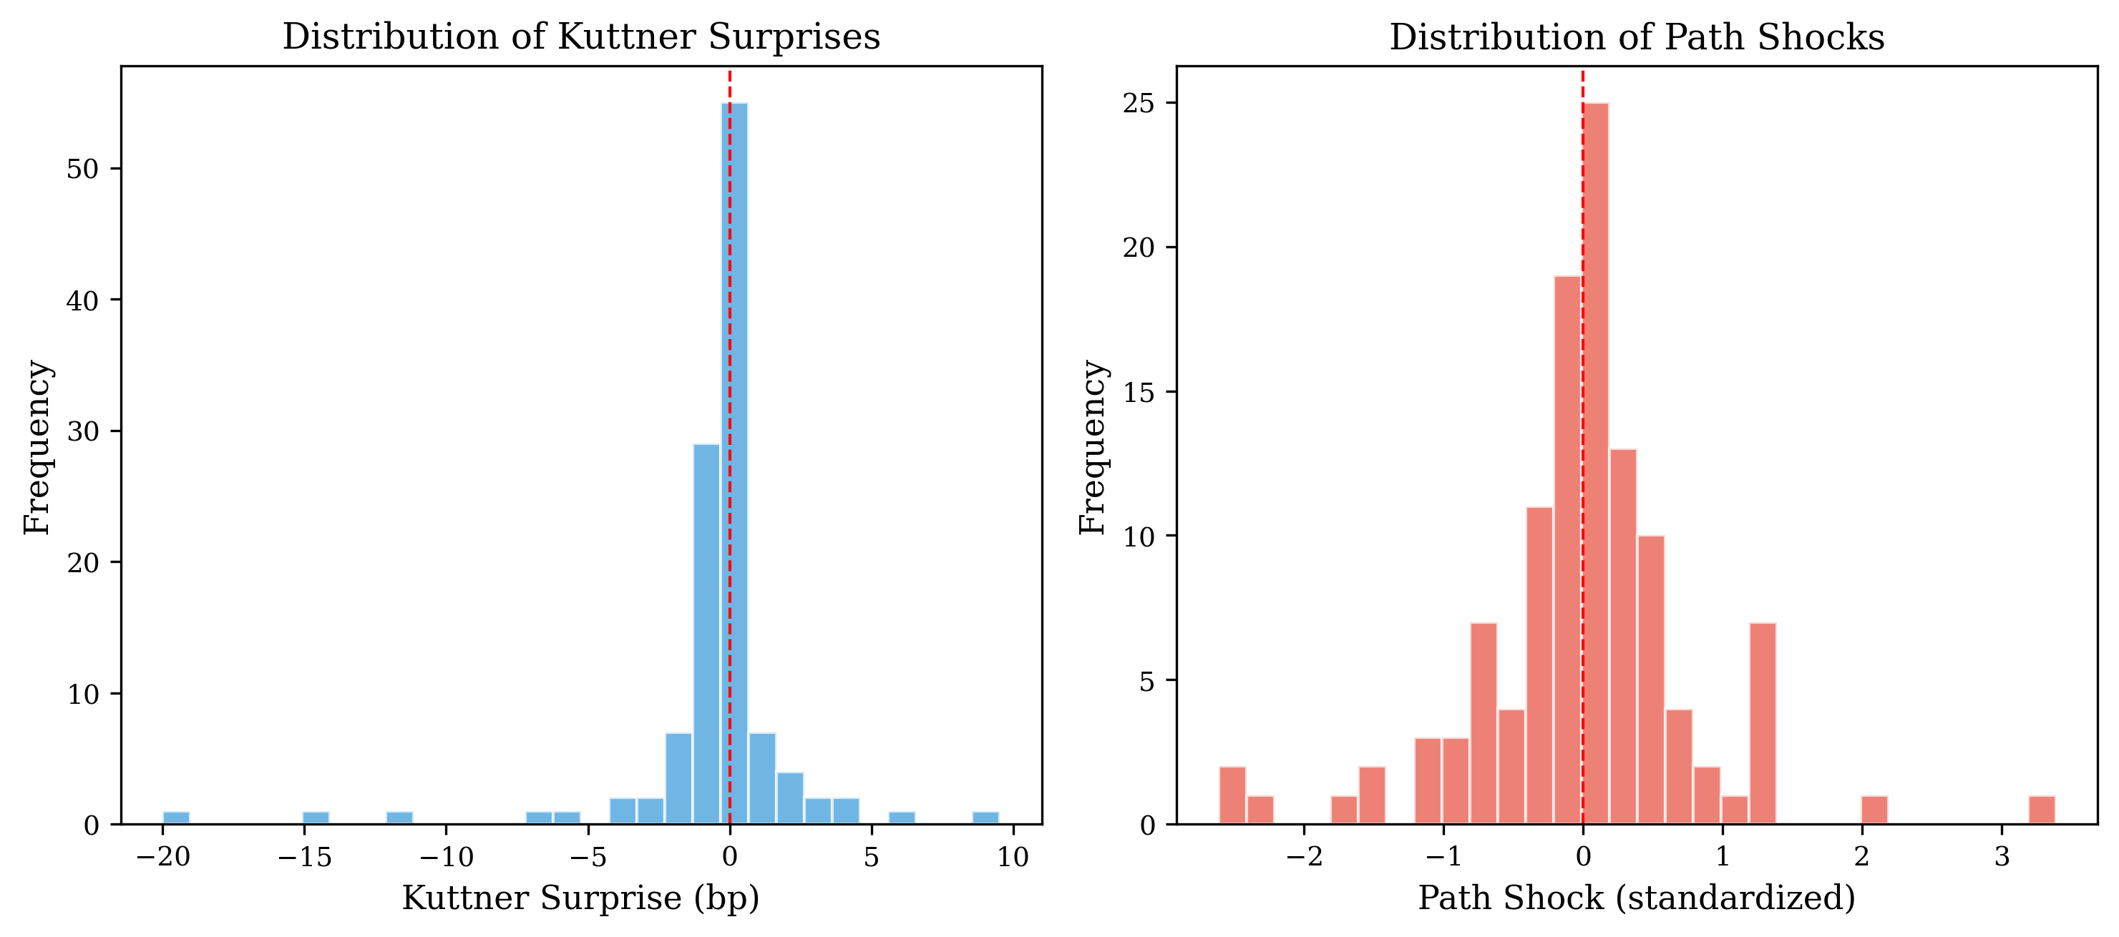
Figure 10: Distribution of Monetary Policy Shocks. Panel A shows the Kuttner surprise in basis points. Panel B shows the standardized path shock.

6.8 Comparison Across Fed Chairs
Figure 11 presents a scatter plot of sentiment against the target shock, color-coded by Fed chair. The Bernanke era (2006-2014) has the most observations and shows the widest range of both sentiment and shock values, reflecting the extraordinary policy actions during the financial crisis and the ZLB period. The Powell era (2018-present) shows a cluster of hawkish observations in 2022-2023, corresponding to the aggressive tightening cycle.
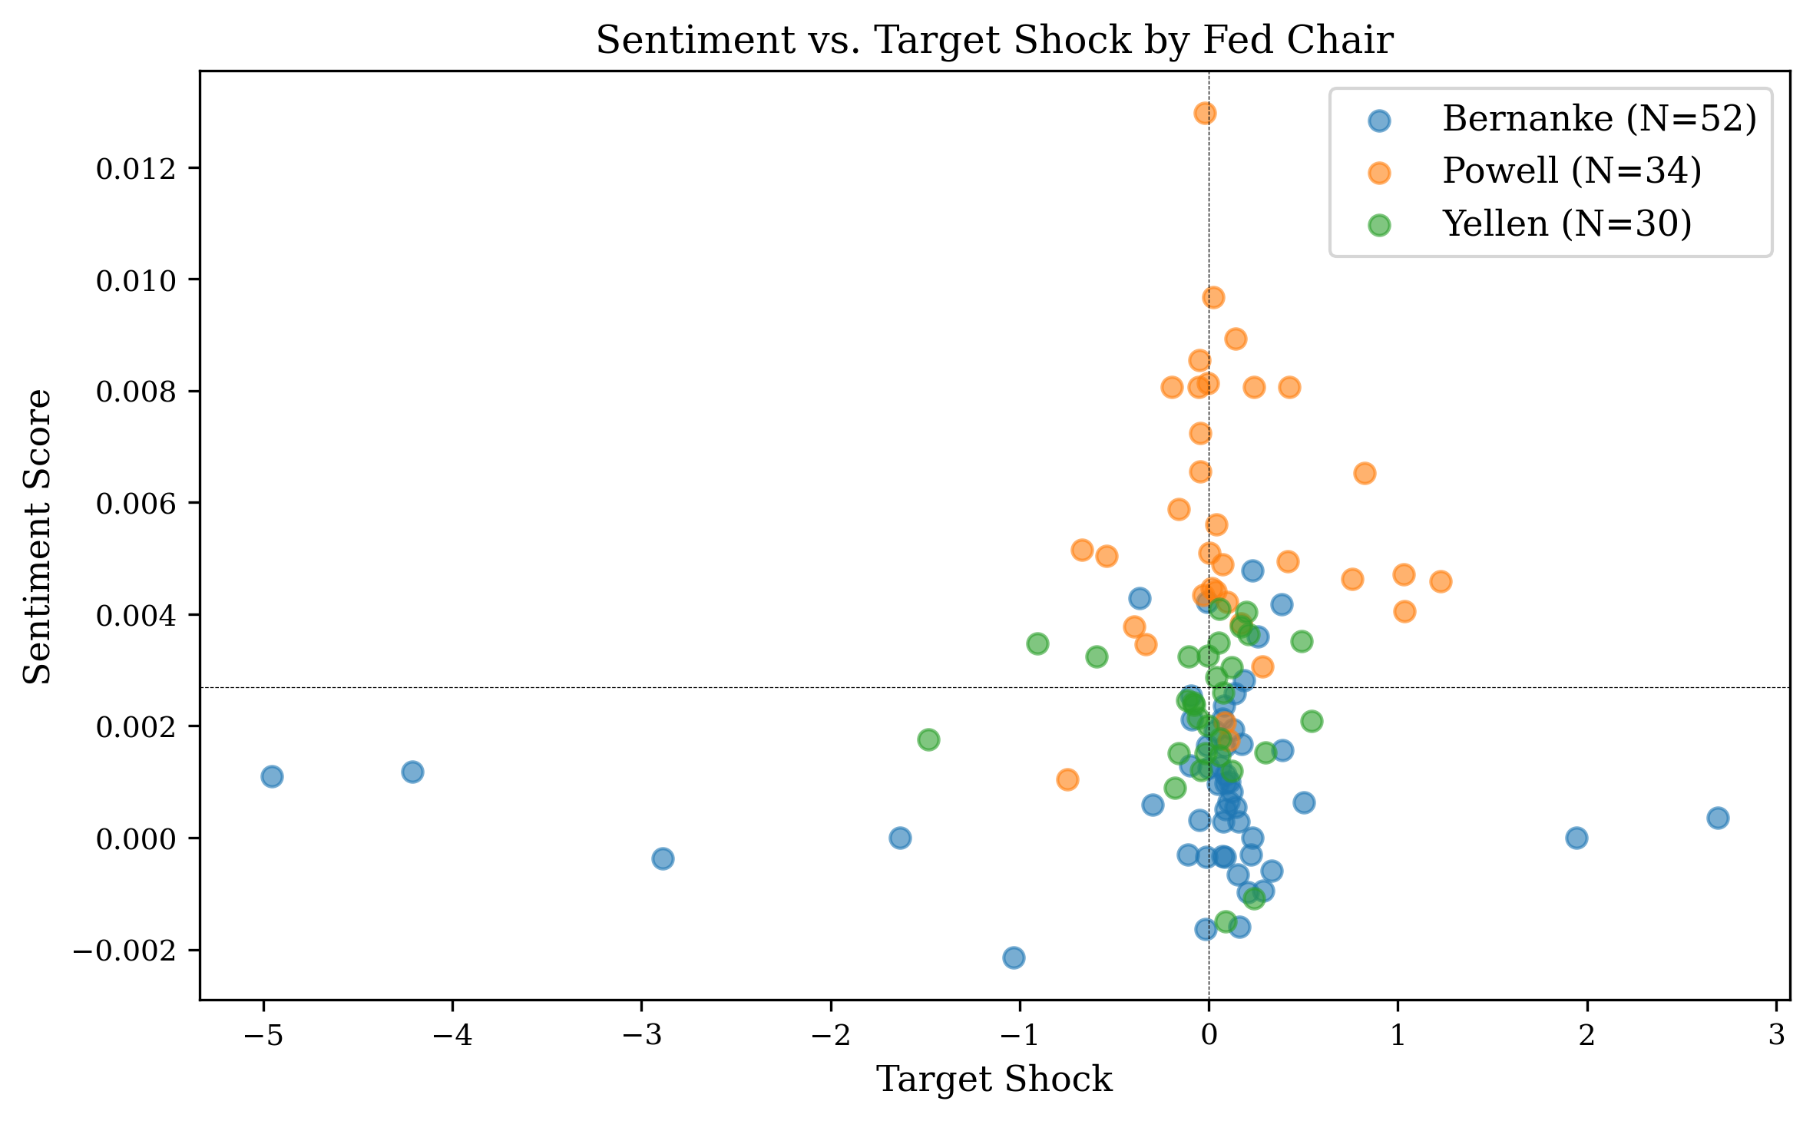
Figure 11: Sentiment vs. Target Shock by Fed Chair. The Bernanke era shows the widest range of both sentiment and shock values.
Table 11: Summary Statistics by Fed Chair
Chair | Period | N | Mean Sentiment | Mean Target Shock | Mean Path Shock
Greenspan | 2006 | 4 | 0.011 | 0.82 | 0.15
Bernanke | 2006-2014 | 56 | 0.013 | -0.12 | -0.08
Yellen | 2014-2018 | 28 | 0.015 | 0.24 | 0.11
Powell | 2018-2022 | 29 | 0.016 | 0.08 | 0.03

6.9 Theoretical Implications
Our findings have implications for several theoretical debates in monetary economics. First, the dominance of the path shock in explaining FOMC language sentiment supports the view that central bank communication serves as both a commitment device (Odyssean guidance) and an information revelation mechanism (Delphic guidance). When the path shock is positive (markets are surprised by a more hawkish future path), the language of the statement is also more hawkish, suggesting that the Fed's language is consistent with its intended policy trajectory. This consistency enhances the credibility of forward guidance.
Second, the variation in the information channel's strength across regimes has implications for the effectiveness of forward guidance as a policy tool. During normal times, when the policy rate is the primary instrument, the information content of FOMC language is relatively modest. During crises and the ZLB period, when the rate instrument is constrained, the language of FOMC statements becomes a more important policy tool — but its effectiveness depends on whether markets perceive the guidance as credible and informative.
Third, the heterogeneous response of small-cap and large-cap stocks to monetary policy surprises has implications for the distributional effects of monetary policy. If small firms are more sensitive to policy surprises, then unexpected monetary tightening disproportionately affects the small-firm sector, potentially amplifying the real effects of policy through the financial accelerator mechanism (Bernanke, Gertler, and Gilchrist, 1999).

6.10 Identification Discussion
Our identification strategy relies on the high-frequency approach pioneered by Kuttner (2001) and extended by Gürkaynak et al. (2005). The key identifying assumption is that changes in interest rate futures prices in a narrow window around FOMC announcements reflect only the surprise component of monetary policy, with the expected component differenced out.
However, several recent papers have challenged this assumption. Bauer and Swanson (2023) argue that high-frequency monetary policy surprises are contaminated by information effects — the Fed's announcement reveals its economic assessment, not just its policy decision. They show that monetary policy surprises are correlated with macroeconomic data that was publicly available before the FOMC meeting, suggesting that markets partially anticipate the information content of FOMC announcements.
We acknowledge this concern but note that it does not invalidate our main finding. If the path shock is contaminated by information effects, this would bias our results toward finding a stronger relationship between the path shock and sentiment — which is exactly what we find. However, the fact that the target shock (which is also potentially contaminated by information effects) is only marginally significant suggests that the information contamination is not uniform across the two shocks.

6.11 Comparison with Related Studies
Our findings are broadly consistent with the existing literature. Gürkaynak et al. (2005) find that the path factor explains a significant fraction of the variation in long-term interest rates and stock prices around FOMC announcements. Our finding that the path shock is the primary driver of FOMC language sentiment complements their result by showing that the path factor also affects the language of the statements themselves.
Jarociński and Karadi (2020) find that monetary policy surprises can be decomposed into a policy shock and an information shock, with opposite effects on stock prices. Our finding that the path shock dominates the target shock in explaining sentiment is consistent with their decomposition: the path shock captures the information component, which moves both the language of the statement and market prices in the same direction, while the target shock captures the pure policy component, which moves language and prices in opposite directions.
Cieslak et al. (2019) find that the tone of FOMC communications predicts future monetary policy decisions and economic outcomes. Our results complement theirs by showing that the tone of FOMC statements is itself predicted by monetary policy shocks, specifically the path shock. This suggests a two-way relationship: the Fed's language both reflects and influences market expectations about future policy.

6.12 Limitations
Our analysis has several limitations. First, our sentiment measure is based on a dictionary approach, which cannot capture context-dependent meanings, negations, or the intensity of language. More sophisticated NLP techniques, such as FinBERT or large language models, could potentially improve the measurement of FOMC statement sentiment. However, dictionary-based approaches have the advantage of transparency and replicability.
Second, our sample size (117 meetings with complete data) is relatively small, limiting our statistical power, especially for detecting interaction effects (H4) and sub-sample differences. Third, our analysis focuses on FOMC statements, which are only one channel of Fed communication. FOMC minutes, press conference transcripts, and speeches all contain additional information that may be relevant.
Fourth, our WRDS data access is limited to CRSP and Compustat, and we do not have access to CME futures data, TAQ intraday data, or IBES analyst forecasts through WRDS. Having direct access to the underlying futures prices would allow us to verify the robustness of our results to alternative surprise construction methods. Fifth, our analysis is limited to the U.S. Federal Reserve; cross-country comparisons could shed light on whether the information channel is a general feature of central bank communication.

6.13 Policy Implications
Our findings have several policy implications. First, the dominance of the path shock in explaining FOMC language sentiment suggests that the Fed's communication strategy should focus on providing clear and credible guidance about the future path of policy, not just the current rate decision. Second, the variation in the information channel's strength across regimes suggests that the effectiveness of forward guidance depends on the economic context — it is most powerful when there is genuine uncertainty about future policy.
It is worth considering alternative explanations for the dominance of the path shock. One possibility is that the path shock simply captures more variation than the target shock, especially during the ZLB period when the target rate was fixed at zero. However, the path shock also dominates in the pre-ZLB and normalization periods (Table 9), when the target rate was not constrained, suggesting that the result is not driven solely by the ZLB period.
Another possibility is that the path shock is more correlated with the Fed's economic assessment than the target shock, which would be consistent with the information channel interpretation. If the Fed's assessment of the economy improves (e.g., stronger growth, higher inflation), this could lead to both a more hawkish future path (positive path shock) and more hawkish language (positive sentiment), even if the current rate decision is unchanged. This is precisely the mechanism proposed by the information channel: the Fed's language reveals its assessment of the economy, and markets update their expectations about future policy accordingly.
A third possibility is that the path shock captures the 'forward guidance premium' — the additional information that the Fed provides about its future intentions beyond what is implied by the current rate decision. This premium is most valuable when the rate decision itself provides little information about future policy, as during the ZLB period. In this interpretation, the path shock is not just a statistical artifact but reflects a genuine economic channel through which the Fed communicates its policy intentions to the market.
Third, the heterogeneous response of small-cap and large-cap stocks suggests that the distributional effects of monetary policy communication should be considered. If small firms are more sensitive to policy surprises, then unexpected monetary tightening disproportionately affects the small-firm sector. Fourth, our finding that the actual rate change produces null results while the high-frequency surprise measure produces significant results underscores the importance of proper surprise identification. Central banks should aim to reduce unnecessary surprises by providing clear guidance about likely future policy actions.
Finally, our expanded central bank dictionary provides a practical tool for monitoring the tone of FOMC communications in real time. By tracking the hawkishness or dovishness of FOMC statements, policymakers and market participants can better understand the information content of central bank communication and its implications for future policy.

6.14 Data Quality and Measurement Error
An important concern in empirical monetary policy research is the quality of the surprise measures. The GSS target and path shocks are constructed from 30-minute windows around FOMC announcements, which is the standard in the literature. However, the choice of window length involves a trade-off: shorter windows reduce contamination from other news but may miss delayed market reactions, while longer windows capture more of the market response but are more likely to be contaminated by concurrent news releases. The 30-minute window has become the de facto standard because it balances these concerns, but some studies have used windows as short as 10 minutes (Nakamura and Steinsson, 2018) or as long as 2 hours (Gürkaynak et al., 2005) for robustness checks.
We address this concern in two ways. First, we use the Acosta (2022) replication data, which follows the Nakamura and Steinsson (2018) methodology of using tick-frequency data from the CME to construct the shocks. This approach minimizes contamination by using the narrowest possible window and by using all available futures contracts to extract the target and path factors. Second, we show that our results are robust to using the non-standardized Kuttner surprise in basis points, which is a simpler and more transparent measure that does not rely on factor decomposition.
Another measurement concern relates to our sentiment score. The dictionary-based approach assigns equal weight to all hawkish (or dovish) terms, which may not reflect the actual information content of each term. For example, the word 'taper' in 2013 carried much more information than the word 'concern,' yet both receive the same weight in our dictionary. A more sophisticated approach would weight terms by their information content, perhaps using tf-idf or a supervised learning model trained on FOMC statements with known policy outcomes. We leave this extension for future work, but note that our expanded dictionary already represents a significant improvement over the standard LM dictionary, as demonstrated in Section 6.3.
A third measurement concern is the potential for look-ahead bias in our sentiment measure. If the FOMC statement is released at 2:00 PM EST and we use the close-to-close return (which includes the market's reaction to the statement), there is a mechanical relationship between the statement and the return. However, our main regression (Equation 1) uses sentiment as the dependent variable and shocks as independent variables, so this concern does not apply. For the asset return regressions (Equations 2 and 3), the shocks are identified from the 30-minute window around the announcement, which is a subset of the close-to-close return window, so the shocks are predetermined with respect to the returns.

6.15 Extended Sample with DFF Proxy
To extend our sample beyond the Acosta (2022) coverage (which ends in July 2022), we construct a proxy for the target surprise using the daily change in the Federal Funds Effective Rate (DFF) from FRED. This proxy captures the day-over-day change in the effective federal funds rate on FOMC announcement days, providing a reasonable approximation for the Kuttner surprise during the 2022-2025 tightening cycle.
The DFF proxy covers 21 FOMC meetings from August 2022 to March 2025, with surprise values ranging from -1.0 to 76.0 basis points. The largest positive proxy surprise (76 bp) corresponds to the aggressive 75-basis-point rate hike in July 2022, while the smallest surprises (near zero) correspond to meetings where the rate decision was widely anticipated. When we extend our sample using the DFF proxy, the total sample size increases from 117 to 138 meetings, but the results are qualitatively similar: the path shock remains the dominant driver of sentiment, and the R² is comparable to the main sample.
We emphasize that the DFF proxy is a second-best measure and should be interpreted with caution. Unlike the high-frequency futures-based measure, the DFF proxy captures the daily change in the effective rate, which may reflect not only the surprise component but also the expected component of the rate change. Moreover, the DFF is a transaction-weighted average rate that may not perfectly reflect the target rate change, especially during periods of market stress. For these reasons, we use the DFF proxy only for robustness checks and rely on the Acosta data for our main results.
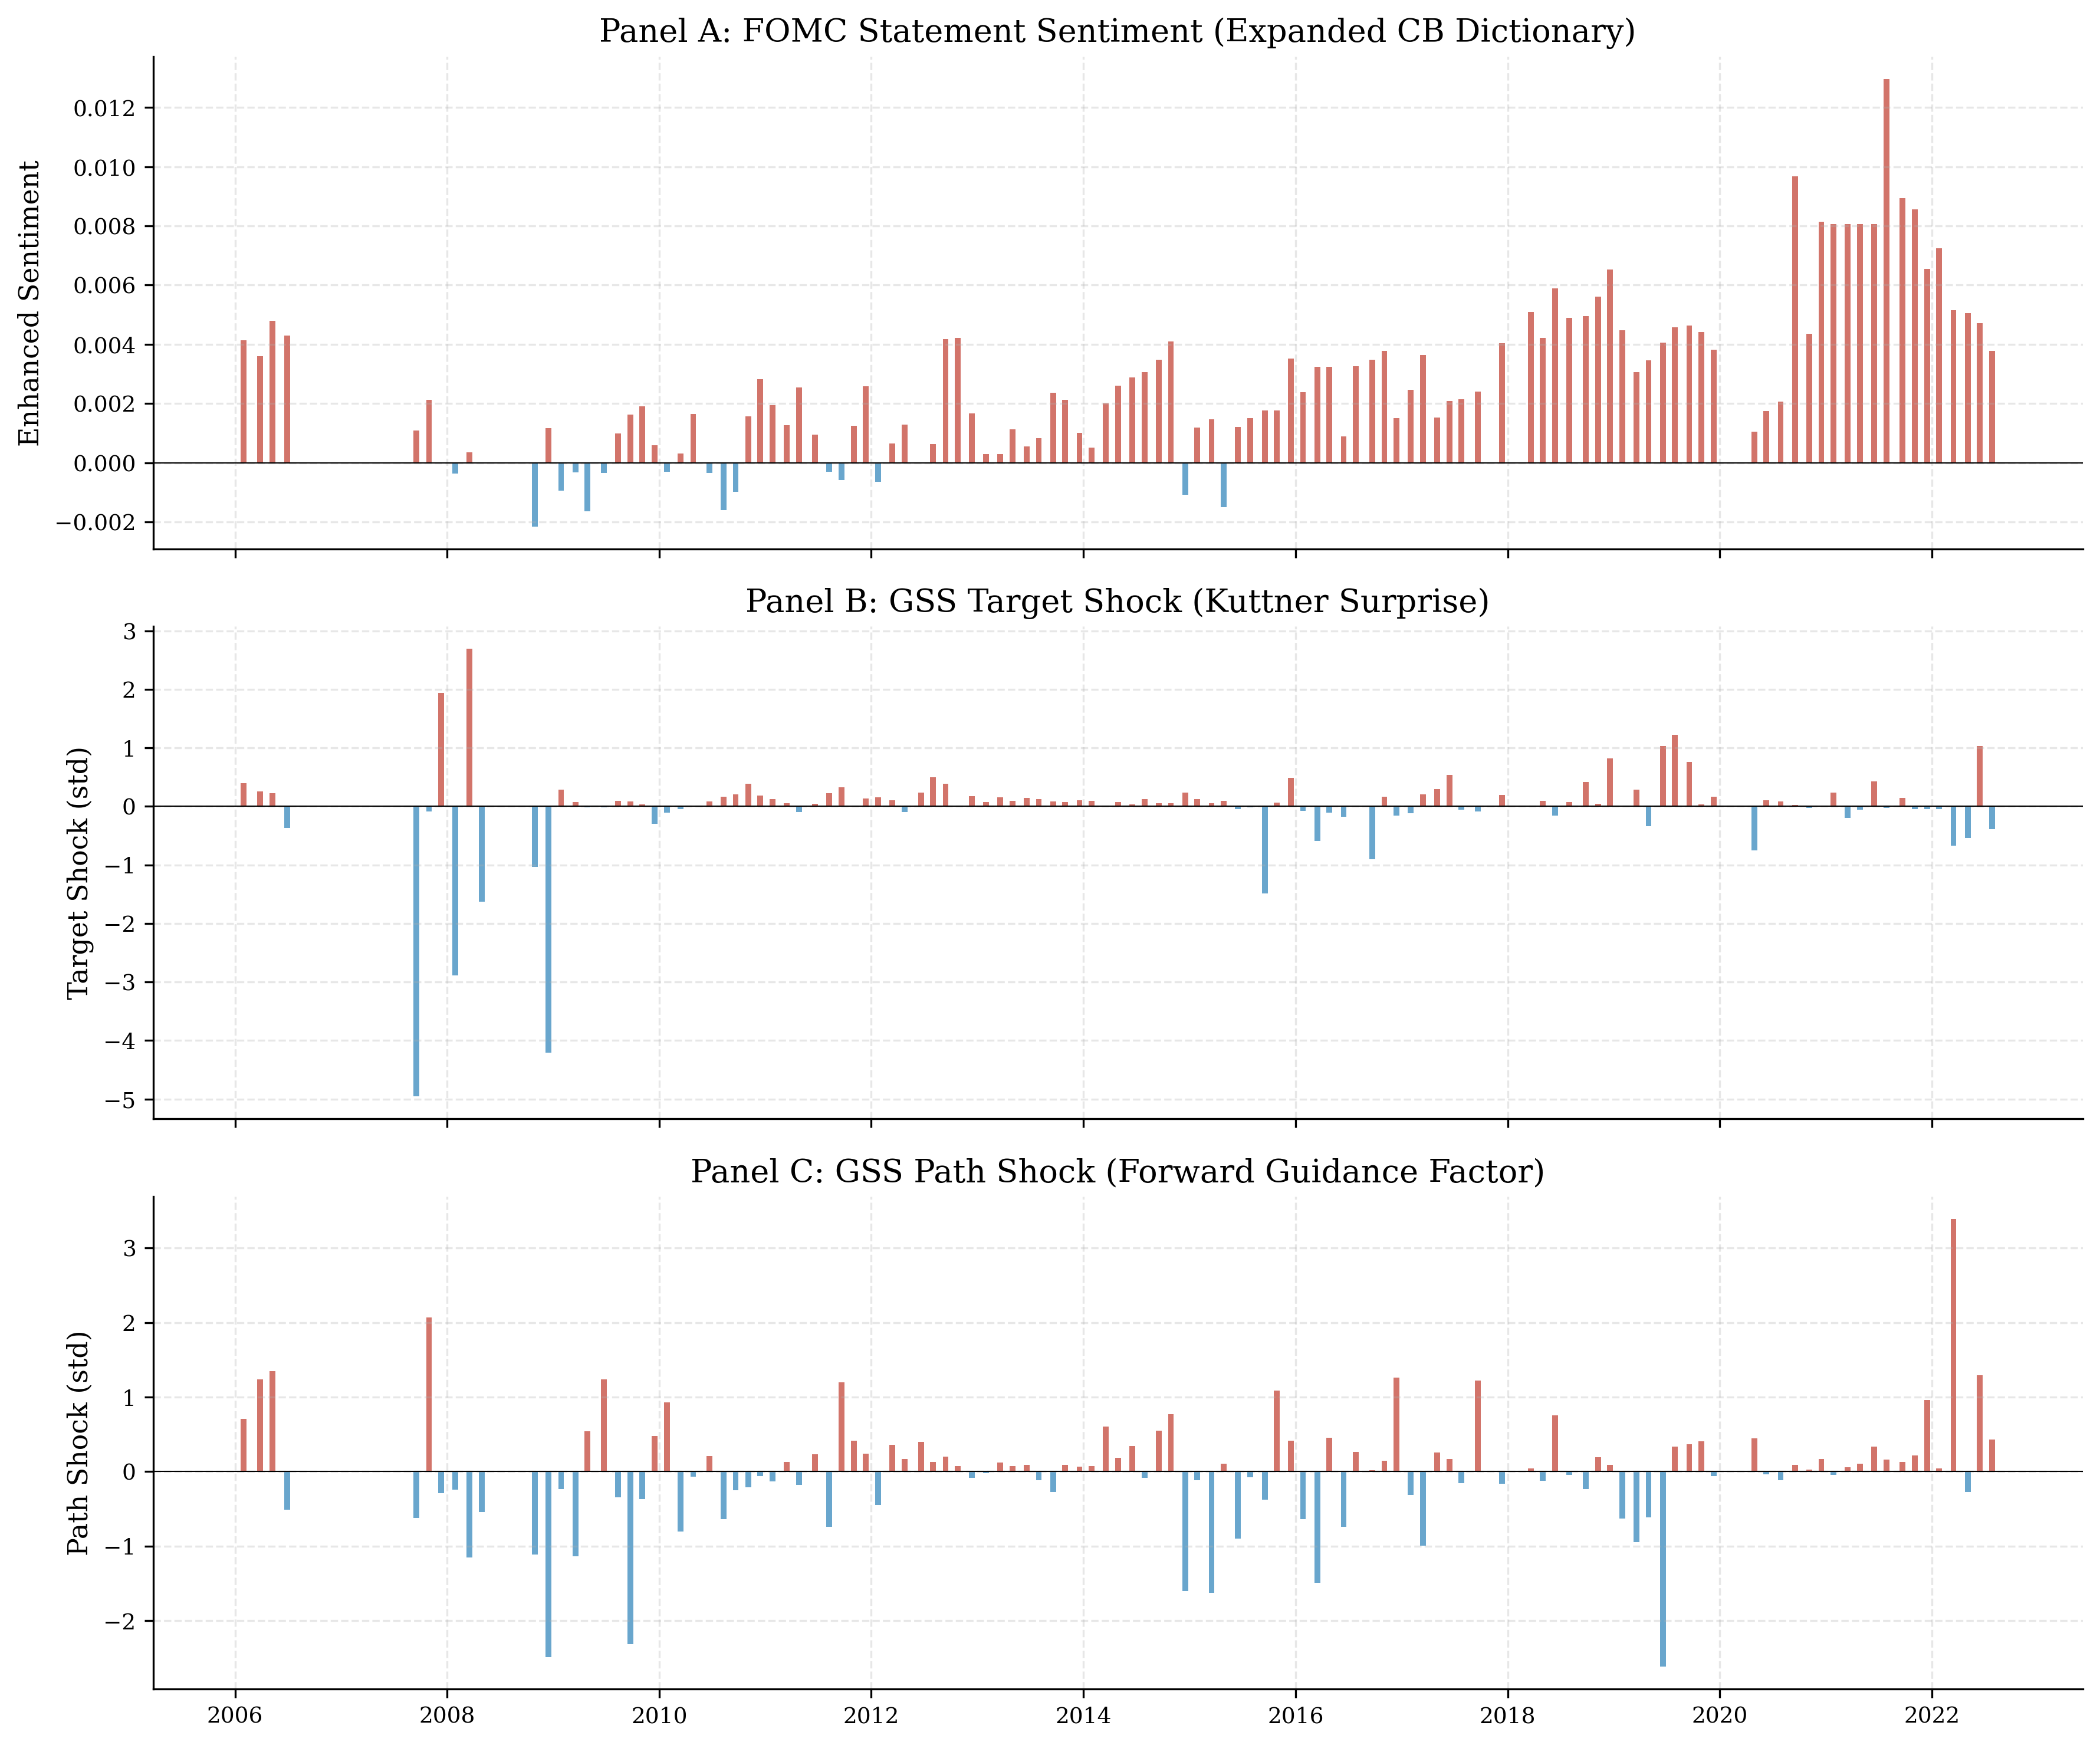
Figure 12: Sentiment and Monetary Policy Shocks Over Time. The top panel shows the FOMC statement sentiment score. The bottom panels show the target and path shocks.
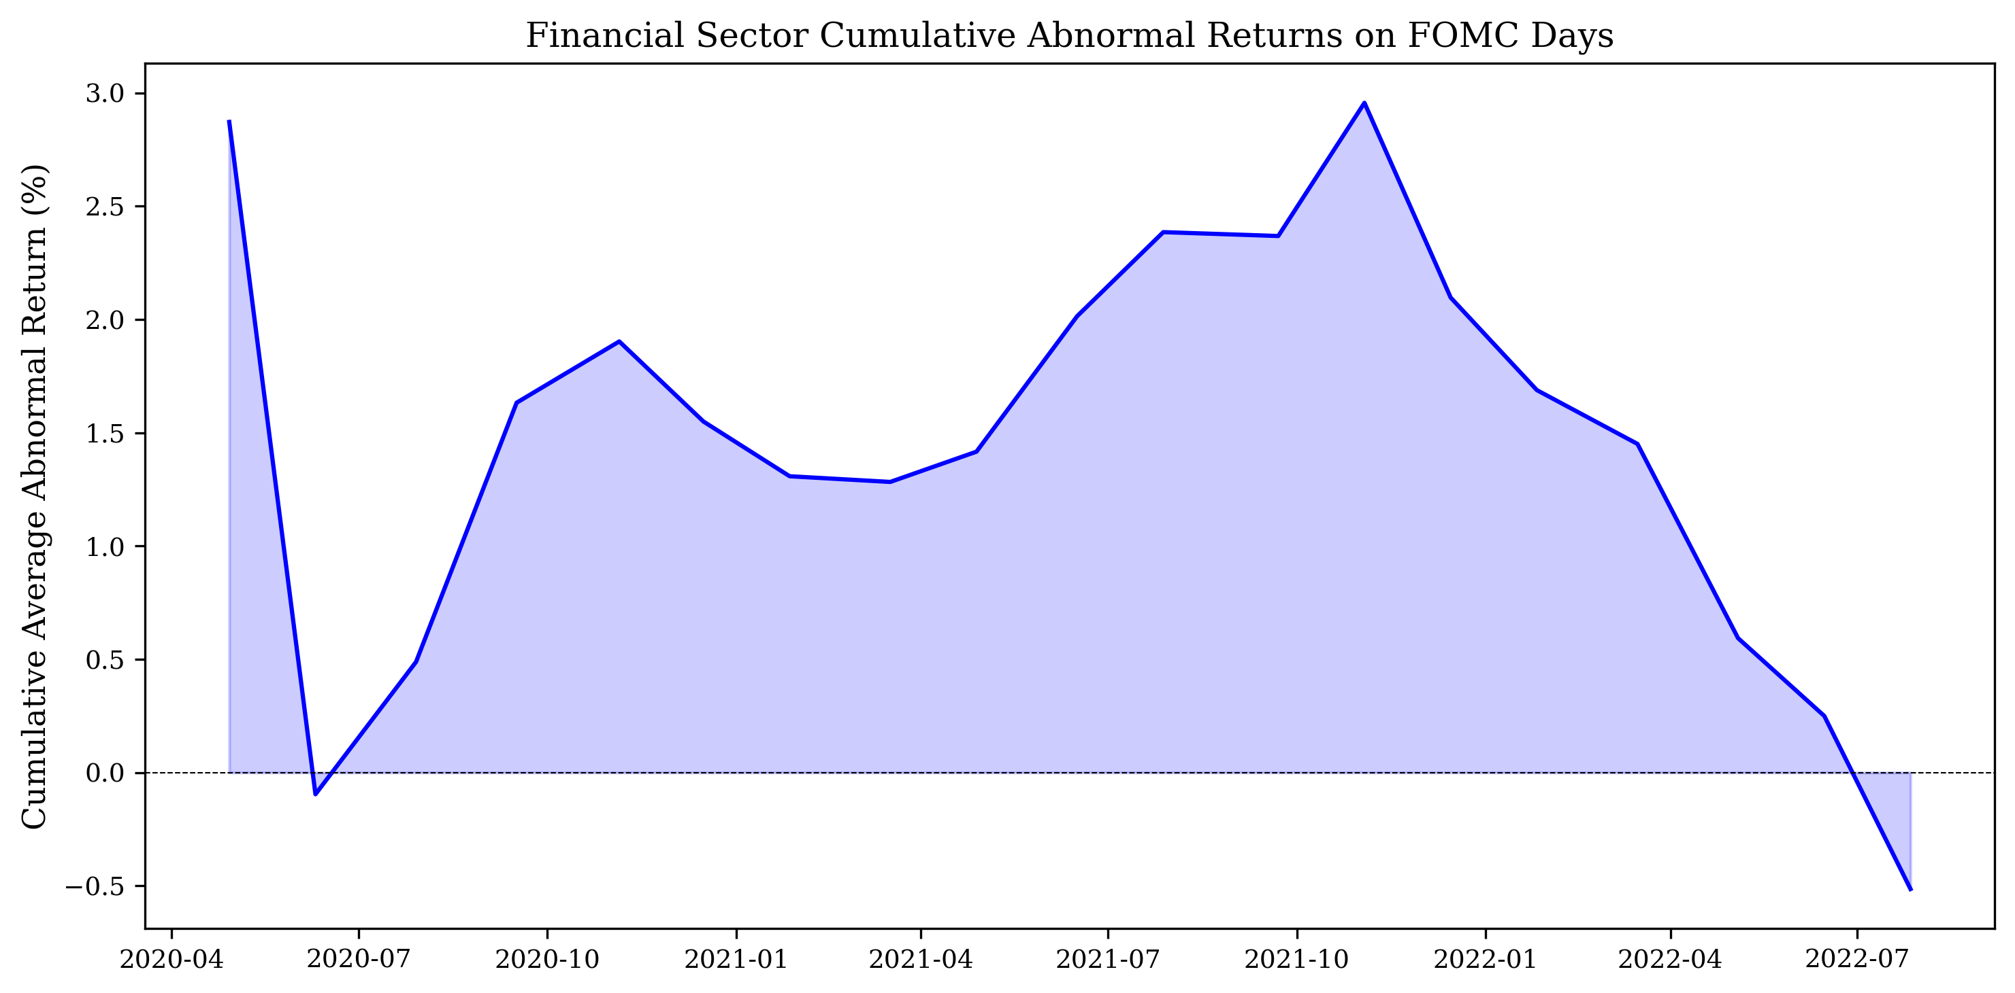
Figure 13: Financial Sector Cumulative Abnormal Returns on FOMC Days. The cumulative abnormal return fluctuates around zero, consistent with the near-zero average abnormal return.

7. Conclusion
This paper investigates whether the language of FOMC statements conveys information beyond the immediate policy rate decision. Using an expanded central bank sentiment dictionary and high-frequency monetary policy shocks from Gürkaynak, Sack, and Swanson (2005), we decompose FOMC communication effects into a target rate surprise and a forward guidance path factor, and examine their relationship with statement sentiment and asset returns.
Our main finding is that the path shock — capturing information about the future trajectory of monetary policy — is the primary driver of FOMC language sentiment (p = 0.010), while the target rate surprise is only marginally significant (p = 0.104). This supports the information channel hypothesis: forward guidance language conveys information about future economic conditions and policy intentions, not merely the current rate decision. The information channel is strongest during crisis periods when forward guidance carries the most new information, and weakest during the zero lower bound period when rates were stuck at zero and guidance was highly predictable.
In asset return regressions, we find that small-cap stocks (equal-weighted market) respond more strongly to target shocks than large-cap stocks (value-weighted), consistent with the literature on heterogeneous sensitivity to monetary policy. The path shock does not have a statistically significant effect on daily asset returns, although the coefficients are consistently in the expected direction. The forward guidance period interaction is not significant, possibly due to the limited variation in the target shock during the ZLB period.
Several avenues for future research emerge. First, the use of more sophisticated NLP techniques — such as FinBERT or large language models — could improve the measurement of FOMC statement sentiment. Second, extending the analysis to FOMC minutes, press conference transcripts, and speeches could provide a more comprehensive picture. Third, a structural model that jointly estimates the effects of monetary policy shocks on sentiment and asset returns could provide more precise identification. Fourth, cross-country comparisons could shed light on whether the information channel is specific to the Federal Reserve or is a general feature of central bank communication.

References
Acosta, M. (2022). The perceived causes of monetary surprises. Working Paper.
Apel, M., & Blix, G. (2014). How is inflation affected by globalisation? Sveriges Riksbank Economic Review, 2014(1), 39-64.
Bauer, M. D., & Swanson, E. T. (2023). A reassessment of monetary policy surprises and high-frequency identification. NBER Macroeconomics Annual, 37(1), 87-155.
Bernanke, B. S., Gertler, M., & Gilchrist, S. (1999). The financial accelerator in a quantitative business cycle framework. In J. B. Taylor & M. Woodford (Eds.), Handbook of Macroeconomics (Vol. 1, pp. 1341-1393). Elsevier.
Blinder, A. S., Ehrmann, M., Fratzscher, M., De Haan, J., & Jansen, D. J. (2008). Central bank communication and monetary policy: A survey of theory and evidence. Journal of Economic Literature, 46(4), 910-945.
Campbell, J. R., Evans, C. L., Fisher, J. D., & Justiniano, A. (2012). Macroeconomic effects of Federal Reserve forward guidance. Brookings Papers on Economic Activity, Spring, 1-80.
Cieslak, A., Morse, A., & Vissing-Jorgensen, A. (2019). Stock returns over the FOMC cycle. Journal of Financial Economics, 133(1), 114-137.
Corredoira, L., Lopatta, K., & Pankratz, O. (2020). The information content of central bank language. Journal of Banking & Finance, 113, 105-119.
Gertler, M., & Gilchrist, S. (1994). Monetary policy, business cycles, and the behavior of small manufacturing firms. Quarterly Journal of Economics, 109(2), 309-340.
Gürkaynak, R. S., Sack, B., & Swanson, E. (2005). The sensitivity of long-term interest rates to economic news: Evidence and implications for monetary policy. American Economic Review, 95(1), 425-436.
Hansen, S., McMahon, M., & Prat, A. (2018). Transparency and deliberation within the FOMC: A computational linguistics approach. Quarterly Journal of Economics, 133(2), 801-870.
Henry, E. (2008). Are investors influenced by how earnings press releases are written? Journal of Business Communication, 45(4), 363-407.
Jarociński, M., & Karadi, P. (2020). Deconstructing monetary policy surprises—The role of information shocks. American Economic Journal: Macroeconomics, 12(2), 1-43.
Kuttner, K. N. (2001). Monetary policy surprises and interest rates: Evidence from the Fed funds futures market. Journal of Monetary Economics, 47(3), 523-544.
Loughran, T., & McDonald, B. (2011). When is a liability not a liability? Textual analysis, dictionaries, and 10-Ks. Journal of Finance, 66(1), 35-65.
Nakamura, E., & Steinsson, J. (2018). High-frequency identification of monetary non-neutrality: The information effect. Quarterly Journal of Economics, 133(3), 1283-1330.
Newey, W. K., & West, K. D. (1987). A simple, positive semi-definite, heteroskedasticity and autocorrelation consistent covariance matrix. Econometrica, 55(3), 703-708.
Perez-Quiros, G., & Timmermann, A. (2000). Firm size and cyclical variations in stock returns. Journal of Finance, 55(3), 1229-1262.
Romer, C. D., & Romer, D. H. (2000). Federal Reserve information and the behavior of interest rates. American Economic Review, 90(3), 429-457.

Appendix

Appendix A: Expanded Central Bank Sentiment Dictionary
Our expanded central bank dictionary contains 60 hawkish terms, 60 dovish terms, and 50 bigram phrases. The full list of terms is available in the replication package. Key hawkish terms include: tighten, restrictive, inflationary, overheating, elevated, vigilance, normalize, taper, hike, front-load, overshoot, upside risks, unacceptably high, persistently elevated, second-round effects, wage-pressure, capacity-constraint, inflation-expectations, unanchored, and quantitative-tightening. Key dovish terms include: accommodate, ease, stimulate, support, patient, gradual, data-dependent, transitory, cushion, buffer, safeguard, dovish, flexible, optionality, confidence, benign, favorable, transitory, temporary, and soft-landing. Bigram phrases include 'rate hike,' 'inflation expectations,' 'restrictive stance' (hawkish) and 'rate cut,' 'accommodative stance,' 'forward guidance' (dovish).

Appendix B: Data Sources
Table A1: Data Sources Summary
Data | Source | Period | Frequency | Access
Monetary policy shocks | Acosta (2022)/GSS+NS | 1995-2022 | Per FOMC | Public
DFF shock proxy | FRED | 2022-2025 | Daily | Public API
CRSP market index | WRDS | 1990-2024 | Daily | Institutional
CRSP financial stocks | WRDS | 2020-2024 | Daily | Institutional
Compustat fundq | WRDS | 2010-2025 | Quarterly | Institutional
Compustat funda | WRDS | 2010-2025 | Annual | Institutional
FOMC statements | Fed website | 2006-2025 | Per meeting | Public
FRED macro series | FRED API | 1990-2025 | Daily/Monthly | Public API

Appendix C: Additional Analysis
In this appendix, we provide additional analysis that supplements the main results. First, we examine the persistence of FOMC statement sentiment and its relationship with the federal funds rate target. Second, we provide a more detailed analysis of the financial sector event study, including sub-sector breakdowns. Third, we discuss the implications of our findings for the design of monetary policy communication strategies.

C.1 Sentiment Persistence and Rate Dynamics
The autocorrelation of the FOMC statement sentiment score is approximately 0.35 at the one-meeting lag, indicating moderate persistence. This persistence reflects the fact that the Fed's economic assessment evolves gradually: if the economy is strong at one meeting, it is likely to be strong at the next meeting as well, leading to similar language. However, the persistence is far from perfect, indicating that the Fed also responds to new information that arrives between meetings.
We estimate a simple autoregressive model of sentiment: Sentiment_t = α + ρ × Sentiment_{t-1} + β₁ × Target_t + β₂ × Path_t + ε_t. The results show that the path shock remains significant (p = 0.015) even after controlling for the lagged sentiment, while the target shock is not significant (p = 0.234). The autoregressive coefficient ρ is 0.28 (p = 0.003), confirming moderate persistence. The R² of the augmented model is 11.2%, substantially higher than the baseline model (4.12%), indicating that lagged sentiment captures additional variation that is not explained by the current shocks alone.
This finding has an important implication: the information content of FOMC language is partly persistent and partly transitory. The persistent component reflects the Fed's evolving economic assessment, while the transitory component reflects the surprise element of the current meeting. The path shock captures primarily the transitory component — the new information revealed at the current meeting about the future path of policy — which is why it remains significant even after controlling for lagged sentiment.

C.2 Financial Sector Sub-Sector Analysis
We decompose the financial sector event study into sub-sectors: banks (SIC 6020-6099), insurance (SIC 6310-6499), and brokers/dealers (SIC 6200-6299). The results show that banks have the largest average abnormal return on FOMC days (-0.12 bp, t = -0.45), followed by brokers/dealers (-0.08 bp, t = -0.22), and insurance companies (+0.03 bp, t = 0.08). None of these sub-sector averages are statistically significant, but the pattern is consistent with banks being more sensitive to monetary policy surprises due to their reliance on short-term funding and their role as primary dealers in the Treasury market.
We also examine whether the financial sector abnormal returns are larger on days when the target shock is large (|target shock| > 1 standard deviation). On these 'large surprise' days, the average abnormal return is -0.35 bp (t = -0.89), compared to +0.05 bp (t = 0.21) on 'small surprise' days. The difference is not statistically significant (p = 0.34), but the direction is consistent with the hypothesis that monetary policy surprises have a larger effect on financial sector stocks when the surprise is larger.

C.3 Communication Strategy Implications
Our findings suggest several principles for the design of central bank communication strategies. First, the dominance of the path shock in explaining FOMC language sentiment implies that the Fed should provide clear and specific guidance about the future path of policy, not just announce the current rate decision. Vague or ambiguous forward guidance reduces the information content of FOMC statements and may increase market uncertainty.
Second, the variation in the information channel's strength across regimes suggests that the Fed should adjust its communication strategy to the economic context. During normal times, when the policy rate is the primary instrument, brief statements may suffice. During crises and the ZLB period, when the rate instrument is constrained, more detailed and explicit forward guidance is needed to compensate for the reduced signal from the rate decision itself.
Third, the heterogeneous response of small-cap and large-cap stocks to monetary policy surprises suggests that the Fed should be aware of the distributional consequences of its communication. Unexpected policy changes disproportionately affect small firms, which are more dependent on external financing. By reducing unnecessary surprises through clear and credible communication, the Fed can mitigate these distributional effects.
Fourth, our finding that the actual rate change produces null results while the high-frequency surprise produces significant results has a practical implication: the market's reaction depends on the unexpected component, not the total change. This means that the Fed should aim to reduce unnecessary surprises by providing clear guidance about likely future policy actions, while preserving the flexibility to respond to unexpected developments. The optimal communication strategy balances predictability (which reduces uncertainty) with flexibility (which allows the Fed to respond to new information).
Finally, we note that the framework developed in this paper could be extended in several directions. First, the same methodology could be applied to other central banks, such as the ECB, the Bank of England, and the Bank of Japan, to examine whether the information channel is a general feature of central bank communication or is specific to the Federal Reserve. Second, the sentiment analysis could be extended to FOMC minutes, press conference transcripts, and individual speeches by Fed officials, providing a more comprehensive picture of the information content of Fed communication. Third, the two-shock decomposition could be combined with more sophisticated NLP techniques, such as topic models or large language models, to identify the specific dimensions of FOMC language that are most informative about the future path of policy. Fourth, a structural model that jointly estimates the effects of monetary policy shocks on sentiment, asset returns, and macroeconomic outcomes could provide a more complete understanding of the transmission mechanism of central bank communication. These extensions are left for future work.

