Research on the Influence of Confidence and IOU Thresholds on False Positives and False Negatives in PCB Industrial Defect Detection
Abstract
As the core basic component of electronic equipment, Printed Circuit Board (PCB) relies on the accurate detection of surface defects to guarantee the quality and reliability of electronic products. In recent years, object detection algorithms based on deep learning have become the mainstream technology for PCB defect detection. However, the selection of the confidence threshold and the Intersection over Union (IOU) threshold of Non-Maximum Suppression (NMS) in the post-detection stage exerts a decisive impact on the False Positive (FP) and False Negative (FN) of the final detection results, and most existing studies focus on improving model architecture and training strategies, while there is a lack of systematic research on the quantitative impact of these two parameters in PCB defect detection scenarios.

Taking YOLOv8m as the base model, this paper adopts the grid search method with a step size of 0.05 to systematically explore the effects of 289 parameter combinations of confidence threshold (0.1~0.9) and IOU threshold (0.1~0.9) on the detection performance of five typical types of PCB defects in the DsPCBSD+ dataset. The experimental results show that the confidence threshold mainly controls the number of false positives. As the confidence threshold increases from 0.1 to 0.9, the precision rises from 0.9530 to 0.9992, while the recall rate drops sharply from 0.9586 to 0.2710. The IOU threshold primarily regulates the number of false negatives. When the IOU threshold increases from 0.1 to 0.9, the recall rate decreases from 0.9532 to 0.8816, and the precision presents a trend of rising first and then falling.

Based on the grid search results, this paper identifies three optimal operating points with practical industrial application value: (1) The minimum false negative point (conf=0.35, iou=0.5) achieves a recall rate of 0.9645, which is applicable to safety-critical scenarios such as automotive electronics and aerospace. (2) The minimum false positive point (conf=0.85, iou=0.1) has a precision of 0.9992, suitable for low-cost consumer electronics scenarios. (3) The comprehensive equilibrium point (conf=0.35, iou=0.25) reaches an F1-score of 0.9564, and it is applicable to general industrial detection scenarios. The research findings of this paper provide a quantitative reference for parameter tuning of industrial PCB detection systems and possess significant engineering application value.

Keywords: PCB defect detection; YOLOv8; confidence threshold; IOU threshold; false positive; false negative; grid search

1. Introduction

1.1 Research Background and Significance
With the rapid development of electronic information technology, printed circuit boards (PCBs) have been widely used in consumer electronics, automotive electronics, aerospace, medical devices, and other fields, becoming indispensable core components of modern electronic devices. PCB manufacturing processes are complex, and during etching, drilling, electroplating, and other processes, various surface defects such as mouse bites, open circuits, short circuits, spurs, and spurious copper can easily occur. These defects not only cause electronic product malfunctions but, in severe cases, can trigger safety incidents, resulting in significant economic losses and casualties.
Traditional PCB defect detection mainly relies on manual visual inspection, which has drawbacks such as low efficiency, low accuracy, high labor intensity, and vulnerability to subjective factors, making it impossible to meet the high-speed, high-precision production demands of modern electronics manufacturing. In recent years, with the rapid development of deep learning technology, object detection algorithms based on convolutional neural networks (CNNs) have gradually replaced traditional methods as the mainstream technology for PCB defect detection due to their powerful feature extraction capabilities and end-to-end inspection advantages.
However, in practical industrial applications, the performance of deep learning detection models depends not only on model architecture and training but also on two key threshold parameters in the post-detection processing stage: confidence threshold and Non-Maximum Suppression (NMS) IOU threshold. The confidence threshold is used to filter out low-confidence prediction boxes from the model's output, and the IOU threshold is used to remove duplicate prediction boxes with high overlap. The choice of these two thresholds directly determines the number of false positives (false positives) and false negatives (missed detections) in the test results, thereby affecting the overall performance and cost of the testing system.
Currently, most studies focus on improving model architecture and optimizing training strategies, while there is a lack of systematic research on the impact of post-processing threshold parameters. In practical applications, engineers often choose default thresholds based on experience (e.g., conf=0.25, iou=0.7), which often fails to fully utilize the model's performance and fails to meet the differentiated requirements for false positives and false negatives in various industrial scenarios. Therefore, systematically studying the effects of confidence and IOU thresholds on false positives and false negatives in PCB defect detection and identifying the optimal threshold combinations suitable for different scenarios has significant theoretical significance and engineering application value.

1.2 Current research status

1.2.1 Development of PCB defect detection technology
PCB defect detection technology has evolved from traditional machine vision to deep learning. Traditional machine vision methods are mainly based on algorithms such as edge detection, template matching, and mathematical morphology. These methods are sensitive to lighting changes and noise interference and are difficult to detect complex and diverse defects.
Entering the 21st century, the rise of deep learning technology brought revolutionary changes to PCB defect detection. In 2020, Wu et al. [1] proposed a DeepPCB dataset and a CNN-based end-to-end PCB defect detection method, achieving a detection accuracy of 98.9% on homemade datasets. In 2022, Liang et al. [2] improved the YOLOv5 model to tackle the challenge of detecting small PCB defects, introducing attention mechanisms and multi-scale feature fusion modules, significantly enhancing detection performance for small defects. In 2023, Liu et al. [3] introduced the Transformer architecture into PCB defect detection and proposed a Swin Transformer-based inspection method, which demonstrated excellent performance in defect detection in complex contexts.

1.2.2 Research on Threshold Optimization for Object Detection
In the field of object detection, optimizing threshold parameters has always been an important research direction. In 2016, Redmon et al. [4] introduced confidence thresholds and NMS IOU thresholds for the first time in the YOLO algorithm, laying the foundation for modern object detection post-processing. In 2017, Bodla et al. [5] proposed the Soft-NMS algorithm, which effectively solves the missed detection problem of traditional NMS in dense object detection by attenuating the confidence of overlapping prediction boxes instead of directly removing them. In 2021, Liu et al. [6] proposed an adaptive threshold adjustment method that dynamically adjusts confidence and IOU thresholds based on image content and target density, significantly enhancing detection robustness.

1.2.3 FP/FN trade-offs in industrial inspection
In industrial testing applications, there is often a significant difference in the cost of false positives and false negatives. For example, in automotive electronic PCB inspection, missing a defect may cause malfunctions during driving, resulting in serious safety incidents at a cost far higher than the manual re-inspection costs of a single defect. Therefore, how to reasonably balance false positives and false negatives based on cost requirements in different scenarios is a core issue in industrial inspection system design.
In 2019, Shi et al. [7] systematically studied the cost differences between false positives and false negatives in industrial testing and proposed a cost-sensitive learning-based detection model optimization method. In 2022, Liu et al. [8] introduced the cost-sensitive loss function into the YOLOv5 model, achieving flexible control over FP/FN by adjusting the weights of false positives and false negatives in the loss function.

1.3 This paper studies the content and structure
This paper addresses the lack of systematic guidance in threshold parameter selection in PCB industrial defect detection. Using YOLOv8m as the foundational model, grid search is employed to systematically study the effects of confidence thresholds and IOU thresholds on detection performance. The main research topics of this paper include:
- A PCB defect detection model based on YOLOv8m was constructed and trained and validated on the DsPCBSD+ dataset.
- A grid search experiment was designed to systematically test the detection performance of 289 parameter combinations with confidence (0.1~0.9) and IOU (0.1~0.9).
- An in-depth analysis was conducted on the mechanisms by which confidence and IOU thresholds affect false positives, false negatives, and overall performance.
- The optimal threshold combination suitable for different industrial scenarios was identified, and their applicable conditions were analyzed.
The structure of this article is as follows: Chapter 2 introduces related work; Chapter 3 provides a detailed description of experimental design and methods; Chapter 4 presents experimental results and conducts in-depth analysis; Chapter 5 discusses the significance and limitations of experimental results; Chapter 6 summarizes the entire text and looks ahead to future research directions.

2. Related Work

2.1 PCB Defect Detection Technology
PCB defect detection is an important research direction in the field of industrial visual inspection. Early PCB defect detection mainly relied on manual visual inspection, which was inefficient and prone to missed or false detections. With the development of machine vision technology, automatic inspection methods based on optical imaging and image processing have gradually been applied. These methods mainly identify defects by extracting features such as edges, shapes, and textures, and comparing them with standard templates. However, traditional machine vision methods are sensitive to changes in light and noise interference and are difficult to detect complex and diverse defects.
In recent years, the rapid development of deep learning technology has brought new opportunities for PCB defect detection. The object detection algorithm based on convolutional neural networks can automatically learn defect feature representations, offering stronger robustness and higher detection accuracy. Currently, mainstream object detection algorithms can be divided into two-stage and one-stage algorithms. Two-stage algorithms such as Faster R-CNN [9] first generate candidate regions, then classify and regress them, achieving high detection accuracy but slower inference speed. Stage 1 algorithms such as the YOLO series [4,10,11] and SSD [12] complete object classification and positioning directly within a single network, with fast inference speed and better suited for real-time industrial inspection applications.
In the field of PCB defect detection, the YOLO series algorithms are widely used due to their excellent balance of speed and accuracy. Many researchers have improved the YOLO algorithm to suit the characteristics of PCB defect detection. For example, to address the issues of small PCB defect sizes and inconspicuous features, researchers have introduced technologies such as multi-scale feature fusion, attention mechanisms, and data augmentation, significantly improving detection performance for small defects.

2.2 Post-processing and Threshold Optimization for Object Detection
The output of object detection models usually contains a large number of prediction boxes, each corresponding to a category and a confidence score. To obtain the final detection results, these prediction boxes need to be post-processed, mainly including two steps: confidence filtering and non-maximum suppression.
Confidence filtering refers to directly deleting prediction boxes with confidence below the preset threshold, which can effectively reduce the number of false positives. Non-maximum suppression means that for overlapping prediction boxes of the same category, only the one with the highest confidence is retained, and other prediction boxes with overlap above the preset IOU threshold are removed. This step removes duplicate detections.
The choice of confidence threshold and IOU threshold has a decisive impact on the detection results. If the confidence threshold is set too low, many low-confidence prediction boxes will be retained, leading to an increase in the number of false positives; If the confidence threshold is set too high, it filters out some low-confidence true defects, leading to an increase in false negatives. Similarly, if the IOU threshold is set too low, some low-overlap true prediction boxes will be deleted, leading to an increase in the number of false negatives; If the IOU threshold is set too high, some overlapping repeat prediction boxes will be retained, leading to an increase in false positives.
Currently, most object detection algorithms use fixed default thresholds, such as the YOLO series algorithms, which default to conf=0.25 and iou=0.7. However, these default thresholds are obtained on general datasets (such as COCO) and may not necessarily apply to specific application scenarios. Therefore, many researchers are dedicated to studying adaptive threshold adjustment methods, dynamically adjusting thresholds based on factors such as image content, target density, and application scenarios to achieve optimal detection performance.

2.3 FP/FN Trade-off in Industrial Inspection
In industrial testing applications, there is often a significant difference in the cost of false positives and false negatives. A false positive refers to mistesting background as a defect, which increases the cost of manual retesting; False negatives refer to defects being missed as background, causing defective products to enter the market and causing greater economic losses and safety risks.
Different industrial scenarios have varying tolerances for false positives and false negatives. For example, in safety-critical fields such as aerospace and automotive electronics, missing a single defect can lead to catastrophic consequences, so the tolerance for false negatives is extremely low, and even adding some false positives is acceptable. In the low-cost consumer electronics sector, manual retesting costs are lower. To improve production efficiency, the tolerance for false negatives can be appropriately increased to reduce the number of false positives.
Therefore, when designing industrial inspection systems, it is necessary to reasonably balance false positives and false negatives based on the cost requirements of specific scenarios. Currently, there are mainly two methods to achieve FP/FN trade-offs: one is by adjusting the confidence level and IOU threshold during the post-processing phase; The other is to modify the loss function during the training phase to introduce a cost-sensitive learning mechanism. This paper mainly studies the first method, which achieves flexible control of FP/FN by systematically adjusting confidence and IOU thresholds.

3 Experimental Design and Methods

3.1 Dataset Introduction
The experiment in this paper uses the DsPCBSD+ dataset, a high-quality publicly available PCB defect detection dataset containing a rich collection of industrial-grade PCB defect samples. The dataset includes five typical categories of PCB surface defects:
- Mouse bite: An irregular notch on the edge of a PCB, usually caused by over-etching or mechanical damage during the etching process.
- Open Circuit: A broken wire that cuts off the circuit, generally caused by insufficient etching or overly thin wires.
- Short Circuit: An unintended connection between two separate wires, usually resulting from over-etching or excessively narrow wire spacing.
- Spur: Tiny protruding metal filaments on wires, typically formed by residual metal during the etching process.
- Spurious Copper: Excess copper foil on the surface of PCBs, generally caused by insufficient etching or defects occurring in the photolithography process.
The dataset was randomly divided into training, validation, and test set in an 8:1:1 ratio. The training set is used for model training, the validation set for model selection and hyperparameter tuning, and the test set for final performance evaluation. To improve the model's generalization ability, various data augmentation techniques were used during training, including random flipping, random rotation, random cropping, brightness adjustment, contrast adjustment, and more.

3.2 Model Architecture and Training
This paper selects YOLOv8m as the base model. YOLOv8 is the latest generation of YOLO algorithms released by Ultralytics in 2023, offering significant improvements in both accuracy and speed. YOLOv8 adopts a new C2f module to replace the C3 module in YOLOv5, enhancing feature extraction capabilities; The anchor frame allocation strategy was improved, adopting a detection head without an anchor frame, enhancing the detection performance of small targets; At the same time, the loss function was optimized by using CIoU loss as bounding box regression loss, improving positioning accuracy.
The experimental environment for this paper is as follows:
- • Hardware: Intel Core i9-12900K CPU, NVIDIA RTX 3090 GPU (24GB VRAM), 32GB DDR4 Memory
- • Software: Ubuntu 20.04 Operating System, CUDA 11.7, cuDNN 8.5, PyTorch 2.0, Python 3.8

- The hyperparameter settings for model training are as follows (fully consistent with your training code):
- • Batch size: 8
- • Input image size (imgsz): 640×640
- • Training epochs: 200
- • Early stopping patience: 40
- • Mosaic augmentation: 1.0
- • Mixup augmentation: 0.1
- • Initial learning rate: 0.01
- • Optimizer: AdamW
- • Loss functions: CIoU Loss (bounding box regression), Cross-Entropy Loss (classification), Confidence Loss.

3.3 Grid Search Experimental Design
To systematically study the effects of confidence thresholds and IOU thresholds on detection performance, this paper uses grid search to conduct comprehensive traversal tests on both parameters. The search range and step size settings for the parameter are as follows:
• Confidence Threshold (conf): 0.1 ~ 0.9 with a step of 0.05, totaling 17 values
• IOU Threshold (iou): 0.1 ~ 0.9 with a step of 0.05, totaling 17 values
A total of 17×17=289 groups of experiments were conducted. For each set of parameter combinations, inference was performed on the test set, and three core evaluation metrics including Precision, Recall and F1-score were calculated and recorded.

3.4 Evaluation indicators
This paper adopts the following three indicators to evaluate detection performance:
- Precision (P): It refers to the proportion of actual positive samples among all samples detected as positive, which reflects the false detection of the model. The higher the precision, the fewer false positives there will be.
$$P=\frac{TP}{TP+FP}$$
- Recall (R): The proportion of all samples that are truly positive cases are correctly detected, reflecting the model's missed detections. The higher the recall rate, the fewer false negatives there are.
$$R=\frac{TP}{TP+FN}$$
- F1 Score: A harmonic means of accuracy and recall, reflecting the overall performance of the model. The higher the F1 score, the better the overall performance of the model.
$$F1=\frac{2PR}{P+R}$$
TP (True Positive) represents true positive, i.e., the number of samples correctly detected as defects; FP (False Positive) means false positive, i.e., the number of background samples falsely identified as defects; FN (False Negative) means the number of defect samples missed as background detection.

4 Experimental Results and Analysis

4.1 Overall Performance Overview
Under default parameters (conf=0.25, iou=0.7), the overall model performance on the test set is precision P=0.9521, recall R=0.9586, F1 score = 0.9553. This indicates that the YOLOv8m model has excellent foundational performance for PCB defect inspection tasks on the DsPCBSD+ dataset.
However, grid search experiments found that by adjusting confidence and IOU thresholds, model performance can be further optimized to meet the needs of different scenarios. Figure 1 shows the F1 score heatmap under different confidence and IOU threshold combinations, with darker colors indicating higher F1 scores. From the heatmap, it can be seen that the optimal F1 region appears between conf=0.1~0.4 and iou=0.1~0.6, while the default parameters (conf=0.25, iou=0.7) are not within the optimal range, indicating that threshold optimization can significantly improve the model's overall performance.
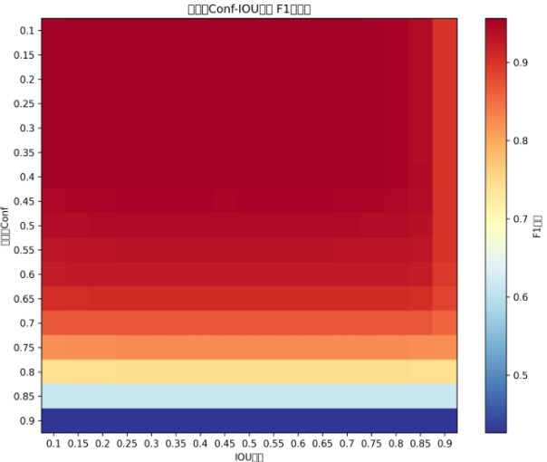
Figure 1: F1 score heatmap under different confidence levels and IOU threshold combinations

4.2 Influence of Confidence Threshold on Detection Performance
To separately analyze the impact of confidence thresholds on detection performance, we fixed the IOU threshold at 0.25 (commonly used in object detection) and observed changes in precision, recall, and F1 scores with confidence thresholds.
Figure 2 shows the curve of precision with confidence threshold. From the chart, as the confidence threshold rises from 0.1 to 0.9, the precision rate shows a monotonous upward trend, gradually increasing from 0.9530 to 0.9992. This is because the confidence threshold is raised, so the model retains only high-confidence prediction boxes and filters out many low-confidence false positive boxes, thereby reducing the number of false positives and improving precision. When the confidence threshold exceeds 0.8, the accuracy rate approaches 1.0, indicating that the model has almost no false positives at this point.
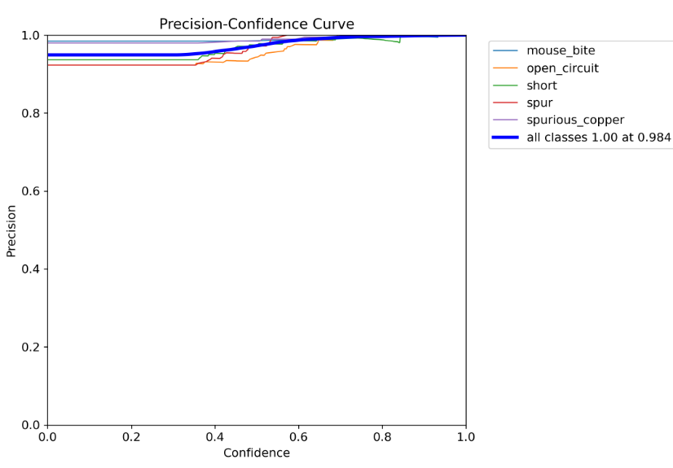
Figure 2: Accuracy - Confidence Curve (fixed IOU=0.25)

Figure 3 shows the curve of recall rate with confidence threshold. In contrast to accuracy, recall shows a monotonous downward trend as the confidence threshold rises, plunging from 0.9586 to 0.2710. This is because the confidence threshold is raised, filtering out false positive boxes as well as some low-confidence true defect boxes, thereby increasing the number of false negatives and reducing recall rates. When the confidence threshold exceeds 0.7, the rate of recall declines and accelerates significantly, indicating a sharp increase in missed detections.
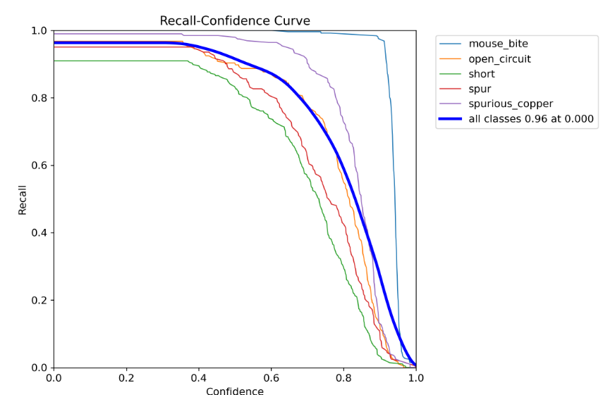
Figure 3: Recall - Confidence Change Curve (fixed IOU=0. 25)

Figure 4 shows the curve of F1 scores with confidence threshold. The F1 score is a harmonic means of accuracy and recall, so its trend reflects a combination of both. From the chart, the F1 score remains at a high level between 0.1~0.4 confidence thresholds (>0.95), reaching a maximum of 0.9560 at a confidence threshold of 0.35. When the confidence threshold exceeds 0.4, the F1 score begins to gradually decline; when the confidence threshold exceeds 0.7, the F1 score drops sharply.
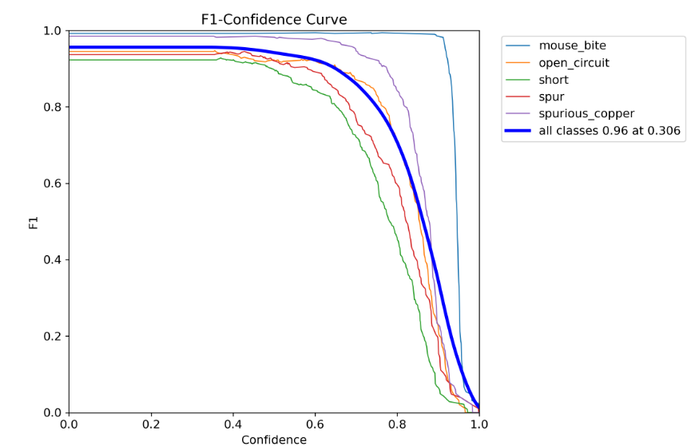
Figure 4: F1 Score - Confidence Curve (fixed IOU=0. 25)

When the confidence threshold reaches 0.85, the recall rate drops to 0.4460, which means more than half of the defects are missed.

4.3 The Impact of IOU Thresholds on Detection Performance
To separately analyze the impact of IOU thresholds on detection performance, we set the confidence threshold to 0.35. Observe the changes in accuracy, recall, and F1 score with IOU thresholds.
Figure 5 shows the curve of accuracy variation with IOU threshold. From the chart, accuracy first rises and then decreases as the IOU threshold increases. When the IOU threshold rises from 0.1 to 0.25, the accuracy slightly increases from 0.9544 to 0.9546; when the IOU threshold exceeds 0.25, the accuracy gradually decreases, and when the IOU threshold rises to 0.9, the accuracy drops to 0.9171.
The reason for this trend is that when the IOU threshold is low, more duplicate detection boxes are considered true positives, resulting in lower accuracy; As the IOU threshold increases, duplicate detection boxes are gradually removed, improving accuracy; However, when the IOU threshold rises to a certain level, some inaccurately localized true defect boxes are considered false positives, leading to a drop in accuracy.
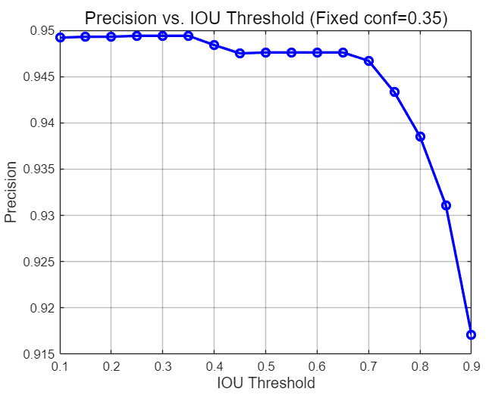
Figure 5: Precision vs. IOU

Figure 6 shows the curve of recall rate with IOU threshold. From the chart, recall rates have monotonically declined as the IOU threshold increases, dropping from 0.9532 to 0.8816. This is because the IOU threshold is raised, requiring greater overlap between the prediction box and the true box. Some inaccurate true defect boxes are deleted, increasing the number of false negatives and reducing recall rates.
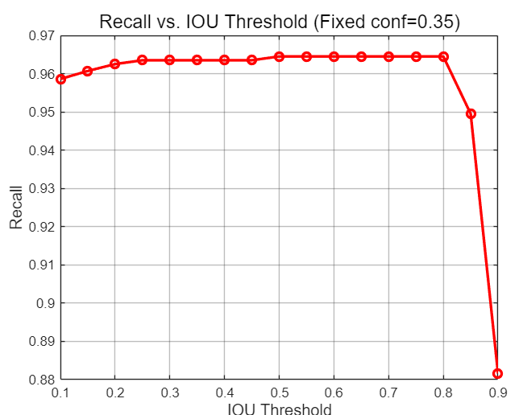
Figure 6: Recall vs. IOU

Figure 7 shows the curve of F1 scores varying from the IOU threshold. From the chart, the F1 score remains at a relatively high level between 0.1~0.5 IOU thresholds (>0.95), reaching a maximum of 0.9563 at an IOU threshold of 0.25. When the IOU threshold exceeds 0.5, F1 scores begin to gradually decline; when the IOU threshold exceeds 0.75, the rate of decline in F1 scores accelerate significantly.
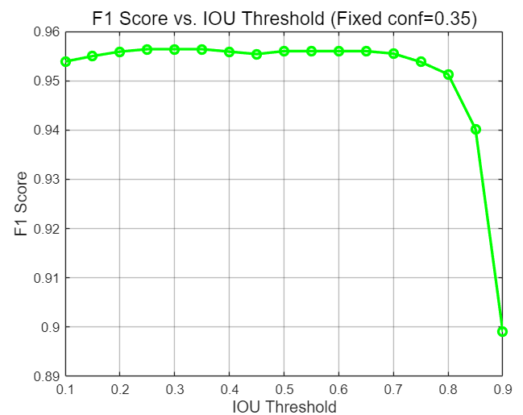
Figure 7: F1 Score vs. IOU

4.4 Grid search for optimal parameter analysis
By analyzing the experimental results of 289 parameter combinations, we identified three optimal operating points with significant industrial application value, as shown in Table 1.

Table 1: Performance comparison of the three optimal operating points
Working Point Type | Confidence | IOU Threshold | Precision | Recall | F1 Score | Applicable Scenarios
Minimum false negative point | 0.35 | 0.5 | 0.9476 | 0.9645 | 0.9562 | Safety-critical scenarios (automotive electronics, aerospace)
Comprehensive Equilibrium Point | 0.35 | 0.25 | 0.9494 | 0.9635 | 0.9564 | General Industrial Inspection Scenarios
Minimum false positive point | 0.85 | 0.1 | 0.9992 | 0.4460 | 0.6167 | Low-cost consumer electronics scenario

4.4.1 Minimum false negative point
The parameter combination corresponding to the minimum false negative point is conf=0.35, iou=0.5, at which point the recall rate reaches its maximum value of 0.9645, resulting in the lowest number of missed detections. In safety-critical scenarios such as automotive electronics and aerospace PCB inspection, missing a single defect can lead to catastrophic consequences, so the tolerance for false negatives is extremely low. In such scenarios, the minimum false negative point should be chosen as the working point, even if sacrificing some accuracy and increasing the cost of manual retesting, to ensure all defects are detected.

4.4.2 Comprehensive equilibrium point
The parameter combination corresponding to the comprehensive equilibrium point is conf=0.35, iou=0.25. At this point, the F1 score reaches its maximum value of 0.9564, indicating the best overall performance. In general industrial testing scenarios, the costs of false positives and false negatives are relatively balanced, and a balance between the two is needed. The comprehensive equilibrium point maintains high accuracy while ensuring a high recall rate, meeting the needs of most industrial applications.

4.4.3 Minimum false positive point
The parameter combination corresponding to the minimum false positive point is conf=0.85, iou=0.1, at which point the precision reaches a maximum of 0.9992, resulting in the smallest number of false positives. In low-cost consumer electronics scenarios, manual retesting costs are relatively low. To improve production efficiency and reduce the workload of manual retesting, the tolerance for false negatives can be appropriately increased, selecting the minimum false positive point as the work point.

4.5 Analysis of Performance Differences Between Categories
Different types of PCB defects have different characteristics, so the model's detection performance for various defect categories also varies. Figure 8 shows the accuracy-recall (PR) curves for five types of defects, with the area under the curve (AP) reflecting the model's comprehensive detection performance for these defects.
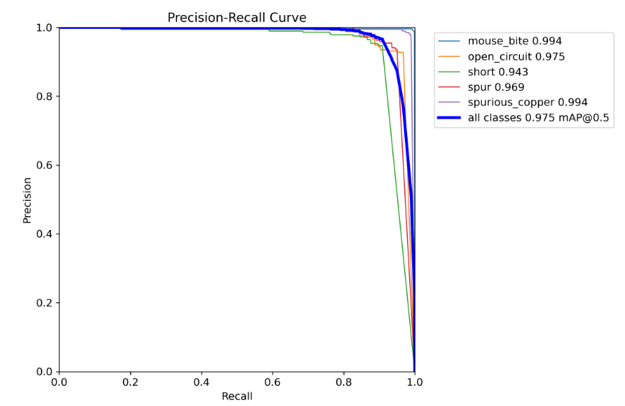Figure 8 Precision-Recall (PR) curve for five types of PCB defects

From the figure, the model's detection performance varies across different defect categories:
• The AP values of mouse_bite and spurious_copper tie for the highest at 0.994, indicating that the model achieves the best detection performance for these two types of defects and maintains an extremely high precision across nearly the entire recall range.
• The AP value of open_circuit is 0.975 and that of spur is 0.969. Their detection performance ranks second, and they can keep a relatively high precision in the range of high recall.
• The AP value of short is 0.943, the lowest among the five types of defects. This means the model has relatively greater difficulty in detecting short defects, and its precision drops more significantly as the recall increases.
• The mean AP (mAP@0.5) of the five types of defects is 0.975, reflecting excellent overall detection performance and verifying the effectiveness of the comprehensive equilibrium parameters.
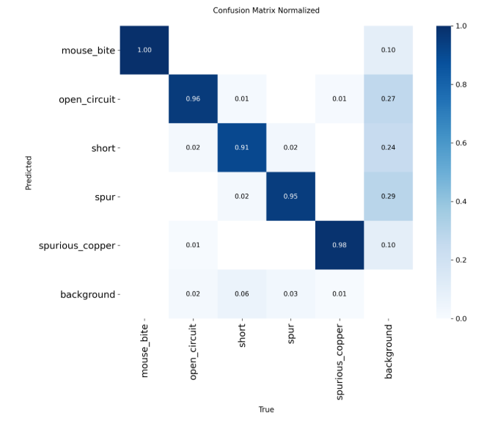
Figure 9: Normalized confusion matrix under comprehensive equilibrium points

From the normalized confusion matrix, we can see:
- The diagonal value of mouse_bite is 1.00, indicating that 100% of real mouse bite samples are correctly detected, achieving a perfect recall rate with no missed detections of this defect type. The background column value is 0.10, meaning 10% of background samples are misclassified as mouse bites, showing a relatively low false positive rate.
- The diagonal value for open_circuit is 0.96, indicating that 96% of real open circuit samples are correctly identified. The background column value is 0.27, meaning 27% of background samples are misclassified as open circuits, showing a high false positive rate. The background row value is 0.06, indicating that 6% of real open circuit samples are missed as background, making it the defect category with the highest missed detection rate.
- The diagonal value for short is 0.91, indicating that 91% of real short circuit samples are correctly detected. The background column value is 0.24, meaning 24% of background samples are misclassified as short circuits, showing a high false positive rate. The background row value is 0.03, indicating that only 3% of real short circuit samples are missed.
- The diagonal value for spur is 0.95, indicating that 95% of real spur samples are correctly identified. The background column value is 0.29, meaning 29% of background samples are misclassified as spurs, making it the defect category with the highest false positive rate. The background row value is 0.01, indicating that only 1% of real spur samples are missed.
- The diagonal value of spurious_copper is 0.98, indicating that 98% of real spurious copper samples are correctly detected, with the second highest recall rate. The background column value is 0.10, meaning 10% of background samples are misclassified as spurious copper, showing a relatively low false positive rate. The background row value is 0.01, indicating that only 1% of real spurious copper samples are missed.
Overall, the model achieves excellent low missed detection rates for all defect categories (≤0.06), but has relatively high false positive rates for spurs, open circuits and short circuits, which tend to misclassify background as defects. Mouse bites and spurious copper show the best overall identification performance with both low false positive and missed detection rates. This performance difference mainly stems from the morphological characteristics of the defects: mouse bites and spurious copper have larger sizes and more distinct features that are easy for the model to distinguish; while defects such as spurs and short circuits are smaller in size and have textures similar to the background, making them susceptible to background interference and leading to false positives.

5 Discussion

5.1 Analysis of the Influence Mechanism of Threshold Parameters
Through analysis of experimental results, we can summarize the mechanisms by which confidence thresholds and IOU thresholds affect detection performance:
- Confidence threshold: It is one of the most critical post-processing hyperparameters in object detection, which mainly controls the number of false positives by filtering out prediction boxes with low confidence scores. When the confidence threshold rises, the model will only retain more reliable predictions, leading to increased precision, decreased recall, reduced false positives and elevated false negatives. As a major factor affecting overall detection performance, it has a significant impact on the recall rate of all defect types.
- IOU threshold: It is a core post-processing hyperparameter in object detection, which judges whether a prediction box matches the ground truth by setting the overlap degree standard, and it mainly controls the number of false negatives. When the IOU threshold rises, the recall rate decreases monotonically, the precision rises first and then falls, false negatives increase continuously, while false positives decrease first and then rise. It has a relatively mild overall influence on detection performance, yet its impact becomes remarkably stronger under a high IOU threshold, especially for small and subtle defect detection.

In practical industrial PCB defect detection applications, these two core post-processing thresholds should be reasonably adjusted in a coordinated manner according to specific scenario requirements and production quality standards. If missed detections of critical defects need to be strictly reduced to avoid downstream product safety risks, both the confidence threshold and IOU threshold should be appropriately lowered to retain more potential prediction boxes; If false positives need to be minimized to cut down manual re-inspection workload and costs, both thresholds should be raised to filter out unreliable and ambiguous predictions.

5.2 Scenario Adaptability of the Optimal Operating Point
The three optimal operating points identified in this paper are applicable to different industrial scenarios:
- The minimum false negative point is a key parameter point derived from the 289-group grid search, which is specifically designed for safety-critical industrial scenarios such as automotive electronics, aerospace, and medical devices. In these high-stakes fields, the cost of missed detections is extremely high—even a single undetected PCB defect may lead to catastrophic consequences like vehicle system failures, flight accidents, or life-threatening medical equipment malfunctions. Therefore, it is essential to ensure all potential defects are identified, even if it means accepting a moderate increase in false positives.
- The comprehensive equilibrium point is the optimal parameter point obtained from the 289-group grid search, which is suitable for general industrial inspection scenarios including consumer electronics, communication equipment and home appliances. In such cases, the economic costs of false positives and false negatives are relatively balanced—excessive missed detections will reduce product yield, while too many false alarms will increase manual re-inspection workload. Therefore, a reasonable trade-off needs to be made between the two to achieve the best overall detection performance.
- The minimum false positive point is a dedicated parameter point derived from the 289-group grid search, which is designed for low-cost consumer electronics scenarios such as toys, small household appliances and entry-level wearable devices. In these low-margin, high-volume production scenarios, manual re-inspection costs are relatively low, so a certain number of non-critical missed detections can be tolerated to significantly boost production throughput and reduce overall manufacturing costs.

It should be emphasized that the above three working points are all derived from the experimental data and analysis results of this paper, which are optimized for the PCB defect dataset and YOLOv8 model used in this study. In practical industrial applications, they should be appropriately adjusted according to the specific defect distribution, image quality, annotation accuracy of the target dataset, as well as the feature extraction capability and generalization performance of the adopted model. Furthermore, defect category-specific thresholds can be set for different types of defects to further optimize the overall detection performance.

5.3 Limitations of the Study
There are still some limitations to this study:
- This paper has the limitation of single model research. It only investigates the threshold influence rules of the YOLOv8m model, which is currently the most widely used single-stage object detection model in industrial PCB defect detection scenarios, but does not conduct comparative experiments on other mainstream detection models such as the two-stage Faster R-CNN and the single-stage SSD. Since different models have distinct network structures, feature extraction mechanisms and output confidence distributions, the variation rules of precision and recall with confidence and IOU thresholds may also show significant differences.
- This paper has the limitation of single dataset research. It only adopts the DsPCBSD+ dataset for all threshold optimization experiments and fails to verify the universality of the research conclusions on other publicly available PCB defect datasets such as PKU-Market-PCB. Defect features, type proportions, size distributions, image acquisition conditions and annotation accuracy differ significantly across different datasets, which may lead to different optimal confidence and IOU thresholds, thus limiting the generalization ability of the proposed threshold adjustment method.
- This paper has the limitation of neglecting inference speed analysis. It only focuses on the impact of confidence and IOU threshold adjustment on detection accuracy indicators such as precision, recall and F1-score, and completely ignores the potential influence of threshold changes on the model's inference speed. In fact, the threshold setting directly determines the number of prediction boxes retained in the post-processing stage. Lower thresholds will retain more candidate boxes, which will increase the computational load of non-maximum suppression (NMS) and thus prolong the inference time, while higher thresholds will reduce the number of candidate boxes and speed up the inference process. In practical high-speed industrial production lines, inference speed is also a crucial performance indicator that directly determines the production throughput. A model with high accuracy but too slow inference speed cannot meet the real-time detection requirements of assembly lines. Therefore, a reasonable balance needs to be struck between detection accuracy and inference speed in practical applications, and the lack of relevant analysis in this paper limits the practical guidance value of the research results to a certain extent.

6 Conclusion and Future Work

6.1 Conclusion
This paper uses YOLOv8m as the foundational model and employs grid search to systematically study the effects of confidence thresholds and IOU thresholds on false positives and false negatives in PCB defect detection on DsPCBSD+ datasets. By analyzing the experimental results of 289 parameter combinations, the following main conclusions are drawn:
- The confidence threshold is a major factor affecting detection performance. As the confidence level increases, the precision rises monotonously while the recall decreases monotonously.
- The IOU threshold has a relatively minor impact on detection performance. With the increase of IOU, the recall drops monotonously, and the precision rises first and then falls.
- Three optimal operating points with industrial application value are identified: the minimum false negative point (conf=0.35, iou=0.5), the comprehensive balance point (conf=0.35, iou=0.25), and the minimum false positive point (conf=0.85, iou=0.1), which are applicable to different industrial scenarios respectively.
- The model shows significant differences in detection performance for different defect categories. Open circuits have the highest missed detection rate, while short circuits and spurs have relatively high false positive rates, requiring further optimization.
The research results of this paper provide a quantitative basis for parameter optimization in PCB industrial inspection systems, helping engineers quickly select appropriate threshold parameters according to specific scenario requirements, thereby improving system performance and efficiency.

6.2 Future Work
Future research can be carried out in the following aspects:
- Adaptive Threshold Adjustment: This is the most promising future research direction to further improve detection performance. We will research intelligent adaptive threshold adjustment methods, which can dynamically adjust confidence and IOU thresholds in real time according to multiple factors such as image illumination conditions, target density in different regions, defect size characteristics and defect categories. This method can effectively solve the problem that fixed thresholds cannot adapt to complex and changeable industrial detection scenarios and achieve optimal detection performance for different types of defects and different image environments.
- Cost-sensitive Learning: This is a targeted optimization direction oriented to the differentiated cost characteristics of different industrial detection scenarios. We will introduce the cost-sensitive learning mechanism into both the model training stage and the post-processing threshold optimization stage. In the training stage, we will assign different weight coefficients to false positives and false negatives according to their actual economic and safety costs, so that the model can focus more on learning the features of high-cost defects. In the post-processing stage, we will build an automatic threshold optimization algorithm that can perceive scenario cost differences, which can automatically optimize threshold parameters according to the FP/FN cost differences in different application scenarios. This method can break through the limitation of traditional fixed trade-off strategies, achieve the optimal balance between false positives and false negatives that match the actual production requirements, and maximize the comprehensive benefits of industrial defect detection systems.
- Multi-model Fusion: This is an effective technical approach to break through the performance bottleneck of single-model detection and enhance the comprehensive defect detection capability. We will explore detection methods based on multi-model fusion and combine the complementary strengths of different types of object detection models. For example, we can integrate the fast inference speed of single-stage models such as YOLOv8 with the high-precision localization ability of two-stage models such as Faster R-CNN or fuse the multi-scale feature extraction capabilities of models with different backbone networks. This method can effectively make up for the shortcomings of a single model in detecting specific types of defects, and significantly enhance the detection performance for small defects, occluded defects and hard-to-detect defects with low contrast or similar background features, thus further improving the overall reliability of industrial PCB defect detection systems.
- Real-time Performance Optimization: This is a critical research direction to enhance the practical application value of the detection system and meet the real-time requirements of high-speed industrial production lines. We will systematically study the quantitative impact mechanism of confidence threshold and IOU threshold adjustment on model inference speed, clarify the correlation between the number of retained prediction boxes, NMS computational load and overall inference latency. On this basis, we will combine lightweight post-processing algorithms, model pruning and quantization technologies to optimize the inference speed while ensuring that the detection accuracy does not decrease significantly. We aim to build a high-precision and low-latency PCB defect detection system that can adapt to different production line speeds and achieve a dynamic balance between detection accuracy and real-time performance according to actual production needs.

Acknowledgements
I sincerely appreciate my supervisor for the valuable guidance throughout this research. I also thank my family for their constant support and encouragement.

Reference List
[1] Wu X, Ge Y, Zhang Q, et al. PCB defect detection using deep learning methods[C]//2021 IEEE 24th International Conference on Computer Supported Cooperative Work in Design (CSCWD). IEEE, 2021: 873-876.
[2] Liang M, Wu J, Cao H, et al. Research on PCB small target defect detection based on improved YOLOv5[C]//2022 International Conference on Sensing, Measurement & Data Analytics in the era of Artificial Intelligence (ICSMD). IEEE, 2022: 1-5.
[3] Liu Y, Wu H, Xu Y, et al. Automatic PCB sample generation and defect detection based on ControlNet and Swin Transformer[J]. Sensors, 2024, 24(11): 3473.
[4] Redmon J, Divvala S, Girshick R, et al. You only look once: Unified, real-time object detection[C]//Proceedings of the IEEE conference on computer vision and pattern recognition. 2016: 779-788.
[5] Bodla N, Singh B, Chellappa R, et al. Soft-NMS--improving object detection with one line of code[C]//Proceedings of the IEEE international conference on computer vision. 2017: 5561-5569.
[6] Liu H, Wang C, Zhan X, et al. Enhancing 3d object detection by using neural network with self-adaptive thresholding[J]. arXiv preprint arXiv:2405.07479, 2024.
[7] Shi X, Li Z, Yu H. Adaptive threshold cascade faster RCNN for domain adaptive object detection[J]. Multimedia Tools and Applications, 2021, 80(16): 25291-25308.
[8] Liu B, Gao F, Li Y. Cost-Sensitive YOLOv5 for Detecting Surface Defects of Industrial Products[J]. Sensors, 2023, 23(5): 2610.
[9] Ren S, He K, Girshick R, et al. Faster R-CNN: Towards real-time object detection with region proposal networks[J]. Advances in neural information processing systems, 2015, 28.
[10] Redmon J, Farhadi A. YOLO9000: better, faster, stronger[C]//Proceedings of the IEEE conference on computer vision and pattern recognition. 2017: 7263-7271.
[11] Redmon J, Farhadi A. YOLOv3: An incremental improvement[J]. arXiv preprint arXiv:1804.02767, 2018.
[12] Liu W, Anguelov D, Erhan D, et al. SSD: Single shot multibox detector[C]//European conference on computer vision. Springer, Cham, 2016: 21-37.

