With data aggregation and data visualization answer the following questions:
- What is the change in pct of divorced danes from 2008 to 2020?
- 26.98%
- Which of the 5 biggest cities has the highest percentage of 'Never Married'?
- Hovedstaden: 34.23%
- Syddanmark: 19.97%
- Sjælland: 12.96%
- Midtjylland: 22.97%
- Nordjylland: 9.8%
- Show a bar chart of changes in marrital status in Copenhagen from 2008 till now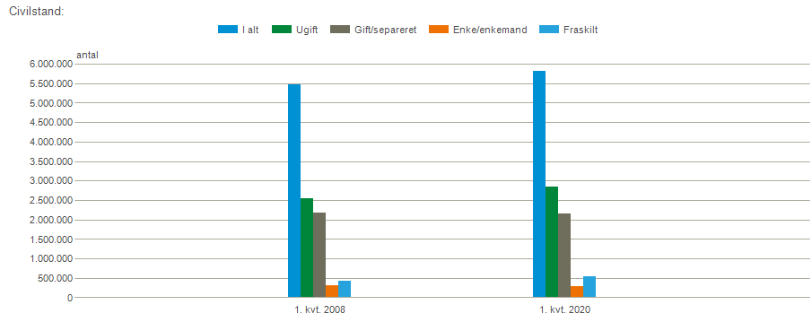
- Show a bar chart of 'Married' and 'Never Married' for all ages in DK (Hint: 2 bars of different color)
