Dynamic_Models_Exercise.R

MaBe

Wed Sep 16 17:47:23 2015

NO <- 25  
RR <- 1.05  
ttMax <- 100  
  
NN <- matrix (NA, nrow=1, ncol=ttMax+1)  
NN[1] <- NO  
for(tt in 1:ttMax) {NN[tt+1] <- RR*NN[tt]}  
print (NN)

## [,1] [,2] [,3] [,4] [,5] [,6] [,7] [,8]  
## [1,] 25 26.25 27.5625 28.94063 30.38766 31.90704 33.50239 35.17751  
## [,9] [,10] [,11] [,12] [,13] [,14] [,15]  
## [1,] 36.93639 38.78321 40.72237 42.75848 44.89641 47.14123 49.49829  
## [,16] [,17] [,18] [,19] [,20] [,21] [,22]  
## [1,] 51.9732 54.57186 57.30046 60.16548 63.17375 66.33244 69.64906  
## [,23] [,24] [,25] [,26] [,27] [,28] [,29]  
## [1,] 73.13152 76.78809 80.6275 84.65887 88.89182 93.33641 98.00323  
## [,30] [,31] [,32] [,33] [,34] [,35] [,36]  
## [1,] 102.9034 108.0486 113.451 119.1235 125.0797 131.3337 137.9004  
## [,37] [,38] [,39] [,40] [,41] [,42] [,43]  
## [1,] 144.7954 152.0352 159.6369 167.6188 175.9997 184.7997 194.0397  
## [,44] [,45] [,46] [,47] [,48] [,49] [,50]  
## [1,] 203.7417 213.9288 224.6252 235.8565 247.6493 260.0317 273.0333  
## [,51] [,52] [,53] [,54] [,55] [,56] [,57]  
## [1,] 286.685 301.0192 316.0702 331.8737 348.4674 365.8908 384.1853  
## [,58] [,59] [,60] [,61] [,62] [,63] [,64]  
## [1,] 403.3946 423.5643 444.7425 466.9796 490.3286 514.8451 540.5873  
## [,65] [,66] [,67] [,68] [,69] [,70] [,71]  
## [1,] 567.6167 595.9975 625.7974 657.0873 689.9416 724.4387 760.6606  
## [,72] [,73] [,74] [,75] [,76] [,77] [,78]  
## [1,] 798.6937 838.6284 880.5598 924.5878 970.8171 1019.358 1070.326  
## [,79] [,80] [,81] [,82] [,83] [,84] [,85]  
## [1,] 1123.842 1180.034 1239.036 1300.988 1366.037 1434.339 1506.056  
## [,86] [,87] [,88] [,89] [,90] [,91] [,92]  
## [1,] 1581.359 1660.427 1743.448 1830.621 1922.152 2018.259 2119.172  
## [,93] [,94] [,95] [,96] [,97] [,98] [,99]  
## [1,] 2225.131 2336.387 2453.207 2575.867 2704.66 2839.893 2981.888  
## [,100] [,101]  
## [1,] 3130.982 3287.531

plot(1:(ttMax+1),NN, xlab = "time", ylab = "N", type = "b", col="blue")

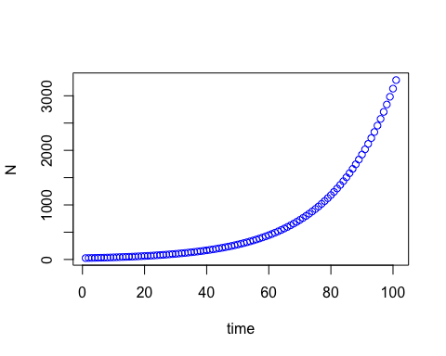

#Mini-exercise 3.2.1  
#you have to put a RR < 1 to make the population decline  
NO <- 25  
RR <- 0.9  
ttMax <- 100  
  
NN <- matrix (NA, nrow=1, ncol=ttMax+1)  
NN[1] <- NO  
for(tt in 1:ttMax) {NN[tt+1] <- RR*NN[tt]}  
print (NN)

## [,1] [,2] [,3] [,4] [,5] [,6] [,7] [,8] [,9]  
## [1,] 25 22.5 20.25 18.225 16.4025 14.76225 13.28603 11.95742 10.76168  
## [,10] [,11] [,12] [,13] [,14] [,15] [,16]  
## [1,] 9.685512 8.716961 7.845265 7.060738 6.354665 5.719198 5.147278  
## [,17] [,18] [,19] [,20] [,21] [,22] [,23]  
## [1,] 4.63255 4.169295 3.752366 3.377129 3.039416 2.735475 2.461927  
## [,24] [,25] [,26] [,27] [,28] [,29] [,30]  
## [1,] 2.215735 1.994161 1.794745 1.61527 1.453743 1.308369 1.177532  
## [,31] [,32] [,33] [,34] [,35] [,36] [,37]  
## [1,] 1.059779 0.9538011 0.858421 0.7725789 0.695321 0.6257889 0.56321  
## [,38] [,39] [,40] [,41] [,42] [,43] [,44]  
## [1,] 0.506889 0.4562001 0.4105801 0.3695221 0.3325699 0.2993129 0.2693816  
## [,45] [,46] [,47] [,48] [,49] [,50] [,51]  
## [1,] 0.2424434 0.2181991 0.1963792 0.1767413 0.1590671 0.1431604 0.1288444  
## [,52] [,53] [,54] [,55] [,56] [,57]  
## [1,] 0.1159599 0.1043639 0.09392755 0.0845348 0.07608132 0.06847319  
## [,58] [,59] [,60] [,61] [,62] [,63]  
## [1,] 0.06162587 0.05546328 0.04991695 0.04492526 0.04043273 0.03638946  
## [,64] [,65] [,66] [,67] [,68] [,69]  
## [1,] 0.03275051 0.02947546 0.02652792 0.02387512 0.02148761 0.01933885  
## [,70] [,71] [,72] [,73] [,74] [,75]  
## [1,] 0.01740497 0.01566447 0.01409802 0.01268822 0.0114194 0.01027746  
## [,76] [,77] [,78] [,79] [,80]  
## [1,] 0.009249712 0.008324741 0.007492267 0.00674304 0.006068736  
## [,81] [,82] [,83] [,84] [,85]  
## [1,] 0.005461863 0.004915676 0.004424109 0.003981698 0.003583528  
## [,86] [,87] [,88] [,89] [,90]  
## [1,] 0.003225175 0.002902658 0.002612392 0.002351153 0.002116037  
## [,91] [,92] [,93] [,94] [,95]  
## [1,] 0.001904434 0.00171399 0.001542591 0.001388332 0.001249499  
## [,96] [,97] [,98] [,99] [,100]  
## [1,] 0.001124549 0.001012094 0.0009108847 0.0008197963 0.0007378166  
## [,101]  
## [1,] 0.000664035

plot(1:(ttMax+1),NN, xlab = "time", ylab = "N", type = "b", col="blue")

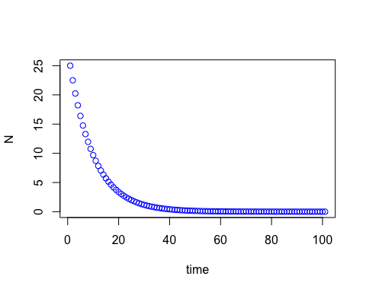

#base in the plot the qualitative behavior does not depend of population size  
NO <- 1000  
RR <- 1.05  
ttMax <- 100  
  
NN <- matrix (NA, nrow=1, ncol=ttMax+1)  
NN[1] <- NO  
for(tt in 1:ttMax) {NN[tt+1] <- RR*NN[tt]}  
print (NN)

## [,1] [,2] [,3] [,4] [,5] [,6] [,7] [,8] [,9]  
## [1,] 1000 1050 1102.5 1157.625 1215.506 1276.282 1340.096 1407.1 1477.455  
## [,10] [,11] [,12] [,13] [,14] [,15] [,16]  
## [1,] 1551.328 1628.895 1710.339 1795.856 1885.649 1979.932 2078.928  
## [,17] [,18] [,19] [,20] [,21] [,22] [,23]  
## [1,] 2182.875 2292.018 2406.619 2526.95 2653.298 2785.963 2925.261  
## [,24] [,25] [,26] [,27] [,28] [,29] [,30] [,31]  
## [1,] 3071.524 3225.1 3386.355 3555.673 3733.456 3920.129 4116.136 4321.942  
## [,32] [,33] [,34] [,35] [,36] [,37] [,38]  
## [1,] 4538.039 4764.941 5003.189 5253.348 5516.015 5791.816 6081.407  
## [,39] [,40] [,41] [,42] [,43] [,44] [,45]  
## [1,] 6385.477 6704.751 7039.989 7391.988 7761.588 8149.667 8557.15  
## [,46] [,47] [,48] [,49] [,50] [,51] [,52]  
## [1,] 8985.008 9434.258 9905.971 10401.27 10921.33 11467.4 12040.77  
## [,53] [,54] [,55] [,56] [,57] [,58] [,59] [,60]  
## [1,] 12642.81 13274.95 13938.7 14635.63 15367.41 16135.78 16942.57 17789.7  
## [,61] [,62] [,63] [,64] [,65] [,66] [,67] [,68]  
## [1,] 18679.19 19613.15 20593.8 21623.49 22704.67 23839.9 25031.9 26283.49  
## [,69] [,70] [,71] [,72] [,73] [,74] [,75]  
## [1,] 27597.66 28977.55 30426.43 31947.75 33545.13 35222.39 36983.51  
## [,76] [,77] [,78] [,79] [,80] [,81] [,82]  
## [1,] 38832.69 40774.32 42813.04 44953.69 47201.37 49561.44 52039.51  
## [,83] [,84] [,85] [,86] [,87] [,88] [,89]  
## [1,] 54641.49 57373.56 60242.24 63254.35 66417.07 69737.92 73224.82  
## [,90] [,91] [,92] [,93] [,94] [,95] [,96]  
## [1,] 76886.06 80730.37 84766.88 89005.23 93455.49 98128.26 103034.7  
## [,97] [,98] [,99] [,100] [,101]  
## [1,] 108186.4 113595.7 119275.5 125239.3 131501.3

plot(1:(ttMax+1),NN, xlab = "time", ylab = "N", type = "b", col="blue")

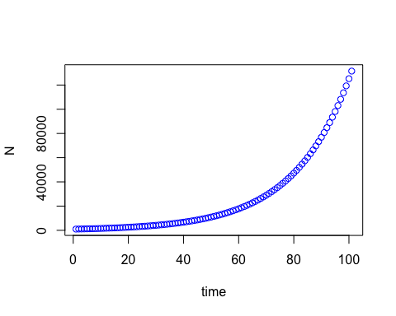

#base in the plot RR and time change the behavior of the model.   
#In particular RR can make the population grow or decline, and less generations show the population size variation as constant trough time  
  
NO <- 25  
RR <- 0.9  
ttMax <- 10  
  
NN <- matrix (NA, nrow=1, ncol=ttMax+1)  
NN[1] <- NO  
for(tt in 1:ttMax) {NN[tt+1] <- RR*NN[tt]}  
print (NN)

## [,1] [,2] [,3] [,4] [,5] [,6] [,7] [,8] [,9]  
## [1,] 25 22.5 20.25 18.225 16.4025 14.76225 13.28603 11.95742 10.76168  
## [,10] [,11]  
## [1,] 9.685512 8.716961

plot(1:(ttMax+1),NN, xlab = "time", ylab = "N", type = "b", col="blue")

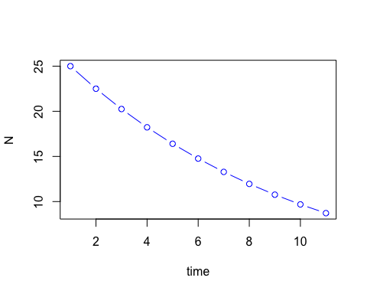

#Exercise 3.2.2  
#Function version  
geomFun <- function(RR, NO, ttMax) {  
 NN <- rep(NA,ttMax+1)  
 NN[1] <- NO  
 for (tt in 1:ttMax) {  
 NN[tt+1] <- RR*NN[tt]  
 }  
 plot(1:(ttMax+1),NN,xlab = "time", ylab = "b", col ='blue')  
}  
geomFun(NO=10, RR=0.95, ttMax = 100)

