DECIBEL SYSTEMS
DECIBEL RUNTIME & TEAMS
Local-first project memory with shared cloud intelligence

PROPOSAL TYPE | Product + architecture
PREPARED FOR | Decibel Systems
DATE | August 29, 2026

CORE PROPOSAL
Keep .decibel/ as the durable project record. Route every client through one shared runtime. Add Supabase as an optional Teams layer for permissions, cross-project search, shared memory, and coordination.

Decision requested
Approve the architecture direction and the local-foundation implementation sequence.

Executive proposal
Decibel Tools should remain local-first. Its project intelligence should live beside the code in readable Markdown, survive without an account, work offline, and remain portable through ordinary Git and filesystem workflows. That is a product advantage, not merely a storage convenience.
The current weakness is not the use of files. It is that multiple clients can instantiate full runtimes and mutate the same logical store through duplicated paths. The durable correction is one shared Decibel Runtime with lightweight adapters for MCP, CLI, VS Code, Cursor, Claude Code, and Codex.
Supabase should enter above that local model as the Decibel Teams coordination layer. It should index and synchronize project intelligence across people, projects, and agents without becoming a synchronous dependency for local work.
POSITIONING
Decibel Tools makes a project intelligent. Decibel Teams connects that intelligence across people, projects, and agents.

Decision in one page
Decision | Proposal | Why
Local source of truth | .decibel/ Markdown with typed frontmatter | Preserves inspectability, Git history, portability, and offline use
Runtime topology | One shared runtime; thin per-client adapters | Centralizes lifecycle, mutation, caches, project resolution, and tool behavior
Cloud role | Optional Supabase/Postgres coordination layer | Adds identity, permissions, cross-project query, team search, activity, and analytics
Mutation policy | Auto-start runtime; fail clearly if unavailable | No silent in-process writer fallback that breaks the single-writer invariant
Sync policy | Write locally, acknowledge, then synchronize | Cloud outages never block ordinary project work

What this proposal does not do
- It does not replace local project files or introduce a competing local source of truth.
- It does not treat one stdio adapter per client as a defect or make Teams sync, identity, or billing prerequisites for free local Tools.

Why change now
The current store is usable, but the measured state shows architectural drift that will become more expensive as Decibel adds more clients and moves toward Teams.
Figure | Signal | Meaning
169 | Issue files | 111 Markdown and 58 YAML records
2 | Live create paths | Independent implementations can diverge
4 | Duplicate ID groups | A live allocation race remains
10 | Degraded records | Recovered scar tissue from an older, fixed writer defect
7 + 1 | Observed processes | Seven stdio servers plus one daemon; roughly 883 MB RSS

Important distinction: multiple stdio processes are normal. Multiple complete runtimes with independent stores, caches, project registries, and mutation paths are the problem.
- The advisory lock makes the current model safe enough to repair.
- The shared runtime makes the product coherent enough to scale.
- The cloud layer makes that intelligence useful to teams without taking ownership away from the project.

Proposed architecture
The architecture separates transport, local intelligence, and team coordination. Every client talks to the same runtime contract. The runtime owns services and repositories, writes the local store atomically, and publishes a change stream to the cloud when Teams is enabled.
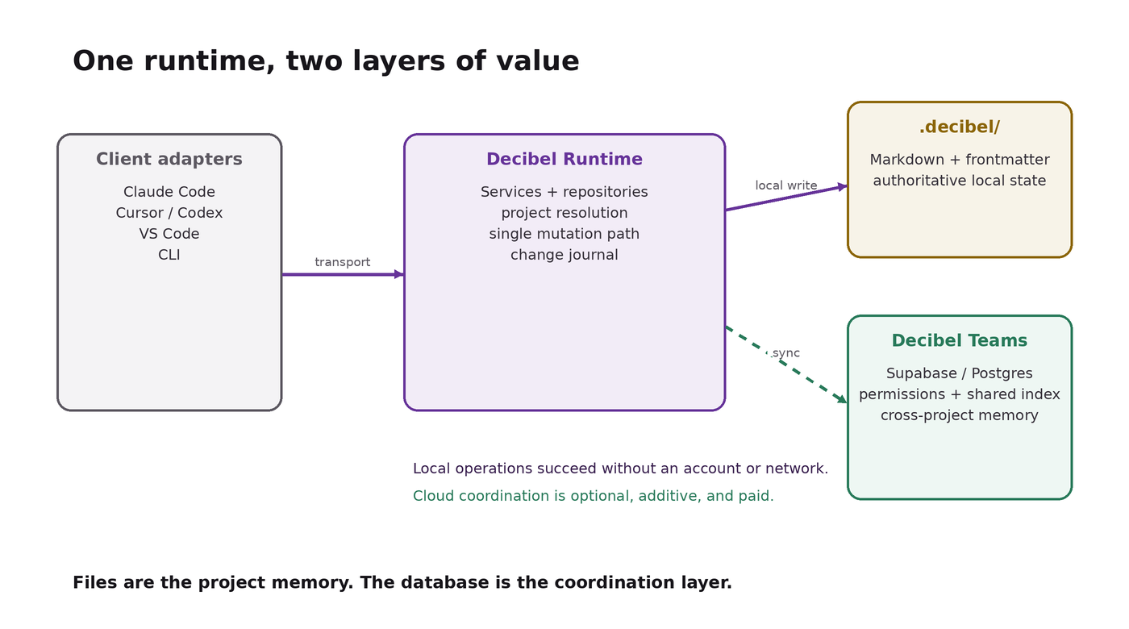
Figure 1. Proposed local-first runtime and optional Teams layer.

Runtime boundaries
Boundary | Responsibility
Client adapters | Translate MCP stdio, CLI, extension, or HTTP transport. Carry project context. Hold no domain state.
RuntimeClient | One versioned client contract used by all adapters and first-party surfaces.
DaemonController | Implements ensureRuntime(), singleton startup, compatibility checks, retry, and clean shutdown.
RuntimeService | Owns tool behavior, validation, caches, project context, aggregation, and mutations.
Repositories + codecs | Expose typed domain operations. Hide Markdown/YAML serialization and filesystem details.
SyncEngine | Journals local changes and asynchronously exchanges authorized projections with Decibel Teams.

Lifecycle contract
- A client calls ensureRuntime() with its protocol and runtime version.
- One contender acquires the startup lock or socket; concurrent contenders wait and connect.
- The runtime health response reports status, PID, uptime, runtime version, protocol version, tier, and capabilities.
- Mutations route to the shared runtime. If it cannot start, the client returns a useful error instead of silently becoming another writer.
- Read-only emergency fallback can be considered later, but it must never reintroduce mutation paths.

Local storage remains a first-class product feature
Markdown with structured frontmatter is the recommended canonical representation because Decibel records are both machine state and human project artifacts. The schema should be defined independently of the file extension, and one codec should own every parse and serialization path.
STORAGE PRINCIPLE
Files are the project memory. The database is the coordination layer.

Dimension | Local Markdown | Resolution
Inspectability | Open, search, diff, and repair records with ordinary tools | Excellent
Offline + zero account | Full local value without authentication or network | Excellent
Git history | Human-readable review and forensic history | Excellent
Concurrent writes | Handled through one runtime, locks, and atomic rename | Good after consolidation
Team permissions | Not a filesystem strength | Provided by Teams
Cross-project query | Expensive across many repositories | Provided by Teams index
Analytics + activity | Awkward as raw files | Provided by Teams

Canonical record model
- Use one typed Issue model and one IssueRepository interface for create, get, list, update, and close.
- Preserve project as a real schema field in Markdown frontmatter; current omission is format drift, not a reason to prefer YAML.
- Retain human-facing IDs such as ISS-0142, but introduce a globally stable sync identifier before Teams replication.
- Serialize structured values through a parser and serializer, then write to a temporary file and atomically rename.
- Protect ID allocation through successful creation, even after the shared runtime exists, as defense in depth.

Decibel Teams: the paid coordination layer
Teams should sell the shared intelligence that local files alone cannot provide cleanly: identity, access, cross-project retrieval, shared context, agent activity, and organizational learning. The local project remains useful if a team disconnects or stops paying.
Decibel Tools / Free | Decibel Teams / Paid
Local project memory in .decibel/ | Organization, users, groups, and permissions
Issues, epics, wishes, experiments, decisions | Shared project index and cross-project search
MCP, CLI, and editor surfaces | Team memory and reusable patterns across repositories
Offline operation and Git history | Agent activity, audit trail, notifications, and analytics
Project-scoped context | Policy, retention, and administrative controls
No account required | Authenticated collaboration and managed synchronization

Synchronization contract
- Validate and write the local record atomically.
- Return success to the client immediately after the local commit.
- Append an operation to a durable local change journal.
- Synchronize authorized projections in the background when Teams is connected.
- Use optimistic revisions and explicit conflict records; never silently overwrite divergent human edits.
- Rebuild the cloud index from local records when needed. The index is reproducible; project memory is not disposable.

Security and privacy posture
- Sync only the Decibel artifact types enabled by the workspace policy; source code should not be uploaded by default.
- Encrypt transport and hosted data, and enforce organization/project authorization on every server operation.
- Expose sync state, failures, and last successful exchange. Hidden replication is the enemy of trust.
- Support disconnect and export cleanly because the local record already exists.

Implementation proposal
First converge correctness and behavior. Then converge representation. Only after the local foundation is stable should Teams synchronization begin.
Phase | Outcome | Work | Exit gate
0 | Reliable lifecycle | Implement ensureRuntime(); auto-start; startup arbitration; compatibility-rich health response | No manual daemon launch
1 | Integrity invariants | Round-trip tests, escaping, advisory allocation lock, atomic writes, CI/preflight guards | Zero new corruption or duplicate IDs
2 | Repair existing state | Close recovered records correctly, renumber duplicates, normalize project values | degraded: 0; duplicate groups: 0
3 | Canonical domain API | One schema, repositories, codecs, project resolver, and runtime service | One issue mutation implementation
4 | Thin-client topology | Move domain behavior out of stdio/CLI/editor clients into the runtime | Six clients share one runtime
5 | Format convergence | Migrate remaining YAML records to Markdown with frontmatter | One canonical representation
6 | Teams sync foundation | Stable IDs, change journal, permissions model, projection contracts | Offline-first sync pilot ready
7 | Teams pilot | Cross-project index, search, shared memory, activity, and admin controls | Small internal team operating safely

Backlog hygiene is a parallel workstream
Closing historical issues and re-baselining open counts is useful, but it should not sit on the architectural critical path. Run it after repair tooling is trusted and keep it separate from runtime and format migrations.

Success measures
Area | Acceptance measure
Correctness | 0 duplicate IDs under concurrent create tests; 0 degraded records; every create/close round trip passes
Lifecycle | No manual daemon startup in normal use; simultaneous clients converge on one compatible runtime
Efficiency | Less than 200 MB total RSS with six active clients, measured on the same baseline used for EPIC-0038
Consistency | MCP, CLI, VS Code, Cursor, Claude Code, and Codex expose the same domain behavior and errors
Local resilience | Cloud loss does not block local reads or writes; queued changes recover after reconnect
Teams value | Authorized cross-project search returns current results with visible project and revision provenance
Trust | Users can see sync state, disable sync, and retain all local project intelligence

Principal risks and mitigations
Risk | Impact | Mitigation
Daemon becomes a point of failure | High | Auto-start, singleton arbitration, bounded retry, clear diagnostics, health/version contract
Old clients bypass the runtime | High | Keep filesystem lock and schema validation; deprecate legacy writers; fail incompatible protocols
Cloud and files become competing truth | High | Local authority, append-only journal, reproducible cloud projections, explicit conflict states
Sync exposes sensitive content | High | Artifact allowlist, workspace policy, least-privilege access, transparent sync inventory
Topology rewrite delays repair | Medium | Ship lifecycle and integrity phases first; preserve independent exit gates
Format migration loses fields | Medium | Define schema before conversion; dry-run; preserve project and stable IDs; review diffs
Teams scope expands prematurely | Medium | Pilot only after local exit gates pass; start with index/search and shared memory

Decision requested
APPROVE
Adopt the local-first, shared-runtime, cloud-coordination architecture as the target for Decibel Tools and Decibel Teams.

- Approve Phases 0–5 as the local foundation and engineering priority.
- Confirm Markdown with typed frontmatter as the canonical project representation.
- Confirm fail-closed mutations when the shared runtime cannot be reached.
- Authorize Phase 6 design work for the Teams sync contract, stable identifiers, and permission model.
- Defer hosted feature breadth, billing, and organization analytics until the internal pilot proves sync trustworthiness.

Recommended product statement
Your project intelligence stays with your project. Decibel Teams connects it across the people and agents doing the work.

Internal evidence base
This proposal incorporates the measured state, failure analysis, and repair sequencing documented in EPIC-0038, “Sentinel store repair & single-writer consolidation — plan for review,” dated August 28–29, 2026. Counts and memory targets should be re-measured before implementation begins.

