Introduction:

GIS:

GIS(Geographical information system) is used for storing, editing, and analyzing geographical data. GIS connects data to maps and extracts data of locations. GIS helps to understand patterns and relationships in terms of geographical context.

**Spatial Databases:**

Spatial Databases store geographic information in the relational format including coordinates and topologies. There are two ways to represent data i.e. vectors and raster. Vector is high-quality geographical data, raster used to show patterns, made available large sets of data.

**PostGIS**

PostGIS is a spatial database and an extension of PostgreSQL. It is used to perform CRUD operations on GIS data. PostGIS extends PostgreSQL by adding three new features: spatial indexes, spatial types, and spatial functions.

Now, let's start with installation:

**Installation:**

1. Go to <https://www.pgadmin.org/> and download the latest version of pgAdmin for your system
2. Download PostgreSQL from <https://www.enterprisedb.com/downloads/postgres-postgresql-downloads>
3. Follow downloading steps from <https://postgis.net/workshops/postgis-intro/installation.html>.

**Creating Server and databases:**

1. Open pgAdmin.

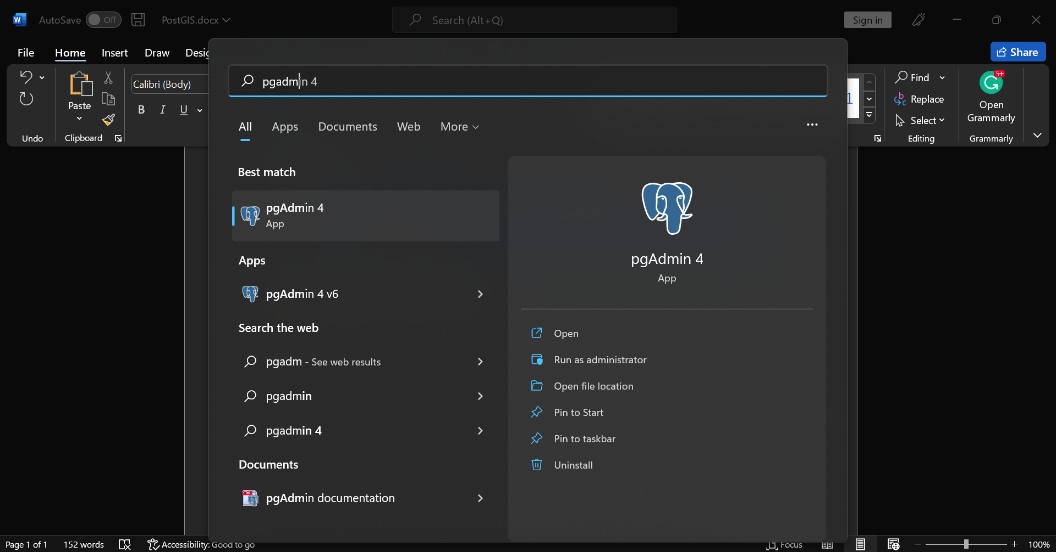

1. Type your password of the master user you created while installing
2. Right Click on servers > Register > Server...

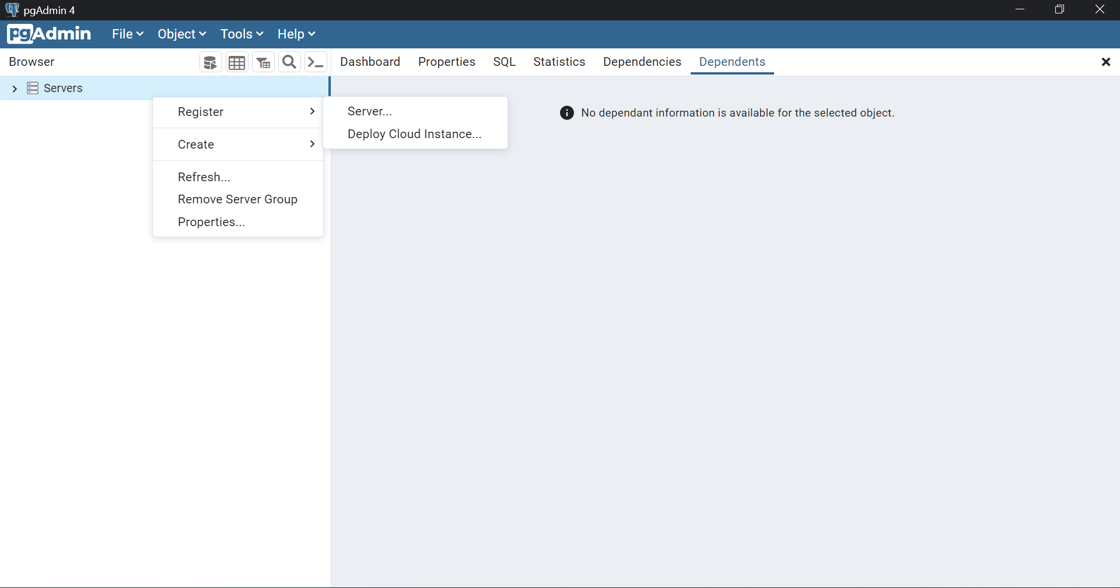

1. Create a Server on port 5432
2. Right click on server > create > database.
3. Now navigate to tools > query tool and run: CREATE EXTENSION postgis;
4. To confirm that PostGIS is installed run : SELECT postgis_full_version();