NOTICE OF UNSAFE BUILDING
CONDITIONS

2/17/2025

Property: Elizabeth Gardens HOA, 116 Marmion Way, S. Pasadena, CA 91030

Property Manager / Board of Directors: Board President, Trevor Kwan
Property Manager: AMPAC Management Grp. 323-268-1800

Authority Submission: Pasadena Building and Safety Department.
csc@cityofpasadena.net

Deck Inspectors, Inc. has conducted a visual inspection in compliance with CA 5551 (SB326) or Health and Safety Code 17973 (SB721) on 2/17/2025. Unsafe conditions were found and made part of the visual inspection report to be issued for this project.

Cal. Civil Code § 5551 (HOA and Condo)).

“If, after inspection of any exterior elevated element, the inspector advises that the exterior elevated element poses an immediate threat to the safety of the occupants, the inspector shall provide a copy of the inspection report to the association immediately upon completion of the report, and to the local code enforcement agency within 15 days of completion of the report. Upon receiving the report, the association shall take preventive measures immediately, including preventing occupant access to the exterior elevated element until repairs have been inspected and approved by the local enforcement agency”.
(2) Local enforcement agencies shall have the ability to recover enforcement costs associated with the requirements of this section from the association.

Health and Safety Code 17973 (Apartment and Commercial)

The California Building Standards Code, consistent with subdivision (d) of Section 17922 of the Health and Safety Code.
An exterior elevated element that the inspector advises poses an immediate threat to the safety of the occupants, or finds preventing occupant access or emergency repairs, including shoring, or both, are necessary, shall be considered an emergency condition and the owner of the building shall perform required preventive measures immediately. Immediately preventing occupant access to the exterior elevated element until emergency repairs can be completed constitutes compliance with this paragraph. Repairs of emergency conditions shall comply with the requirements of subdivision (g), be inspected by the inspector, and reported to the local enforcement agency.
The owner of the building shall be responsible for complying with the requirements of this section.

Deck Inspectors is currently evaluating the visual inspection performed and working to create the required report, however because of the Unsafe Conditions noted during the visual inspection, this NOTICE OF UNSAFE CONDITIONS will serve to immediately notify the owner and its agents of the unsafe conditions found.

It is critical that the unsafe conditions be repaired immediately and access to the exterior element(s) be restricted to all persons other than those making repairs.

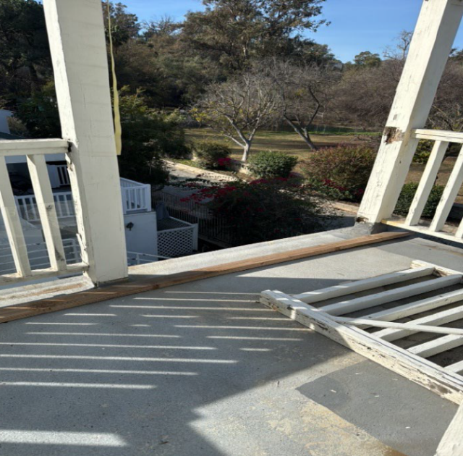
  Balcony Railings at levels 2,3 & 4 have failed.
  A resident has fallen from the 3rd floor.
  Railings are rotted and missing on the 2nd & 3d floors.
  The President of the Board is aware of the conditions and injury to the resident.
  Units affected: 18, 15, 3, 7, 9 & 10
  Including structural posts below level 3 supporting 2, 3, & 4 Balconies

Deck Inspectors, Inc. makes no assessment as to the structural integrity of the areas of unsafe conditions, only that in the opinion of our professional inspectors, conditions have been found which could lead to injury should pedestrian traffic be permitted.

Deck Inspectors, Inc.:

David Mazor,

License # DM, CA CSLB GC 714639

