
F
F
SIMPER


{{NAMA}}

{{NO_BADGE}}

{{COMPANY}}

{{KATEGORI }}
EXPIRED DATE: {{EXP_DATE}}
VIOLATION

ACCIDENT

-
KTT
HSR
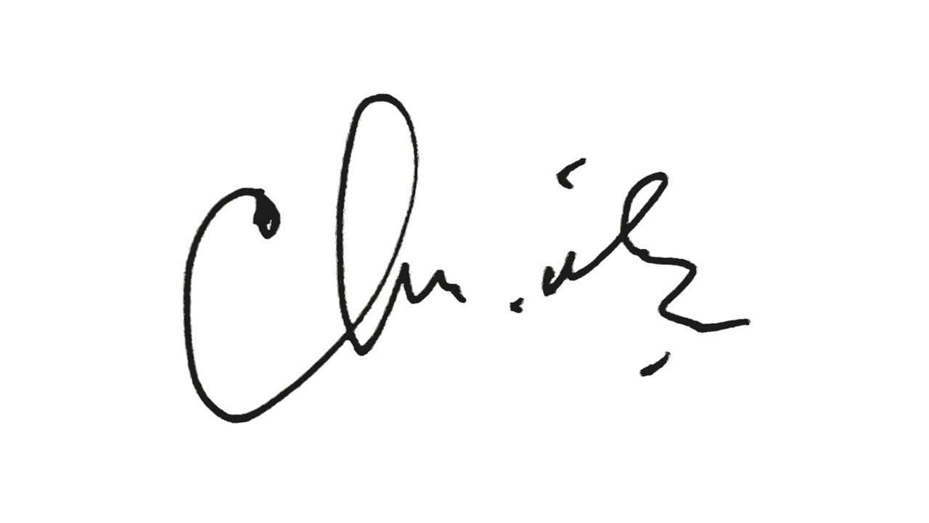
{{SIMPER_NUM}}

EQUIPMENT TYPE
{{VEHICLE_LIST}}

SIGNATURE

