Assignment2

Haojin Li (Declan)

2020/7/23

Table of Contents

## # 3.2.4 Exercises

## 1. Run ggplot(data = mpg). What do you see?

library(ggplot2)  
ggplot(data = mpg)

 I see nothing…

## 2. How many rows are in mpg? How many columns?

dim(mpg)

## [1] 234 11

## 3. What does the drv variable describe? Read the help for ?mpg to find out.

?mpg()

## starting httpd help server ... done

# `drv` is the type of drive train, where `f = front-wheel drive`, `r = rear wheel drive`, `4 = 4wd`

## 4. Make a scatterplot of hwy vs cyl.

library(ggplot2)  
ggplot(mpg, aes(hwy, cyl)) + geom_point()

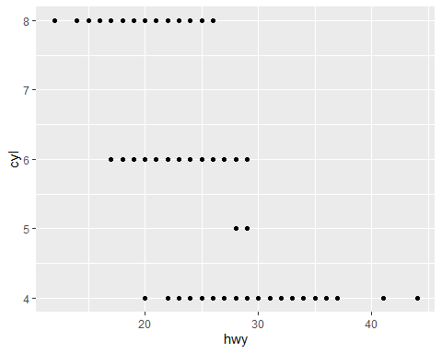

# plot(mpg$hwy, mpg$cyl, xlab="hwy", ylab="cyl")

### 5. What happens if you make a scatterplot of class vs drv? Why is the plot not useful?

library(ggplot2)  
ggplot(mpg, aes(class, drv)) + geom_point()

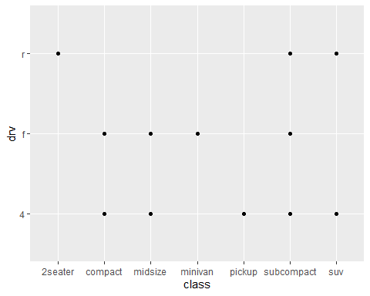

There’s no correlation between class and drv.

## # 3.3.1 Exercises

## 1

ggplot(data = mpg) +   
 geom_point(mapping = aes(x = displ, y = hwy), color = "blue")

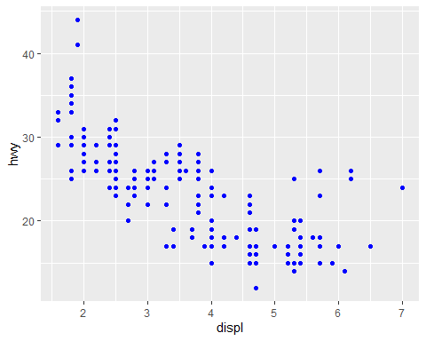

## 2

mpg

## # A tibble: 234 x 11  
## manufacturer model displ year cyl trans drv cty hwy fl class  
## <chr> <chr> <dbl> <int> <int> <chr> <chr> <int> <int> <chr> <chr>  
## 1 audi a4 1.8 1999 4 auto(l~ f 18 29 p comp~  
## 2 audi a4 1.8 1999 4 manual~ f 21 29 p comp~  
## 3 audi a4 2 2008 4 manual~ f 20 31 p comp~  
## 4 audi a4 2 2008 4 auto(a~ f 21 30 p comp~  
## 5 audi a4 2.8 1999 6 auto(l~ f 16 26 p comp~  
## 6 audi a4 2.8 1999 6 manual~ f 18 26 p comp~  
## 7 audi a4 3.1 2008 6 auto(a~ f 18 27 p comp~  
## 8 audi a4 quat~ 1.8 1999 4 manual~ 4 18 26 p comp~  
## 9 audi a4 quat~ 1.8 1999 4 auto(l~ 4 16 25 p comp~  
## 10 audi a4 quat~ 2 2008 4 manual~ 4 20 28 p comp~  
## # ... with 224 more rows

### Catagorical Variables

manufacturer model trans drv fl class

### Continuous Variables

displ year cyl cty hwy

## 3

ggplot(mpg, aes(x = displ, y = hwy, colour = cty)) +  
 geom_point()

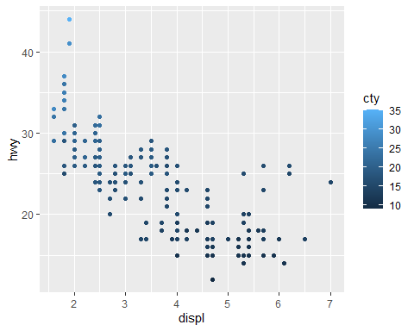

ggplot(mpg, aes(x = displ, y = hwy, size = cty)) +  
 geom_point()

