The impacts of a marine heatwave on sea cucumber wasting: Insert rest of title here

by

Jonathan Farr and Declan Taylor

A report submitted in partial fulfilment of the requirements of

DIRECTED STUDIES

at

Bamfield Marine Sciences Centre

Instructor: Daniel Wuitchik and Sara Wuitchik

Teaching Assistant: Jenna Fleet

© Jonathan Farr, 12/2021

Home University: University of Alberta

© Declan Taylor, 12/2021

Home University: The University of British Columbia

**Abstract**

Marine heat waves and warming oceans have profound effects on disease dynamics in marine invertebrates. Wasting diseases, potentially triggered by extreme heat events, have devastated sea stars across the Pacific Northwest coast. Recent evidence has emerged of wasting in giant California sea cucumbers (*Parastichopus californicus*). Following a severe wasting event in Nanoose Bay, B.C. following an extreme climatic heat event, our study aimed to determine whether heat stress could trigger wasting in *P. californicus*. We also aimed to improve the understanding of how two unusual sea cucumber characteristics, stiffening and evisceration, are affected by thermal stress. Under a controlled laboratory setting, we exposed *P. californicus* to an 82-hour simulated marine heat wave. While we observed both minor and major handling ulcers, no wasting-like symptoms were exhibited in 12ºC ,17ºC or 22ºC treatments. However, mortality in the 22ºC treatment demonstrated that *P. californicus* were under extreme physiological stress during our experiment. Furthermore, stiffening behaviour was significantly affected by heat treatments, suggesting that physiological mechanisms behind stiffening were impaired by thermal stress. We did not observe a link between evisceration and temperature treatment but did find further evidence in support of seasonal evisceration of digestive tract organs. We also observed the traumatic and lethal expulsion of respiratory tract in two heat treated individuals. Our study provides evidence that wasting is not solely triggered by heat stress. Instead, further studies should investigate other potential abiotic triggers in addition to potential pathogenic agents. The ecological and economic importance of *P. californicus* demands that the causal agents of wasting be identified in order to prevent future catastrophic mortality events in sea cucumbers and other echinoderms.

# Keywords *Wasting disease, echinoderma, sea cucumber, skin ulceration syndrome, thermal stress*

# Introduction

Anthropogenic climate change is increasing the intensity, duration, size and frequency of marine heat waves across the globe with potentially catastrophic effects on organism fitness, marine ecosystems and human economies (Allan et al., 2021; Frölicher et al., 2018). These extreme climatic events often cause immediate and mass mortality at all trophic levels from thermal stress, starvation, toxicity, and hypoxia (Cavole et al., 2016; Di Lorenzo & Mantua, 2016; Suryan et al., 2021; von Biela et al., 2019). For example, the 2014-2015 warm water anomaly in the Northeast Pacific Ocean triggered a harmful algal bloom which harmed salmon, tuna, and shellfish fisheries (Cavole et al., 2016; Di Lorenzo & Mantua, 2016; Frölicher et al., 2018). This bloom reduced the abundance of important mid-trophic prey species and caused the starvation of species from salmon to sea birds (Cavole et al., 2016; von Biela et al., 2019). Marine heat waves can also impact marine ecosystems more subtly by impacting biological processes including foraging and movement behaviour (Chiu et al., 2021), reproduction (Shanks et al., 2020), and disease dynamics (Aalto et al., 2020)..

Marine heat waves can profoundly impact disease dynamics in marine invertebrates (Aalto et al., 2020). This occurs in part because thermal stress can compromise organism’s immune response (Branco et al., 2012; Matozzo et al., 2012). In addition, the virulence of many marine diseases appears to be temperature regulated through temperature effects on pathogen transmission and growth (Marcogliese, 2008; Rubio-Portillo et al., 2016). For example, the appearance and outbreak of Pacific Oyster Mortality Syndrome in Tasmania has been linked to marine heatwaves (Oliver et al., 2017). Many marine bacterial pathogens, including those which affect dominant cover species such as corals and macroalgae, also display temperature-dependent virulence (Case et al., 2011). Abnormally warm temperatures have also been accredited to triggering and exacerbating sea star wasting disease (Aquino et al., 2021; Bates et al., 2009; Eisenlord et al., 2016; Harvell et al., 2019; Hewson et al., 2018). Over the past decade, sea star wasting disease has decimated the populations of over 20 sea star species in the Northeast Pacific Ocean (Hewson et al., 2018). Wasting in sea stars is described as a broad set of symptoms including twisted arms, lesions, deflation/loss of turgor, lost arms, lack of grip strength in tube feet, and disintegration (Bates et al., 2009; Hewson et al., 2018; Menge et al., 2016). Although wasting-like symptoms are variable and non-specific, recent evidence has emerged that wasting may occur in echinoderms other than sea stars.

Giant California sea cucumbers (*Parastichopus californicus)* are echinoderms of the class Holuthuroidea and have been reported to display wasting symptoms similar to those of their sea star relatives. These benthic detritivores are found from the Gulf of Mexico to Alaska, and are found from the low intertidal zone to a depth of 250 meters (Purcell et al., 2016). Since 2014, wasting symptoms have been reported in small numbers throughout the Salish Sea and the Northwest Coast of British Columbia and Alaska (Hewson et al., 2020; Schroeder, 2017).

Symptoms of wasting in sea cucumbers are anecdotally reported as similar to those observed in sea stars: non-focal lesions and fissures across the body wall, epidermal tissue sloughing, and rapid liquefaction (Hewson et al., 2020b). A recent wasting event occurred in Nanoose, B.C., Canada, from August – October 2021 (Em Lim, *personal communication*). Reports from citizen scientist divers indicated that up to 75 *P. californicus* exhibited wasting symptoms, and that wasting sea cucumbers were disproportionally found at shallow depths (Em Lim, *personal communication)*. Southwest British Columbia was affected by multiple heat waves in the months leading up to wasting outbreak (Environment & Climate Change Canada, 2021); these extreme air temperatures led to elevated subtidal temperatures in the Strait of Georgia where Nanoose Bay is located (Ocean Networks Canada Data Archive, 2021). As such, there is a potential link between thermal stress and wasting in *P. californicus*, especially given that wasting was mostly observed in the warmer part of the water column*.* However, understanding the impact of heat stress on sea cucumber wasting also requires knowledge of how their unique behavioural and physiological characteristics are affected by thermal stress.

Sea cucumbers have several unusual and poorly understood traits that distinguish them from other echinoderms such as sea stars, and may affect the underlying physiological mechanisms behind wasting symptoms. Wasting symptoms in *P. californicus* have been observed to start as small ulcers on the aboral body wall and grow into larger lesions and fissures which can fully cover the organism (Hewson et al., 2020a). The sea cucumber dermis is primarily mutable collagenous tissue that allows them to change mechanical properties of their dermis in response to environmental stimuli (Motokawa & Tsuchi, 2003). Under normal seawater conditions, sea cucumber dermal stiffness can rapidly increase, which is thought to be adaptive for posture maintenance and antipredator defense (Motokawa & Tsuchi, 2003; Yamada et al., 2010). If these lesions extend into the dermis, wasting may affect changes in stiffening behaviour, especially if stiffening is already affected by an altered thermal regime. Another unique behaviour of sea cucumbers is evisceration, the ability to expulse and subsequently regenerate their digestive tract (Fankboner & Cameron, 1985). The mechanisms which trigger evisceration are poorly understood but include disease stress (Deng et al., 2008), and seasonality, as a response to the low-productivity winter months (Swan, 1961). Evisceration may have unknown physiologic consequences, and Hewson et al. (2020a) proposed that seasonal evisceration may be linked to wasting disease because wasting has been reported during the same season when evisceration occurs (Swan, 1961). If wasting is linked to thermal stress, changes in stiffening and evisceration behaviours resulting from temperature changes could be used as indicators of overall stress and thus wasting potential in *P. californicus*.

Considering recent marine heat waves and reports of a sea cucumber wasting outbreak in Nanoose Bay, this study assesses whether thermal stress as an isolated factor causes wasting symptoms in *P. californicus*. We also aim to evaluate how *P. californicus* behaviours like stiffening, spawning, and evisceration are affected by extreme temperatures to understand if they may relate to wasting, and, more broadly, to sea cucumber thermal stress. We hypothesized that prolonged elevated temperature exposure will cause wasting symptoms, mortality, and behavioural changes due to physiological stress. Based on our hypothesis, we make three predictions: 1) we will observe wasting symptoms only in sea cucumbers in high temperatures; 2) we will observe greater mortality with higher temperatures; and 3) we will observe changes in stiffening, spawning and evisceration in temperature treatments.

# Methods:

## Study organisms

63*Parastichopus californicus* were collected by divers Em Lim and Siobhan Gray in Scott’s Bay and the entrance to Bamfield Inlet in Barkley Sound, British Columbia (48°50'02"N, 125°08'45"W) in July 2021. All were gathered from the shallow subtidal, between {NUMBER} and {NUMBER} depth. We placed the cucumbers in 19 cm deep flow-through sea tables at the Bamfield Marine Sciences Centre, which had a constant flow of seawater from Barkley Sound. The sea cucumbers were fed with kelp, plankton cultures and bloodworms. The cucumbers remained in the lab for {NUMBER} days prior to the start of the experiment. As part of a separate study, individuals were tagged with several types of tags and monitored; the results of this study indicated that the tags did not affect the sea cucumbers’ behaviour or survival (Lim et al., unpublished data).

We measured sea cucumber size as some studies have shown that body size can affect the thermal tolerance of marine organisms (Di Santo & Lobel, 2017; Kelley et al., 2011). We weighed sea cucumbers twice, 24 hours apart, to get an average wet weight. We conducted a pilot study before the start of our experiment to determine how many cucumbers had their internal organs. Prior to the start of the experiment, we isolated cucumbers into individual containers for 24 hours to determine if they were defecating.

## Experimental Design

Our experiment exposed sea cucumbers to 12ºC, 17ºC, and 22ºC temperature treatments. The 12ºC control treatment represents the average seawater temperature 50 meters below surface in Barkley Sound, while 17ºC mimics a high subtidal temperature and 22ºC represents an extreme heat event that is unlikely to occur under natural circumstances (Chen et al., 2021b; Pawlowicz, 2017; Xuereb et al., 2018).

We separated the sea cucumbers into three temperature treatments (n22ºC treatment = 18, ncontrol & 17ºC treatments = 19, N = 56). Sea cucumbers were separated into 30 bins with 2 cucumbers in each (except 4 bins in which only housed one cucumber). Each treatment consisted of two sea tables with a total of 10 bins. Cucumbers were randomly assigned to bins, and bins were randomly assigned to sea tables. The bins sat in 5cm deep water baths that were either at the temperature of the sea tables’ flow through system (12ºC), standing at ambient (room) temperature (17ºC), or heated with two 800W aquarium heaters to 24ºC, to keep the bins at 22ºC. The temperature treatments lasted from 09:00 on November 09 (Day 1) to 01:00 on November 13 (Day 5) for a total of X hours of heat exposure, and bucket temperature was ramped up over 24h on Day 1 and decreased over 8h on Day 5 to limit temperature shock. In the 22ºC treatment, the water bath was circulated around the sea table with powerhead aquarium pumps to ensure even temperature distribution. We monitored temperature in every bin at least twice daily. We used a water-permeable divider to separate cucumbers within bins to allow for individual identification throughout the experiment. We did not provide sea cucumbers with food during the experiment.  Water changes were done as need to keep nitrate and ammonium levels below 0.5 parts per million. Sea water was heated to the appropriate treatment temperature prior to water changes. We exposed sea cucumbers to treatments for 82 hours and monitored them for 7 days afterwards for mortality and wasting symptoms.

## Measuring Sea Cucumber Stress & Wasting

We assessed cucumbers for ulcers on the 4th, 5th, 6th, and 12th days of the experiment. We classified ulcers as either minor or major ulcers based on their size and visual appearance (Fig. 1). We considered minor ulcers to be small lesions on the ends of spines, which did not have severe discoloration, where the dermis was not fully removed. Scars and closed ulcers were not counted. We considered major ulcers to be open wounds that were fully through the dermis, where white tissue could be seen beneath. We then determined the maximum number of minor and major ulcers per cucumber across the experiment’s duration.

We assessed sea cucumber stiffness for antipredator defense and posture maintenance using two different ordinal scales. First, to assess antipredator defense stiffening we gently palpated the cucumber for 10 seconds to mimic an attempted predation event. We assigned the cucumber a score of 0 if it failed to stiffen and felt like the texture of fat (soft), a score of 1 if it stiffened to the level of un-flexed muscle (standard), and a score of 2 if the cucumber got comparably stiff to a flexed bicep muscle (stiff). Secondly, we removed each cucumber from their tank and placed them on a 5 cm x 5 cm elevated platform to measure their ability to maintain their structure over 5 seconds. We assigned the cucumber a score of 0 if it failed to stiffen at all (soft), a score of 1 if it failed to remain stiff when placed on the platform (standard), a and a score of 2 if it maintained its structure for the entire 5 seconds (stiff; Fig. 2). Each stiffness test was performed daily.

We checked sea cucumber tanks every 12 hours for evisceration, an act where they partially or fully expulse their inner organs. We also determined if spawning had occurred, since heat-stress induced spawning has been reported in other sea cucumber species (Battaglene et al., 2002). Spawning was only able to be measured per-bucket instead of per-cucumber because the gametes, especially sperm, would flow from one side of the bucket to the other and we were unable to determine which of the cucumbers had spawned.

## Statistical Methods

To assess which variables affected the maximum number of minor ulcers, we used a generalized additive model. Using the function *fitdist* from package GAMLSS (Rigby et al., 2021), we determined that the number of minor ulcers best fit a geometric distribution . We modelled the maximum number of minor ulcers as a function of treatment, weight, evisceration, and defecation status. We included sea table and bucket as random effects. We used backwards selection to determine the combination of variables that best explained the maximum number of ulcers.

To examine how sea cucumber mortality varied across temperature treatments we used a Kruskal-Wallis (K-W) test followed by a Dunn’s Kruskal-Wallis (Dunn’s K-W) test for multiple comparisons. We built a logistic regression model with cucumber mortality (binary dead/alive) as the response variable and evisceration, defecation status, initial droop and squeeze scores, and initial weight as explanatory variables. We used backwards model selection to investigate which combination of these variables best explained the variation in sea cucumber mortality.

We determined if the two sea cucumber stiffness metrics (antipredator response and structure maintenance) were correlated using spearman’s rank correlation coefficient (Schober & Schwarte, 2018). We assumed that these metrics represent two different behaviours, regardless of correlation strength, and therefore constructed separate models with each metric as the response variable. For both response variables, we constructed full ordinal regression models with the following predictor variables: temperature treatment, date (as a discrete variable), and the interaction term between treatment and date. We restricted our measurement period to the days preceding (Day 1), during (Day 2-4) and immediately after the heat treatment (Day 5). We included individual cucumber identity as a random effect to account for repeated measures on the same individuals over time. We also included bucket ID and sea table ID as random effects to account for our paired (two cucumbers per bucket) and blocked (five buckets per sea table) experimental design. We used model selection to determine the most parsimonious models (ΔAIC > 2). From top selected models we calculated 95% confidence intervals and considered effects to be significant if confidence intervals did not overlap zero.

We used a K-W test to compare the number of buckets with spawning cucumbers across temperature treatments. To examine the effect of temperature on the likelihood of a cucumber eviscerating, we created a logistic regression model with treatment, weight, and defecation status as explanatory variables in the full model, and sea table as a random effect. We conducted backwards model selection to determine appropriate explanatory variables.

All statistical analyses were conducted in R version 4.0.3 (CITE). Dunn’s K-W tests were done using the *dunnTest* function in package FSA (Derek et al., 2021). Models for minor ulcers, mortality effects and evisceration were conducted using the *gamlss* function, and model selection was done using the *stepGAIC* function, both from package GAMLSS (Rigby et al., 2021). Ordinal regression models were conducted using the *clmm* function in package ordinal (Christensen, 2019); model selection for these models was conducted using the *dredge* function in package MuMIN (Barton & Barton, 2020). We considered results to be significant at P < 0.05 or if 95 % confidence intervals did not overlap zero.

**Results**

The temperature treatments for the experimental heatwaves varied slightly from the target temperatures (Fig. 3). The mean temperature of the 12°C treatment was 12.5°C, but varied from 11.2-14.0°C; the mean of the 17°C treatment was 16.8°C but ranged from 14.9°C to 17.9°C; the mean of the 22°C treatment was 21.9°C but varied from 20.0°C to 23.3°C.

Skin ulcers occurred during the experiment in all three treatments. Minor ulcers were observed on 17 cucumbers in the 12ºC treatment, 15 cucumbers in the 17ºC treatment, and 10 individuals in the 22ºC treatment (Fig. S1). Major ulcers were observed in only the heat treatment: on the final day of the treatment, two cucumbers had 1 and 4 ulcers respectively. Neither of these individuals died, and after the heat treatment stopped their major ulcers appeared to heal and were re-classified as minor ulcers on day 12 of the experiment. The maximum number of minor ulcers per individual was not significantly explained by treatment, weight, evisceration, or defecation status, because all explanatory variables were excluded from the final backward-selected model (Table S1).

Five mortalities occurred in the 22°C treatment on day 3 (n = 2), day 4 (n = 1), day 6 (n = 1) and day 7 (n = 1) of the experiment. These mortalities all occurred in different buckets and in no cases did both sea cucumbers in a shared bucket die. Mortality was significantly different across temperature treatments (K-W χ2 = 11.383, df = 2, p = 0.00337). There was no significant difference between the 12°C and 17°C treatments (Dunn’s K-W Z = 0, p-adj = 1), but the 22°C treatment had significantly higher mortality than the 12°C (Dunn’s K-W Z = 2.935, p-adj = 0.00334) and 17°C (Dunn’s K-W Z = -2.935, p-adj = 0.00334) treatments. Based on backwards selection, our null model was the best fit, indicating that evisceration, defecation status, initial droop and squeeze score, and weight did not significantly predict mortality in the 22°C treatment.

Sea cucumber stiffness, as measured by antipredator response and structure maintenance, was lower in the 22ºC and 17ºC treatments compared to the 12ºC treatment (Fig. 3, 4). Antipredator response and structure maintenance were significantly positively correlated with each other (rs = 0.53, p < 0.001; Fig. S2). Backward-selected models indicated that temperature treatment and day affected both stiffness metrics (Table S2, S3). There was a significantly lower likelihood of high antipredator stiffness values for the 17°C (p = 4.80 x 10-5) and 22°C (p = 5.88 x 10­-9) treatments relative to the control. Sea cucumber antipredator stiffness scores were significantly likely to be lower on day 2 (p = 1.16 x 10­-6), day 3 (p = 1.33 x 10­-7), day 4 (p = 2.06 x 10­-6) and day 5 (p = 5.05 x 10­-8) than on day 1 (Table S2). For structural stiffness, cucumbers were significantly less likely to have high stiffness scores relative to the control treatment in the 17°C (p = 1.99 x 10-7) and 22°C (p = 2.44 x 10­-11) treatments. Structural stiffness values were significantly likely to be lower than day 1 on day 3 (p = 1.37 x 10­-5), day 4 (p = 2.50 x 10­-5) and day 5 (p = 8.66 x 10­-5), but not on day 2 (p = 0.0627; Table S3). In both antipredator and structural stiffness metrics, there were no significant differences in the likelihood of low stiffness values between 17°C and 22°C treatments, as indicated by the high degree of overlap in 95% confidence intervals (Fig. S3).

Over the course of the experiment, evidence of stress spawning (eggs or sperm) occurred in 11 buckets. Nine of these buckets were in the 17ºC and 22ºC treatments. There was no significant difference in per-bucket spawning between temperature treatments (K-W χ2 = 1.94, df = 2, p = 0.379).

We observed *N* = 13 cucumbers eviscerate their digestive organs in the 12 ºC (n = 3), 17ºC (n = 5) and 22ºC (n=5) treatments. Logistic regression results indicated that treatment temperature does not explain a significant amount of the variance in evisceration data because it was excluded from our backwards selected model (Table S5). However, weight (p = 0.0383) and defecation status (p = 0.0163) were included in the top model as significant predictors of evisceration (Table S5). Two cucumbers in the heat treatment eviscerated their respiratory trees in addition to their internal organs (Fig. 5). One cucumber mortality occurred 12 hours after respiratory evisceration, while the other was observed 68 hours after. The latter cucumber was severely impacted by the evisceration of the respiratory tree as stiffness values dropped to zero for the remaining days.

**Discussion**

*Broad overview*

The objective of our study was to determine if heat stress can induce wasting symptoms in *Parastichopus californicus*. Our hypothesis that heat stress would trigger wasting symptoms, mortality, and changes in behaviour was partially supported. Unexpectedly, we observed minor skin ulcers at all treatments and major ulcers in the heat treatment, but neither were characteristic wasting symptoms (Hewson et al., 2020b) (Fig. S1). Although no wasting was observed, we observed mortality in the high temperature treatment, indicating that sea cucumbers were experiencing extreme physiological stress. Further indicating physiological stress, we observed decreased stiffness of cucumbers in the elevated temperature treatments (Fig. 4, 5). Spawning and evisceration were not significantly explained by temperature treatments, which was unexpected.

*Minor and major ulcers*

Neither the minor or major ulcers that we observed matched the wasting symptoms observed in *P. californicus* in Nanoose Bay, B.C., or the isolated wasting events throughout the Pacific coast (Hewson et al., 2020b). Both types of ulcers were very different from the white open lesions and fissures covering the whole aboral body surface of wasting cucumbers in Nanoose (Em Lim, *personal communication*). We also did not see any sloughing of body tissues or liquefaction, as has been anecdotally reported in previous literature (Hewson et al., 2020a; Schroeder, 2017). The minor ulcers we observed on numerous *P. californicus* across treatments were small skin ulcers on the epidermis of the spines. These minor lesions did not break through the epidermal tissue. The major ulcers (N = {NUMBER}) that we observed on two *P. californicus* also did not match the full suite of wasting symptoms, though they bore a closer resemblance in colour, texture, and location (Fig. 1). These major ulcers fully wore through the epidermis, were white and oozing, and some were located on the aboral body wall as opposed to only on the ends of spines. Unlike reports of widespread mortality resulting from wasting in wild *P. californicus*,the major ulcers in both of our specimens healed within the 7-day recovery period. As such, there is no evidence that the sea cucumbers in our experiment were afflicted by the fatal wasting condition that has been previously reported (Hewson et al., 2020a; Schroeder, 2017).

While we are uncertain of the ultimate cause of the lesions that we observed, they may have been the product of intensive daily handling. During the experiment, specimens were handled daily and measured for their posture maintenance. This would have represented a large increase in the potential for abrasion of the epidermal tissue to occur across treatments, and we saw an even distribution of *P. californicus* presenting lesions across all treatments (Fig. S1). Major ulcers may have begun as minor ulcers that had become infected in sea cucumbers that were under high levels of stress in the 22°C treatment.

*Mortality*

Five *P. californicus* died in our extreme heat treatment and mortality was not explained by any measured variables outside of temperature treatment. None of these mortalities occurred on the first day of the heat treatment, indicating that acute heat shock was not responsible for deaths. We did not observe mortality of both *P. californicus* in a bucket, meaning that bucket water quality or contagious disease presence was unlikely to have affected mortality. Our findings therefore suggest that 22°C exceeds the thermal tolerance of *P. californicus*, but 17ºC does not. Although there are no studies on adult *P. californicus* thermal tolerance, our findings align with previous work on larval life stages. Ren et al. (2018) who found that 22°C but not 16°C or 18°C temperatures limited the survival, specific growth rate, and metamorphosis of larval giant California sea cucumbers. Together, these findings provide evidence that temperatures above 22°C are physiologically detrimental to both larval and adult stages of *P. californicus*.

*Stiffness*

The stiffening behaviours that we quantified were both significantly effected by temperature and were indicative of two physiological processes: longitudinal muscle contractions and dermal stiffening (CITE). Sea cucumbers have a band of longitudinal muscle along each ambulacral zone, and rings of circular muscle throughout the length body which allow them to contract and lengthen. ADD IN DEETS ABOUT HOW HEAT AFFECTS MUSCLE HERE The dermis layer of sea cucumbers is rich in mutable collagenous tissue which allows the dermis to rapidly stiffen as a predator defense mechanism, and to maintain posture (Gao & Yang, 2015). Protein-mediated changes in the attractive forces between macromolecules in the extracellular matrix (the bulk of the cell material in mutable collagenous tissue) drives this stiffening (Takehana et al., 2014). Based on the lack of stiffening observed at higher temperatures, heat stress may increase the production of the de-stiffening protein softenin (Takehana et al., 2014), or denature/decrease the production of the stiffening protein tensilin (Tamori et al., 2016; Yamada et al., 2010). Although the 17°C treatment did not cause any mortality, the sublethal impact of this treatment on stiffening behaviours was comparable to the 22°C treatment, suggesting that the physiological mechanisms behind stiffening are disrupted by heat stress. Even less extreme temperature fluctuations could have adverse effects on sea cucumber stiffening in a broader ecological context.

*Spawning*

While we did not observe any significant trends in per-bucket spawning; 9 of 11 spawning events occurred in temperature treatments. This trend suggests that *P. californicus* are among Holothuroidea that release gametes in response to thermal stress (Battaglene et al., 2002; Rakaj et al., 2018; Schagerström et al., 2021). Our ability to connect spawning to individual *P. californicus* traits (e.g., size, stiffness, evisceration status) was limited due to the paired bucket experimental design. To better understand spawning, we would recommend keeping specimens in isolated containers to allow researchers to better track and identify spawning individuals.

*Evisceration*

We did not observe a treatment-related trend in digestive tract evisceration. The lack of a trend could have occurred because all *P. californicus* were overstimulated and stressed from extensive handling during the experiment (Ding et al., 2019). However, both weight and defecation status had significant effects on evisceration (Table S1). In particular, defecation status had a strong predictive power in determining that defecating *P. californicus* were less likely to eviscerate. This indicates that the link between evisceration and defecation likely has biological importance (Nakagawa & Cuthill, 2007). Our findings may provide further evidence of seasonal evisceration because evisceration was significantly more likely when *P. californicus* were not observed to be using their digestive tract (Swan, 1961). Additionally, the *P. californicus* specimens in our experiment may have been undergoing a seasonal senescence, making them more likely to eviscerate their digestive tract in response to handling-induced stress (Ding et al., 2019), as the energetic cost of eviscerating could be lower than sea cucumbers that continued to gather energy from feeding. Our findings in support of seasonal evisceration do not align with the claims of Fankboner and Cameron (1985), who provided evidence of seasonal atrophy, rather than evisceration of *P. californicus* internal organs. We propose that these two explanations may not be mutually exclusive. Instead, intraspecific phenotypic or genetic variation in seasonal organ evisceration or atrophy could maximize fitness in a highly variable environment (Ellis et al., 2006; Smith & Blumstein, 2008).

Respiratory tract evisceration was an unexpected event that only occurred in two individuals in the high temperature treatment. As it was followed by mortality on both occasions, we do not believe there is an adaptive advantage to respiratory evisceration in *P. californicus*. Instead, we postulate that this traumatic event was a physiological response to extreme temperature stress.

*Limitations*

There are several limitations to our study that are worth noting. First, we did not find any wasting symptoms and thus are unable to refute or support evidence that a link may exist between seasonal evisceration and wasting disease in *P. californicus* (Hewson et al., 2020a). Second, we obtained *P. californicus* from Bamfield, B.C., a population where wasting symptoms have not been reported (Hewson et al., 2020b). While no population genetic studies have specifically examined *P. californicus* in Bamfield, we assume that they are closely related to the Tofino, B.C. subpopulation (Xuereb et al., 2018). The Tofino subpopulation receives significant genetic influx from the *P. californicus* population in the Strait of Georgia where wasting has been reported (Xuereb et al., 2018). Therefore, we do not expect that genetic differentiation could confer differential vulnerability to wasting for  *P. californicus* from Bamfield compared to those in Nanoose. Third, seasonality may explain the lack of wasting symptoms, as our experiment was conducted during November 2021 while the wasting event in Nanoose Bay occurred between August and October 2021. However, wasting in *P. californicus* has been previously reported year-round (Hewson et al., 2020b). The final limitation of our study was its short duration. We only exposed sea cucumbers to heat stress for a total of 82 hours and the majority of minor and major ulcers formed in the later days of our experiment. We cannot confirm that they would not have developed into more severe, wasting-like lesions provided with a more extended duration of extreme temperature. However, during our short-term experiment we observed mortality and a significant stiffness-based behavioural response. Despite our findings that *P. californicus* was under extreme thermal stress, wasting did not occur. If wasting was induced by physiological heat stress as an isolated factor, we expect that it would have occurred under these conditions.

*Synthesis*

White skin ulcerations like those that we observed are a well-documented disease phenomenon in sea cucumbers, described as a Skin Ulceration Disease or Skin Ulceration Syndrome (SUS) (Delroisse et al., 2020). SUS has been documented in commercially farmed sea cucumbers, *Apostichopus japonicus* and *Holothuria scabra,* and has been characterized by white ulcers on the oral and aboral sides of the body wall (Deng et al., 2009; Li et al., 2012; Wang et al., 2007; Zhang et al., 2018). Based on the photographic evidence provided by Zhang et al. (2018) and Deng et al. (2009), minor SUS symptoms in *A. japonicus* and the major ulcers in our *P. californicus* specimens are visually similar. Unlike in SUS reports, we did not see any indication of swelling or discolouration of the peristomes, and we did not see an initial abundance of ulcers around the mouth or cloaca (Becker et al., 2004; Delroisse et al., 2020; Wang et al., 2007). In severe cases, SUS also resembles wasting-like symptoms reported in wild *P. californicus* in Nanoose and elsewhere (CITE HEWSON) (Em Lim, *personal communication*). *A. japonicus* is similar to *P. californicus* as it is a temperate species with a similar life history strategy (CITE), but because of their geographic and morphological differences it is difficult to fully apply knowledge about SUS to skin ulceration in *P. californicus*. However, severe cases of SUS have high transmissibility and mortality (CITE), and similar to wasting outbreaks in *P. californicus* the cause remains uncertain. In SUS, experiments have identified bacterial pathogenetic origins through sampling infected tissue and injection experiments, but SUS has not been linked to any specific bacteria (Delroisse et al., 2020; Liu et al., 2010a; Zhang et al., 2018). Viruses have also been considered as a potential causal agent based on affected tissue samples, but this has not been corroborated with injection experiments (Deng et al., 2008; Hewson et al., 2020b; Liu et al., 2010a; Wang et al., 2007).

We observed major ulcers only in 2 of 18 sea cucumbers in the 22ºC treatment, and the lack of similarity between these ulcers and wasting symptoms further suggests that the wasting event in Nanoose was not triggered solely by thermal stress. Future research on sea cucumber wasting should investigate the potential for shared pathology with SUS, given the symptomatic similarities between *P. californicus* wasting and SUS in *A. japonicus*. Furthermore, studies should investigate the potential for a pathogenic causal agent, as this has been previously linked to wasting-like symptoms both in other sea cucumbers (Deng et al., 2008, 2009; Liu et al., 2010b) and sea stars (Hewson et al., 2014, 2018; Work et al., 2021). Infection experiments examining vectors of varying size fraction (parasitic, bacterial, viral) will be an essential part of this future research. Abiotic factors that may act alone or in combination with pathogenic agents to trigger wasting in *P. californicus* should also be further investigated. Studies conducted in locations where wasting has not previously occurred (e.g., Bamfield) could provide insight into whether wasting can occur in populations without pre-existing vulnerability to wasting. In the face of widespread environmental degradation and climate change (Allan et al., 2021; Marcogliese, 2008), multifactorial stressors will likely increase the severity of wasting across the Pacific Northeast Ocean.

In this study we have demonstrated that *P. californicus* stiffening behaviour degrades under extreme thermal stress, but we found no evidence that wasting is triggered by temperature stress in the absence of pathogenic agents. Determining the factors that cause and exacerbate wasting in *P. californicus* will be essential for preventing the mass mortality of these ecologically important echinoderms, as seen in sea star wasting (Hewson et al., 2014, 2018; Work et al., 2021) and SUS (Choo, 2008). Sea cucumbers, often underappreciated, provide several important ecological and economic services. As benthic detritivores, sea cucumbers break down organic matter, recycle nutrients and maintain sediment health (Purcell et al., 2016; Wheeling et al., 2007). In North America, sea cucumber harvest is a growing industry (Hannah et al., 2013; van Dam-Bates et al., 2016), that is worth 10.2 million dollars in British Columbia alone (Fisheries and Oceans Canada, 2021). Efforts to protect, manage and harvest giant California sea cucumbers in the face of global climate change and environmental degradation will require a comprehensive understanding of sea cucumber wasting.

**Literature Cited**

Allan, R. P., Arias, P. A., Berger, S., Canadell, J. G., Cassou, C., Chen, D., Cherchi, A., Connors, S. L., Coppola, E., Cruz, F. A., Diongue-Niang, A., Doblas-Reyes, F. J., Douville, H., Driouech, F., Edwards, T. L., Engelbrecht, F., Eyring, V., Fischer, E., Flato, G. M., … Zickfeld, K. (2021). IPCC: Climate Change 2021: The Physical Science Basis. *Cambridge University Press. In Press.*, 42. https://www.ipcc.ch/report/ar6/wg

Aquino, C. A., Besemer, R. M., DeRito, C. M., Kocian, J., Porter, I. R., Raimondi, P. T., Rede, J. E., Schiebelhut, L. M., Sparks, J. P., Wares, J. P., & Hewson, I. (2021). Evidence That Microorganisms at the Animal-Water Interface Drive Sea Star Wasting Disease. *Frontiers in Microbiology*, *11*. https://doi.org/10.3389/fmicb.2020.610009

Bates, A. E., Hilton, B. J., & Harley, C. D. G. (2009). Effects of temperature, season and locality on wasting disease in the keystone predatory sea star Pisaster ochraceus. *Diseases of Aquatic Organisms*, *86*(3), 245–251. https://doi.org/10.3354/dao02125

Battaglene, S. C., Seymour, J. E., Ramofafia, C., & Lane, I. (2002). Spawning induction of three tropical sea cucumbers, Holothuria scabra, H. fuscogilva and Actinopyga mauritiana. *Aquaculture*, *207*(1–2), 29–47. https://doi.org/10.1016/S0044-8486(01)00725-6

Brothers, C. J., Lee, R. W., & Nestler, J. R. (2015). The uptake of dissolved organic material by the sea cucumber Parastichopus californicus (Stimpson) and its potential role in visceral regeneration. *Journal of Experimental Marine Biology and Ecology*, *469*, 69–75. https://doi.org/10.1016/J.JEMBE.2015.04.016

Case, R. J., Longford, S. R., Campbell, A. H., Low, A., Tujula, N., Steinberg, P. D., & Kjelleberg, S. (2011). Temperature induced bacterial virulence and bleaching disease in a chemically defended marine macroalga. *Environmental Microbiology*, *13*(2), 529–537. https://doi.org/10.1111/j.1462-2920.2010.02356.x

Cavole, L. M., Demko, A. M., Diner, R. E., Giddings, A., Koester, I., Pagniello, C. M. L. S., Paulsen, M. L., Ramirez-Valdez, A., Schwenck, S. M., Yen, N. K., Zill, M. E., & Franks, P. J. S. (2016). Biological impacts of the 2013–2015 warm-water anomaly in the northeast Pacific: Winners, Losers, and the Future. *Oceanography*, *29*(2), 273–285. https://doi.org/10.5670/oceanog.2016.32

Chen, Z., Shi, J., Liu, Q., Chen, H., & Li, C. (2021a). A Persistent and Intense Marine Heatwave in the Northeast Pacific During 2019–2020. *Geophysical Research Letters*, *48*(13). https://doi.org/10.1029/2021GL093239

Chen, Z., Shi, J., Liu, Q., Chen, H., & Li, C. (2021b). A Persistent and Intense Marine Heatwave in the Northeast Pacific During 2019–2020. *Geophysical Research Letters*, *48*(13). https://doi.org/10.1029/2021GL093239

Cox, D. R. (1972). Regression Models and Life-Tables. *Journal of the Royal Statistical Society: Series B (Methodological)*, *34*(2), 187–202. https://doi.org/10.1111/J.2517-6161.1972.TB00899.X

Delroisse, J., Van Wayneberghe, K., Flammang, P., Gillan, D., Gerbaux, P., Opina, N., Todinanahary, G. G. B., & Eeckhaut, I. (2020). Epidemiology of a SKin Ulceration Disease (SKUD) in the sea cucumber Holothuria scabra with a review on the SKUDs in Holothuroidea (Echinodermata). *Scientific Reports*, *10*(1). https://doi.org/10.1038/S41598-020-78876-0

Deng, H., Zhou, Z. C., Wang, N. Bin, & Liu, C. (2008). The syndrome of sea cucumber (Apostichopus japonicus) infected by virus and bacteria. *Virologica Sinica*, *23*(1), 63–67. https://doi.org/10.1007/S12250-008-2863-9

Di Lorenzo, E., & Mantua, N. (2016). Multi-year persistence of the 2014/15 North Pacific marine heatwave. *Nature Climate Change*, *6*(11), 1042–1047. https://doi.org/10.1038/nclimate3082

Di Santo, V., & Lobel, P. S. (2017). Body size and thermal tolerance in tropical gobies. *Journal of Experimental Marine Biology and Ecology*, *487*, 11–17. https://doi.org/10.1016/J.JEMBE.2016.11.007

Dong, Y. wei, Yu, S. shan, Wang, Q. lin, & Dong, S. lin. (2011). Physiological responses in a variable environment: Relationships between metabolism, hsp and thermotolerance in an intertidal-subtidal species. *PLoS ONE*, *6*(10). https://doi.org/10.1371/journal.pone.0026446

Eisenlord, M. E., Groner, M. L., Yoshioka, R. M., Elliott, J., Maynard, J., Fradkin, S., Turner, M., Pyne, K., Rivlin, N., Van Hooidonk, R., & Harvell, C. D. (2016). Ochre star mortality during the 2014 wasting disease epizootic: Role of population size structure and temperature. *Philosophical Transactions of the Royal Society B: Biological Sciences*, *371*(1689). https://doi.org/10.1098/rstb.2015.0212

Fankboner, P. V., & Cameron, J. L. (1985). Seasonal atrophy of the visceral organs in a sea cucumber. *Canadian Journal of Zoology*, *63*(12), 2888–2892. https://doi.org/10.1139/Z85-432

Fisheries and Oceans Canada. (2021). *Integrated Fisheries Management Plan Summary, Sea Cucumber (Apostichopus californicus) By Dive, Pacific Region*. https://www.pac.dfo-mpo.gc.ca/fm-gp/mplans/sea-cucumber-holothurie-ifmp-pgip-sm-eng.pdf

Frölicher, T. L., Fischer, E. M., & Gruber, N. (2018). Marine heatwaves under global warming. *Nature*, *560*(7718), 360–364. https://doi.org/10.1038/s41586-018-0383-9

Hannah, L., Pearce, C. M., & Cross, S. F. (2013). Growth and survival of California sea cucumbers (Parastichopus californicus) cultivated with sablefish (Anoplopoma fimbria) at an integrated multi-trophic aquaculture site. *Aquaculture*, *406*–*407*, 34–42. https://doi.org/10.1016/J.AQUACULTURE.2013.04.022

Harley, C. D. G., & Paine, R. T. (2009). Contingencies and compounded rare perturbations dictate sudden distributional shifts during periods of gradual climate change. *PNAS*, *106*(27), 11172–11176. www.pnas.org/cgi/content/full/

Harvell, C. D., Montecino-Latorre, D., Caldwell, J. M., Burt, J. M., Bosley, K., Keller, A., Heron, S. F., Salomon, A. K., Lee, L., Pontier, O., Pattengill-Semmens, C., & Gaydos, J. K. (2019). Disease epidemic and a marine heat wave are associated with the continental-scale collapse of a pivotal predator (Pycnopodia helianthoides). *Science Advances*, *5*(1), 1–9. https://doi.org/10.1126/sciadv.aau7042

Hewson, I., Bistolas, K. S. I., Quijano Cardé, E. M., Button, J. B., Foster, P. J., Flanzenbaum, J. M., Kocian, J., & Lewis, C. K. (2018). Investigating the complex association between viral ecology, environment, and northeast Pacific Sea Star Wasting. *Frontiers in Marine Science*, *5*(MAR). https://doi.org/10.3389/fmars.2018.00077

Hewson, I., Johnson, M. R., & Tibbetts, I. R. (2020). An Unconventional Flavivirus and Other RNA Viruses in the Sea Cucumber (Holothuroidea; Echinodermata) Virome. *Viruses*, *12*(1057). https://doi.org/10.3390/v12091057

Kelley, A. L., de Rivera, C. E., & Buckley, B. A. (2011). Intraspecific variation in thermotolerance and morphology of the invasive European green crab, Carcinus maenas, on the west coast of North America. *Journal of Experimental Marine Biology and Ecology*, *409*(1–2), 70–78. https://doi.org/10.1016/J.JEMBE.2011.08.005

Kotyk, A. (2021, August 13). More than a dozen weather records broken in B.C. in latest heat wave. *CTV News Vancouver*. https://bc.ctvnews.ca/more-than-a-dozen-weather-records-broken-in-b-c-in-latest-heat-wave-1.5546239

Kühnhold, H., Kamyab, E., Novais, S., Indriana, L., Kunzmann, A., Slater, M., & Lemos, M. (2017). Thermal stress effects on energy resource allocation and oxygen consumption rate in the juvenile sea cucumber, Holothuria scabra (Jaeger, 1833). *Aquaculture*, *467*, 109–117. https://doi.org/10.1016/j.aquaculture.2016.03.018

Liu, H., Zheng, F., Sun, X., Hong, X., Dong, S., Wang, B., Tang, X., & Wang, Y. (2010). Identification of the pathogens associated with skin ulceration and peristome tumescence in cultured sea cucumbers Apostichopus japonicus (Selenka). *Journal of Invertebrate Pathology*, *105*(3), 236–242. https://doi.org/10.1016/J.JIP.2010.05.016

McCullagh, P. (1980). Regression Models for Ordinal Data. *Journal of the Royal Statistical Society: Series B (Methodological)*, *42*(2), 109–127. https://doi.org/10.1111/J.2517-6161.1980.TB01109.X

Menge, B. A., Cerny-Chipman, E. B., Johnson, A., Sullivan, J., Gravem, S., & Chan, F. (2016). Sea Star Wasting Disease in the Keystone Predator Pisaster ochraceus in Oregon: Insights into differential population impacts, recovery, predation rate, and temperature effects from long-term research. *PLoS ONE*, *11*(5). https://doi.org/10.1371/journal.pone.0153994

Motokawa, T., & Tsuchi, A. (2003). Dynamic Mechanical Properties of Body-Wall Dermis in Various Mechanical States and Their Implications for the Behavior of Sea Cucumbers. *Biological Bulletin*, *205*(3), 261–275. https://doi.org/10.2307/1543290

Oliver, E. C. J., Benthuysen, J. A., Bindoff, N. L., Hobday, A. J., Holbrook, N. J., Mundy, C. N., & Perkins-Kirkpatrick, S. E. (2017). The unprecedented 2015/16 Tasman Sea marine heatwave. *Nature Communications*, *8*(May), 1–12. https://doi.org/10.1038/ncomms16101

Oliver, E. C. J., Benthuysen, J. A., Darmaraki, S., Donat, M. G., Hobday, A. J., Holbrook, N. J., Schlegel, R. W., & Sen Gupta, A. (2021). Marine Heatwaves. *Annual Review of Marine Science*, *13*, 313–342. https://doi.org/10.1146/annurev-marine-032720-095144

Pawlowicz, R. (2017). Seasonal Cycles, Hypoxia, and Renewal in a Coastal Fjord (Barkley Sound, British Columbia). *Atmosphere - Ocean*, *55*(4–5), 264–283. https://doi.org/10.1080/07055900.2017.1374240

Purcell, S., Conand, C., Uthicke, S., & Byrne, M. (2016). Ecological Roles of Exploited Sea Cucumbers. *Oceanography and Marine Biology: An Annual Review*, *54*, 367–386. https://doi.org/10.1201/9781315368597-8

Schneider, K., Silverman, J., Woolsey, E., Eriksson, H., Byrne, M., & Caldeira, K. (2011). Potential influence of sea cucumbers on coral reef CaCO3 budget: A case study at One Tree Reef. *Journal of Geophysical Research: Biogeosciences*, *116*(G4). https://doi.org/10.1029/2011JG001755

Schroeder, L. (2017). Wasting-like lesions occurring on California Sea Cucumbers. *The Dredgings*, *57*(3), 3. www.PNWSC.org

Steffen, W., Rockström, J., Richardson, K., Lenton, T. M., Folke, C., Liverman, D., Summerhayes, C. P., Barnosky, A. D., Cornell, S. E., Crucifix, M., Donges, J. F., Fetzer, I., Lade, S. J., Scheffer, M., Winkelmann, R., & Schellnhuber, H. J. (2018). Trajectories of the Earth System in the Anthropocene. *Proceedings of the National Academy of Sciences of the United States of America*, *115*(33), 8252–8259. https://doi.org/10.1073/PNAS.1810141115

Suryan, R. M., Arimitsu, M. L., Coletti, H. A., Hopcroft, R. R., Lindeberg, M. R., Barbeaux, S. J., Batten, S. D., Burt, W. J., Bishop, M. A., Bodkin, J. L., Brenner, R., Campbell, R. W., Cushing, D. A., Danielson, S. L., Dorn, M. W., Drummond, B., Esler, D., Gelatt, T., Hanselman, D. H., … Zador, S. G. (2021). Ecosystem response persists after a prolonged marine heatwave. *Scientific Reports*, *11*(1), 1–17. https://doi.org/10.1038/s41598-021-83818-5

Swan, E. F. (1961). Seasonal evisceration in the sea cucumber, Parastichopus californicus (Stimpson). *Science*, *133*(3458), 1078–1079. https://doi.org/10.1126/science.133.3458.1078

van Dam-Bates, P., Curtis, D., Cowen, L., Cross, S., & Pearce, C. (2016). Assessing movement of the California sea cucumber Parastichopus californicus in response to organically enriched areas typical of aquaculture sites. *Aquaculture Environment Interactions*, *8*, 67–76. https://doi.org/10.3354/AEI00156

von Biela, V., Arimitsu, M. L., Piatt, J. F., Heflin, B. M., & Schoen, S. (2019). Extreme reduction in condition of a key forage fish during the Pacific marine heatwave of 2014–2016. *Marine Ecology Progress Series*, *613*, 171–182.

Walther, G.-R., Post, E., Convey, P., Menzel, A., Parmesank, C., Beebee, T. J. C., Fromentin, J.-M., Hoegh-Guldberg, O., & Bairlein, F. (2002). Ecological responses to recent climate change. *Nature*, *419*. www.nature.com

Wernberg, T., Bennett, S., Babcock, R. C., Bettignies, T. De, Cure, K., Depczynski, M., Dufois, F., Fromont, J., Fulton, C. J., Hovey, R. K., Harvey, E. S., Holmes, T. H., Kendrick, G. A., Radford, B., Santana-garcon, J., Saunders, B. J., Smale, D. A., Thomsen, M. S., Tuckett, C. A., & Tuya, F. (2015). Climate-driven regime shift of a temperate marine ecosystem. *Science*, *353*(6295), 169–172. https://doi.org/10.1126/science.aad8745

Wheeling, R. J., Verde, E. A., & Nestler, J. R. (2007). Diel cycles of activity, metabolism, and ammonium concentration in tropical holothurians. *Marine Biology*, *152*(2), 297–305. https://doi.org/10.1007/S00227-007-0683-3

Work, T. M., Weatherby, T. M., DeRito, C. M., Besemer, R. M., & Hewson, I. (2021). Sea star wasting disease pathology in Pisaster ochraceus shows a basal-to-surface process affecting color phenotypes differently. *Diseases of Aquatic Organisms*, *145*, 21–33. https://doi.org/10.3354/DAO03598

Xuereb, A., Kimber, C. M., Curtis, J. M. R., Bernatchez, L., & Fortin, M.-J. (2018). Putatively adaptive genetic variation in the giant California sea cucumber (Parastichopus californicus) as revealed by environmental association analysis of restriction-site associated DNA sequencing data. *Molecular Ecology*, *27*(24), 5035–5048. https://doi.org/10.1111/MEC.14942

**Figures**

**Figure 1**. Minor (left) and major (right) ulcers on *Parastichopus californicus*. Scale bars represent ~1 cm on each image.

**Figure 2**. Structural maintenance stiffness tests on *Parastichopus californicus* indicating a score of 0 (soft; right), 1 (standard; center) or 2 (stiff; left).

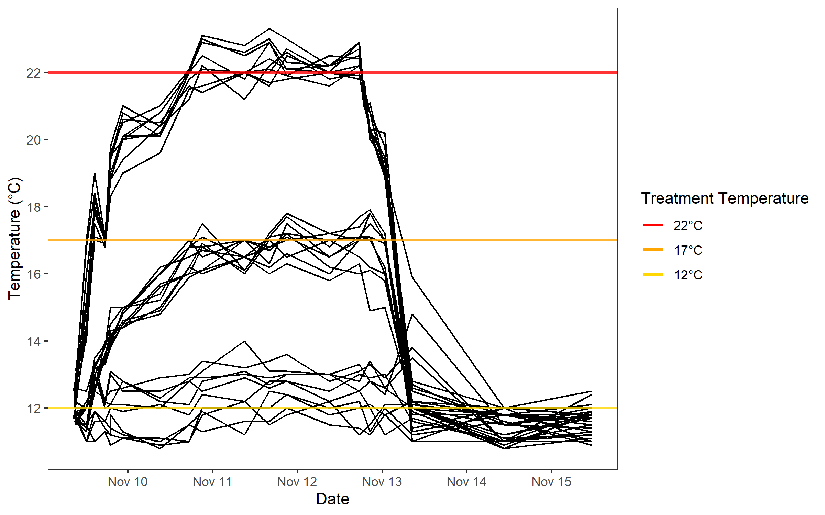

**Figure 3**. Water temperatures over the duration of our experiment. Day 1, the start of the warming, was November 09. Each black line indicates a single bin housing 1 or 2 cucumbers. The 3 horizontal lines indicate target temperatures for the heat treatments.

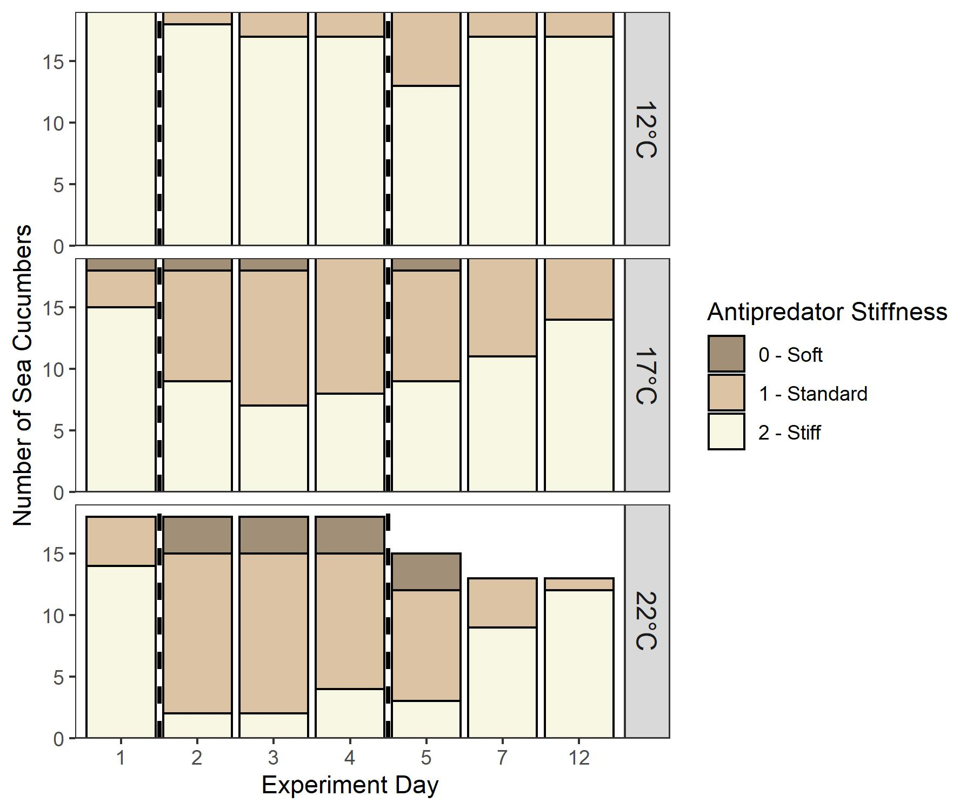

**Figure 4**. *Parastichopus californicus* stiffness as measured by antipredator defense over the duration of the heat treatment (days 1-5) and on recovery days after the treatment ended (day 7 and 12). Dashed lines indicate days where buckets were consistently at target temperatures. Antipredator response was categorized by manually palpating the cucumber to mimic the occurrence of an attempted predation event.

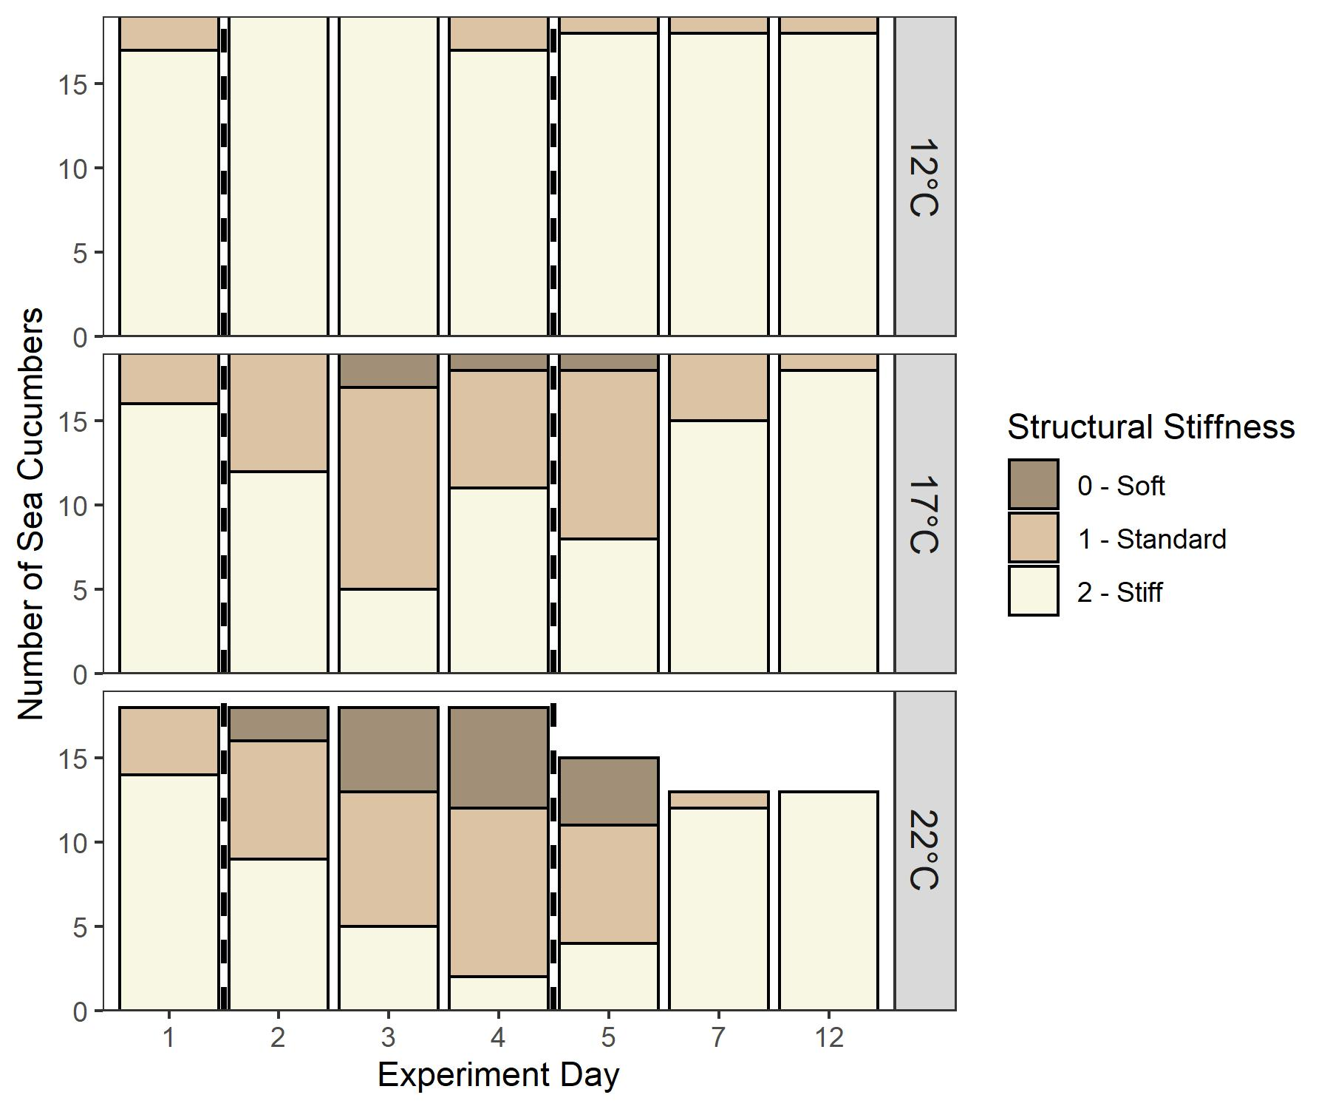

**Figure 5.** *Parastichopus californicus* stiffness as measured by structural maintenance over the duration of the heat treatment (days 1-5) and on recovery days after the treatment ended (day 7 and 12). Structural maintenance stiffness was categorized by placing a stiff cucumber on an elevated platform for 5 seconds and determining if they could maintain their posture. Dashed lines indicate the days during which heat was applied.

**Figure 6.** The eviscerated digestive tract (left) and respiratory tree (right) of *Parastichopus californicus* in the 22ºC treatment. Respiratory tree (A) and digestive tract (B) were both eviscerated in right panel. Sea cucumbers frequently expel their digestive tract as a stress response, but respiratory tree evisceration only occurred twice in the 22ºC treatment and was followed by mortality.

**Supplementary Information**

**Table S1**. Results from a geometric regression model examining the effect of treatment and weight on sea cucumber maximum lesion counts.

|  |  |  |  |  |
| --- | --- | --- | --- | --- |
| Variable | Coefficient | Standard error | T | P |
| (intercept) | 0.965 | 0.157 | 6.15 | 9.35e-08 * |

**Table S2**. Results of ordinal regression model examining the effect of treatment and date on sea cucumber antipredator defense stiffness. Asterisks indicate significant effects.

|  |  |  |  |  |
| --- | --- | --- | --- | --- |
| Variable | Coefficient | Standard error | T | P |
| Treatment: 17C | -3.03 | 0.748 | -4.07 | 4.80e-05 * |
| Treatment: 22C | -4.76 | 0.818 | -5.82 | 5.88e-09 * |
| Date: 2 | -3.09 | 0.634 | -4.86 | 1.16e-06 * |
| Date: 3 | -3.39 | 0.643 | -5.28 | 1.33e-07 * |
| Date: 4 | -3.00 | 0.632 | -4.75 | 2.06e-06 * |
| Date: 5 | -3.62 | 0.664 | -5.45 | 5.05e-08 * |

**Table S3**. Results of ordinal regression model examining the effect of treatment and date on sea cucumber structural maintenance stiffness. Asterisks indicate significance.

|  |  |  |  |  |
| --- | --- | --- | --- | --- |
| Variable | Coefficient | Standard error | T | P |
| Treatment: 17C | -2.99 | 0.575 | -5.20 | 1.99e-07 * |
| Treatment: 22C | -4.05 | 0.606 | -6.68 | 2.44e-11 * |
| Date: 2 | -0.976 | 0.524 | -1.86 | 0.0627 |
| Date: 3 | -2.30 | 0.528 | -4.35 | 1.37e-05 * |
| Date: 4 | -2.22 | 0.527 | -4.21 | 2.50e-05 * |
| Date: 5 | -2.12 | 0.541 | -3.93 | 8.66e-05 * |

**Table S4**. Results from a backwards-selected logistic regression model examining the effect of evisceration as a function of defecation status and weight. Asterisks indicate significant effects.

|  |  |  |  |  |
| --- | --- | --- | --- | --- |
|  | Estimate | Std. Error | t-value | P |
| (Intercept) | 1.7126 | 1.1281 | 1.518 | 0.135 |
| Poop (yes) | -2.780 | 1.1202 | -2.482 | 0.0163 * |
| Weight | -0.004309 | 0.002029 | -2.124 | 0.0383 * |

**Figure S1**. Maximum number of minor ulcers found on each individual *Parastichopus californicus* during the heat treatment, compared between the three temperature treatments.  We examined sea cucumbers for ulcers and classified them as minor or major based on their apparent severity.

**Figure S2:** Scatter plot displaying the relationship between *Parastichopus californicus* stiffness metrics. Spearman’s rank correlation coefficient indicated a high degree of correlation between metrics (rs = 0.53, p < 0.001). Stiffness metrics were measured daily for each sea cucumber throughout the experiment.

**Figure S3**. Ordinal regression coefficient and 95% confidence intervals from two AIC selected models with stiffness as antipredator defense or structural maintenance as the response variables. Variable reference categories were Temp: 12°C and Day 1. If confidence intervals overlap 0 (dashed line) the effect is non-significant.