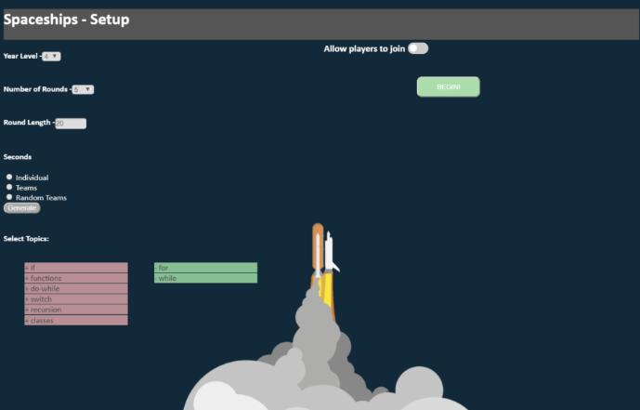

Teacher can select topics that activities will focus

on and can also activate the.

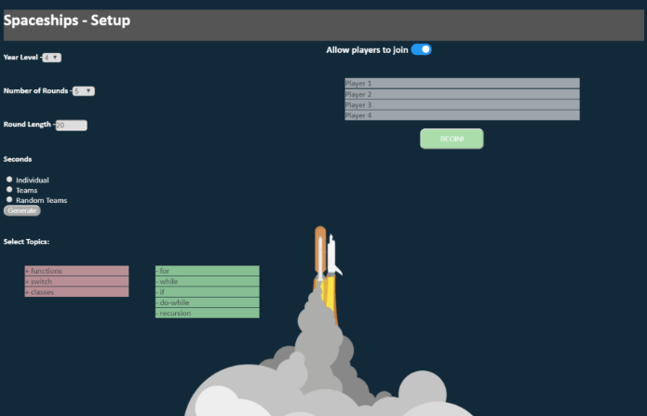

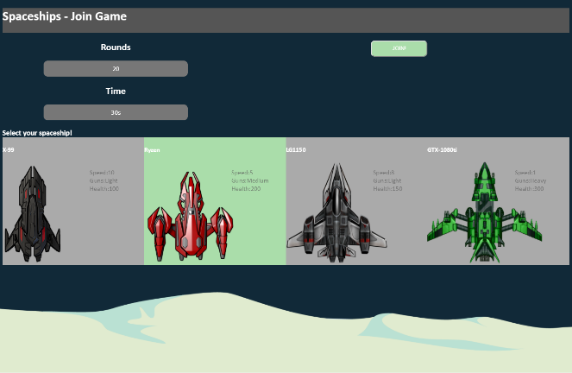

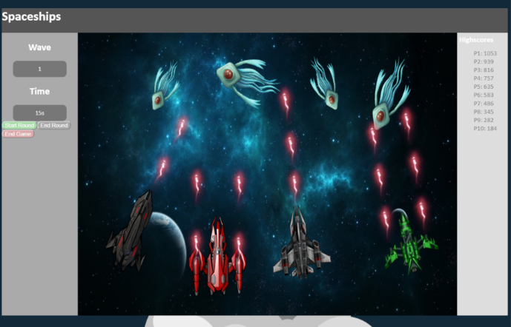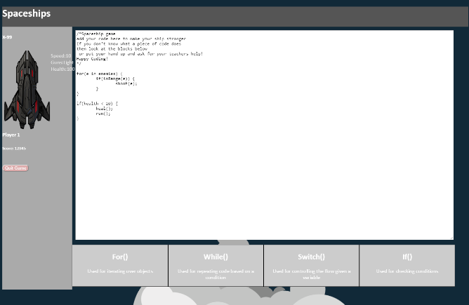

Teacher screen displays the game and its setup.

Students complete series of challenges to upgrade their spacecraft and help the class defeat the attackers. Groups also compete against each other to build the best ship.