

Studyhub – on going project documentation

DECO3500 – Social Mobile Computing



October 27, 2017

University of Queensland

Team Members: Samuel Lucht () Bob Moses (43502967) Nick Cook () Zach Mansfield () Migao Du (43542329)

Promotional Material

(Posters, brochure)

Link to Prototype

(And how to use it)

Community – how they engage with course resources

Supporting physical evidence

photographs of users, sketches, wireframes or functioning websites.

Poster – A2

**Format**

We are keen to see a strong visual component

Research Phase

The benefits of group work in an educational setting are well established. Educational professionals see working as a large or small team as one of the best, if not the best way to learn.1 Countless studies have shown the benefits of working and learning as a group.

Working with fellow students within a cohort is a very effective way for students to further their learning. Discussing the course material and working together is the best way that users can improve their understanding of the topic at hand. Working with fellow students allows students to: break complex tasks into parts and steps, pool knowledge and skills, share diverse perspectives, tackle more complex problems than they could on their own and develop stronger communication skills.2

## User Research

We conducted a series of interviews and surveys in order to receive useful user feedback. Being university students ourselves, we were fortunate enough to have many friends that were are our target audience and could be used for our research purposes.

Link to the Survey: <https://docs.google.com/forms/d/e/1FAIpQLSdiKTDAX38rbtVxc8j9dFwI61RIBFyVFWnrUyP-vGeUcPAgLg/viewform>

Link to the Responses:  
<https://drive.google.com/file/d/0B94otuxunxRrRVFHUW1McFA3bjA/view?usp=sharing>

**Summary of responses:**

Out of all responses, 61% of the respondents currently use Facebook Messenger to interact and collaborate with other students in their courses. All respondents agree that communication is easy using Facebook Messenger due to its push notifications so that peers are alerted and can reply quickly. Many dislike Messenger and find it difficult to collaborate with peers as it lacks appropriate file sharing. Other recommendations include: a screen sharing function, automatic group forming for teams and a way to browse attached files without going through chat dialogues.

**Task Allocation:**

Survey creation – Bob

Survey distribution – Everyone

## Requirements

Based on the evidence we have collected it is clear that there is a gap between users requirements in terms of group and class collaboration and a easy to use and viable application that allows them to do so. The benefits of working as a group are well established and based on our user research it is clear that the current methods of group collaboration do not sufficiently meet students’ requirements.

We have decided to develop a mobile based application that allows users to work with a small group or their entire class. Users will add all of the classes in which they are currently enrolled to StudyHub. Users’ can chat to their entire class or, if they are after help in more specific areas, chat rooms dedicated to topics such as practicals, tutorials or past exams. Tutors and Course coordinators will have access to the chat logs in order to discourage plagiarism.

StudyHub will also provide access to many different external resources in one place such as: github, Google drive (for the group section) as well as past exams and lectures. StudyHub is a project designed to solve numerous common problems that students encounter every semester such as:

* Not knowing anyone in the course, making it difficult to discuss course content with peers.
* Scattered resources – apart from Blackboard, there are many other sites with useful resources for students to utilize during revision periods. However, students need to create many accounts to access such resources.
* Ability to store passwords and account details for external resources.

There are three major features of StudyHub and they are:

* A centralised place for resources – where students can access all useful resources from the app instead of opening multiple tabs trying to find the resources they need.
* A communication/collaboration platform where students can discuss the course with all students that are enrolled in the same course.
* A platform where students can work effectively as a group, making group work and group communication much more efficient.

Stand Up 1  
**Feedback**

There were a number of issues that the tutors had with our concept. They did not like the idea of reinventing the wheel and trying to outdo existing websites (like Google Drive and UQ Attic). Tutors may have misunderstood our concept which is party our fault due to poor communication on our behalf; tutors thought our concept was trying to replace Blackboard.

**Changes to Concept**

Instead of storing past exams and lecture recordings, StudyHub will now just provide external links to these resources. Lorna has suggested that we store all of the passwords and accounts of students in our application which is something we will consider using. We will also focus our attention more on the group page of the concept instead of the entire course.

## Prototype Design Phase

**Design Process:**

After summarising the feedback we have received from surveys, we created a prototype online using the atomic platform.

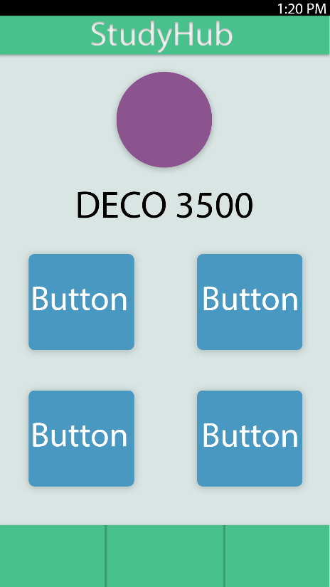Early Wireframe:

Link to prototype:

<https://app.atomic.io/d/82zyEp7cE2Sg>

**Task Allocation:**

Prototype design and creation – Bob, Nick, Sam

Prototype review and testing – Bob, Nick, Sam

## User Testing

Link to form:

<https://docs.google.com/forms/d/e/1FAIpQLScMeJyys67a3JPfFC5WXyGoYHPZXY0G2qNgHK4asBQQRevIRQ/viewform?usp=sf_link>

Link to user responses:

<https://drive.google.com/open?id=0B94otuxunxRrMVVmZmdtR05FdVE>

**Goal:**

To gain specific and actionable user feedback on our low fidelity prototype.

**Feedback:**

Users mostly liked our prototype. They thought the colour scheme could be improved, minor bugs could be ironed out and there could be some slight improvements in the menus.

**Task Allocation:**

Prototype design and creation – Bob

Prototype review and testing – Bob, Nick, Sam

Stand Up 2  
**Feedback**

The tutors thought that we should go back to what the original concept was that we started on. The tutors believed that we had lost sight of our problem space and were instead focusing on unnecessary features. The tutors also commented that our colour scheme could use some work. Tutors also suggested that perhaps a mobile might not best suit our application as students may not want to access Github or Google Drive on a mobile device.

**Changes to Concept**

We looked back at the original concept that we began our project working from. We refocused our design on students that did not know anyone in the course and were looking for help. We developed our colour scheme and made it aesthetically pleasing.

## Prototype II Design Phase

**Design Process:**

We began working on our interactive prototype II with the aim of making it higher fidelity and closer to our intended final design.

Wireframes used to Develop Prototype II

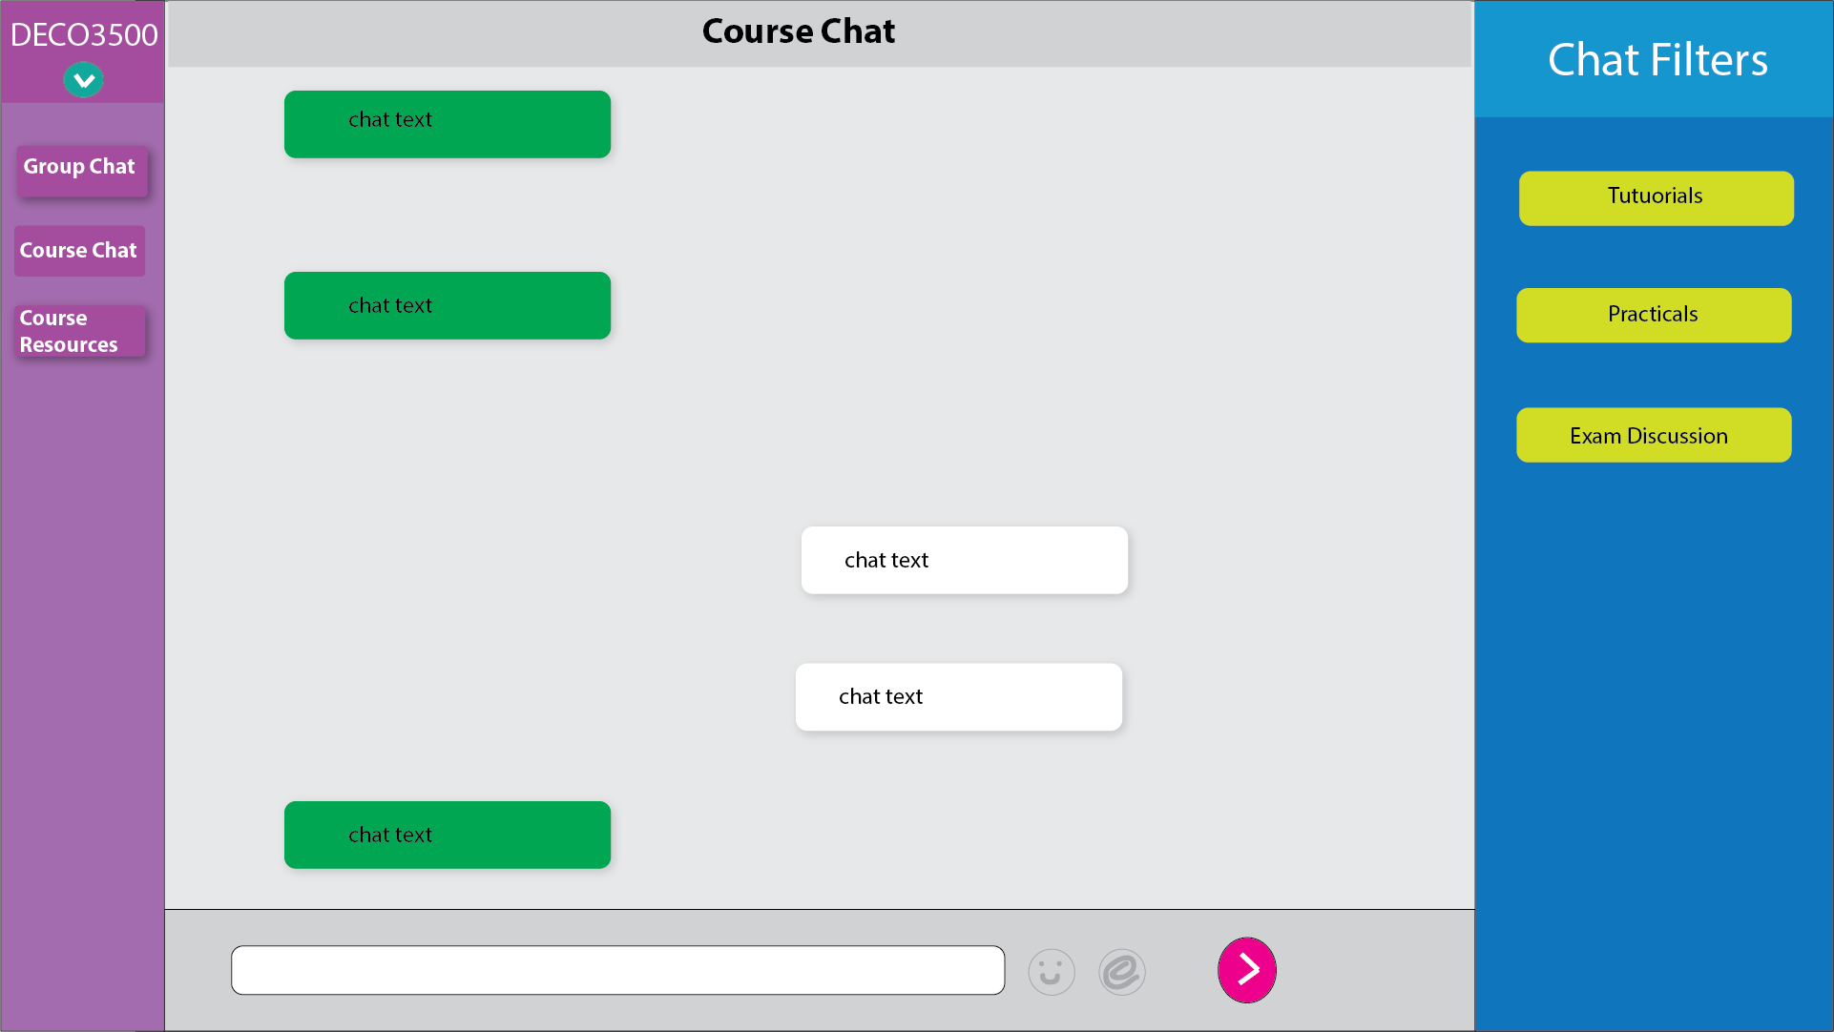

Course Chat Page

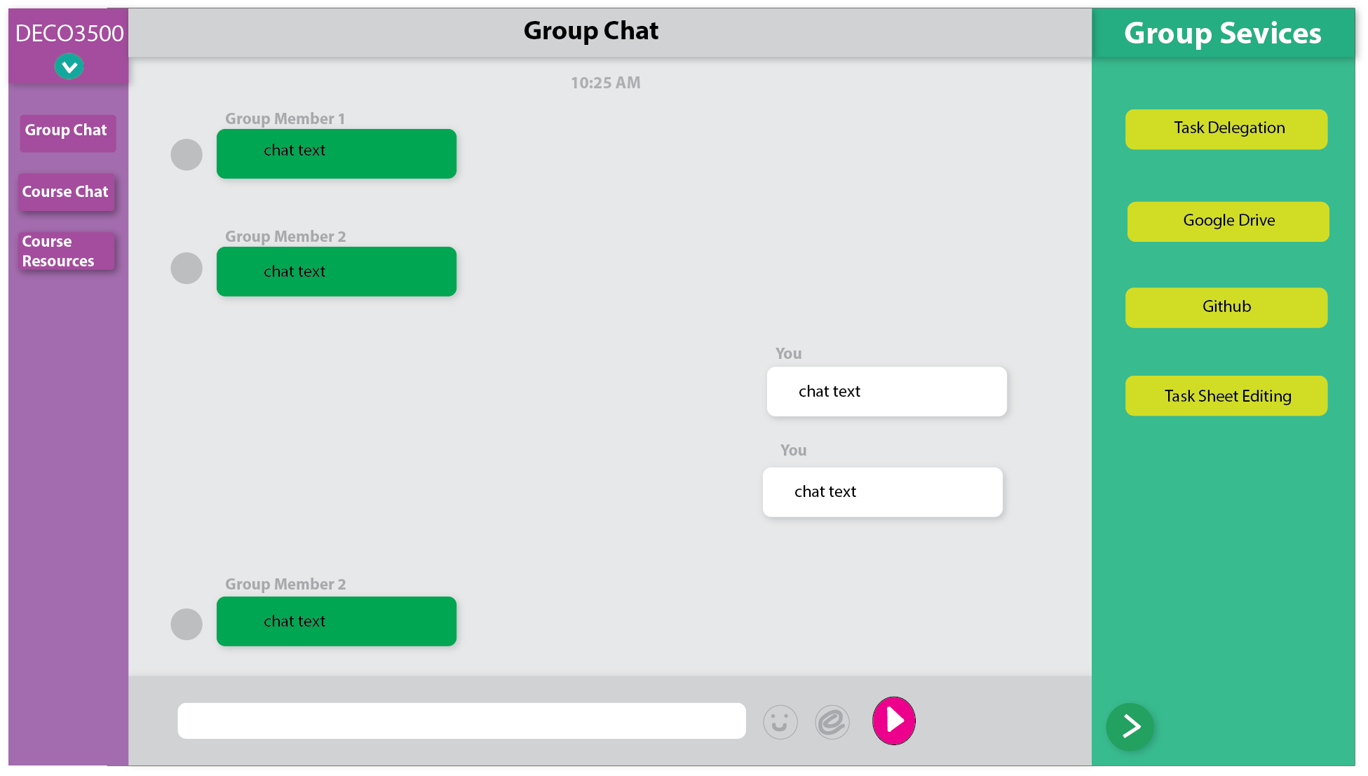

Group Chat Page 1

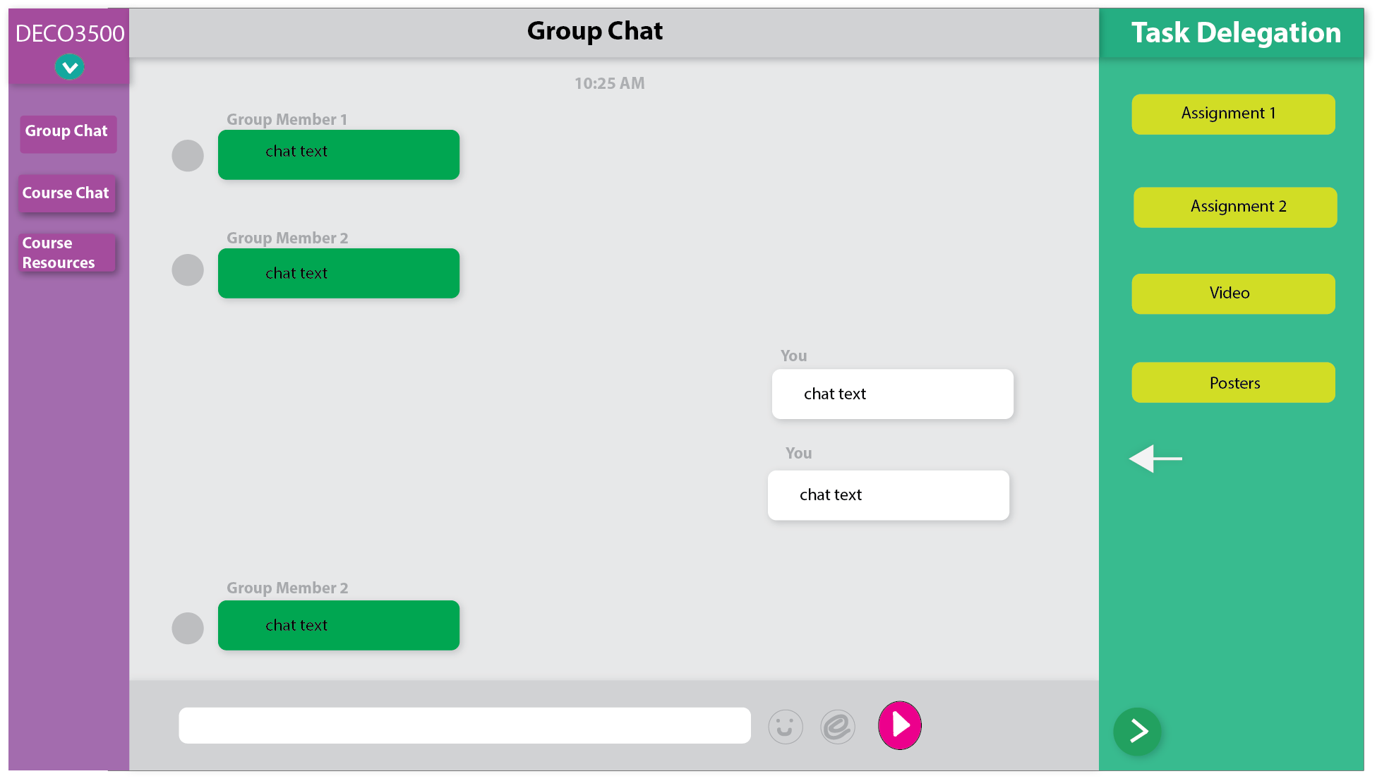

Group Chat Page 2

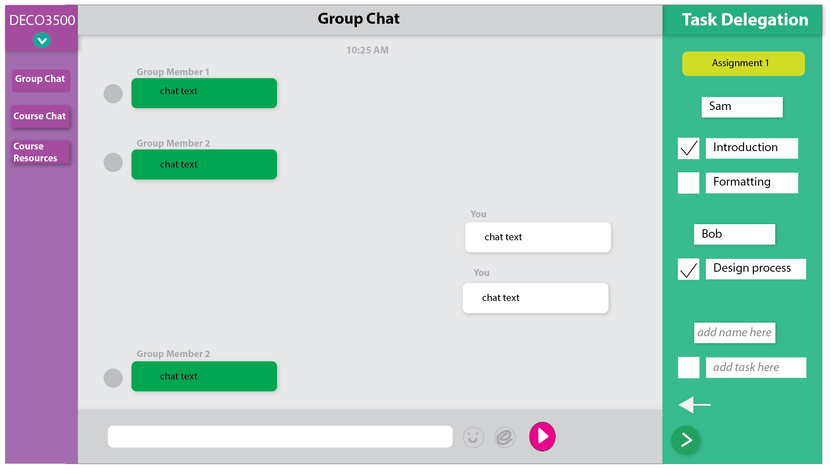

Group Delegation Feature

Link to prototype:

**Task Allocation:**

Prototype design and creation – Nick, Sam

Prototype review and testing – Bob

## User Testing

Link to form:

<https://docs.google.com/forms/d/e/1FAIpQLSdi9PxeXJkKLKzjudcJi7Q7v90t9Sz3bnd9qFJY-udg4HZRQw/viewform?usp=sf_link>

Link to user responses:

**Goal:**

To gain specific and actionable user feedback on our high fidelity prototype.

**Feedback:**

The feedback was generally positive but most people commented that perhaps additional features were required to make the application have a broader appeal. Everyone liked the layout and colour scheme of the application as well as the task delegation feature.

## Week 11 Concept Development

Based on the feedback we received on our Prototype II, it was clear that more features needed to be implemented. Our group worked hard to developed and refine additional features for our final project.

We developed a new feature revolving around meeting up for study sessions. Someone will initiate the session, selecting the room and the general topic that they will be focusing on in that session. Other course members will be able to see the session and its details as well as who else will be attending.

To have a more personalised feel we are going to include a profile picture and a rating function for users. Users will be able to rate fellow course members if they help answer a question or explain a topic. Users are required to use their real name and profile picture to get to know fellow course members and to help facilitate friendships. After a study session has been completed users will rate the session based on how they thought it went. For example someone who got a lot of work done and had help from their peers would rate the session highly. This rating will give stars to all of those who attended the session.

Having a good rating is advantageous as people are more likely to want to attend sessions with higher rated users and more likely to accept advice or constructive criticism from someone who knows what they are talking about.

The course chat functions as any other chat room does, additionally users can tag their questions with the tags: practical, tutorial exam or mid-sem. The tags are colour coded; allowing everyone to clearly see what each question is related to. Furthermore, using these tags means that the asked question is designated a question and means that people can receive stars if they answer it.

Another feature that we have decided to implement is time specific chat topics. In the course chat, during specific times there will be an encouraged focus on specific areas of conversation. For example on 8pm on a Tuesday the focus could be on practical discussion. To encourage this double points will be earned for those who answer questions regarding that topic during the specified time.

Stand Up 3 (week 12)  
**Feedback**

**Changes to Concept**

## Prototype Development

## Theories used in Prototype Development

Our concept is an example of computer-supported cooperative work (CSCW). Our concept revolves around facilitating and encouraging students to learn and engage with each other. Our application is capable of helping any student complete their work. The application allows for students to collaborate and coordinate.

The application is also an example of social software. The use of the chat application, time specific chat topics, the task delegation feature and the group study sessions are all forms of social software. The application encourages social interaction and collaborative learning online as well as study sessions and discussions of particular topics.

Groupware is where an application helps people involved in a common task achieve their objective. Our application helps students in a group delegate work between each of the group members and update their progress as they proceed. Our application is clearly an example of groupware as it helps students plan and work towards their tasks completion.

## References

(APA Style)

1. Brame, C. (n.d.). Group work: Using cooperative learning groups effectively. Retrieved August 9, 2017, from https://cft.vanderbilt.edu/guides-sub-pages/setting-up-and-facilitating-group-work-using-cooperative-learning-groups-effectively/
2. University, C. M. (n.d.). Retrieved September 10, 2017, from https://www.cmu.edu/teaching/designteach/design/instructionalstrategies/groupprojects/benefits.html

## Appendix List

(APA Style)

Learning & Teaching @ UNSW. (n.d.). Ideas for effective large-group learning and teaching. Retrieved August 10, 2017, from https://teaching.unsw.edu.au/sites/default/files/upload-files/large_group_ideas.pdf

Sheffield, U. O. (2013, September 24). Learning and Teaching Services. Retrieved August 9, 2017, from https://www.sheffield.ac.uk/lets/toolkit/teaching/largegroup