**Interest Page design**

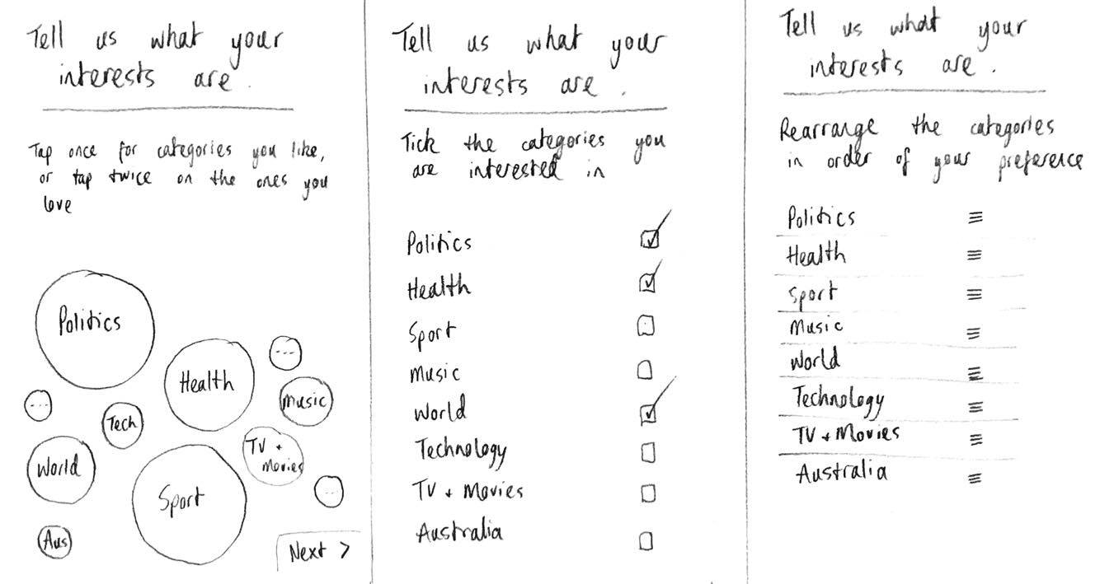

Connor Wager

The middle one (boxes with ticks) due to its simplicity and less time consuming. Direct thought is involved compared to the other two where you'll just select things in a preference that you may not even care about.

Daniel Goonan

I like the middle one best but I also like organisation and that seems to be the neatest one. But the one on the right would be my second preference because it would be like our voting system in that it would group people in order of their interests

Blake Tyler

I like the left one because it’s visually aesthetic and would provide the quickest and most enjoyable way to select topics. The middle one is my second preference as it’s simple and avoids selecting or rearranging topics you may not understand

Laura Mangos

The middle option seems to be the most intuitive for me. Simple and to the point which is what you’d need for this component of the app. There’s too much fooling around with options and preferences in the other two possibilities.

User testing on the app rating system and messenger debate duration.

Daniel Goonan

* **Section 1** The Rating system
* Look into some marking criteria for the debaters to rate each other. A single broad rating would not be sufficient to represent a user’s ability. Normal debates have a particular debating metric which accurately portrays a participants debating traits.
* **Section 2** Debate Duration/ continuation
* Conventional debates go on for three rounds so the current 3 round setting in the chat functions correctly

Connor Wager

* **Section 1** The Rating System
* If users are using the app to hone their debating skills, I don’t think they would be biased and the current single tier rating system would be sufficient. It’s better not to over complicate a simple aspect of the app like
* **Section 2** Debate Duration/ continuation
* Keep the current function of 3 round debates in the app but simply add an option for the users to choose if they’d like to discuss the topic further upon completion of the debate.

Laura Mangos

* **Section 1** The rating System
* The rating system would probably be affective for the majority of users but not those “sore loser” types. Keeping the rating system simple but maybe having three points of criteria may help this.
* **Section 2** Debate Duration/ continuation
* Have a 3 round default for the users like you currently have. but allow us to either choose longer debate categories or have an option to continue the debate or a discussion afterwards.

Blake Tyler

* **Section 1** The rating system
* Have 3 criteria to rate the users, the current system seems insufficient for any form of debate.
* **Section 2** Debate Duration/ continuation
* Keep the round system the way it is, a traditional debate is 3 rounds (messages) each side. Having more or less rounds would take away from the debating feel