Plan for development:

|  |  |
| --- | --- |
| Timeline | Activities |
| Development for low-fidelity prototypes.  (Paper prototypes)  (Week 8 to Week 10) | Development of paper prototypes.  (UI Layout) |
| Testing Approach design/User testing. |
| Summary and results of user testing. |
| Discuss any issues/changes and assign work for the next phase. |
| Development for interactive prototype.  (Electronic prototypes)  (Week 10 to Week 12) | Development of interactive prototype.  (Interaction flow/codes for key parts of idea) |
| Testing Approach design/User testing. |
| Summary and results of user testing. |
| Discuss any issues/changes and assign work for the next phase. |
| Final prototype  (Week 13) | Demonstration. |
| Upload URL of Github repository. |

Success criterial:

|  |  |
| --- | --- |
| Success criterial | Measurement |
| Positive experience - use again and again. |  |
| Interaction and navigational flow – make sense and easy | Construction of the web should depend on the elderly’s mental model (Do more user research). |
| The elderly people navigate within the site and reach the final goal without training or assistance (or a little training) | The web should not look like fuzzy. And the functions should easy understand and shown in navigation bar. |
| The target audience feel easy and efficient to use the web. | Optional function: feedback.  After users using the web, get more information and feedback by a function like questionnaire |

The ultimate measure to the success of our concept is that the age users of the web have a **positive experience.** A positive experience is made up of:

1. Allowing them to search relevant knowledge/information about their hobby.
2. Browse status from others and post comments.
3. Post status and photos about themselves.
4. Engage the elderly to meet outside and face to face.
5. Allowing them to join group by tag of hobby.

The overall user experience must **encourage the elderly to use the web again and again and engage them to go outside in order to face to face with others.** The interaction flow must make sense to users so that it is easy for them to follow and they make few errors.

In order that the application delivers this experience we will need to **undertake regular user testing and evaluation of the functionality we develop, the interaction flow and the aesthetics of the user interface**. We will conduct more user testing sessions or as new features are developed and use the feedback we receive to iterate on the Apps design.

**The experience, of what the user is presented with is important** - the product must function well and have good navigational and interaction flow. The experience allows the age people to navigate within the site and reach the final goal without training or assistance (or a little training) and within a reasonable amount of time. Therefore, navigation will be clearly recognizable and lead to a logical pathway.

Example of chartroom:

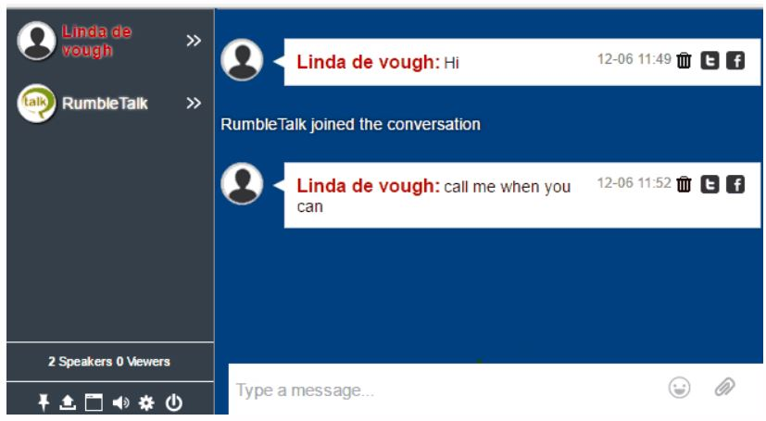

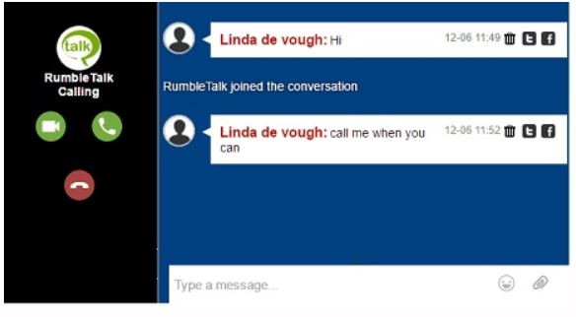

(Retried form: <https://www.rumbletalk.com/blog/index.php/2016/12/06/five-reasons-html-chat-room/>)

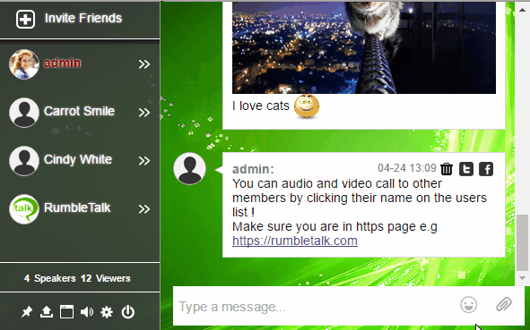

(Retried form: <https://www.quora.com/I-want-to-add-a-chat-between-my-website-and-mobile-app-users-Which-application-or-service-can-be-used-for-this>)

More research about (Problem from feedback week8):

1. How age group actually engage with others through technology.
2. Query why they don’t engage with social media.

Example of how age group actually engage with others through technology:

*Digital lives of Order Australians*

(Retried from: <https://www.acma.gov.au/theACMA/engage-blogs/engage-blogs/Research-snapshots/Digital-lives-of-older-Australians>)

More information/materials:

Two different groups of older Americans emerge. The first group (which leans toward younger, more highly educated, or more affluent seniors) has relatively substantial technology assets, and also has a **positive view toward the benefits of online platforms.** The other **(which tends to be older and less affluent, often with significant challenges with health or disability)** is largely disconnected from the world of digital tools and services, both physically and psychologically.

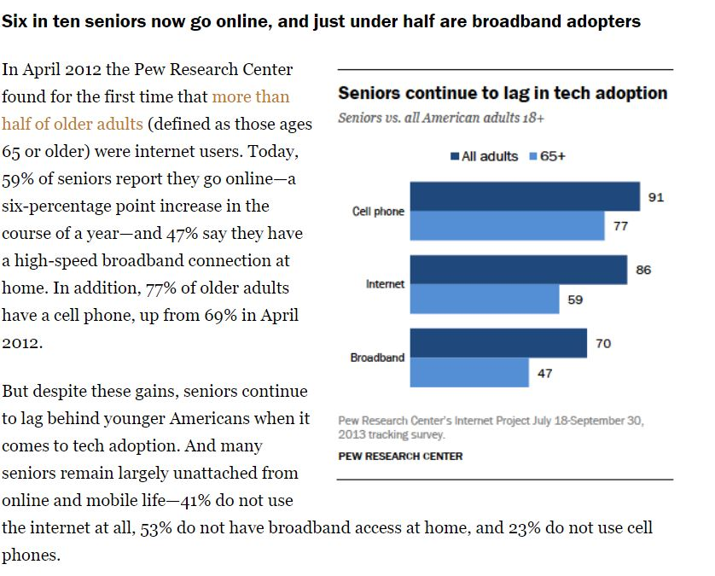

Older adults face a number of problems to adopting a new technology **(why the elderly don’t engage with social media.)**:

1. **Physical challenges to using technology.** Many seniors have physical conditions or health issues that make it difficult to use new technologies.
2. **Skeptical attitudes about the benefits of technology.** Older adults who do not currently use the internet are divided on the question of whether that lack of access hurts them or not.
3. **Difficulties learning to use new technologies.** A significant majority of older adults say they need assistance when it comes to using new digital devices.

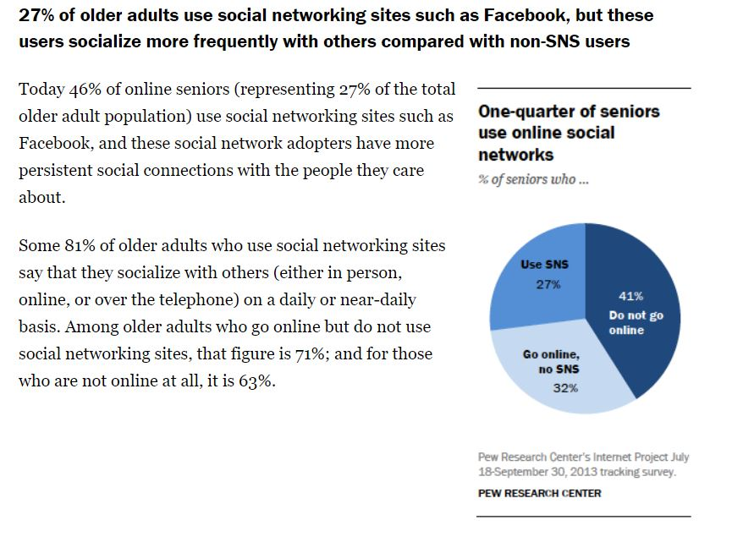

Retried form: <http://www.pewinternet.org/2014/04/03/older-adults-and-technology-use/>