**DECO3500 - Social & Mobile Computing**

**Project proposal**

**Team: Newsvid**

**Members**

**Tien Vinh Truong - 4421567**

**Tom Hemy - 43235452**

**Johnny Wong - 43670594**

**Harrison lisewski - 43590245**

**Outline**

Introduction

1. Concept

2. Team

3. Communication

4. Plan

5. Tags

# **Introduction**

Traditional mediums of news often take a long time to watch or read. Not only that but most important news is published on next day by world’s biggest or national media companies. In today’s fast paced lifestyles this is problematic and is potentially driving people away from the news. Newsvid is aimed at providing much more concise and easily consumed news stories in the form of short videos uploaded by both news corporations and individuals.

Another problem that exists in the current news media is that to find out about a story, people have to wait until the article has been published or broadcast, which can take time and can lead to news being outdated once it is distributed. By allowing individuals to upload their own videos if they are on the scene removes this waiting period and creates a truly up to date news platform.

# **Concept**

**Idea:**

The aim of this application is to create a new way of consuming news. By providing smaller and more concise segments of visual reporting we can change traditional reading behaviours and allow users to consume news as fast as possible. Being mobile lets anybody catch up on the news wherever they are as it would just take a few minutes to watch breaking news or top stories with 24 hour around the world coverage. There are most certainly social media platforms that allow anyone to post news if they want but not necessarily in a verifiable, trustworthy way.

We want to make news more reliable and accurate. Letting users create their own videos from the scene of the story gives an immediate accuracy so that you know the truth as it happens. By allowing moderators or specific trusted people to approve new user created videos we create a much more reliable environment and the trust is placed on a smaller, well known group rather than any anonymous user.

We will also allow news companies to upload their own videos of the daily headlines or whatever segment they choose. These particular videos will also include a link to the full report on the company’s website.

**Possible additional features**

* Live streaming that will allow users to stream certain breaking news stories as they happen if they are on the scene
* Voting: Allow user to rate the news quality and truthfulness - the rating also affect the news provider’s reputation.
* Comment: Let user leave their opinions about the news in order to allow users have more interaction.
* Let user can add friend and they can share news with each other
* Personalized recommended news based on the user’s interests, location and various other factors.

**Rationale:**

* People may find watching long news programs time-consuming and boring, which can result in them being less aware of their own society. Moreover, some news providers can’t be trusted and may hide some information from their viewers.
* With users being able to submit their own content, more stories are able to be told and with moderators staying on top of user submitted content, users can choose verified news that is provided with evidence or unverified news where they see stories that may or may not be true at their own risk.

**Target users/audience：**

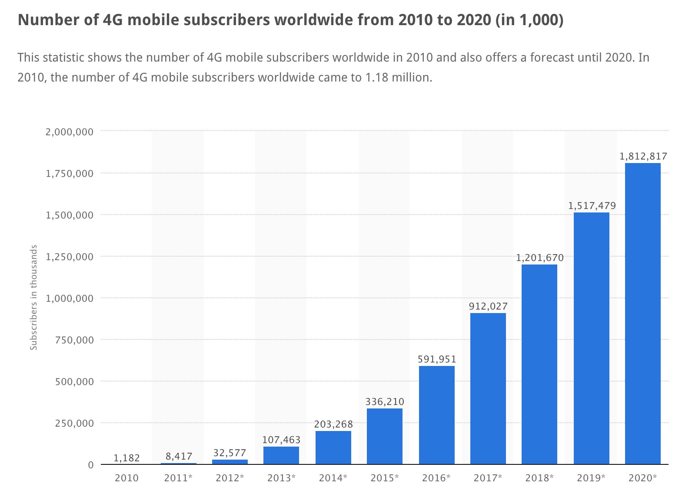

Because our mobile application provides much more concise and easily consumed news stories in the form of short videos, its network needs 4G to support its high performance in order to meet our aims, which demonstrates a growing number of potential customers.. According to above figure, we can see that the number of 4G mobile subscribers worldwide in 2016 is 591 million users who can meet our mobile application requirement. In addition, there is an increasing trend which predicts that there will be about 1.8 billion users in 2020. On the other hand, we pay more attention to the newspaper digital audience, they are familiar with digital newspaper and they are more willing to accept our new idea to read news due to their reading behavior. Our target audience is simply anyone with a busy lifestyle that wants to find out about news quickly and effectively. This may not be ideal for older generations that are still interested in more traditional means of getting news, but having said that there is nothing that prevents anyone from using it as it is designed to be simple to use.

# **Team**

|  |  |
| --- | --- |
| Team Member | Responsibility |
| Tom Hemy | Project Manager, back end |
| Johnny Wong | Logistics, features design, back end |
| Tien Vinh Truong | Designing mockup & features,back end |
| Harrison Lisewski | Multimedia design, front end |

* Making team decision:
  + Step 1: Nominate the problem/decision that needs to made or dealt with.
  + Step 2: Discuss on facebook messenger or have a meeting if necessary.
  + Step 3: If no compromises can be made, vote to get the majority choice.
  + Step 4: After making a decision, no change or discuss will be made. Every member has to commit and respect that decision
* Problem dealing rule: No criticizing, no blaming, having meeting and solving the problems then make sure it won’t happen again.
* If a team member does not follow the rules or refuse to do the work, the team will report to the course coordinator.
* Every member need to respect the others’ opinion
* If some cases are difficult to make a decision, for example the vote is tied, the project manager will make the decision.

**How will the team handle poor performance and resolve conflicts:**

Conflict is not necessarily a bad thing. Healthy and constructive conflict is a component of high-functioning teams. Everyone has different opinion and experience, we need various constructive idea to make teamwork more effective.However when we have any disputes,we have some rules to take actions:

1. Understand why the conflict has occurred – there must be some reason to cause the conflict. Understanding why the conflict has occurred is an effective way to reduce the chance that the conflict will occur again. So each member should be willing to give a reason to explain their problem.
2. Act immediately – When members have misunderstanding and conflict, it is essential to communicate as fast as possible in order to avoid any negative impacts on the team and the project.
3. Arrange to meet with both people – Encourage team member to summarise their view, uninterrupted. This is essential as often people involved in conflict do not feel that they are being heard. Sometimes resolving workplace conflict is as easy as providing a forum for people to express their views.
4. Agree to communicate – The most important thing throughout the resolution process is for everyone to keep communications open. The team members involved need to talk about the issue and discuss their feelings. Everyone should have active listening, because to move on you need to really understand where the other person is coming from.

If a team member is not able to finish his own work allocated by manager , we will:

1. Having a team meeting and discuss the problem with the member concerned.We will

|  |  |  |
| --- | --- | --- |
| give assistance with the member. | |  |

1. If the team member does not attend the team meeting or does not complete their work then they would need to provide a reason.

# **Communication**

**Meeting:**

|  |  |  |  |
| --- | --- | --- | --- |
| **Place** | **Time** | **Work** | **Members** |
| Building 49 at UQ | Wednesday 2pm to 4pm | Document work | Whole team |
| Engineering and Sciences Library at UQ | Tuesday  2pm to 3pm | Discussion and checking works | Whole team |

We’ve kept the meetings flexible according to our workload. Facebook is the main social platform for communicating between other team members. We have also set up a group on Facebook to post documents or important information, if there are some urgent case we have to deal with, we will discuss in the facebook chat and phone call. The team will upload documents on Google Drive during development and upload final products onto GitHub.

# **Plan**

**Assessment**:

|  |  |  |  |  |
| --- | --- | --- | --- | --- |
| **Assessment** | ***Tasks*** | ***Deliverable*** | ***Resource*** | ***Due date*** |
| **Project Idea** | A single slide explaining a certain journalistic dilemma they want to address as well as their solution | PDF |  | 12 Aug 16 17:00 |
| **Oral Pitch** | A single slide explaining a certain journalistic dilemma they want to address as well as their solution | Presentation | * Collect feedback * Collect additional requirements | 31 Aug 16 08:00 - 5 Sep 16 23:59 |
| **Project Proposal** | A single slide explaining a certain journalistic dilemma they want to address as well as their solution | PDF | Feedback from Oral Pitch | 28 Oct 16 23:59 |
| **Design Portfolio and Prototype** | Develop a design portfolio, including a design prototype,and promotional video | PDF ,Design Prototype ,and Video Blog | Online survey (interview and questionnaire) | 28 Oct 16 23:59 |
| **Reflective Essay** | Write a reflective essay, up to 2000 words, that analyses the project within the theoretical context provided through seminars and self-directed learning. | PDF | Compiled Document | 6 Nov 16 23:59 |

**Project Plan**

|  |  |  |
| --- | --- | --- |
| **Date** | **Tasks** | **members** |
| 12/9/16 | 1. Survey for UQ student by interview or online questionnaire | 1Tom  2Johnny |
| 14/9/16 | 1. To analyze the survey  2. Based on the survey feedback to finish UI and UX design | 1.Tien,  2.Harrison |
| 18/9/ 16 | 1. Design Paper Prototype  2. Discussion and modify prototype | 1. Tien, Johnny 2. Team |
| 25/9/ 16 | 1. Work on simple mobile application interface  2. Develop basic feature | 1. Tien 2. Tien, Johnny |
| 30/9/ 16 | 1. Gather feedback on paper Prototype  2. Present a limited functioning prototype to users  3. Design Video content | 1. Harrison 2. Tien 3. Johnny 4. Tom |
| 2/10/ 16 | 1. Script Video | 1. Johnny  2.Harrison |
| 2/10/ 16 | 1. Film and edit video  2 Start Design Portfolio | 1. Johnny  2.Harrison |
| 27/10/ 16 | 1. Submit Design Portfolio  2. Present Interactive Prototype | 1.Harrison  2.Tien  3.Johnny  4.Tom |
| 28/10/ 16 | 1. Work on Individual Essay | Individual |

# 

|  |  |  |  |
| --- | --- | --- | --- |
|  | Programming language | tools | member |
| Application  (Android) | C++/java | Visual studio | Tien, Johnny |
| Website | HTML ,css,javascript | Sublime or notepad++  Or Visual studio | Harrison |
| server | PHP,SQL | Netbeans | Tom |

# 

# **Tags**

* Key concepts: #Awareness, #MoSoSo, #CSCW, #Coordination, #Collaboration
* Journalism & News: #journalist, #reporter.

References：

http://www.statista.com/statistics/226101/global-4g-mobile-subscriber-forecast/