**FEDERAL UNIVERSITY OF TECHNOLOGY, AKURE**

**SCHOOL OF MANAGEMENT TECHNOLOGY**

**TRANSPORT MANAGEMENT TECHNOLOGY**

railOS: A Technology System for Rail Management

by

Fasina Oreoluwa

TMT/14/9304

Project Supervisor: Dr Faiyetole

CHAPTER ONE

* 1. BACKGROUND STUDY

Technology has been a relevant factor in the changes accompanied in a society. The Merriam Webster’s Dictionary defines technology as the use of science in industry engineering, agriculture e.tc to invent, innovate useful things to solve problems (Merriam Webster's Dictionary). Technology can also be defined as the tools, devices, machines, methods, techniques that are created, invented, or innovated in order to solve problems in the society.Technology has been a revolutionizing force in the transport sector; from the wheel which when invented changed the transportation industry to the harnessing of electricity to create innovations such as the electric motor which led to the invention of airplanes and automobiles.

Technology keeps on transforming the way we develop, regulate and operate the various existing transportation system. Technology is used by different transport agencies for the role of counting car crashes, payment of toll fees, the speed of a vehicle, and carbon-emission rate of a vehicle down to the common traffic system. As consumers of transport service we rely on the data provided by different technologies that influences our trip decision(whether or not to embark on a trip) such as traffic report, the weather report, vehicle performance data , real-time transit arrival information(for BRTs and trains) and even maps which did not exist four decades ago. In developed countries hybrid vehicles or buses powered by hydrogen or biofuels are used in daily commute. We expect additional advances in technology pertaining transportation; not to get to where we want to go but to support economic development, improve air quality and reduce pollution; from solar-powered vehicle to disruptive innovations such as the hyperloop-one designed by Tesla and SpaceX. Musk and SpaceX have made the idea explicitly open-sourced, and others have been encouraged to take the ideas and further develop them.

Transport systems have been a common determinant in the evolution of transport managerial effectiveness and efficiency. Different transport systems have been developed and innovated upon, in which various modes of transport to ease managerial duties and provide the management with real-time data.

A Rail Management System (RMS) just like any other system is composed of subcomponents or subsystems that are interdependent on each other. railOS is an RMS involving IoTs, embedded devices, customer profile database, train schedule etc. These components interact and depend on each other to provide data that can be analyzed for decision making. Rail Management Systems that have been created have only posses a ticket reservation system. railOS is going to be built to provide more than a ticket reservation system but a train tracking system, customer's profile database, train register logs etc.

* 1. STATEMENT OF PROBLEM

It is of a general opinion that the Nigeria Railway Corporation has gone through some bad times, although efforts are in place by the Ministry of Transport to improve it. One of its imposing problems which were discussed with the DYC (District Yard Coordinator) during my internship with them was the lack of government support, poor management (as expressly identified by others). But another problem I observed was the process in which some duties were carried out; the fiscal composition exercises performed were usually written down on pieces of paper that could easily get missing.

Information is power is a statement that has always proved itself; information is a resultant of processed data. Data is an important variable in management; challenges with ticketing often arise at railway stations which results in loss of revenue. There is no proper documentation of customer's data, of which the data can be used to analyze the trip demand of customers, areas with high trip demand. The ticket reservation system reduces customer waiting period for ticket booking and also helps in easier implementation of discounted rates to customers of certain preference. Since transport service cannot be stored, ticket reservation reduces the indivisibility rate by providing data about potential passengers for that journey which enables the manager to know how many coaches or wagons to be marshaled.

1.4 AIM AND OBJECTIVES

**1.4.1 AIM**

The railOS project is aimed at providing the manager and authorized employees with a platform that provide data such as near real-time data for analytical, investigative, decision-making purposes.

**1.4.2 OBJECTIVES**

* To provide a system of near real time train location data to the manager
* To build a system for effective storage of customers information
* To build a system that logs the train departure and arrival

1.5 JUSTIFICATION OF PROJECT

The project points out the importance of technological innovations in management. The project will bring to light application benefits of technology to management. The project will provide the manager and authorized personnel with certain data like train location, train register records, train schedule, customer profile information and so on, in order to make decisions effectively and efficiently.

1.6 PROJECT AREA

The project will be deployed and a trial will be launched at the Nigeria Railway Corporation, Ibadan Station. Nigerian Railway Corporation (commonly abbreviated as NRC) is the state-owned enterprise with exclusive rights to operate railways in Nigeria. The Nigerian Railway Corporation traces its history to the year 1898, when the first railroad in Nigeria was constructed by the British colonial government; on October 3, 1912 the Lagos Government Railway and the Baro-Kano Railway were amalgamated (John Stocker, 1951).The Lagos Government Railway began operations in March 1901 and was extended to Minna in 1911, where it met the Baro–Kano Railway that was built by the government of Northern Nigeria between 1907 and 1911. The Ibadan Station is one of the railway stations existing in Nigeria. The rail network reached its maximum extent shortly after Nigerian independence, in 1964. Shortly after that, the NRC entered a long period of decline, inept management, and eventually a complete lack of maintenance of rail and locomotive assets. Years of neglect of both the rolling stock and the right-of-way have seriously reduced the capacity and utility of the system. Couplings of the chopper kind, vacuum brakes and non-roller bearing plain axles are also obsolete. By early 2013, the only operational segment of Nigeria's rail network was between Lagos and Kano (Ross Will, 2013).

**CHAPTER TWO**

**LITERATURE REVIEW**

1. **INTRODUCTION**

There have been numerous kinds of systems that have been developed over the past several years. These systems had helped to accomplish the need for making effective decisions at both managerial and operational level. Most organizations develop their own management system which is totally dependent on the personal needs of the organizations. Most systems usually developed are not generic; in that they are only limited to what it has programmed to do without flexibility.

Technology has acted an accelerant in improving various sectors that affect our human life. From cultural values to societal communication, technology has helped in increasing the efficiency of transportation. Technological systems have helped to eliminate the crude ways we do things before and helped in making them easier. From the basic mechanical clock to the Hyperloop concept; this are examples of the impact of technology in our society this are all ways in which technology has made our lives much easier. In transport we can see the impact of technology in the olden days; the invention of wheel all the way down to the theory of spatial interaction and as high as the space shuttle.

**2.1 WHAT IS A SYSTEM**

The Merriam Webster defines a system as is a group of interacting or interrelated entities that form a unified whole.A system is encapsulated by its spatial and temporal boundaries, surrounded and influenced by its environment, described by its structure and purpose and expressed in its functioning. Systems are the subjects of study of systems theory. Within any particular time period, all of these complex components are related in more or less stable way with at least some other components (Thierauf 1984). A well developed and interactive system should provide the best and useful information to the managers at all levels for optimum and efficient operations.

**2.2 WHAT IS A TECHNOLOGICAL SYSTEM**

Understanding the definition of technological system requires background knowledge of the word **technology**; Technology is defined as the application of tools, equipment, ideas, processes, and materials to the satisfactory solution of human need. Technology could also be further defined as innovation of already existing ideas, processes, methods and techniques in order to proffer solutions to social, political, environmental, technological, economic, legal and other human needs and gaps.

In light of this definition, a technological system would then involve a group of interacting or interrelated entities of technology that form a unified whole to meet human needs. For example, satisfying the human need to explore space involves the same use of a technological system, as used in NASA or SpaceX; and also this project (railOS) is a technological system intent on easing managerial duties at the railway station.

**COMPONENTS OF A TECHNOLOGICAL SYSTEM**

**Fig 2.0** Components of a Technological system

**INPUTS** for a technological system include:

* The needs or wants that you are seeking to meet.
* The design or ideas for ways in which those needs or wants might be met.

For example, you may have a need to keep your CDs organized and safely stored. The idea you have is to build a CD holder with a glass door to neatly display them and provide a dust free storage place. Before construction can begin, you will need to work on a suitable design for the cabinet. Other necessary inputs include estimates of resources needed to complete the project such as time, materials and money.

**PROCESSES** are the things that you do to construct whatever it is you have designed to meet the needs established at the input stage.

For example, if you had established a need or want for a CD storage cabinet and have completed your design and cost estimates, you would now carry out the process of building it. The processes phase requires resources such as people, information, materials, tools & machines, energy, capital (money), and time to enable the processes to be carried out.

**OUTPUTS** are the items that are created as a result of the processes phase. These items may include drawings, structures or artifacts.

For example, if you had built a CD storage cabinet, the output would have been the finished cabinet.

**FEEDBACK** is the phase in which you analyze your outputs and make any necessary adjustments to the input.

For example, after building your CD cabinet you may have discovered that you needed a larger cabinet to allow for your growing collection of CDs. This feedback information would then be taken into account if you were to build a second cabinet. Some technological systems do not use feedback and are called *open systems*. A system that uses feedback is called a *closed system*.

Technological systems are developed by people to meet a need, bridge a gap or to proffer solution to existing problem. It takes a lot of teamwork to create a technological system. Designers, engineers are needed to create the product, and then we have the people who then test this product to ensure it works properly. Just look around you and you are sure to see a technological system of some kind. The clock on the wall with moving hands is a technological system.

For example, your clock with its moving hands is made up of gears, a battery, and the hands that are moved by the gears. They all work together to change the input: the battery power; into time, the moving of the hands at a set pace. If you updated your status on WhatsApp this morning you made use of a technology system. Technological systems generally usually comprise of subsystems that could exist independently. Taking your iPhone as an example, it contains a camera, various applications, a touch screen, a vibration setting and a GPS each of these components can exist as a system.

**2.3 WHAT IS A RAILWAY MANAGEMENT SYSTEM**

Systems have been created to provide efficient ways to improve the operations of an organization. Management systems being developed for rail transportation do not have a generic name since they are usually developed by individual companies as S-a-a-S (Software-as-a-Service); although the name railway management system encapsulates the technological system I am building.

A railway management system should integrate solutions and related services to supplement the speed, safety, reliability, and efficiency of rail service(s). A rail management system is supposed to aid in streamlining rail operations, boosting security, and delivering enhanced environmental protection. They allow station operators to more effectively coordinate and manage train arrivals, departures, and cargo handling to boost the throughput. They also provide efficient revenue & ticketing management solutions, ensuring accuracy in the fare collection, increased security against frauds, reduced revenue losses, improved end-user customer satisfaction, and lower maintenance costs

**CHAPTER THREE**

**PROJECT METHODOLOGY**

1. **railOS**

railOS is a would be technological system intent on aiding certain rail management activities. It features the following functions:

* Real time train tracking
* Documentation of Logs
* Storage of customer information on a No-SQL Relations Database
* Proper data for maintenance
* Train Ticketing & Reservation

Although for this research time, the functions of the system would be limited to the first three functions; which is real time train tracking, documentation of train logs and storage of customer information.

railOS is a management system platform built on hardware and software components to cushion difficulty in some various operations being undertaken in a railway company (like documentation, record-keeping, logs) and assist in other managerial decisions by providing semi-processed data which could be used in inculcating proper managerial decisions for improving efficiency and effectiveness in operations .

**3.1 railOS: AS A TECHNOLOGICAL SYSTEM**

As a technological system it comprises of the Input, Processes, Resources and its Output. As a system it is composed of other subsystems which are also regarded as technological systems of their own accord.

These technological subsystems include:

* The GPS
* The Arduino Microcontroller
* Application Server
  + Nodejs
  + Pug
  + HTML
  + Bootstrap
  + Javascript
* MongoDB Database System

**3.1.0 The GPS**

The Global Positioning System (GPS), originally NAVSTAR GPS, is a satellite-based radionavigation system owned by the United States government and operated by the United States Air Force. It is a global navigation satellite system (GNSS) that provides geolocation and time information to a GPS receiver anywhere on or near the Earth where there is an unobstructed line of sight to four or more GPS satellites. Obstacles such as mountains and buildings block the relatively weak GPS signals. The GPS does not require the user to transmit any data, and it operates independently of any telephonic or internet reception, though these technologies can enhance the usefulness of the GPS positioning information. The GPS provides critical positioning capabilities to military, civil, and commercial users around the world. The United States government created the system, maintains it, and makes it freely accessible to anyone with a GPS receiver. The GPS project was launched by the U.S. Department of Defense in 1973 for use by the United States military and became fully operational in 1995. It was allowed for civilian use in the 1980s. Advances in technology and new demands on the existing system have now led to efforts to modernize the GPS and implement the next generation of GPS Block IIIA satellites and Next Generation Operational Control System (OCX).

In railOS, the GPS technological system would be used to monitor and track the train’s location. For this the NEO

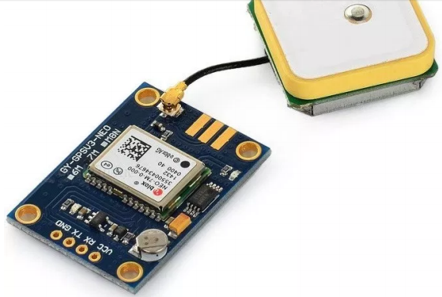

**Fig 3.0** NEO-6M GPS Module

**3.1.1 ARDUINO MICROCONTROLLER**

Arduino is an open-source electronics platform based on easy-to-use hardware and software. Arduino boards are able to read inputs - light on a sensor, a finger on a button, or a Twitter message - and turn it into an output - activating a motor, turning on an LED, publishing something online. You can tell your board what to do by sending a set of instructions to the microcontroller on the board. To do so you use the Arduino programming language (based on Wiring), and the Arduino Software (IDE), based on Processing.

Over the years Arduino has been the brain of thousands of projects, from everyday objects to complex scientific instruments. A worldwide community of makers - students, hobbyists, artists, programmers, and professionals - has gathered around this open-source platform, their contributions have added up to an incredible amount of accessible knowledge that can be of great help to novices and experts alike.

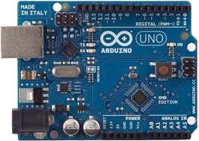 **Fig 3.1** An Arduino Uno

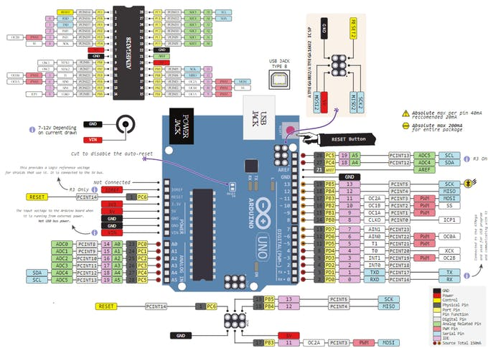

**Fig 3.2** Circuit Schema Diagram of an Arduino Uno

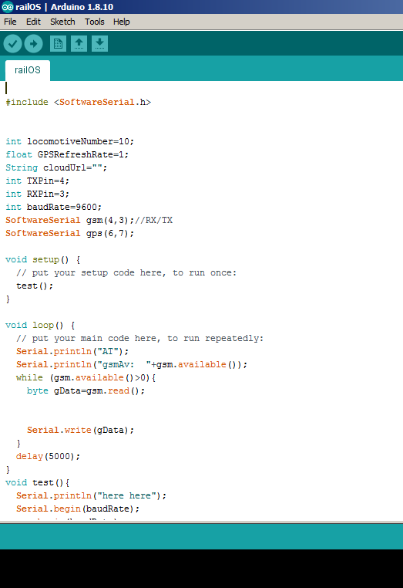

**Fig 3.3** Arduino IDE with railOS code for device

**3.1.2 MongoDB Database System**

MongoDB is a document-oriented NoSQL database used for high volume data storage. MongoDB is a database which came into light around the mid-2000s. It falls under the category of a NoSQL database.

MongoDB was used over the more popular RDMS because of the following reasons:

1. Since MongoDB is a NoSQL type database, instead of having data in a relational type format, it stores the data in documents. This makes MongoDB very flexible and adaptable to real business world situation and requirements.
2. Relational databases are known for enforcing data integrity. This is not an explicit requirement in MongoDB.
3. RDBMS requires that data be normalized first so that it can prevent orphan records and duplicates. Normalizing data then has the requirement of more tables, which will then result in more table joins, thus requiring more keys and indexes.

As databases start to grow, performance can start becoming an issue. Again this is not an explicit requirement in MongoDB. MongoDB is flexible and does not need the data to be normalized first.

**3.1.3 Application Server**

The application server would be developed using node.js server scripting language. The application server is used in communication with the database system and also responding to requests made by users on the system. Through the application server, customer’s information would be pooled for storage on the database systems and the trains’ location would be sent from the various trains online with which the railOS device has been embedded with.

Other technologies used in the application are HTML, CSS, Javascript and Pug which would be used to design the User Interface of the system.

**3.2 railOS: APPLICATION DESIGN**

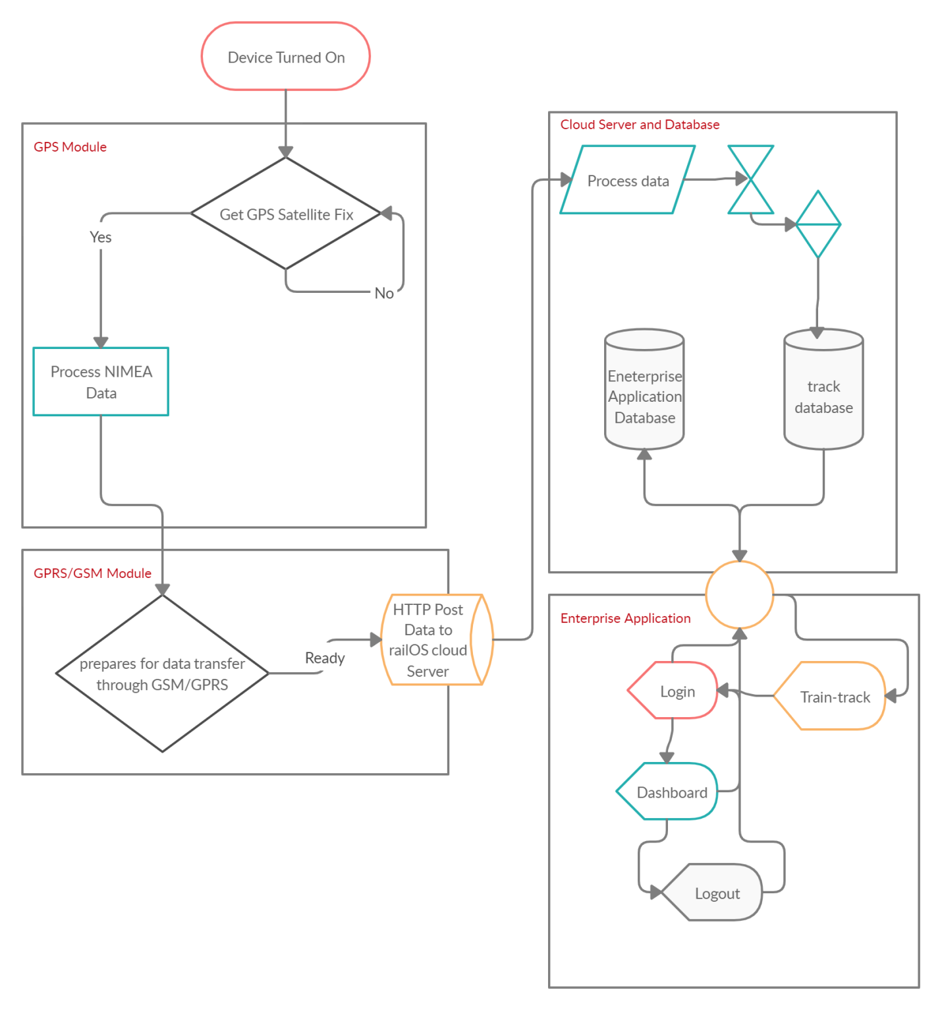

**Fig 3.4** railOS Basic Flowchart

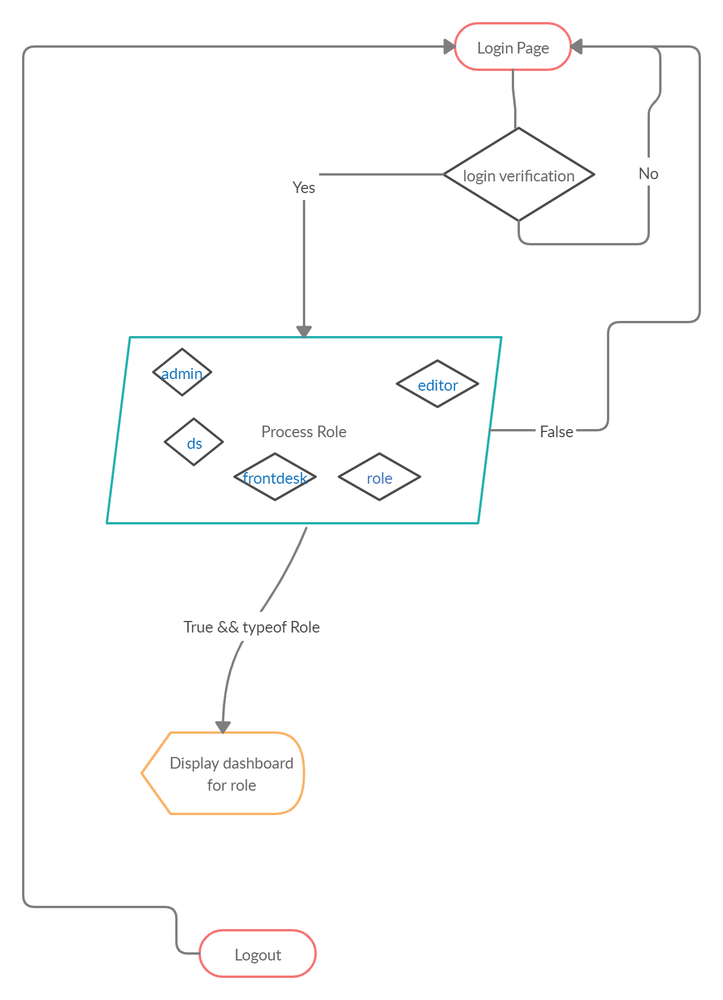

**Fig 3.5** Page Navigation Flowchart

**REFERENCES**

Essays, UK. (November 2018). Literature Review on Management Information Systems Management Essay. Retrieved from <https://www.ukessays.com/essays/management/literature-review-about-management-information-systems-management-essay.php?vref=1>

<http://www.arduino.cc/about-us> What is Arduino?

<https://www.mongodb.org>