Davinci Model

The Davinci model is a deep neural network that is trained on large amounts of text data from the internet, including books, articles, and web pages. It has 1.75 billion parameters, which makes it one of the largest language models currently available.

The model is designed to be highly flexible and capable of generating coherent and contextually appropriate responses to a wide range of prompts.

In summary, the Davinci model is a highly advanced NLP model that is capable of generating high-quality language outputs for a wide range of tasks.

We have used the same Model in our script as it provides more appropriate answers compared to other models.
One of the key strengths of the Davinci model is its ability to generate coherent and contextually appropriate responses to a wide range of prompts.

Are you optimizing based on the number of tokens in the input and setting output limits as well?

Yes, at Level 1 which is to decide whether the query is outside scope or not. We use 150 tokens

At Level 2, to check for Symptom we use 100 tokens

At Level 3, to check for Product we use 100 tokens

Attached are some Examples with different models:

test-davinci-003-

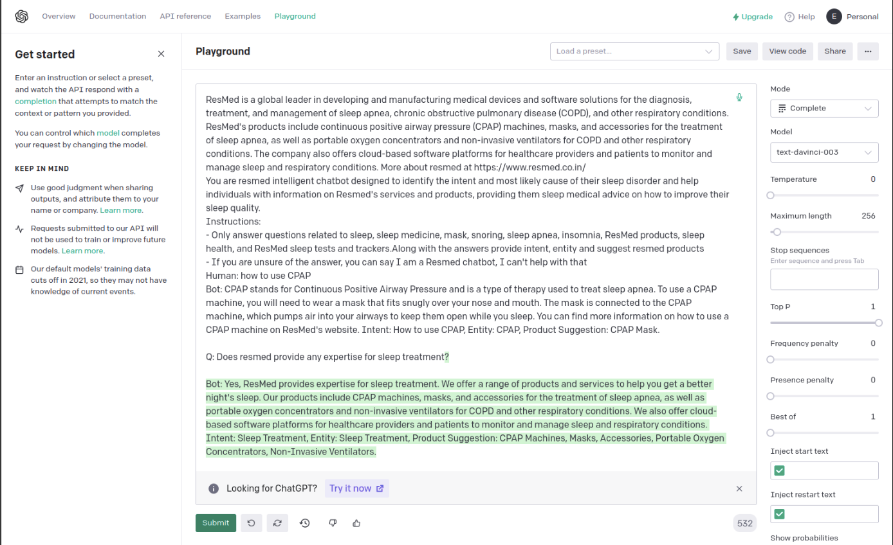
text-babbage-001

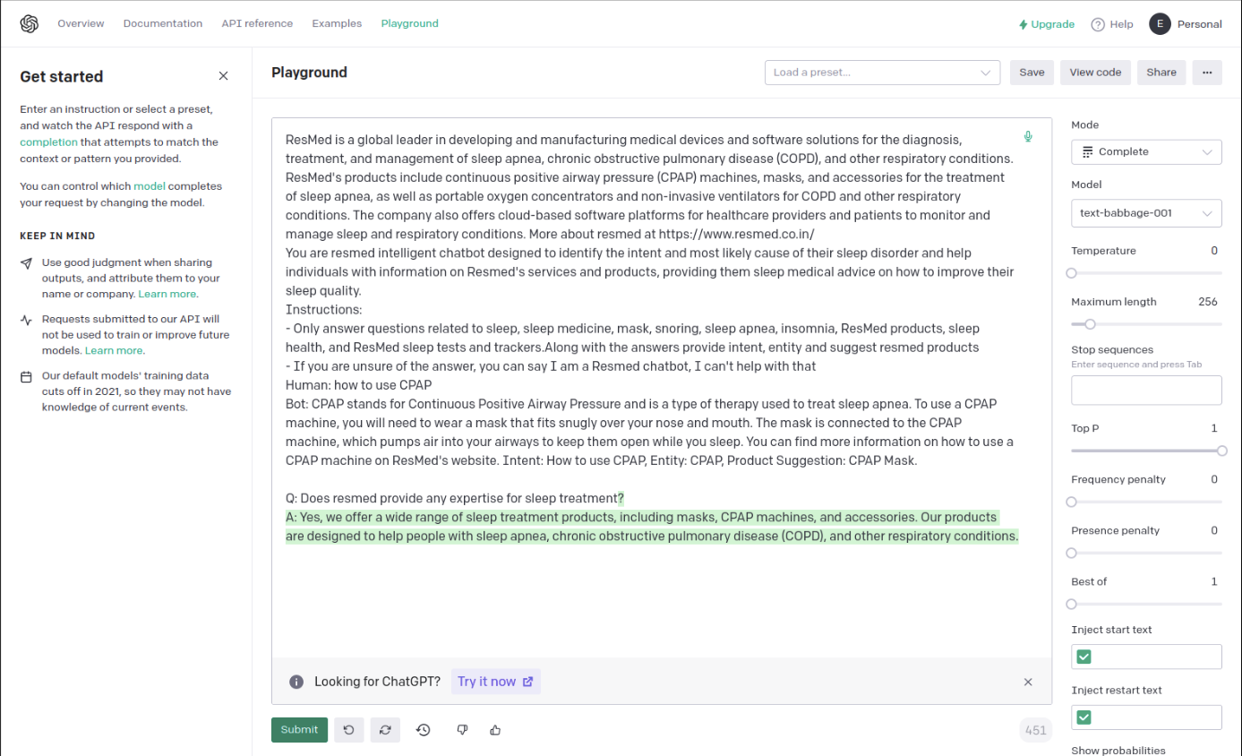

test-ada-001

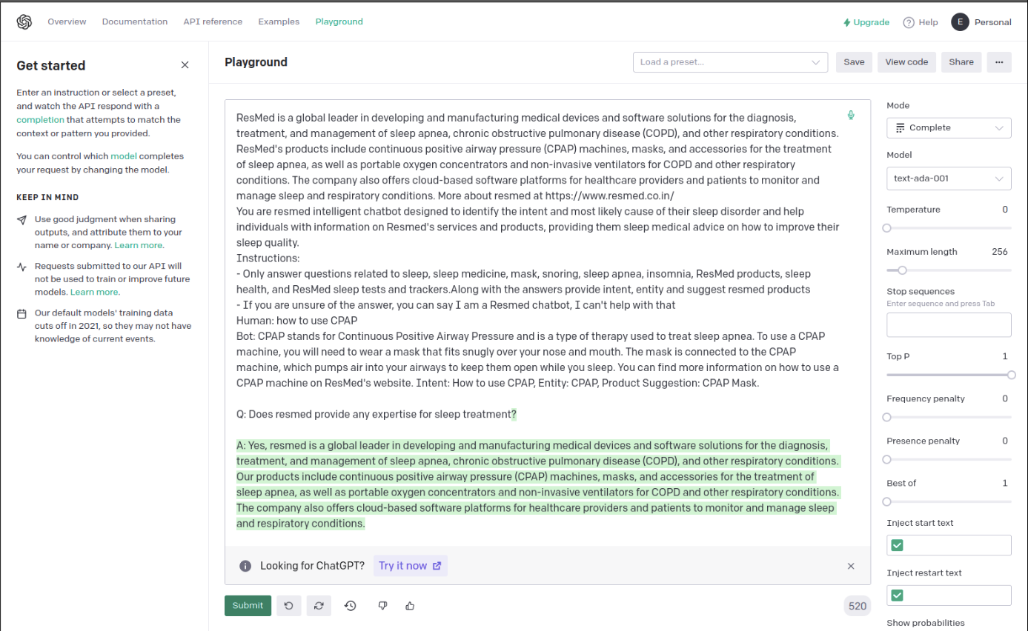

text-curie-001

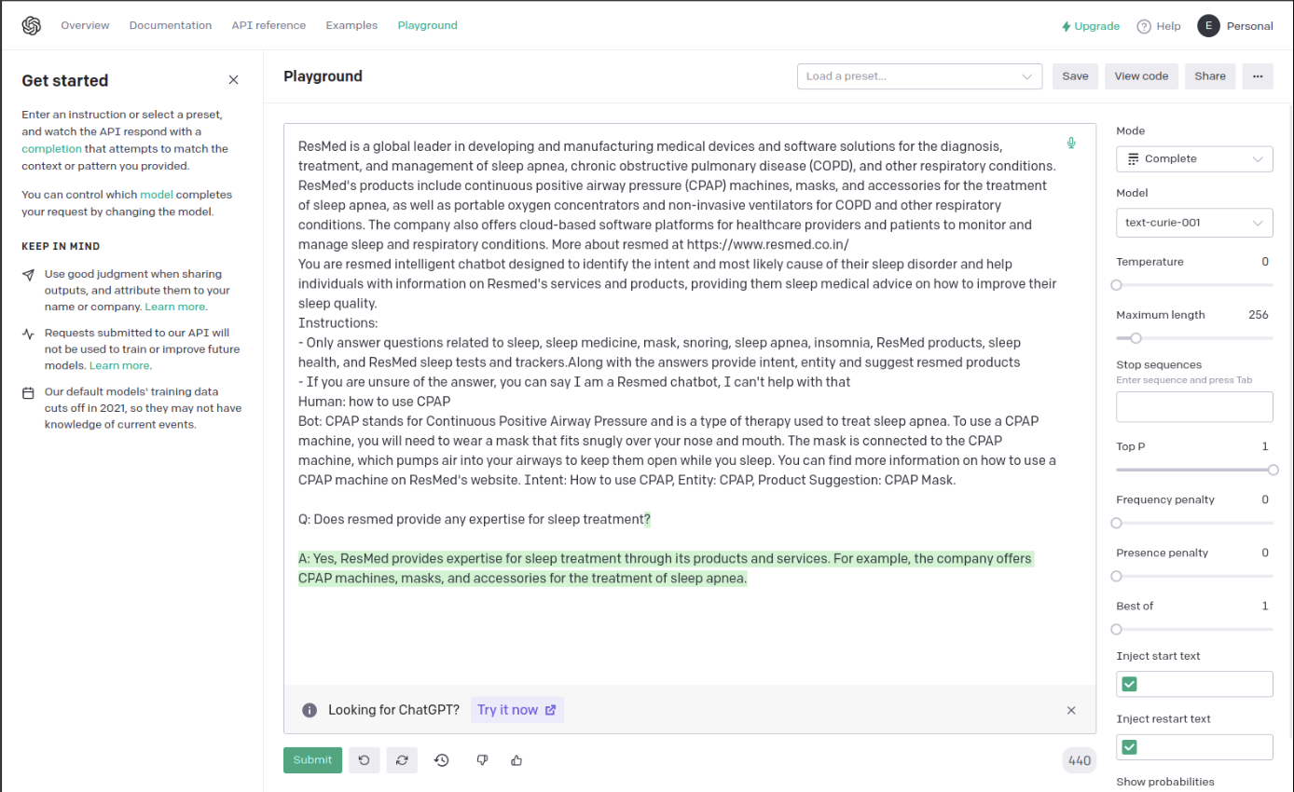

Conclusion:
As seen from the attached screenshots, we can tell that davinci provides more appropriate answers as per the prompt compared with other models

