Table values have been shared through github link. Have deleted email ids of 2 diary_interest_leads for privacy concerns.

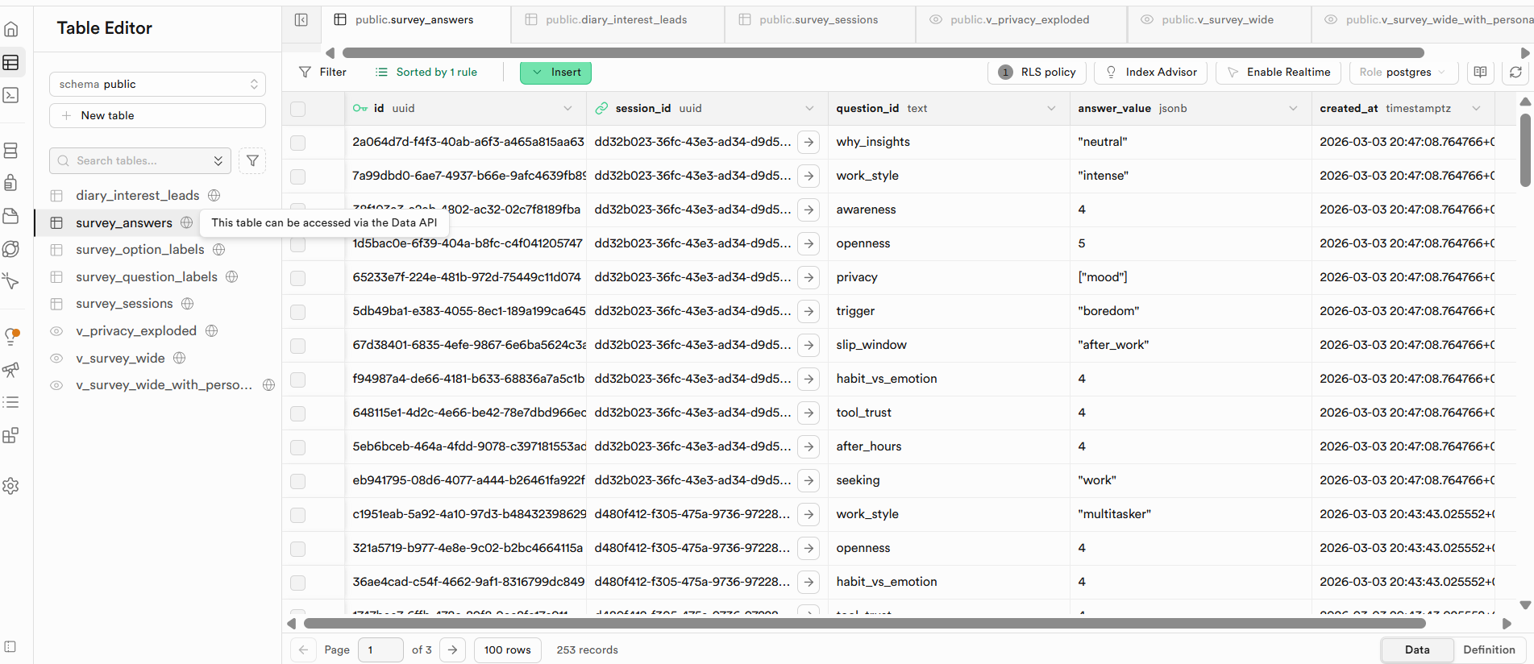
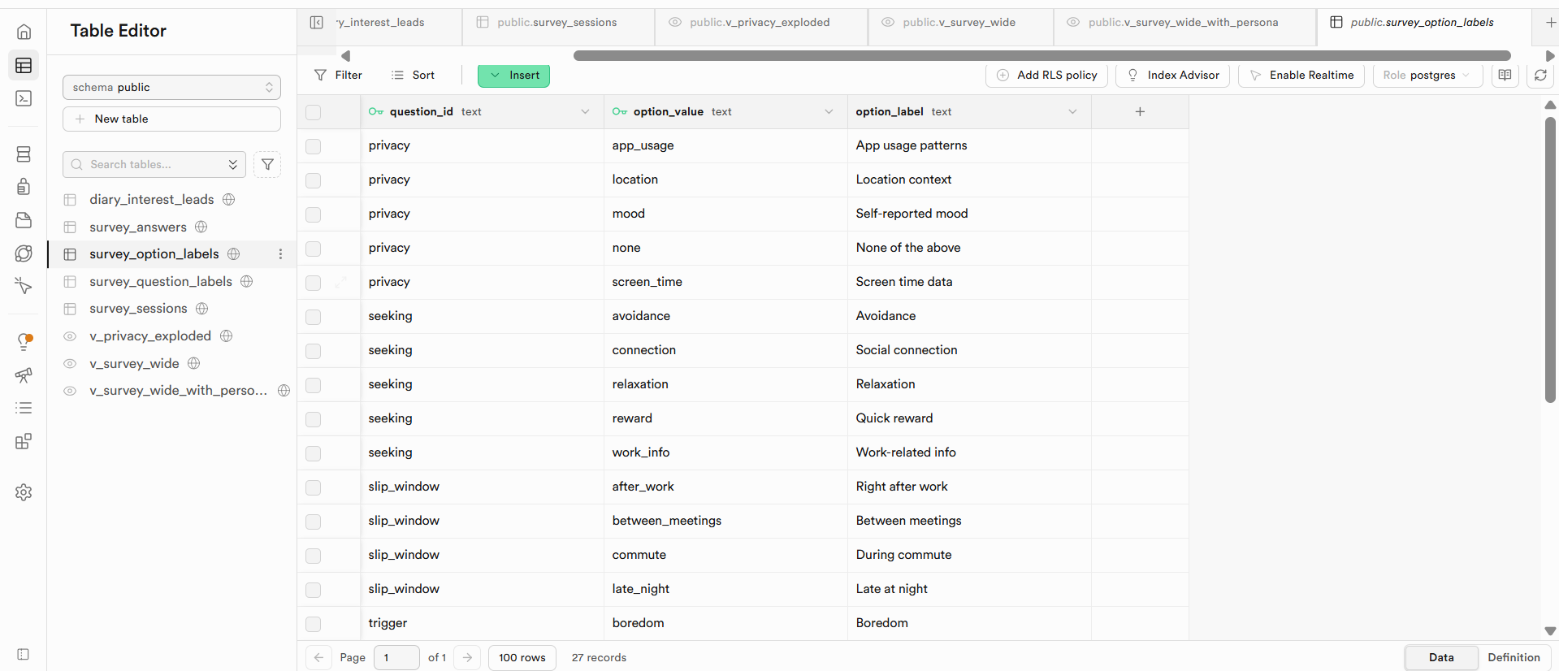

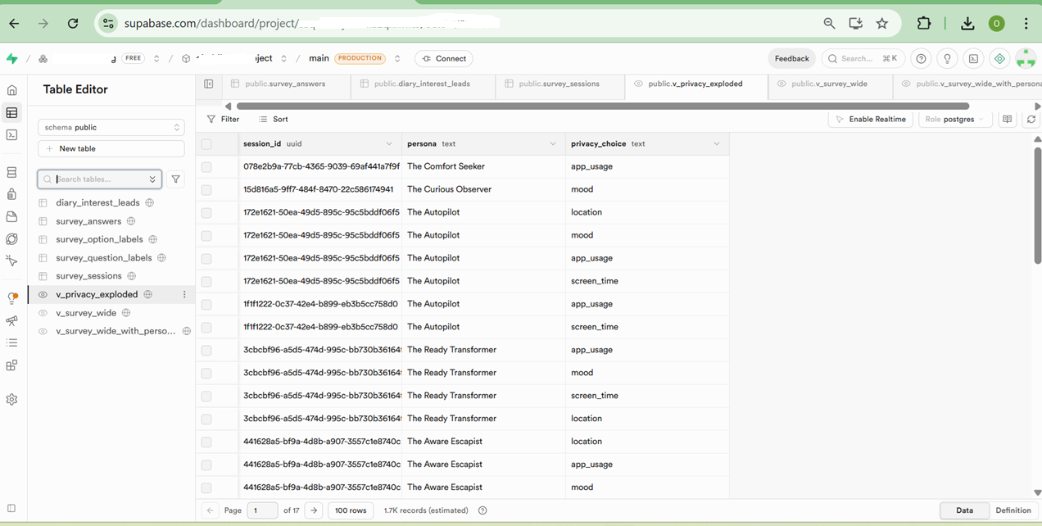

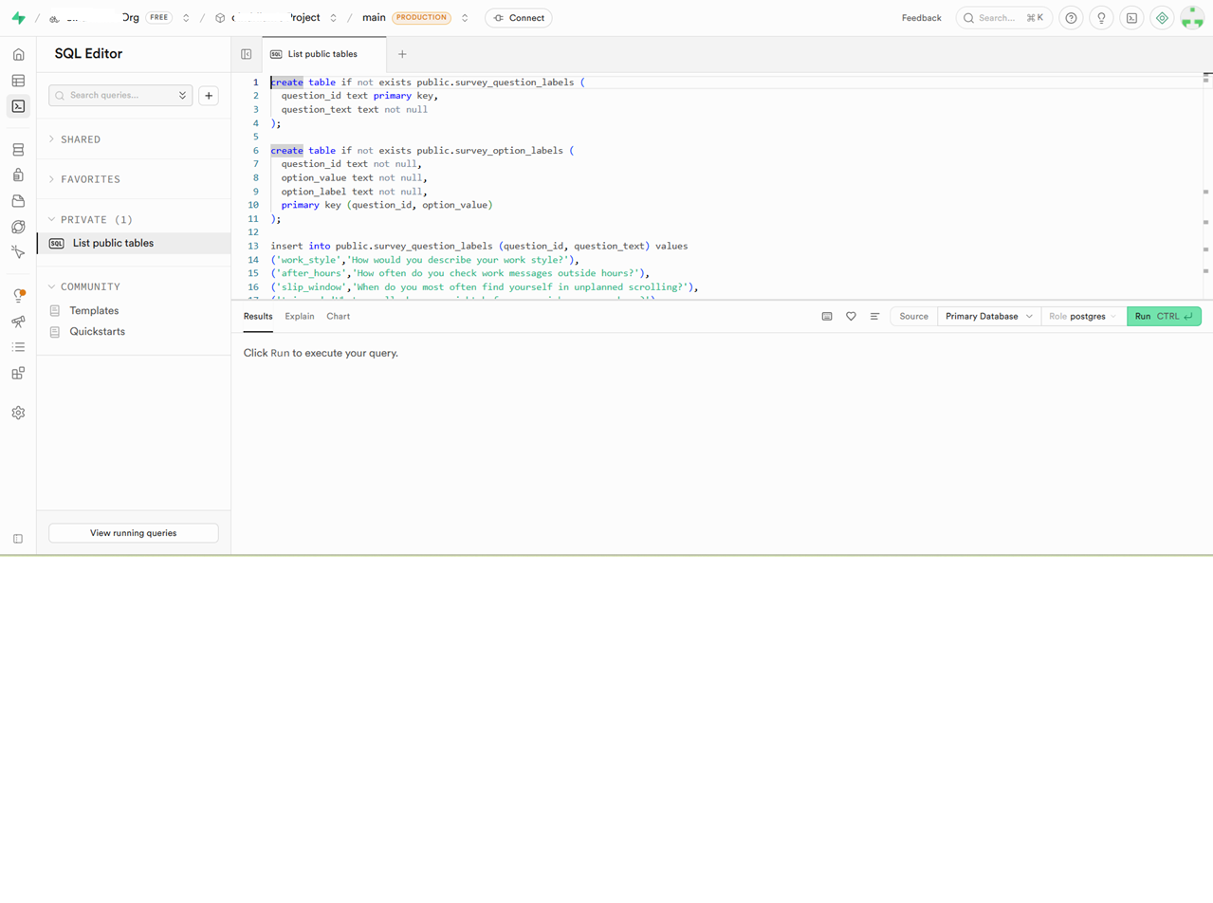

SQL views and label tables were generated with AI assistance and reviewed/edited before execution.
Sharing the AI Prompts:
1.
I have Supabase tables survey_sessions and survey_answers. survey_answers stores question_id and answer_value (jsonb) where questions are saved as IDs like work_style, trigger, etc. Write Postgres SQL to create two lookup tables: survey_question_labels(question_id PK, question_text) and survey_option_labels(question_id, option_value, option_label, composite PK). Use create table if not exists.
2.
Generate SQL insert statements to populate survey_question_labels with my 11 question IDs and their human-readable texts. Use on conflict(question_id) do update so I can rerun.
3.
Generate SQL insert statements to populate survey_option_labels for these questions: work_style, slip_window, trigger, seeking, why_insights, privacy. Include the option tokens and human labels. Use on conflict(question_id, option_value) do update.
4.
Write a Postgres query to list distinct option values and counts for answers where answer_value is a JSONB string. Group by question_id and the extracted string value.
5.
Write a Postgres query to explode JSONB arrays in answer_value (multi-select), list distinct option tokens and counts by question_id, using jsonb_array_elements_text
6.
Write a create or replace view v_survey_wide query that pivots survey_answers into one row per session_id. For string questions, extract (answer_value #>> '{}'). For numeric sliders, cast to int. For privacy (jsonb array), aggregate safely and return a single jsonb array per session (avoid max(jsonb) errors).
7.
Write SQL to create v_survey_wide_with_persona by joining survey_sessions to v_survey_wide. Include: session_id, completed_at, persona, plus all wide columns
8.
Write SQL to create v_privacy_exploded that explodes privacy_json into one row per selected privacy choice using jsonb_array_elements_text, joined with persona
9.
Write SQL queries to
(1) count rows in v_survey_wide_with_persona,
(2) preview first 5 rows,
(3) select all rows from v_survey_wide_with_persona, and
(4) select all rows from v_privacy_exploded for CSV export.

10.
Write SQL to create a read-only Postgres role for Power BI called pbi_reader with a placeholder password, and grant SELECT permissions only on v_survey_wide_with_persona and v_privacy_exploded. Do not grant write permissions.

11. can I delete the email ids from diary interest lead table and share the table? they have asked to show validity.

create table if not exists public.survey_question_labels (
question_id text primary key,
question_text text not null
);

create table if not exists public.survey_option_labels (
question_id text not null,
option_value text not null,
option_label text not null,
primary key (question_id, option_value)
);

insert into public.survey_question_labels (question_id, question_text) values
('work_style','How would you describe your work style?'),
('after_hours','How often do you check work messages outside hours?'),
('slip_window','When do you most often find yourself in unplanned scrolling?'),
('trigger','What usually happens right before you pick up your phone?'),
('seeking','What are you usually looking for when you scroll?'),
('habit_vs_emotion','Is your phone use more habit or emotional response?'),
('awareness','How aware are you of why you reach for your phone?'),
('tool_trust','How useful do you find current screen-time tools?'),
('why_insights','Would evidence-based insights into your emotional triggers be valuable?'),
('privacy','What data would you be comfortable sharing for personalized insights?'),
('openness','How motivated are you to change your digital habits?')
on conflict (question_id) do update
set question_text = excluded.question_text;

insert into public.survey_option_labels (question_id, option_value, option_label) values
-- work_style
('work_style','structured','Structured & scheduled'),
('work_style','flexible','Flexible & adaptive'),
('work_style','intense','Intense bursts of focus'),
('work_style','multitasker','Constant multitasker'),

-- slip_window
('slip_window','late_night','Late at night'),
('slip_window','between_meetings','Between meetings'),
('slip_window','commute','During commute'),
('slip_window','after_work','Right after work'),

-- trigger
('trigger','stressed','Feeling stressed'),
('trigger','fatigue','Mental fatigue'),
('trigger','boredom','Boredom'),
('trigger','notification','A notification'),
('trigger','habit','Pure habit'),

-- seeking
('seeking','relaxation','Relaxation'),
('seeking','avoidance','Avoidance'),
('seeking','reward','Quick reward'),
('seeking','connection','Social connection'),
('seeking','work_info','Work-related info'),

-- why_insights
('why_insights','love','Absolutely, I''d love that'),
('why_insights','interested','Somewhat interested'),
('why_insights','not_sure','Not sure yet'),
('why_insights','not_for_me','Probably not for me'),

-- privacy (multi-select tokens)
('privacy','screen_time','Screen time data'),
('privacy','app_usage','App usage patterns'),
('privacy','mood','Self-reported mood'),
('privacy','location','Location context'),
('privacy','none','None of the above')
on conflict (question_id, option_value) do update
set option_label = excluded.option_label;

select
question_id,
(answer_value #>> '{}') as option_value,
count(*) as n
from public.survey_answers
where jsonb_typeof(answer_value) = 'string'
group by 1,2
order by 1,3 desc;

select
question_id,
jsonb_array_elements_text(answer_value) as option_value,
count(*) as n
from public.survey_answers
where jsonb_typeof(answer_value) = 'array'
group by 1,2
order by 1,3 desc;

create or replace view public.v_survey_wide as
select
sa.session_id,

max(case when question_id='work_style' then (answer_value #>> '{}') end) as work_style,
max(case when question_id='slip_window' then (answer_value #>> '{}') end) as slip_window,
max(case when question_id='trigger' then (answer_value #>> '{}') end) as trigger,
max(case when question_id='seeking' then (answer_value #>> '{}') end) as seeking,
max(case when question_id='why_insights' then (answer_value #>> '{}') end) as why_insights,

max(case when question_id='after_hours' then (answer_value #>> '{}')::int end) as after_hours,
max(case when question_id='habit_vs_emotion' then (answer_value #>> '{}')::int end) as habit_vs_emotion,
max(case when question_id='awareness' then (answer_value #>> '{}')::int end) as awareness,
max(case when question_id='tool_trust' then (answer_value #>> '{}')::int end) as tool_trust,
max(case when question_id='openness' then (answer_value #>> '{}')::int end) as openness,

-- privacy is jsonb array; aggregate it safely and take the first (should be only one per session)
(jsonb_agg(answer_value) filter (where question_id='privacy')) -> 0 as privacy_json

from public.survey_answers sa
group by sa.session_id;

create or replace view public.v_survey_wide_with_persona as
select
ss.id as session_id,
ss.completed_at,
ss.persona,
w.work_style,
w.slip_window,
w.trigger,
w.seeking,
w.why_insights,
w.after_hours,
w.habit_vs_emotion,
w.awareness,
w.tool_trust,
w.openness,
w.privacy_json
from public.survey_sessions ss
join public.v_survey_wide w
on w.session_id = ss.id;

create or replace view public.v_privacy_exploded as
select
ss.id as session_id,
ss.persona,
jsonb_array_elements_text(w.privacy_json) as privacy_choice
from public.survey_sessions ss
join public.v_survey_wide w on w.session_id = ss.id
where w.privacy_json is not null;

select count(*) from public.v_survey_wide_with_persona;
select * from public.v_survey_wide_with_persona limit 5;

select * from public.v_survey_wide_with_persona;

select * from public.v_privacy_exploded;

create role pbi_reader login password ‘replaced’;

grant usage on schema public to pbi_reader;
grant select on public.v_survey_wide_with_persona to pbi_reader;
grant select on public.v_privacy_exploded to pbi_reader;

Lovable DECODE APP

Case 1:
Build a mobile-first installable PWA prototype called “Decode Your Digital Behavior” for Android-style digital wellbeing.
This product is not a restriction app. It is a reflective Just In Time Adaptative Intervention based digital wellbeing companion that helps users understand why they drift into distracting phone use and supports gradual, compassionate behavior change because the system is based on adaptation which is defined as the use of ongoing (dynamic) information about the individual to modify the type, amount, and timing of support . To provide support just-in-time, the adaptation requires monitoring the individual to decide (a) whether the individual is in a state that requires support; (b) what type (or amount) of support is needed given the individual’s state; and (c) whether providing this support has the potential to disrupt the desired process.
Target user: White-collar corporate professionals in India.
Core product principles:
supportive, non-judgmental tone
insight-first, not control-first
moments of intervention only when helpful
transparent reasoning behind insights
recovery after lapses without guilt
privacy and consent clearly visible
Design style:
premium, calm, intelligent
dark/light mode ready
warm neutral palette with one accent color
not childish, not gamified in a loud way
elegant typography, soft cards, subtle motion
one-handed mobile UX
Create these main screens:
Onboarding + consent
Goal and “why this matters” setup
Daily home screen with live wellbeing state
Just-in-time intervention card
Post-lapse reflection flow
Diary / journal screen
Weekly insight summary
Risk-aware wellbeing support screen
Trust / privacy center
Settings and notification preferences
Use research-grounded sample scenarios based on diary study findings: Use research-grounded sample scenarios based on my primary diary study, not generic mock data.
Research-grounded behavioral archetypes:
Effort-Based Restrictor
Works in a product-based MNC
Uses a strict restriction app to block distracting apps
Deep focus matters
Uses a high-friction unlock flow to delay quick reward doom scrolling
Current behavior change relies on external restriction more than internal transformation
Needs help understanding urge patterns and building sustainable self-regulation
Deadline Drift Scroller
Studies and works with a very tight schedule
Tries to restrict distracting apps
Before project submissions, becomes highly drawn to checking Instagram status and scrolling reels
Behavior appears linked to stress, overload, and avoidance rather than laziness
Needs compassionate support during high-pressure moments and recovery after lapses
Notification-Reactive Wanderer
Admits difficulty stopping once distracted
Frequently disables restrictions to view updates
Gets pulled by notifications and social updates
Needs moment-level interruption, awareness of triggers, and non-judgmental guidance
Product principles:
supportive, non-judgmental tone
insight-first, not control-first
adaptive support at the right moment
helps users understand their own behavior
no shame, no streak-failure framing
privacy and consent clearly visible
transparent about why an intervention appears
helps users recover after slips and continue the journey
Design style:
premium, calm, intelligent
not childish
not loud gamification
elegant typography
subtle motion
soft cards
mobile-first
modern Android feel
Main screens to create:
Onboarding + consent
Goal setup + “why this matters”
Daily home screen with current state and likely vulnerable windows
Just-in-time intervention card during drift
Post-lapse reflection flow
Diary / journal screen
Weekly insight summary
Privacy + trust center
Support settings / intervention preferences Important UX requirements:
The app should show that restriction alone is not enough
It should connect behavior to internal state: stress, overload, boredom, reward-seeking, notification reactivity
It should help the user build self-understanding over time
It should phrase insights like:
“This may be stress decompression”
“This looks like reactive checking”
“This seems tied to deadline pressure”
It should always allow the user to confirm, dismiss, or edit the app’s interpretation
Example intervention scenarios to include:
A user opens YouTube or Instagram late at night after a tiring workday
A user drifts to Instagram before an urgent submission
A user gets pulled by notifications and disables restrictions
A user breaks a plan and needs compassionate recovery, not guilt
Feature expectations:
show a just-in-time intervention only when it is likely helpful
include a “What do you need right now?” prompt with options such as unwind, avoid stress, bored, lonely, can’t sleep, overwhelmed, just checking intentionally
show why the intervention appeared in plain language
allow the user to continue intentionally
include a post-lapse recovery screen that asks what happened, what the user needed, and what would make tomorrow easier
include a weekly insight screen that distinguishes likely habit-driven vs stress-driven behavior
include a trust/privacy center showing what data is collected, why, what can be deleted, and how insights are generated
Technical prototype requirements:
Make the prototype responsive, polished, and installable as a PWA
Use realistic sample data based on the 3 research archetypes above
Use mobile-first navigation and app-like transitions
Include mock notifications or intervention cards as part of the demo
Make the experience feel like a reflective coach, not a blocker

Case 2:
Create an onboarding flow for:
the user’s current goal
why this goal matters personally
hardest moments of drift (late night, work avoidance, commute, after meetings, boredom, loneliness, stress)
what kind of support they want
consent choices for data:
app usage patterns
unlock frequency
calendar context
mood check-ins
diary entries
optional wellbeing screeners
Important:
explain each permission in plain language
show “why we ask”
allow opt-in and skip
Reassure users that the app does not judge or diagnose them
include a final screen summarizing the selected support plan
Make it feel premium, calm, and trust-building.

Case 3:
Design a just-in-time intervention screen that appears when the app detects a vulnerable moment.
Scenario: The user opens YouTube at 11:45 pm after a stressful workday and has poor sleep history this week.
Show:
a calm, non-blocking intervention card
“Pause for 10 seconds?”
“You told us sleep matters because you want more energy for mornings.”
“What do you need right now?”
unwind
avoid stress
can’t sleep
lonely
just want to watch
options:
continue intentionally
try a 2-minute wind-down
remind me later
don’t show this type again
Important:
no guilt
no shaming
not a hard restriction
explain why the prompt appeared
Design a post-lapse reflection flow.
Scenario: The user had planned to stop scrolling by 11 pm but continued until 1 am.
The screen should:
acknowledge the lapse compassionately
avoid streak shame
ask 3 quick reflective questions:
what was happening before this started?
what were you needing?
what would make tomorrow easier?
convert the answers into a revised support plan
show one insight: “This seems less like laziness and more like decompression after cognitive overload.”
Use warm and respectful language.

Case 4
Create a weekly review screen for a reflective digital wellbeing app.
This should not just show hours or categories. It should narrate:
your most common drift moments
what triggers appeared most often
when you were most receptive to support
one growing strength
one recurring obstacle
one recommendation for next week
Include:
“patterns you confirmed”
“patterns still uncertain”
“your support is being adjusted”
a trust rating question: “Did this week’s insights feel accurate?”
Use elegant cards, charts, and short narrative summaries.

Case 5:
Design a wellbeing support screen that responsibly handles possible underlying issues without diagnosing the user.
The app may notice patterns such as:
repeated drinking-to-cope mentions in diary entries
frequent restlessness and attention fragmentation
severe sleep disruption
repeated low-mood signals
The screen should:
say “We’ve noticed a pattern that may be worth checking in on”
offer optional next steps:
self-reflection exercise
validated screener
trusted resources
talk to a professional
clearly state: “This app does not diagnose medical or mental health conditions.”
Make the design calm, private, and trust-building.

Case 6:
Create an onboarding flow for new user. A new User do not have all this data , Instead of I am doing fine under What would help right now section? replcase I'm doing fine with My new journey. Here on clicking create a path for the user to input the goals timelines deadlines routines and lifestyle information. the AI Agent needs to input all this data and suggest a routine so that the user can meet his goals.

Case 7:
On opening "My new journey" screen it is not showing AI agent chat space. Please create and then walk the user through goals, timelines, routines, triggers, and unwinding styles, then suggest a personalized daily routine and save it to their profile.

Case 8:
Remove a moment to breathe from home screen under Home. What would help right now? section. The blue button at the end of post lapse recovery and reward flow is so low that difficult to close. Please create a close button at the end of the flow to close the path. Under Journal, the check-in should allow the user to type their feelings or situation at the moment. if drifted then why show some options like family emergency, mood swing, office plan change, health issue. Under Insights, along with weekly create buttons for daily, monthly and annual review. create a roadmap journey under review based on goals and mark with gifts if achieved else with love heart meaning support. under no condition the user should go for a guilt trip through this journey.

Case 9:
Test Case: When I create My new journey on home screen. I start to say that to gen ai agent . that journey progress should reflect in insights monthly progress only. Under Journal Checkin please add a type in section to submit user input and save it under focused if user is able to complere and lapsed if user says unhappy and not completed. intervention is onlyby system and not user

Survey Creation Prompts in Lovable:
This Project Type is Web APP. This opens as a web page link in mobile and desktop. Name of this survey is Decode Your Digital Behavior. Use 10-12 total questions.
Include these topics:
- Work style and after-hours responsiveness
- Most common slip window (late night / between meetings / commute / after work)
- Trigger before scrolling (stress/fatigue/boredom/notifications)
- What user was seeking (relax/avoid/reward/connect/work)
- Habit vs emotional response
- Trust in current screen-time tools
- Interest in evidence-based “why” insights
- Privacy comfort (time/app category/notification count/etc.)
Then end with persona reveal + optional diary study invite.

Use following questions

