**inSight 2017**

**Department : Hostel Office**

**Problem Title : Hostel room allocation**

**Problem Code : PS02**

**Problem Description :**

With the large number of hostel applications received every year, the allocation of rooms to each applicant is a very tedious task. A software solution which would enable the hostel department with the allocation of rooms which would also make it easy for the students (they don’t have to stand in long queues anymore for allocation) would benefit both the management and the students. The priority number concept must be followed. Priority number is given on the basis of first come first serve basis on the mode of payment.

This system must be able to generate report of occupants of each hostel and the rooms which are unallocated after allocation.

Note: The solutions can include webapps, stand-alone windows systems, android apps etc.

**Proposed solution:**

To solve this problem we will create a database which will include all the basic details of the applicant, like his/her USN, name, branch, semester, hostel room allocated. Rather these tables will be updated frequently after each application form submitted by the applicant online for their room allocation. The first come first serve thing is managed by the queue system which has the database of the candidates who has payed the fee, in chronological order. Only those receipt numbers are allowed to take rooms who comes before in the queue. Later a conformation text or email can be sent to the successful candidates. A website will be built which will perform above tasks.

**Technology Stack :**

We are using SQL to create and manipulate database for the room allocation on a website built on HTML and CSS codes.

**Use Case:***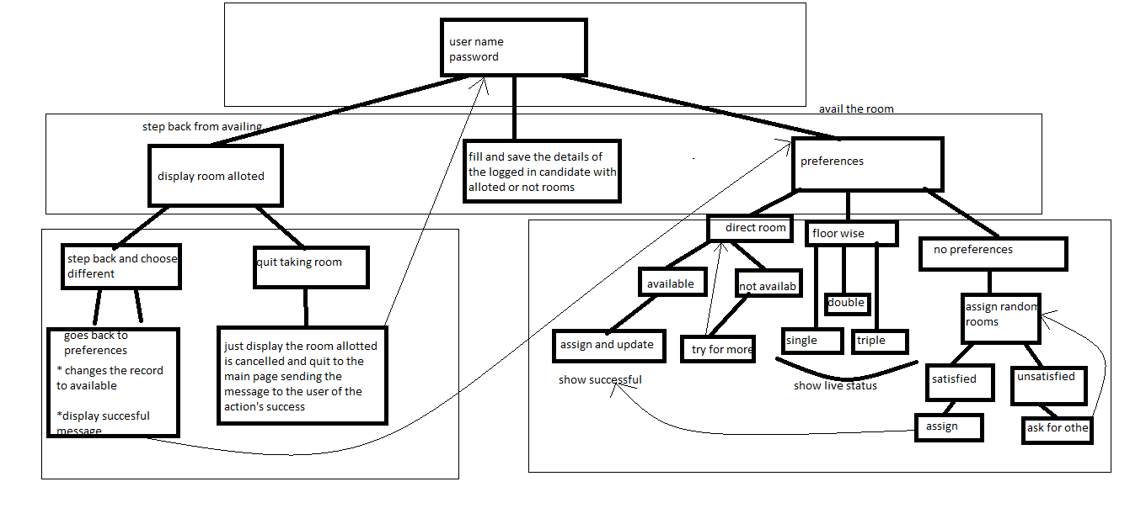*

On the first page of our website, we are going to let the user enter the password and username of the candidate. The second page lets you avail the facility to avail or unavailing the room and also to fill the necessary details. In the third stage.. if one has opted for the unavailing of the room they would be given corresponding options. They would be given chance to fix their preferences, floor wise or directly avail the room or give them random rooms as displayed by our case diagram above.

**Team Members details:**

|  |  |  |  |  |
| --- | --- | --- | --- | --- |
| **Role** | **Name** | **USN** | **Email id** | **Phone no.** |
| Team Leader | Kumar shubham | 1SI16IS026 | [Just.chill.sit@gmail.com](mailto:Just.chill.sit@gmail.com) | 7545962949 |
| Team Member 1 | Annapoorneshwari k. | 1SI16TE003 | [anukrishnakanth98@gmail.com](mailto:anukrishnakanth98@gmail.com) | 7259207629 |
| Team Member 2 | Udhav mohata | 1SI16TE045 | [udhavmohata1@gmail.com](mailto:udhavmohata1@gmail.com) | 9543132564 |