**inSight 2017**

**Department : Common to all departments**

**Problem Title : Notification generator.**

**Problem Code : PS03**

**Problem Description :**

The most important part of the student life is information. There are many information that the students don’t get to know about, it may be regarding the competitions, seminars or general notices from the department or any kind of circular and many more. An android application needs to be developed which would send notifications to all the registered students that the admin intends to send. **The admin must have a facility of creating a circular or notice by just sending an email to the application also, apart from him creating a notification on his version of the app.**

The application should also keep track of the people who have read the information that was sent. (something like blue ticks thing in whatsapp).

**Proposed solution:**

*(In this section, tell us how you are going to solve this problem, in about 400 words)*

***Overview:-*** *We will be making an android app which uses the firebase service from Google to manage our notification sending and receiving . We will also be adding the option to send notifications through a Web application (using javascript).*

*We will include the following features .*

***Features :-***

* *Sending notifications through Mobile app and Web app and also through email.*
* *To register new users , we shall take their detiails before they can use the notification service , so that we won’t have any spam or such.*
* *The details would include Name ,branch , USN , email , phone etc.*
* *We have thought of giving 2 types of permission for users :-*
  + *Admin ( can be a teacher , senior or HOD )*
  + *Non Admin user*
* *When ever normal users send notifications , the app will send a notification only if the admin approves it for notification from the app , otherwise the details of the requested notification will be accessible from the app and won’t disturb users by notifying everytime.*
* *The user has to either send a mail to one of the admins or if time permits , we shall add the option to request admin directly from the app to approve any notification to be sent globally.*
* *The Admin can directly send notifications using either of our android or web app.*
* *The app will also keep track of all the students who have viewed the notifications.*

***Stretch goals (Will be implemented ONLY if time permits after implementing the core features ):-***

* *The admin can create groups along with certain number of users he picked . The notifications can be sent to particular groups if he wishes or send to all.*
* *We will give an option to add event section where in upcoming events will be listed until the specified date will be over after which that event will be auto removed from app.*
* *Sending notifications only to particular students of Perticular Year.*
* *Adding a discussion section to query about the event or notification (like a chat feature).*

**Technology Stack :**

*(In this section, tell us what technologies you are going to use and how)*

*To make the android app , we shall use Android Studio.*

*Javascript , HTML , CSS and (either python or JS on server side to keep checking mails) to make our Web app .*

*Firebase (database server for our notification storage)*

**Use Case:**

*(In this section, provide the use case scenario i.e. how your software is going to work. In this section you should include use case diagrams as well. If you don’t know what a use case diagram is google it. This would also include the work flow of your software.)*

*As mentioned in the above section , the use case is pretty obvious . Users can post notifications in their app to send to all users and request the admin to approve those notifications to avoid unnecessary disturbance to app users. When the College wants to issue any time table or some info to students , the app can be useful and can be used either through app or web app. Workflow is as follows.*

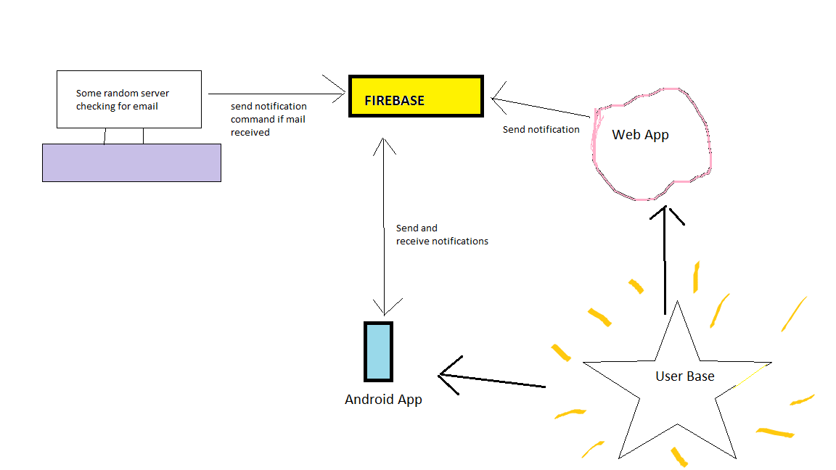

*App stores the data to be notified in the firebase database and when admin approves it , firebase will send the notifications to app users , we can control the same thing using the Web app too . The rest of the uses are reflected in the above written features section itself.*

**Team Members details:**

|  |  |  |  |  |
| --- | --- | --- | --- | --- |
| **Role** | **Name** | **USN** | **Email id** | **Phone no.** |
| Team Leader | Gangadhara Shetty P J | 1SI16CSO43 | gangadharashetty.gs@gmail.com | 9916548851 |
| Team Member 1 | Natesh M Bhat | 1SI16CS066 | nateshmbhat1@gmail.com | 9481575049 |
| Team Member 2 | Anshul Anand |  | [anshulanand1250@gmail.com](mailto:anshulanand1250@gmail.com) | 9459004119 |