**inSight 2017**

**Department : Computer Science department**

**Problem Title : Automated schedule tracker**

**Problem Code : PS05**

**Problem Description :**

The students meet the faculties every now and then and there is a high probability that they have to wait for the faculty since he/she is not free at that particular time. In order to avoid this application should be built in such a way that all the faculties or the people in the office (admin/main office) update their schedule. The calendar will be designed in such a way that it will reflect the timings when faculties are available and hence avoid the waiting time. Depending on the faculties free slot, the students may request a meeting. The meeting should be scheduled only if the faculty confirms .This application will be useful any official (including the principal) in the department. This should keep both student and faculties informed about all the schedules that they need.

**Proposed solution:**

This is a common problem faced by the students.

We can develop a **web application** to overcome this problem.

The basic functionality of the app is to take an input from the user (faculty or the people in administration department or Principal).The input should specify at what time they are free. This input that is the time at which they are available to the students who go in search for them is stored in an online database.

When a student or a person who wishes to meet the person pertaining to the department, he or she may know the timings at which they are available on that day by visiting the **web application** which is directly connected to the database.

Here the students can only view the time at which they are free, but can’t modify any information.

On the other hand the faculty members can access their accounts. This can be enabled by imposing the restriction on the user who logs in. The faculty members have to update the information regularly so that they can manage the timings at which they arrange meetings with the students.

The teachers contact number will also be published on the website along with the timings.

So that the student can copy the number and paste it at dialogue box where the sender number has to be specified in a messenger application in their mobile phone.

**Technology Stack :**

1. HTML -basic webpage framework.
2. CSS -web page sheet styling.
3. MYSQL -to get data in to database.
4. PHP -database management.
5. XAMP -local host server for demonstration.
6. JSP -java script page for dynamic interaction.

**Use Case:**

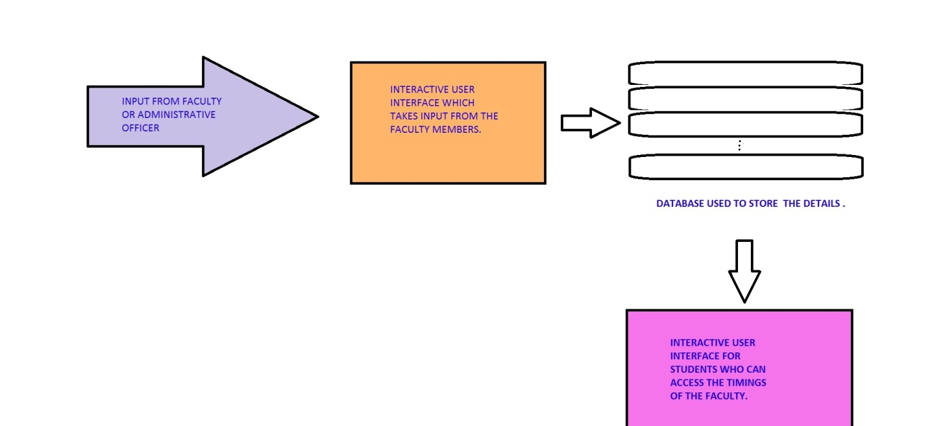

**Team Members details:**

|  |  |  |  |  |
| --- | --- | --- | --- | --- |
| **Role** | **Name** | **USN** | **Email id** | **Phone no.** |
| Team Leader | SUMANTH.M | 1SI16CS115 | [Sumanthmurali48@gmail.com](mailto:Sumanthmurali48@gmail.com) | 9035386608 |
| Team Member 1 | SIDDESH M G | 1SI16CS104 | [vinay22422@gmail.com](mailto:vinay22422@gmail.com) | 8095070167 |
| Team Member 2 | SURESH PADMAPPA NARAGUND | 17SIT0888 | [Snaragund6@gmail.com](mailto:Snaragund6@gmail.com) | 8892909590 |