**inSight 2017**

**Department : Department of Training and placements**

**Problem Title : Dynamic form for feedback.**

**Problem Code : PS07**

**Problem Description :**

Many Training programs like soft skills, aptitude, company specific trainings are given by the placement departments. In order to improve the quality of these training programs feedback plays a key role. An application should be developed in order to automize the feedback process. The application should provide option to generate a dynamic form which would help take the feedback specific to the training and should also be able to generate a report whenever required.

**Proposed solution:**

We will create a dynamic formatted **web application** for this.

* The server will be running on XAMPP, which is a free open source software for all platform (for our demonstration purpose).
* Web application will display the feedback and ratings form in highly formatted with dynamic contents (using CSS and JS respectively).
* Java server page **JSP** will be running.
* It’ll ask the user to enter the details and feedback.
* With aid of **PHP**/**JS** in server computer (computer in which XAMPP is running), The feedback(data) obtained by user could be stored to data base using **SQL** in backend.
* The system admin (HOD) can login using his credentials:-

1. He can create a **new dynamic** form in the same webpage by giving respective entries.
2. He can see **report** of the submitted forms, which will be displayed in tabular form.
3. The summarised report will be displayed in graphical (pie, bar graphs or charts) form using java script.

. **Technology Stack :**

1. HTML - for rendering web app to client.
2. JS (java script) - dynamic design of web app.
3. PHP - server side database handling.
4. SQL - accessing data from database.
5. CSS- web font, structure, tabular design.
6. XAMPP – server side (to run local host server and database maintenance for demonstration).
7. Java server page - (JAVA server for demonstration).

**Use Case:**

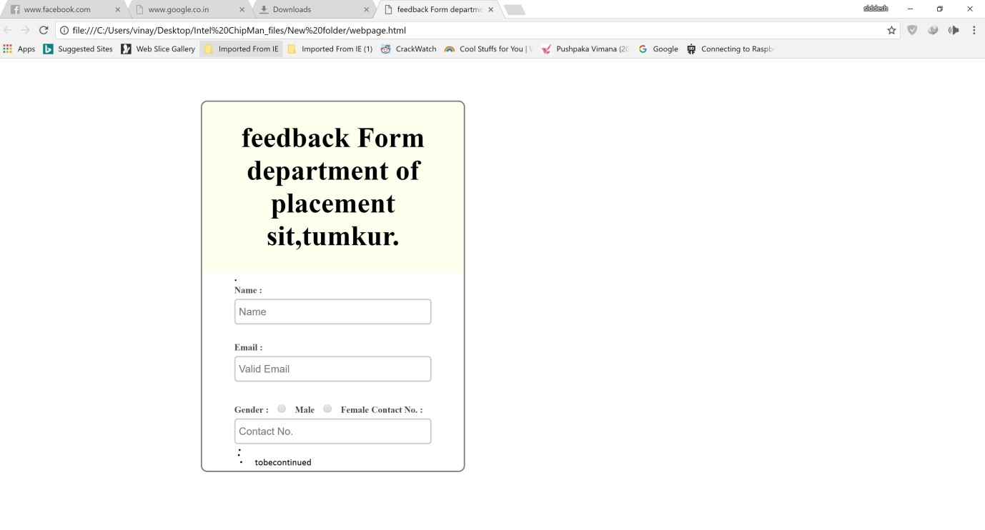

Theabove image is just a illustration.

**Team Members details:**

|  |  |  |  |  |
| --- | --- | --- | --- | --- |
| **Role** | **Name** | **USN** | **Email id** | **Phone no.** |
| Team Leader | SIDDESH M G | 1SI16CS104 | [Vinay22422@gmail.com](mailto:Vinay22422@gmail.com) | 8095070167 |
| Team Member 1 | SUMATNH M | 1SI16CS115 | [Sumanthmurali48@gmail.com](mailto:Sumanthmurali48@gmail.com) | 9035386608 |
| Team Member 2 | SURESH PADMAPPA NARAGUND | 17SIT0888 | [Snaragund6@gmail.com](mailto:Snaragund6@gmail.com) | 8892909590 |