**inSight 2017**

**Department : Hostel Office**

**Problem Title : Hostel room allocation**

**Problem Code : PS02**

**Problem Description :**

With the large number of hostel applications received every year, the allocation of rooms to each applicant is a very tedious task. A software solution which would enable the hostel department with the allocation of rooms which would also make it easy for the students (they don’t have to stand in long queues anymore for allocation) would benefit both the management and the students. The priority number concept must be followed. Priority number is given on the basis of first come first serve basis on the mode of payment.

This system must be able to generate report of occupants of each hostel and the rooms which are unallocated after allocation.

**Proposed solution:**

We have got 6 hostels in our university, which consist of four boy’s hostel and two girl’s hostel .All these hostels at present are managed manually by the hostel office. The Registration form verification to the different data processing are done manually.

Thus there are a lot of repetitions which can be easily avoided. And hence there is a lot of strain on the person who are running the hostel and software’s are not usually used in this context. This particular project deals with the problems on managing a hostel and avoids the problems which occur when carried manually. Identification of the drawbacks of the existing system leads to the designing of computerized system that will be compatible to the existing system with the system which is more user friendly and more GUI oriented. We can improve the efficiency of the system, thus overcome the drawbacks of the existing system.

**User Panel**

**User Login**

**Home**

1. This consist of the different pop-up menus showing the details of the different hostels.

2. It contains a link to the CUSAT official web-site.

3. It allows the different users to access the registration forms.

4. He can view the Student administration division of the different hostels and also view the notice boards.

**Registration Form**

This section provides an online form to the students which can be filled by them, and a copy of the filled page can be taken in the printed form. This is later submitted to the Hostel authorities which can be verified by them before allotting them to the respective hostels.

**Notice Board**

All the 6 hostels have their Notice boards. Any change in the Hostel fee, mess fee will be shown in this. It can be also used for different notifications.

**Admin Panel**

**Administrator Login**

**Home**

The Administrator can :

1. Allot different students to the different hostels.

2. Vacate the students for the hostels.

3. Control the status of the fee payment.

4. Edit the details of the students & modify the student records.

**Allotment of the hostels**

Their will be pre-defined criteria for the admission to the hostels. He checks the attested application forms of the students obtained from the internet and verify it with the student database. If the students are found eligible then they are allotted to the hostel.

**Vacating the rooms**

As the student’s course is over they will vacate their rooms. So it is required for the administrator to remove their records from the database tables. This section includes the option for the room vacation and the deletion of the particular record from the database.

**Technology Stack :**

**PHP** : For producing dynamic web pages

**HTML**: Creating web page

**CSS:** Overlapping styles

**MYSQL:** To store data in database

**Use Case:**

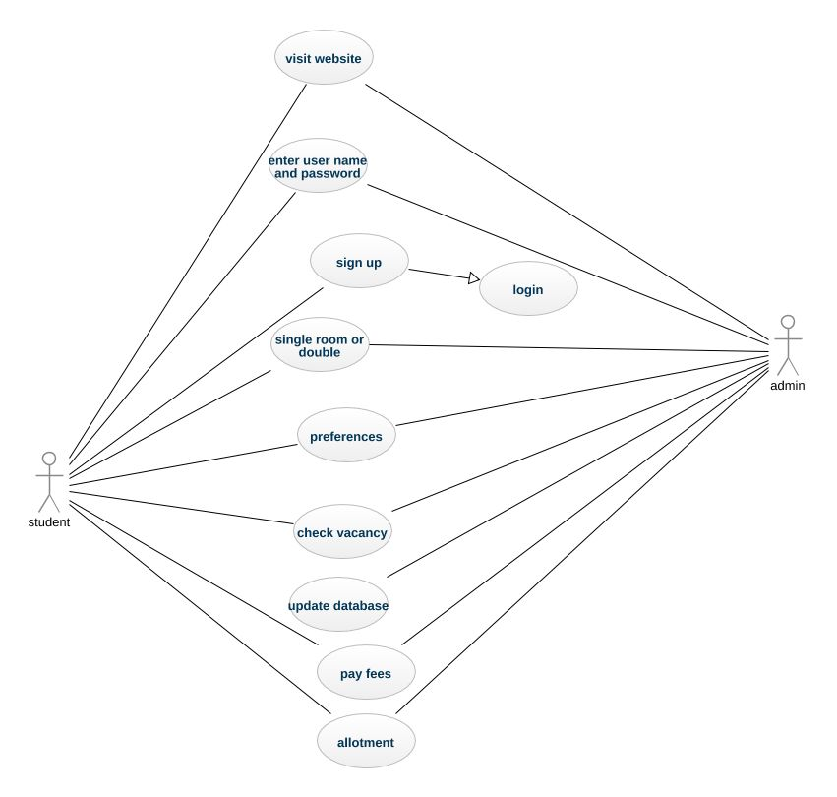

**Team Members details:**

|  |  |  |  |  |
| --- | --- | --- | --- | --- |
| **Role** | **Name** | **USN** | **Email id** | **Phone no.** |
| Team Leader | Shruthi K V | 1SI15CS108 | shruthikvr@gmail.com | 9164448455 |
| Team Member 1 | Pooja R | 1SI15CS074 | poojaraj1797@gmail.com | 9562106422 |
| Team Member 2 | Anushree K P | 1SI15CS142 | anuanshu2105@gmail.com | 7406592474 |