**inSight 2017**

**Department : Hostel Office**

**Problem Title : Digital hostel residents’ record and complaint management**

**Problem Code : PS01**

**Problem Description :**

Every year there are large numbers of students opting to reside in the hostels. It is a very difficult task to maintain and search manual records for the details of these students. If such software solutions can be developed enabling the hostel department with the features mentioned below, it would reduce severe amount of man power and time.

Features the system should include:

* Provisions to add and modify details of the students (including personal details, academic details, room number, hostel block etc.)
* Provisions of searching of records based on any of the fields as mentioned above.
* Registering of complaint by the students. They should also be able to track their complaint status.

**Any more innovative features are welcome and would attract additional points**.

Note: The solutions can include webapps, stand-alone windows systems, android apps etc.

**Proposed solution:**

We will make use of Android to solve this problem. We will use the database of android, in order to store the records of the students residing in the hostel. The application will contain two sections, first, the admin section, Second, the student section. When the admin will use the application, they can see all the records stored and we will provide three buttons, add, search and update. By clicking on Add button, a new form will come and the admin has to fill the respective fields to add a new record. By clicking on Search button, an option will come, select the field to search. Then, it will display all the records, regarding the field data. By clicking on the Update button, the respective record will be displayed and an Edit button will be there, by clicking on the button, the admin can change the record. While updating, another two buttons will be there, Submit and Reset. The Submit button will save the changes. The Reset button will undo all the changes done. We will also add a Complaint section in Admin Section, where the admin can check all the complaints being registered by different students along with the hostel in which they reside and their respective room no. , then the section will contain a button, Take Action. By clicking on that, all the name and phone no. of all the managers of respective hostel will be displayed. By clicking on the name of the manager of the respective hostel, the complaint will be sent as a message to the phone number of the manager from the admin phone. Then, the manager can take the action.

Now, the student section will contain two buttons, Display and Complaint. By clicking on the Display button, their USN will be asked for and then after giving their USN, their respective record will be displayed. By clicking on Complaints, two buttons will come, Register your Complaint and Track your Complaint. By clicking on register complaint, three fields will come up asking for complaint to be registered, their name and Hostel. By clicking on Track your Complaint, Their complaint will be displayed and two checkboxes will be there. First, seen by Chief Warden/Warden, it will be checked if the Admin has opened the complained. Second, forwarded to Manager, it will be checked if the Admin will send the complaint to the respective manager.

**Technology Stack :**

* **ANDROID**
* **FIREBASE**

**Use Case:**

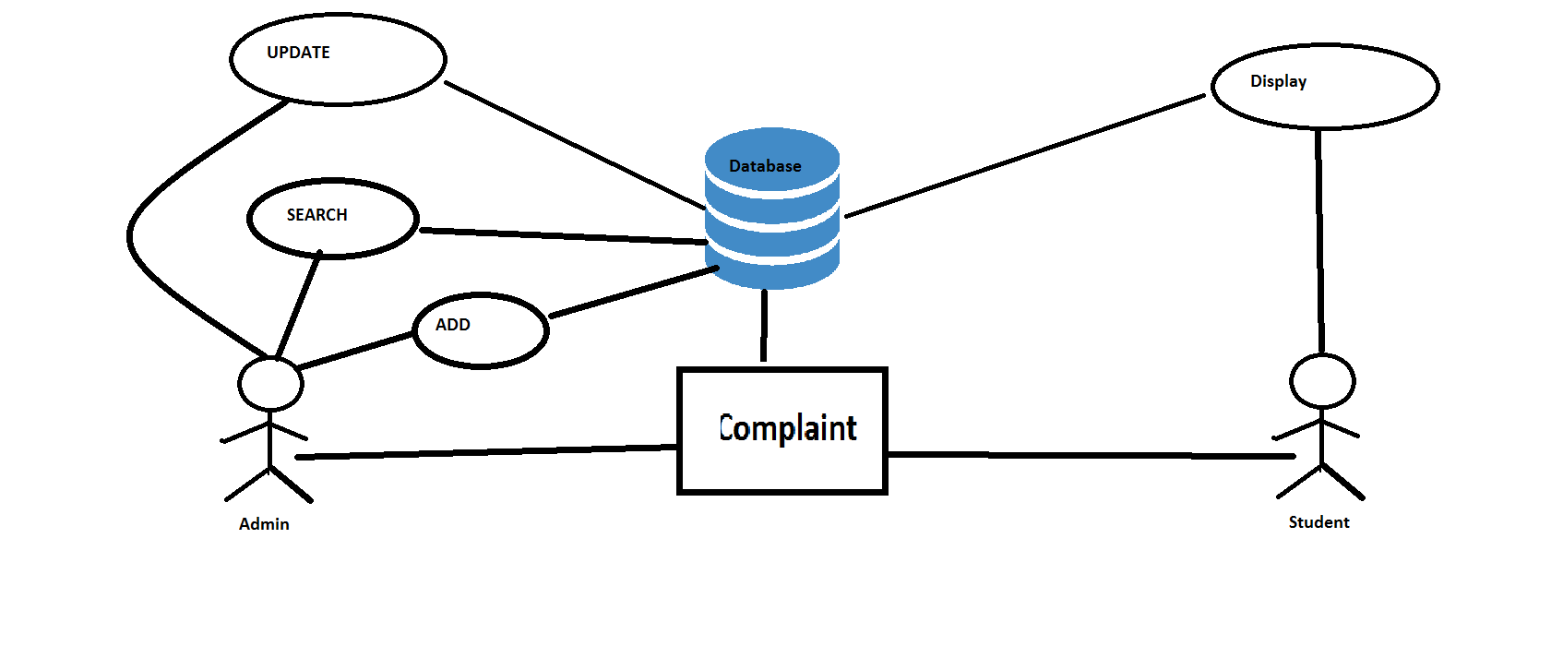

**Team Members details:**

|  |  |  |  |  |
| --- | --- | --- | --- | --- |
| **Role** | **Name** | **USN** | **Email id** | **Phone no.** |
| Team Leader | Sanchay | 1si15cs093 | [sanchay.verma479@gmail.com](mailto:sanchay.verma479@gmail.com) | 8147302779 |
| Team Member 1 | Sankalp Saurabh | 1si15cs096 | [iamsankalpsaurabh@gmail.com](mailto:iamsankalpsaurabh@gmail.com) | 9206397461 |
| Team Member 2 | Shubham K Thakur | 1si15cs111 | [Shubhamt426@gmail.com](mailto:Shubhamt426@gmail.com) | 9535025273 |