**inSight 2017**

**Department : Department of Training and placements**

**Problem Title : Dynamic form for feedback.**

**Problem Code : PS07**

**Problem Description :**

Many Training programs like soft skills, aptitude, company specific trainings are given by the placement departments. In order to improve the quality of these training programs feedback plays a key role. An application should be developed in order to automize the feedback process. The application should provide option to generate a dynamic form which would help take the feedback specific to the training and should also be able to generate a report whenever required.

**Proposed solution:**

Giving the feedback regarding programs(soft-skills, aptitude etc.) organized by the placement department is through by direct interaction with the students or in the form of written statements manually. Hence estimating the performance of trainers and giving counseling to trainers. So, the existing system carries more time to do a piece of work . For this reason the online feedback system is implemented. This is the major advantage of the existing system for giving feedback about the trainers and viewing report of trainers.

Here we aimed to design online web application for issuing the feedback about the Trainers by students, this is named as feedback system. This Online Feedback System is to provide feedback in a easy and quick manner to the Trainers . So we call it as online Feedback System which delivers via the student staff interface as online system which acting as a Service Provider . By using this technology we can make fast feedback about the staff/trainers by students on time to placement department as they referred in online system. This project has four kinds of users Student, Trainer Staff, and Admin. The student can give feedback in online system provided by college staff. Students can give feedback about the trainers/lecturers. These feedback reports were checked by Placement department administrator. He can view overall grades and view the grades obtained to the trainers and give this report to the principal and he can give counseling to the trainers compared to the manual system, online system is very simple to use and also understandable.

Here admin should login to the portal and he should add all details about particular faculty about whom he has to access the feedback. Admin should add the students into the portal by whom he should access feedback. Users/students should register/log in with the user id and password. After successful login students should opt the choices for various questions. Admin(placement officer) will login into the portal and examine the overall percentage/result for particular question of each faculty member/trainer. Admin displays the overall feedback result in the portal.

**Technology Stack :**

**Technical Requirements**

The following software requirements are needed for implementations of our project.

**Software Requirements**

* Platform: Netbeans IDE.
* Web container : Apache Tomcat
* Programming Language(Java): JDK 1.6 and above , JSP Servlets.
* Operating System: Windows xp and above
* Database : MySQL Database Server , JDBC
* Browsers : Google Chrome, Mozilla Firefox etc.

**System Requirements**

* RAM 2 GB
* HDD 160 GB
* Intel®x64 / amd 64-bit above 2.66 GHz

**Language Requirements**

* Java – HTML , JSP(Java Server Page) and CSS(Cascaded Style Set).
* SQL(Structured Query Language).

**Platforms**

* Windows XP and above versions.

**Resource Requirements**

Computer with compatible operating system, power supply (100V outlet).

**Technologies Implementation:**



SERVER

Request

WEB APPLICATION

JSP HTML

WEB Container

DATABASE

Fig 4.3: Architectural Diagram

**Explaination:**

From above Fig 4.3 architecture diagram we can know how web application process will take place. Here client send request to server through web server by operating in web browser . Server which contains web application has JSP and HTML has frameworks accesses the database through web container as Apache Tomcat and gives the response to the web browser.

Here client opens the web browser like for example Mozilla Firefox or Google chrome etc. Then client enters the proper URL (Domain Name)into the browser . Browser in turn sends request to the Server through the Web server to get access for required web application to the client . Server which has web-application built by using JSP and HTML pages accesses the database (Here we have used MySQL as database server) through web container Apache Tomcat. In our project we used JDBC (Java Database Connectivity) to link the web application to the database. Database stores all of the information which is given by the admin or students. For example Admin’s username and password, student’s USN, Name, Password and many more details. Hence Server takes all of these information and responses to the Client through web browser.

**Use Case Diagram :**

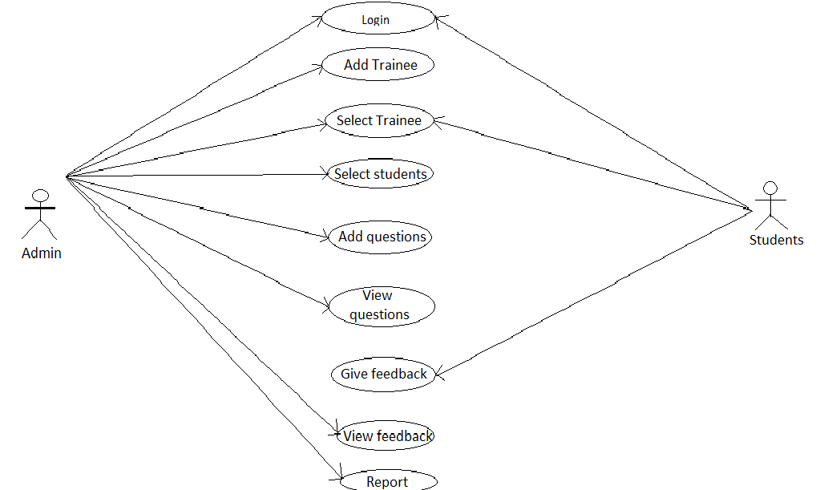

**Process Flow Design:**

Login

Student Login

Admin Login

Add Trainee

Select Trainee

Select Students

Add Questions

View Questions

View Feedback

Select trainee

Give Feedback

**Team Members details:**

|  |  |  |  |  |
| --- | --- | --- | --- | --- |
| **Role** | **Name** | **USN** | **Email id** | **Phone no.** |
| Team Leader | Rakshith .V. S | 1SI13IS041 | vsrakshith@gmail.com | 9738737252 |
| Team Member 1 | Shiv Kumar Suman | 1SI14IS042 | shivksuman95.10@gmail.com | 9019761400 |
| Team Member 2 | M.Ravikrishna | 1SI13IS031 | ravikrishna2809@gmail.com | 8553577158 |