**inSight 2017**

**Department : Department of Training and placements**

**Problem Title : Dynamic form for feedback.**

**Problem Code : PS07**

**Problem Description :**

Many Training programs like soft skills, aptitude, company specific trainings are given by the placement departments. In order to improve the quality of these training programs feedback plays a key role. An application should be developed in order to automize the feedback process. The application should provide option to generate a dynamic form which would help take the feedback specific to the training and should also be able to generate a report whenever required.

**Proposed solution:**

We will make use of Android to solve this problem. We will use the database of android, to store the feedback provided by the students. The application will contain two section, Admin and Student. In Student Section, when the student will open the application, he/she will be asked for LOG-IN or REGISTER. A new student will opt for REGISTER. Then, on clicking REGISTER, the student will be asked for name, usn, email-id and password. After filling all the fields, the student will click on SUBMIT button to save their entries or they want to make some changes, RESET button will be there. If a student will already have a user-id, they will opt for LOG-IN. By clicking on LOG-IN, they will be asked for their usn and password. There will also be a button FORGOT PASSWORD. Supposedly, if a student forgets password, they can get it back or set a new one from the link sent to them on their email-id.Now, after successfully logging in, the different training programs will be displayed. By selecting the training program they have attended, a feedback form will come up. Then, the student will have to fill up the respective feedback form fields. After filling up the form, they can save their entries by clicking on the save button.

Now, as soon as, the feedback form is saved for a particular training program. The feedback will be saved in the database. In the Admin section, they will also be provided with a username and password. When they login, since there will be different admin for different training programs, they can see all the feedback being submitted. We will use machine learning concepts to generate an efficient outcome, being produced to everyone as a report.

**Technology Stack :**

* **ANDROID**
* **FIREBASE**

**Use Case:**

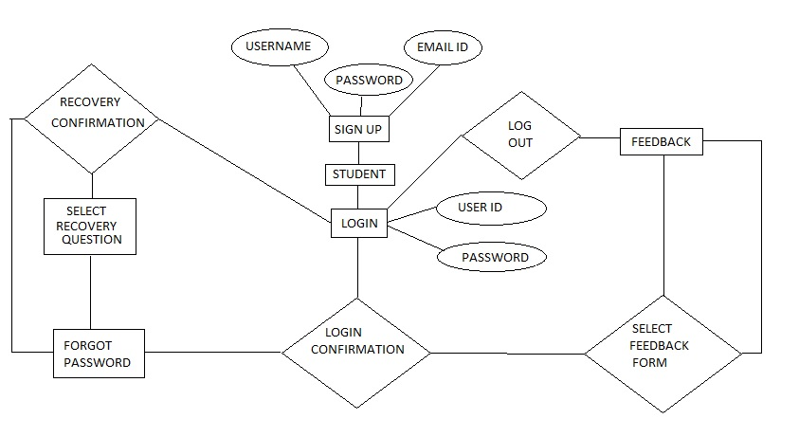

**Team Members details:**

|  |  |  |  |  |
| --- | --- | --- | --- | --- |
| **Role** | **Name** | **USN** | **Email id** | **Phone no.** |
| Team Leader | Sanchay | 1si15cs093 | [Sanchay.verma479@gmail.com](mailto:Sanchay.verma479@gmail.com) | 8147302779 |
| Team Member 1 | Sankalp Saurabh | 1si15cs096 | [iamsankalpsaurabh@gmail.com](mailto:iamsankalpsaurabh@gmail.com) | 9206397461 |
| Team Member 2 | Shubham K Thakur | 1si15cs111 | [Shubhamt426@gmail.com](mailto:Shubhamt426@gmail.com) | 9535025273 |