**inSight 2017**

**Department : Hostel Office**

**Problem Title : Digital hostel residents’ record and complaint management**

**Problem Code : PS01**

**Problem Description :**

Every year there are large numbers of students opting to reside in the hostels. It is a very difficult task to maintain and search manual records for the details of these students. If such software solutions can be developed enabling the hostel department with the features mentioned below, it would reduce severe amount of man power and time.

Features the system should include:

* Provisions to add and modify details of the students (including personal details, academic details, room number, hostel block etc.)
* Provisions of searching of records based on any of the fields as mentioned above.
* Registering of complaint by the students. They should also be able to track their complaint status.

**Any more innovative features are welcome and would attract additional points**.

Note: The solutions can include webapps, stand-alone windows systems, android apps etc.

**Proposed solution:**

The solution is to be simulated on an Android device where the hostel manager can add a student, modify his/ her records, delete his/ her details and view the complaints registered by them and act accordingly, if not addressed to.

The problem is approached on a mobile platform since it is vastly used. Students can lodge a complaint on the go even in cases where the hostel Wifi fails.

The Admin can, as well, view the students’ details whenever necessary. Each hostel block will have the admin read permission, in case they suspect non-boarder and likewise. The Admin can thus meet the needs of the students and maintain the security.

**Technology Stack :**

1. Android Studio
2. XAMPP/ Firebase for database

**Use Case:**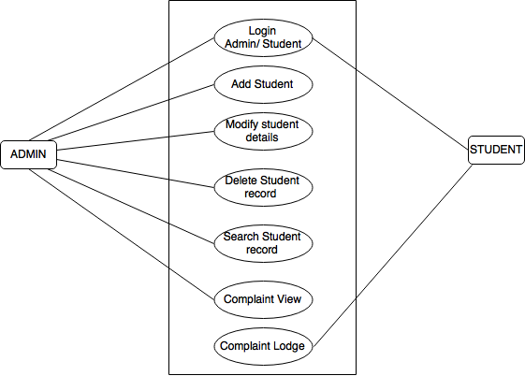

The use case diagram is specified below.

**Team Members details:**

|  |  |  |  |  |
| --- | --- | --- | --- | --- |
| **Role** | **Name** | **USN** | **Email id** | **Phone no.** |
| Team Leader | Rishav Prabhraj | 1SI13CS098 | [rishavforu0123@gmail.com](mailto:rishavforu0123@gmail.com) | 7406224515 |
| Team Member 1 | Pramod Kumar | 1SI14CS086 | [pramodjee1996@gmail.com](mailto:pramodjee1996@gmail.com) | 7899988270 |
| Team Member 2 | Pathikrit Pal | 1SI14SC081 | [pathikrit.pal95@gmail.com](mailto:pathikrit.pal95@gmail.com) | 9836385610 |