**inSight 2017**

**Department : Computer Science department**

**Problem Title : Attendance validation**

**Problem Code : PS04**

**Problem Description :**

There are certain situations like placements for the 4th year students; various technical events cultural events, etc. where in students have to participate. These students tend to miss their classes. Since there is an eighty five per cent (85%) attendance constraint in SIT, the students taking leave from classes for genuine reasons must get attendance for them.

An application which would enable the students to raise request for the attendance to the HOD with provision for the HOD to validate the genuinity of the request and then grant the attendance.

The faculty handling the subject should come to know that the request has been approved and give attendance to the student, i.e. the app should involve student, faculty and the HOD as the end users.

**Proposed solution:**

*A web application which would contain various user interactive pages which would easily guide the user to its solution. There would be different login pages for students , teachers and HOD. The students after logging in can check their attendance of every registered subject and can put up their requests for shortage of attendance if any. The students can also upload their applications in the form pdfs or images which can include certificate of participation , medical certificates etc.*

*The HOD would get requests of all students in the form of text and can also download the documents of students to check the genuinity of request made by students and can grant the attendance via the help of checkboxes present in front of every students request.*

*The Teachers on the other hand can can update students attendance and can inform particular students having shortage of attendance.*

**Technology Stack :**

*Html*

*Css*

*Javascript*

*PHP*

*Local Wamp server*

**Use Case:**

**Team Members details:**

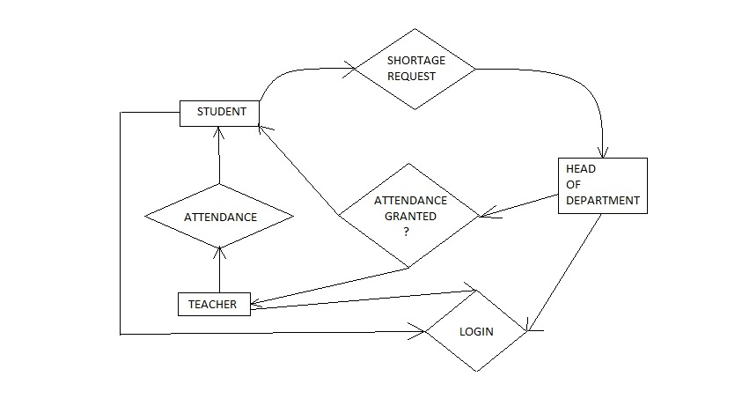

|  |  |  |  |  |
| --- | --- | --- | --- | --- |
| **Role** | **Name** | **USN** | **Email id** | **Phone no.** |
| Team Leader | Sanchay | 1si15cs093 | [Sanchay.verma479@gmail.com](mailto:Sanchay.verma479@gmail.com) | 8147302779 |
| Team Member 1 | Shubham K Thakur | 1si15cs111 | [Shubhamt426@gmail.com](mailto:Shubhamt426@gmail.com) | 9535025273 |
| Team Member 2 | Sankalp Saurabh | 1si15cs098 | [iamsankalpsaurabh@gmail.com](mailto:iamsankalpsaurabh@gmail.com) | 9206397461 |