**inSight 2017**

**Department : Common to all departments**

**Problem Title : Notification generator.**

**Problem Code : PS03**

**Problem Description :**

The most important part of the student life is information. There are many information that the students don’t get to know about, it may be regarding the competitions, seminars or general notices from the department or any kind of circular and many more. An android application needs to be developed which would send notifications to all the registered students that the admin intends to send. The admin must have a facility of creating a circular or notice by just sending an email to the application also, apart from him creating a notification on his version of the app.

The application should also keep track of the people who have read the information that was sent. (something like blue ticks thing in whatsapp).

**Proposed solution:**

The present system have defects,to overcome these defects we proposed a new system.In the proposed system the admin must have a facility of creating a circular or notice by just sending an email to the application also, apart from him creating a notification on his version of the app.

First the admin create an account with the username and password.Then he generate a notifications then he retrive a student information from database and send it through mail and text to thier mail id’s and contact numbers.And he keep track of read information that was sent

**Technology Stack :**

Software requirments:Android studio,sql database,win 10

Hardware requirments:i3 processor,4 GB Ram

**Use Case:**

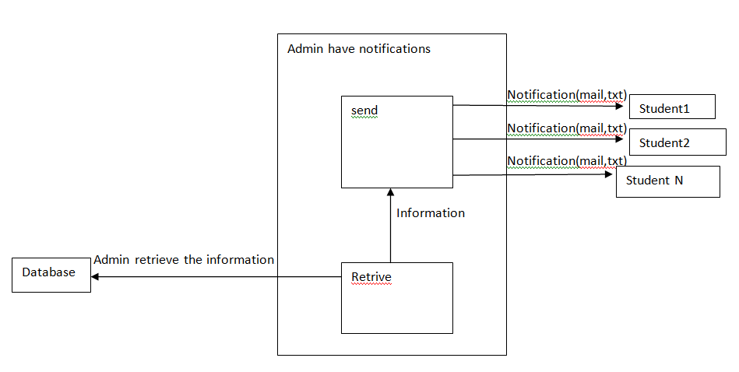

**Use case scenario:**

* Admin create an account
* Generate notification
* Admin retrieve the information from the database
* Send the notification through mail and text to all students
* Keep tack of read information that was sent

**Team Members details:**

|  |  |  |  |  |
| --- | --- | --- | --- | --- |
| **Role** | **Name** | **USN** | **Email id** | **Phone no.** |
| Team Leader | Pavan Kumar M | 1SI15CS072 | pavankumar77777@gmail.com | 9535830395 |
| Team Member 1 | Rachana S | 1SI15CS083 | rachhurachan797@gmail.com | 9036370942 |
| Team Member 2 | Niveditha M | 1SI16CS416 | nidhim739@gmail.com | 9743174051 |