**inSight 2017**

**Department : Department of Library**

**Problem Title : Library management application**

**Problem Code : PS08**

**Problem Description :**

Library management application is an android application which aims in developing a computerized system to maintain all the daily work of library with a user friendly interface. This project has many features which are generally not available in normal library management systems like facility of user login and teachers login .It also has a facility of admin (librarian) login through which the admin can monitor the whole system .It also has facility of an online notice board where teachers and student can put up information about workshops or seminars being held in our colleges or nearby colleges.

Main features:

* It must contain journals, notes, e-books and previous years question papers that are present in OPAC.
* It must push a notification to the students at the time of book issue.
* It must send alert notification to the student about book submission and overdues.
* Students and teachers must see the books that are issued to them.
* Librarian i.e. admin of this application must search the students and books (book bank as well as normal book) issued to particular students with their issue date.

**Proposed solution:**

*This android application aims in searching of books through the Application. This application will have the facility of a student login and a teacher login. The admin of the application will be the librarian. It will have a facility where the student can check the availability of books in the library. The student's details like books issued, due date and return date will be kept track of and also viewed to the respective student. Similarily the teacher can also check the availability of books in the library. There will be a panel for notices where the student and the teacher can update any information on any seminar or other activities that will be occuring in the college. All these details will be viewed to the student/teacher after they login. We will be calculating fine for students if their return date will exceed the due date. The students and the teachers will also have the facility to view various question papers and notes are are present in an e-book format for free. The admin that is, the librarian will have the access to view all the details that the student and the teacher have been shown. He/She will also have the entire list of books that are present in the library.*

**Technology Stack :**

*We will firstly use AndroidStudio which is the IDE(Integrated Development Environment) for android. AndroidStudiio requires an SDK which is a set of software development tools that allows the creation of applications for the software package, software framework, hardware platform, computer system, video game console, operating system, or similar development platform.*

*Along with AndroidStudio, we will be using SQLite to create various databases like login details, the book details that are stored in the library, the student/teacher book issue details. We will also create a database to store various question papers and notes that is available for free to the teachers and students. We will use SQLite queries not only to create databases but to also update them once the books are returned.*

*Further we will be using xml to save configuration settings of the android application. We will also use xml to describe the layout of interface elements for the activities in the android application.*

*We will also be using flask. Flask is a micro-framework for python that is being used for server backend.*

**Use Case:**

*There will be three users accessing the system- Student, Faculty, Admin. Student will login into the system with id and password and have access to available books. They can also search or request for new books and access test papers and e-books. Notifications about the return dates will be given to the students and on the basis of return date and due date, the fine will be calculated. Faculties will also have access to available books and to search and request for new books. Notifications will be given to the faculties as well but no fine will be calculated for them. Admin will control the access of both the students and faculty. He can also update the available books and add new e-books and question papers. He will be the one to collect the fine from the students.*

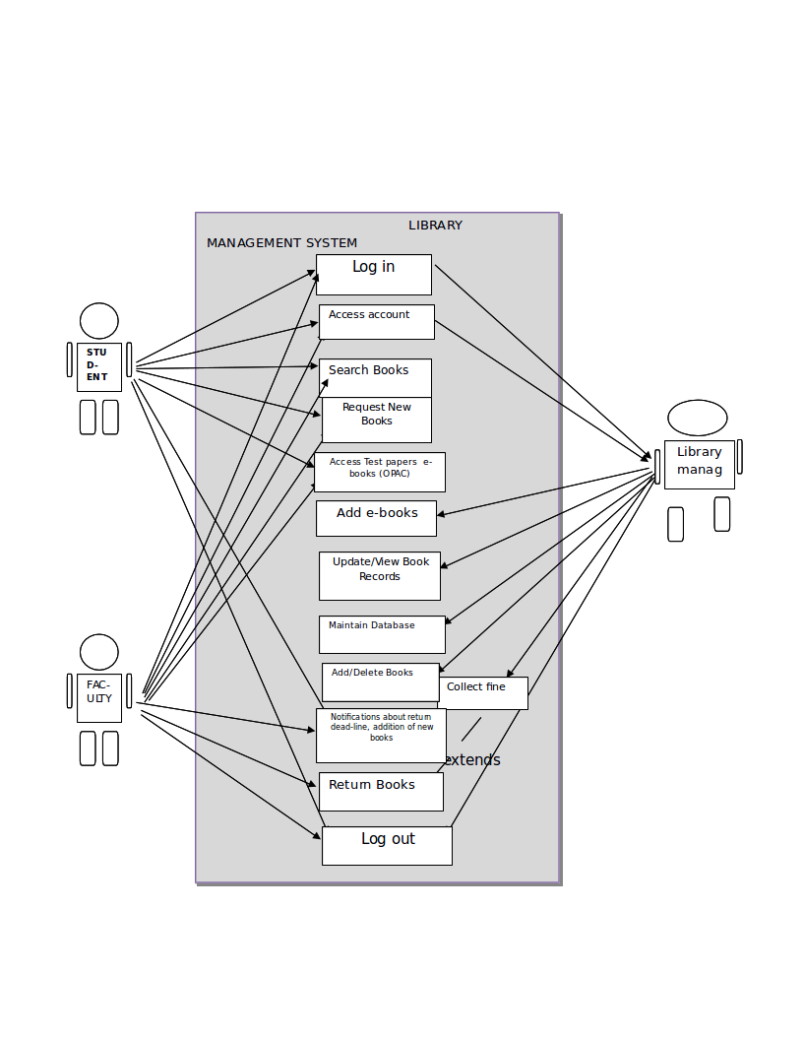

**Team Members details:**

|  |  |  |  |  |
| --- | --- | --- | --- | --- |
| **Role** | **Name** | **USN** | **Email id** | **Phone no.** |
| Team Leader | Aakansha Singh | 1SI15CS145 | aakansha.singh13@gmail.com | 9901594430 |
| Team Member 1 | Akanksha | 1SI15CS138 | akanksha.singh95@gmail.com | 9206400248 |
| Team Member 2 | Divyanshu Anand | 1SI15CS036 | divyanshuanand1998@gmail.com | 9066084907 |