**inSight 2017**

**Department : Hostel Office**

**Problem Title : Digital hostel residents’ record and complaint management**

**Problem Code : PS01**

**Problem Description :**

Every year there are large numbers of students opting to reside in the hostels. It is a very difficult task to maintain and search manual records for the details of these students. If such software solutions can be developed enabling the hostel department with the features mentioned below, it would reduce severe amount of man power and time.

Features the system should include:

* Provisions to add and modify details of the students (including personal details, academic details, room number, hostel block etc.)
* Provisions of searching of records based on any of the fields as mentioned above.
* Registering of complaint by the students. They should also be able to track their complaint status.

**Any more innovative features are welcome and would attract additional points**.

Note: The solutions can include webapps, stand-alone windows systems, android apps etc.

**Proposed solution:**

A Web Application will be designed that will implement the above problem.   
We will Use HTML/CSS for the front end and back end will be handled by JDBC/JSP /Servlets. Website will mainly contain all the options mention above user can add student details, delete student details and will be able to modify the details. A database will be maintained which will store all the details entered by the user (Student and Warded). We will also include a section that will contain the negative records (criminal records) of the students which will facilitate the officials to judge the characteristics of the students.

Website will be divided into following section:

* HOMEPAGE: This page will guide the user to either go to student section or in warden section.
* WARDEN SECTION: User can add, delete, modify the student details they can allot room no to the student and search the details of the required students, i.e. they will be having complete control on the student database.
* STUDENT SECTION: User can fill their details, view their details, and launch complaint dynamically. They can also track the status of the complaint launched.

**Technology Stack:**

FRONT END: HTML/CSS/JSP

* User interface will be developed using HTML/CSS/JSP.

BACK END: JDBC/SERVLETS

* Database will be handled using JDBC and client request and server response will be handled by the SERVLETS.

**Use Case:**

A GUI will be provided for the following options by clicking on each option respective page will be opened. Same is displayed below:-

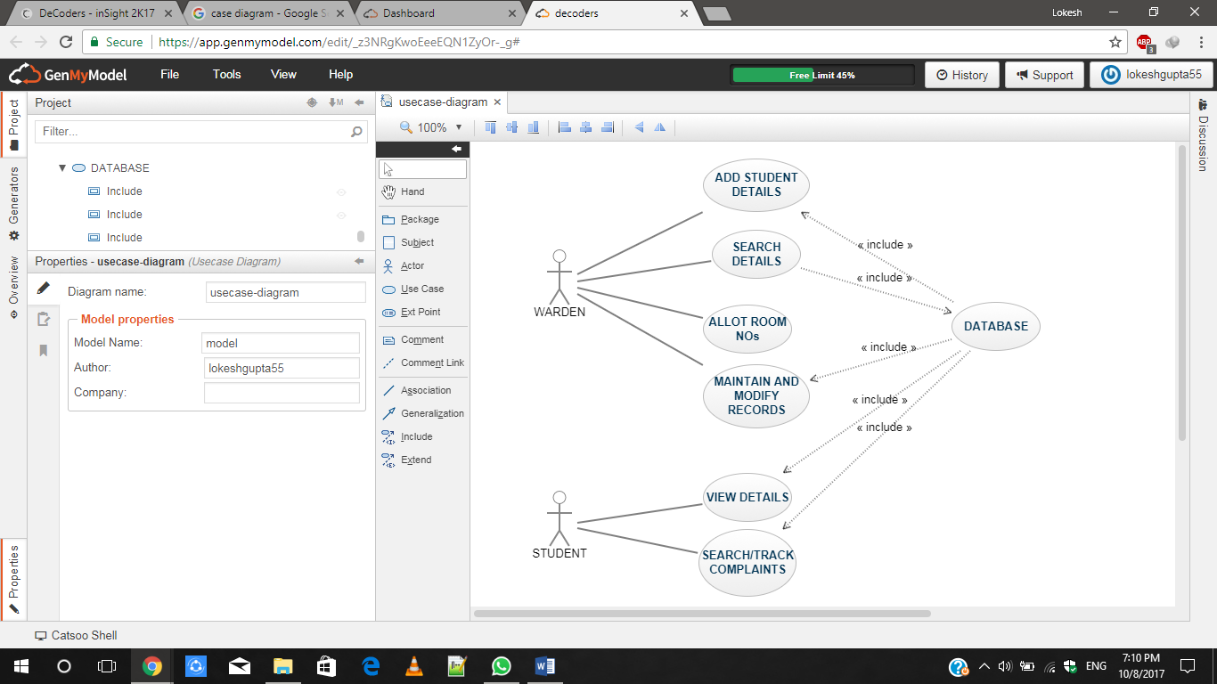

**Team Members details:**

|  |  |  |  |  |
| --- | --- | --- | --- | --- |
| **Role** | **Name** | **USN** | **Email id** | **Phone no.** |
| Team Leader | LOKESH KUMAR GUPTA | 1SI15CS053 | [lkshgupta98@gmail.com](mailto:lkshgupta98@gmail.com) | 7795767332 |
| Team Member 1 | HARSH RAJ | 1SI15CS042 | hraj204@gmail.com | 8123378818 |
| Team Member 2 | AKASHNIDHI B PRASAD | 1SI15CS007 | akashprasad3197@gmail.com | 9538296364 |