**inSight 2017**

**Department : Hostel Office**

**Problem Title : Hostel room allocation**

**Problem Code : PS02**

**Problem Description :**

With the large number of hostel applications received every year, the allocation of rooms to each applicant is a very tedious task. A software solution which would enable the hostel department with the allocation of rooms which would also make it easy for the students (they don’t have to stand in long queues anymore for allocation) would benefit both the management and the students. The priority number concept must be followed. Priority number is given on the basis of first come first serve basis on the mode of payment.

This system must be able to generate report of occupants of each hostel and the rooms which are unallocated after allocation.

Note: The solutions can include webapps, stand-alone windows systems, android apps etc.

**Proposed solution:**

*We will be creating an android application that would contain the student's login. The student will have to first enter his fee receipt number on the basis of which the priority number for the student will be generated. A student that logs in will be first asked his fee receipt number. If the receipt number has already been submitted at a previous date, then he will be viewed the entire list of students that have paid the hostel fees with their priority number. Lesser the fee receipt number higher will be student's priority. The student will also be viewed all the rooms available (those that have no applicants and those that have one or two applicants). It will also give a special access to the student to select the available room when his priority turn comes up. As soon as he selects the room, the main database will be updated and the updated database will be viewed to every other user who is using the application. Once the room is selected, the submission process will take place, that is, the student will have to submit the soft copy of the fee receipt (for validation) along with a passport size photograph.*

**Technology Stack :**

*We will firstly use AndroidStudio which is the IDE(Integrated Development Environment) for android. AndroidStudiio requires an SDK which is a set of software development tools that allows the creation of applications for the software package, software framework, hardware platform, computer system, video game console, operating system, or similar development platform.*

*The database that will contain all the student details like the fee receipt number and the priority number (generated during login), the room that a particular student wants to allocate and the later submissions that a student makes, will be created and modified using SQLite.*

*Further we will be using xml to save configuration settings of the android application. We will also use xml to describe the layout of interface elements for the activities in the android application.*

*We will also be using flask. Flask is a micro-framework for python that is being used for server backend.*

**Use Case:**

*The students will be able to log into their systems with their unique id and password.*

*They will be able to view the rooms available for them and the priority of all other students.*

*The fee receipt will decide the priority of the student and he/she will be able to book their rooms according to their priority.*

*The administrator will update the rooms available and delete the rooms already allocated.*

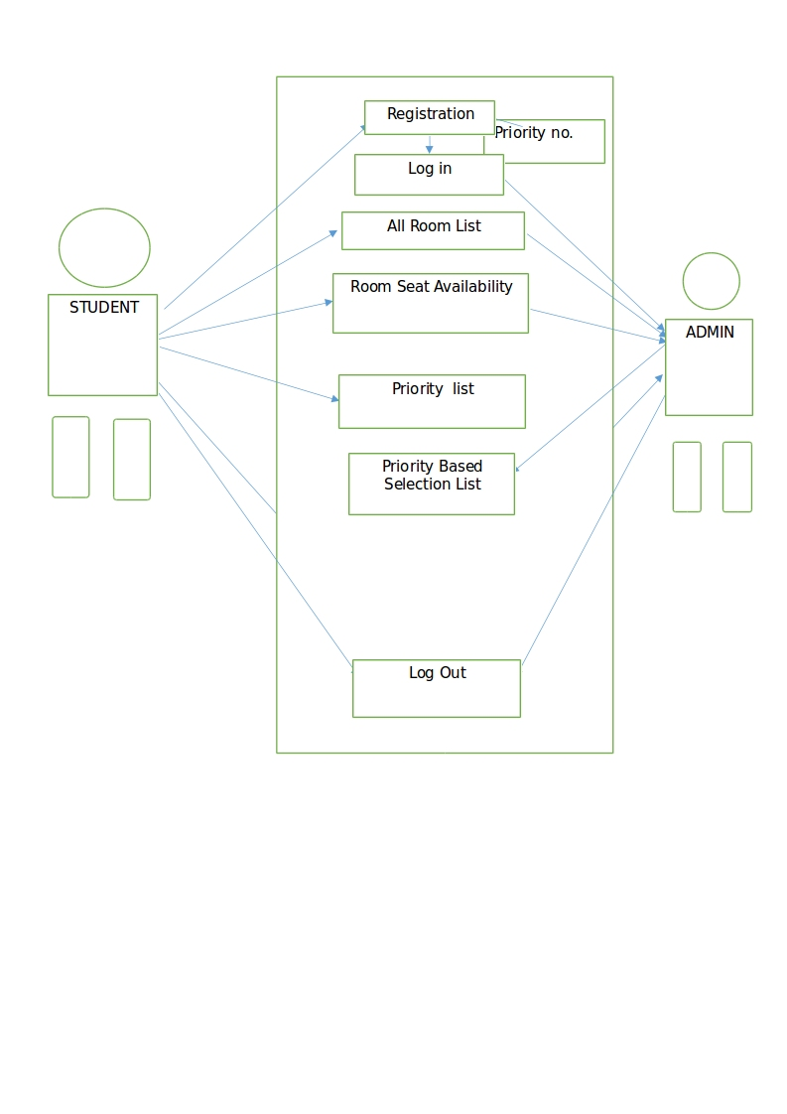

**Team Members details:**

|  |  |  |  |  |
| --- | --- | --- | --- | --- |
| **Role** | **Name** | **USN** | **Email id** | **Phone no.** |
| Team Leader | Aakansha Singh | 1SI15CS145 | aakansha.singh13@gmail.com | 9901594430 |
| Team Member 1 | Akanksha | 1SI15CS138 | akanksha.singh95@gmail.com | 9206400248 |
| Team Member 2 | Divyanshu Anand | 1SI15CS036 | divyanshuanand1998@gmail.com | 9066084907 |