**inSight 2017**

**Department : Common to all departments**

**Problem Title : Notification generator.**

**Problem Code : PS03**

**Problem Description :**

The most important part of the student life is information. There are many information that the students don’t get to know about, it may be regarding the competitions, seminars or general notices from the department or any kind of circular and many more. An android application needs to be developed which would send notifications to all the registered students that the admin intends to send. **The admin must have a facility of creating a circular or notice by just sending an email to the application also, apart from him creating a notification on his version of the app.**

The application should also keep track of the people who have read the information that was sent. (something like blue ticks thing in whatsapp).

**Proposed solution :** An application that asks for signing up first using USN and other general details. After verifying the details and storing it in a database the user profile will be generated. The application will be divided into 5 panels.

First panel : A college clubs news feed page which displays all the events,workshop and fests upcoming in college.Each post in the news feed will contain the organization’s logo followed up with the name and catch phrase a title for the event and event details(poster,gif,link to webite,google forms etc.). It will have a comments section where users can ask relevant information. And buttons which would say how many are interested and are going to attend the event.

Second Panel : A news feed page for college organized activities(like feel employable workshop,internal schedule,entrepreneurship summits etc.). Students will get relevant posts based on their profile say a student is in 1st year will get info about feel employable workshop or about his internals schedule simmilarly a student in 4th year will get information related to placements or industrial visits. Common posts will be sent to everyone. Layout for user interaction to each post will be same as was mentioned in the first panel.Latest college circulars will be posted here.

Third panel : A news feed page which displays all the events,workshop and fests happening outside the college. Same layout as the one mentioned in first panel.

Fourth Panel : All the clubs/organization will be present here and user can view each of them with appropriate filters (say literary,technical,non-technical etc). On selecting them it would display their profile which mentions their agenda and upcoming events and news.

Fifth panel : User’s Dashboard where user can update his/her profile,contact other people on the app and it shows user’s choice/schedule on which all events he is attending and related information.It would also contain the user’s time table. A notification section which would contain all the latest information.

*(In this section, tell us how you are going to solve this problem, in about 400 words)*

**Technology Stack :** Android application for creating the app. The app will be divided into 5 panels. Its layout will be designed in Android Studio. The first 4 panels will each contain link to websites which will be designed using wordpress,css and photoshop. Each posts will contain text fields,buttons and emoji icons which will be created using plugins in wordpress. Since it’s a wordpress site all the content will be saved on the web server database that comes with wordpress itself. Last panel will be designed and push notifications will be sent to this pane using java in android studio.

*(In this section, tell us what technologies you are going to use and how)*

**Use Case: *(In this section, provide the use case scenario i.e. how your software is going to work. In this section you should include use case diagrams as well. If you don’t know what a use case diagram is google it. This would also include the work flow of your software.)***

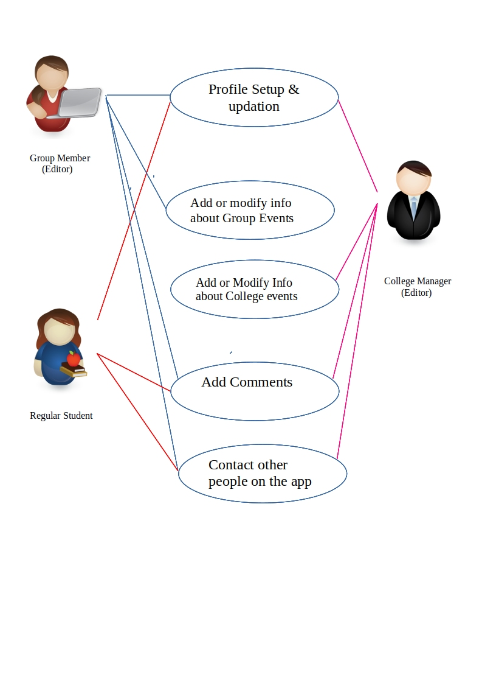

**Team Members details:**

|  |  |  |  |  |
| --- | --- | --- | --- | --- |
| **Role** | **Name** | **USN** | **Email id** | **Phone no.** |
| Team Leader | Karan Pratap | 1SI16CS046 | Karanpratapsinghcosmos@gmail.com | 7348916043 |
| Team Member 1 | Aditya Rao | 1SI16CS087 | adi97rao@gmail.com | 9919261377 |
| Team Member 2 | Nikit Singh | 1SI16CS069 | nikitskulhari@gmail.com | 9672254990 |