**inSight 2017**

**Department : Computer Science department**

**Problem Title : Attendance validation**

**Problem Code : PS04**

**Problem Description :**

There are certain situations like placements for the 4th year students; various technical events cultural events, etc. where in students have to participate. These students tend to miss their classes. Since there is an eighty five per cent (85%) attendance constraint in SIT, the students taking leave from classes for genuine reasons must get attendance for them.

An application which would enable the students to raise request for the attendance to the HOD with provision for the HOD to validate the genunity of the request and then grant the attendance.

The faculty handling the subject should come to know that the request has been approved and give attendance to the student, i.e. the app should involve student, faculty and the HOD as the end users.

**Proposed solution:**

This is to raise the request for the attendance to the HOD by submitting the documents which are verified by the respective HOD and grant the attendance for certain student. This involves the student to claim the request by uploading the certificates he/ she received on a particular date. The date on which the student marked as absent is matched with the date mentioned in the certificates. If the claim is genuine without any disturbances, the HOD sends a notification to the particular faculty member to award the attendance on that day .

The web application will allow user access to all the students. If they are aware that they are going to miss the classes on behalf of attending some technical events then they will use this website to claim the request that on a particular date they are attending some technical event with the proofs like invitation letter or posters which describes the event.When they return from the event they will again submit the proves that they have attended the event on the same day.

The list of students (in case entire class is involved for the request will be uploaded by the CR). The student need to upload documents like participation certificates, certificate of merit, health reports etc.,

We have two cases in this .

1. Only one student submitting the request ,
2. A group of students submitting the request.

The HOD checks all the uploaded documents and send a notification to the faculty member to award the attendance and requizzes if any to the particular student on the basis of usn.

The admin priviliges would be held by the HOD and the respective facultyto modify the student details. Once modified by the faculty member , the student cannot modify details.

**Technology Stack :**

**HTML** (Hyper Text Markup Language)

**CSS** (Cascading Style Sheets )

**JAVASCRIPT**

**AJAX** (Asynchronous JavaScript And XML)

**jQuery**

**MooTools**

**MYSQL**

**PYTHON**

**Google Forms**

**Use Case:**

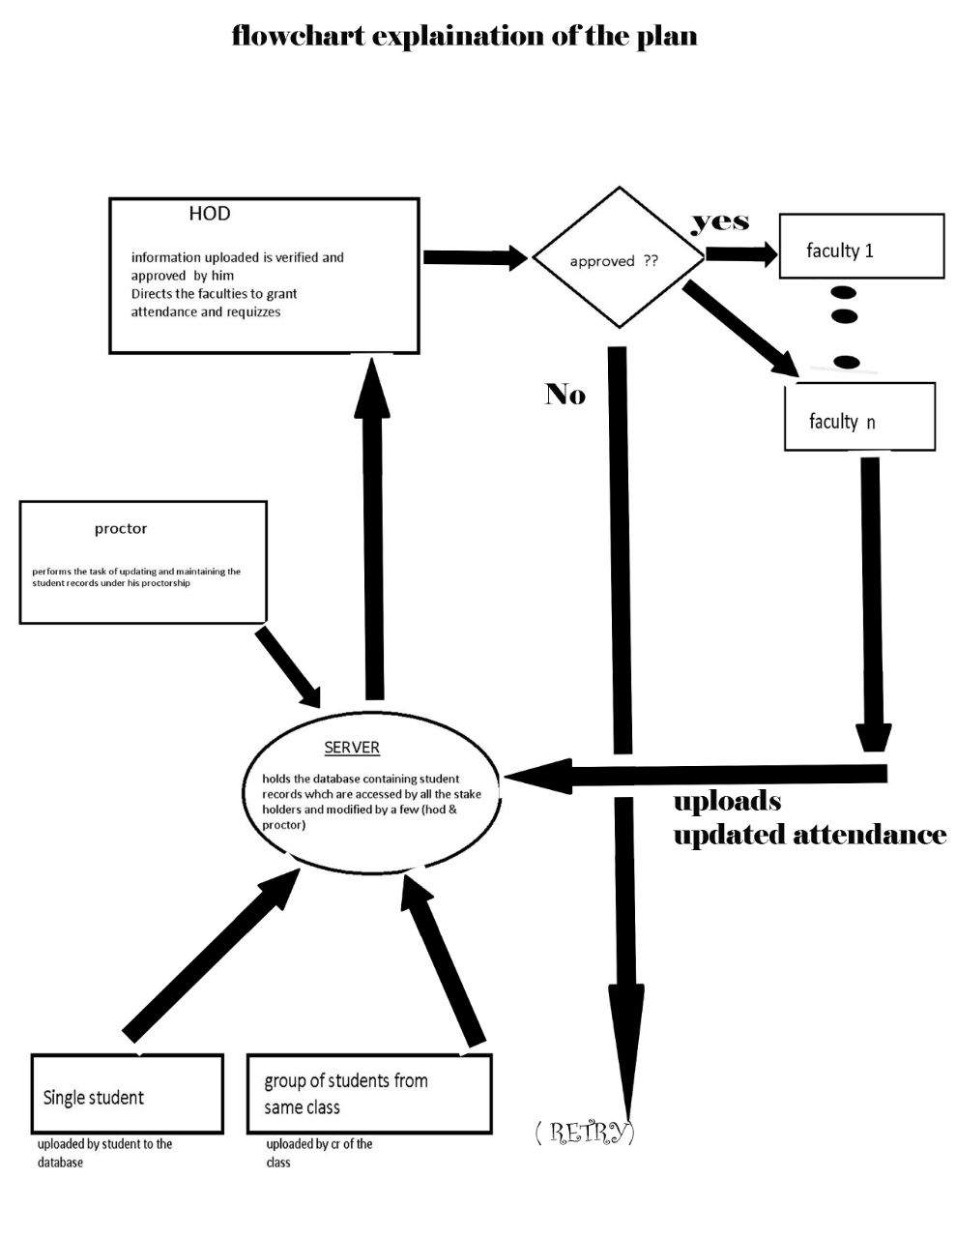

**Team Members details:**

|  |  |  |  |  |
| --- | --- | --- | --- | --- |
| **Role** | **Name** | **USN** | **Email id** | **Phone no.** |
| Team Leader | ANJALI CHOUDARY | 1SI15IS006 | anjali12.ins@gmail.com | 9945313337 |
| Team Member 1 | ANURAG KUMAR | 1SI15IS007 | anuragkumarjsk13@gmail.com | 8987702899 |
| Team Member 2 | BATHINI PRIYA SINDHU | 1SI15IS011 | priyasindhubathini963@gmail.com | 8549949649 |