**inSight 2017**

**Department : Hostel Office**

**Problem Title : Hostel room allocation**

**Problem Code : PS02**

**Problem Description :**

With the large number of hostel applications received every year, the allocation of rooms to each applicant is a very tedious task. A software solution which would enable the hostel department with the allocation of rooms which would also make it easy for the students (they don’t have to stand in long queues anymore for allocation) would benefit both the management and the students. The priority number concept must be followed. Priority number is given on the basis of first come first serve basis on the mode of payment.

This system must be able to generate report of occupants of each hostel and the rooms which are unallocated after allocation.

Note: The solutions can include webapps, stand-alone windows systems, android apps etc.

**Proposed Solution:**

**we will be solving the problem by developing a webapp.**

**Firstly,**

**The student(user) will asked whether he/she wants to apply for the room allocation in the hostel or he/she has applied they will be let to choose the room.In the first page the student will be having only two choices**

**1.To apply for the room allocation.**

**2. To block the room.**

**If they opt (1),it will lead to next page where the student should enter the valid details name,usn,fee receipt number and fee paid date are mandatory .It generates a USERNAME and PASSWORD which helps in blocking the room.All the details are stored in SQL database using PHP or java script.**

**They can opt(2) only if they have successfully filled the details and have got the password and username in opt(1).When they select opt(2) it will lead to the next page where they can block the room.the chart of unallocated and allocated rooms is displayed.Unallocated and allocated are differentiated on the basis of the color filled.**

**A student1 can block the room only if the students whose priority number is less than the priority number of student1 have blocked rooms.So,it is difficult for the students to block the room whenever they can.So after applying for the room allocation,along with user name and password. Certain range of time and date will also be generated ,during that bound time student has to block the room by tapping on the required room in the displayed chart.**

**In order to block the room,student must have generated password,username and date time.**

**We will assume that maximum number of students in each room are three.Once if the room is blocked by three students then it falls under allocated rooms list.**

**From All the passwords,username are stored in a excel sheet which can be accessed by the administrator who will be provided with a login id and password.He can print the records of the student details stored.**

**Technology Stack :**

**Usually a webapp is developed by using HTML,PHP,CSS,JAVA SCRIPT.**

**We also use html,css and javascript to develop the webapp.structuring of the pages is done using html,styling of the pages is done using css and the logics are written in javascript. PHP to write excel sheets.**

**Use Case:**

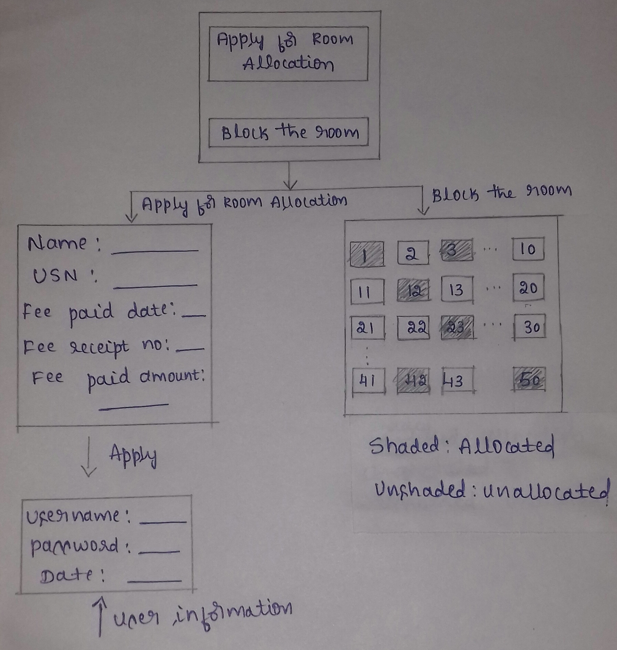

**Team Members details:**

|  |  |  |  |  |
| --- | --- | --- | --- | --- |
| **Role** | **Name** | **USN** | **Email id** | **Phone no.** |
| Team Leader | D SHREYA KISHORE | 1SI16CS032 | shreyakishore5@gmail.com | 7406474358 |
| Team Member 1 | APOORVA K V | 1SI16CS019 | appuappujustin@gmail.com | 7353863401 |
| Team Member 2 | ANUSHA N | 1SI16CS018 | anusha.appu310@gmail.com | 9538245071 |