**inSight 2017**

**Department : Computer Science department**

**Problem Title : Attendance validation**

**Problem Code : PS04**

**Problem Description :**

There are certain situations like placements for the 4th year students; various technical events cultural events, etc. where in students have to participate. These students tend to miss their classes. Since there is an eighty five per cent (85%) attendance constraint in SIT, the students taking leave from classes for genuine reasons must get attendance for them.

An application which would enable the students to raise request for the attendance to the HOD with provision for the HOD to validate the genunity of the request and then grant the attendance.

The faculty handling the subject should come to know that the request has been approved and give attendance to the student, i.e. the app should involve student, faculty and the HOD as the end users.

**Proposed solution:**

*We will be dealing with this problem statement by creating an android application that will be available for use to students, the HOD and the faculty (proctor). The students will login (from the USN) to check his attendance in every subject. The current attendance in percentage will be displayed to the student. An option for submitting a request to the HOD for attendence in case of any seminar or competition will be available. The student will submit a request with the duration of absence and along with it a proof in pdf or image format (for example participation certificte) and the name of his/her proctor. The HOD will conatin the list of all the students who have raised a request. It will be the HOD to check the image for its corretness and after doing this he/she will raise a request for attendance to the student's proctor. This will be done by the HOD through his/her login. Finally the proctor will log in to his system. He will have complete access to the attendance of all the students under his/her proctorship and the time table of each student. The proctor will also have the list of all the students's whose request for attendance has been validated by the HOD and the duration. Under every student's details with the proctor will be the month's calendar. Each date will show the day's time table for the student. Through a change attendance option, the proctor will change the student's attendance in each subject within the given duration. This updated attendance in percentage will be displayed to the student when he logs in again.*

**Technology Stack :**

*We will firstly use AndroidStudio which is the IDE(Integrated Development Environment) for android. AndroidStudiio requires an SDK which is a set of software development tools that allows the creation of applications for the software package, software framework, hardware platform, computer system, video game console, operating system, or similar development platform.*

*We will be creating databases containg student's USN, attendance per subject details, the documents that the student loads for verfication, the list of all proctors, login details of proctor, student and HOD through SQLite.*

*Further we will be using xml to save configuration settings of the android application. We will also use xml to describe the layout of interface elements for the activities in the android application.*

*We will also be using flask. Flask is a micro-framework for python that is being used for server backend.*

**Use Case:**

*The student will be able to log into the system with their USN and unique password.*

*They will be able to view their attendance of all their subjects and can make a request to the HOD according to the dates he/she was absent on and send a soft copy of their co-curricular activity certificate to the HOD.*

*HOD will view the certificate and mark it if he/she approves it and send it to the proctor as a notification that the attendance of the notified dates must be given to a particular student.*

*Proctor will log in to the system and update the student's attendance as per the subjects in the routine on the specified dates.*

*When the student logs in again to the system he/she can view their upated attendance.*

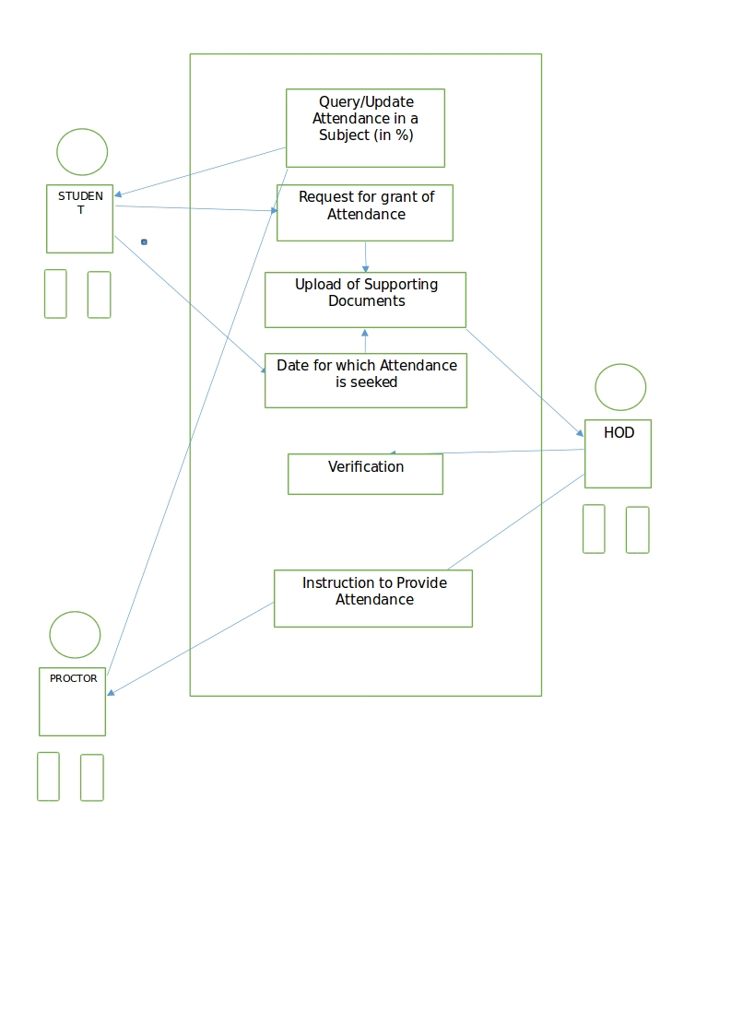

**Team Members details:**

|  |  |  |  |  |
| --- | --- | --- | --- | --- |
| **Role** | **Name** | **USN** | **Email id** | **Phone no.** |
| Team Leader | Aakansha Singh | 1SI15CS145 | aakansha.singh13@gmail.com | 9901594430 |
| Team Member 1 | Akanksha | 1SI15CS138 | akanksha.singh95@gmail.com | 9206400248 |
| Team Member 2 | Divyanshu Anand | 1SI15CS036 | divyanshuanand1998@gmail.com | 9066084907 |