**inSight 2017**

**Department : Hostel Office**

**Problem Title : Hostel room allocation**

**Problem Code : PS02**

**Problem Description :**

With the large number of hostel applications received every year, the allocation of rooms to each applicant is a very tedious task. A software solution which would enable the hostel department with the allocation of rooms which would also make it easy for the students (they don’t have to stand in long queues anymore for allocation) would benefit both the management and the students. The priority number concept must be followed. Priority number is given on the basis of first come first serve basis on the mode of payment.

This system must be able to generate report of occupants of each hostel and the rooms which are unallocated after allocation.

Note: The solutions can include webapps, stand-alone windows systems, android apps etc.

**Proposed solution:**

we gonna make a web portal to solve this problem ,the respective procedures are as follow:

1. The priority no. generated at the time of hostel fee payment will be used for allotment of the respective rooms. In order avoid the forgery a unique key will be generated at that time .for the allotment of room, the candidate must have priority no. along with fee receipt no. and mobile no.
2. The portal will be open on the specified date and time and each student will be given a specified time according to priority no. and the list of available rooms will be display with block ,occupancy , floor no., student have to make decision and have to choose the room within the specified time . if he fails to choose the room within that specified time the chance will be float to the next priority no.
3. Allotment will be done in several round (for eg. Round1 from priority no.1 to 30,two minutes for each candidate).
4. The student having priority no. failed to participate in allotment process in the first round can participate in next round of allotment.

**Technology Stack :**

**C programming , HTML,CSS,PHP**

**Use Case:**

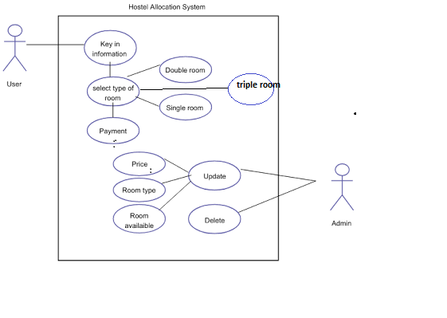

*(In this section, provide the use case scenario i.e. how your software is going to work. In this section you should include use case diagrams as well. If you don’t know what a use case diagram is google it. This would also include the work flow of your software.)*

**Team Members details:**

|  |  |  |  |  |
| --- | --- | --- | --- | --- |
| **Role** | **Name** | **USN** | **Email id** | **Phone no.** |
| Team Leader | Ritesh kumar | 1SI16CS084 | riteshkumar140897@gmail.com | 8764022360 |
| Team Member 1 | Ritesh patel | 1SI16CS085 | [riteshpatel9934941212@gmail.com](mailto:riteshpatel9934941212@gmail.com) | 8105718350 |
| Team Member 2 | Sumit Sourabh Jha | 1SI16IS054 | sumitjha1998@gmail.com | 7795208994 |