**inSight 2017**

**Department : Hostel Office**

**Problem Title : Hostel room allocation**

**Problem Code : PS02**

**Problem Description :**

With the large number of hostel applications received every year, the allocation of rooms to each applicant is a very tedious task. A software solution which would enable the hostel department with the allocation of rooms which would also make it easy for the students (they don’t have to stand in long queues anymore for allocation) would benefit both the management and the students. The priority number concept must be followed. Priority number is given on the basis of first come first serve basis on the mode of payment.

This system must be able to generate report of occupants of each hostel and the rooms which are unallocated after allocation.

Note: The solutions can include webapps, stand-alone windows systems, android apps etc.

**Proposed solution:**

*Since hostel’s rooms are allocated on the basis of priority number. Like the one who got the priority 1 can allocate their room at first. And priority number is given on the basis of first come first serve basis. So we can solve this problem by using priority scheduling algorithm. In this algorithm both case can be solved. If a person is having 1st priority and he failed to report at that time then the one who is having 2nd priority can take their room. When that 1st priority holding person will come. Then he will be treated first.*

**Technology Stack :**

**Html, CSS, PHP, MySQL, javascript**

**Use Case:**

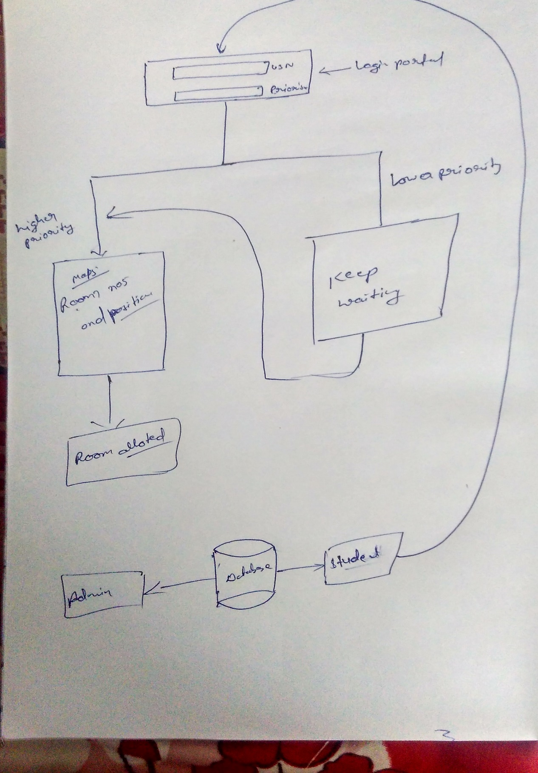

**Team Members details:**

|  |  |  |  |  |
| --- | --- | --- | --- | --- |
| **Role** | **Name** | **USN** | **Email id** | **Phone no.** |
| Team Leader | Somila S kumar | 1si15is050 | somilaskumar.ssk58@gmail.com | 9008717781 |
| Team Member 1 | SIddhant Gautam | 1si16is052 | sgautam8434@gmail.com | 7677034242 |
| Team Member 2 | Rishav Kumar | 1si15is046 | rishav1797@gmail.com | 8296660267 |