**InSight 2017**

**Department : Hostel Office**

**Problem Title : Hostel room allocation**

**Problem Code : PS02**

**Problem Description :**

With the large number of hostel applications received every year, the allocation of rooms to each applicant is a very tedious task. A software solution which would enable the hostel department with the allocation of rooms which would also make it easy for the students (they don’t have to stand in long queues anymore for allocation) would benefit both the management and the students. The priority number concept must be followed. Priority number is given on the basis of first come first serve basis on the mode of payment.

This system must be able to generate report of occupants of each hostel and the rooms which are unallocated after allocation.

Note: The solutions can include webapps, stand-alone windows systems, android apps etc.

**Proposed solution:**

*The problem is quite similar to booking online tickets for movie theatres. So different movie theatres hall within a mall can be considered as different hostels (1st year – boys/girls, etc). All the rooms (which is equivalent to seats in a theatre) will be shown GREY (as being un-occupied). YELLOW if being currently viewing by some other student and RED if occupied. If the room is for two/three students, then lighter shades of colour will be used to show availability. A change request to warden will also be available, if the room selected is not as expected. A chat system will also be introduced for interaction with the warden. A small FAQ section will also be provided.*

*To implement the same, a web application will be designed. Front end will be designed with the help of HTML, CSS, JavaScript and bootstrap.*

*Backend will be implemented using python and mongoDB for database.*

**Technology Stack :**

*FRONT END:*

*HTML/CSS for basic structure of the page.*

*Bootstrap/JavaScript for enhancing the webpage and making it dynamic.*

*BACK END:*

*MongoDB for database and using JSON for sending data and python for maintaining the database.*

**Use Case:**

*A GUI will be provided for the following options by clicking on each option respective page will be opened. Same is displayed below:-*

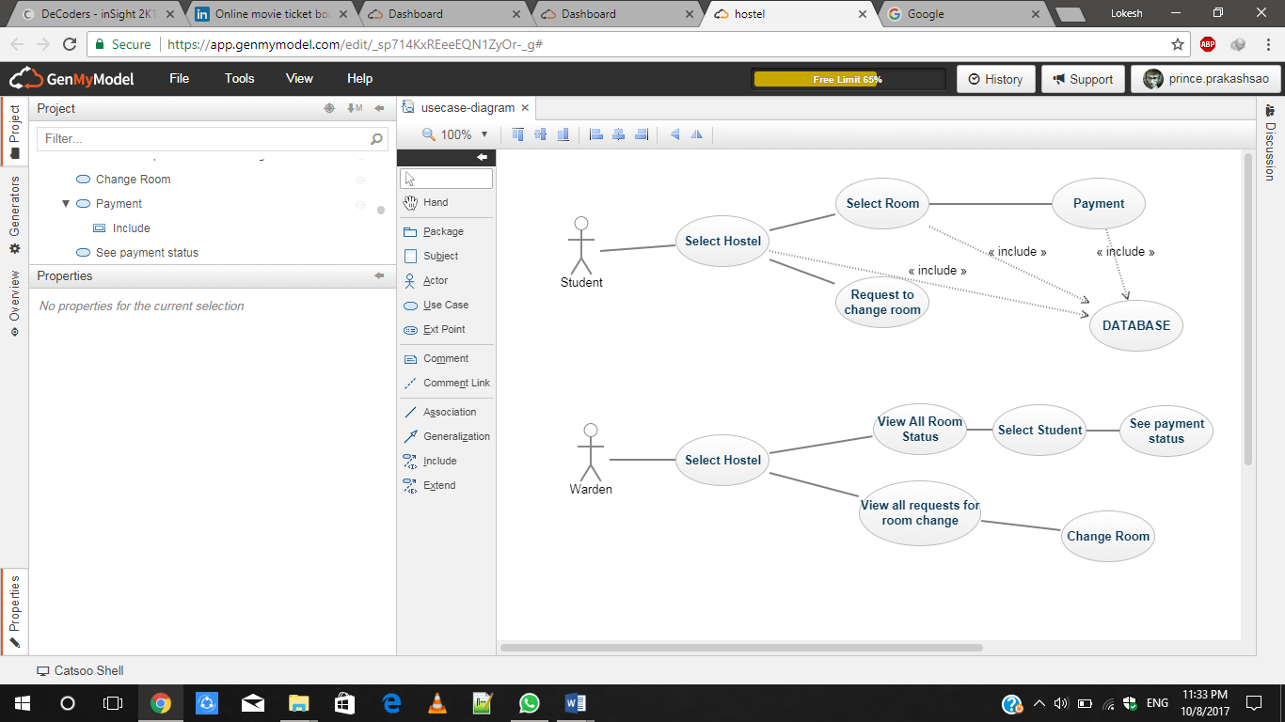

**Team Members details:**

|  |  |  |  |  |
| --- | --- | --- | --- | --- |
| **Role** | **Name** | **USN** | **Email id** | **Phone no.** |
| Team Leader | Prince Kumar | 1SI15CS080 | [Prince.prakashsao@gmail.com](mailto:Prince.prakashsao@gmail.com) | 7795308818 |
| Team Member 1 | Piyush Srivastava | 1SI15CS073 | piyush061996@gmail.com | 7599301269 |
| Team Member 2 | Vatsalya Yadav | 1SI15CS130 | vatsalya.yd@gmail.com | 9113497771 |